Web API Handson 5 - JWT Authentication

Objectives
1. Explain CORS enablement for Web API access for local application.

CORS (Cross-Origin Resource Sharing) is a browser security feature that blocks requests from a different domain than the one that served the web page. To allow a local frontend application to call a Web API hosted on a different port or domain, CORS must be explicitly enabled in the API. This is done by installing the CORS NuGet package and configuring it in Program.cs using builder.Services.AddCors() and app.UseCors() with the allowed origins, methods, and headers defined in a policy.

2. Demonstrate security in Web API using Bearer and JWT token authentication.

JWT (JSON Web Token) is a standard method of securing Web API endpoints. A token is generated by the server after verifying the user identity and is signed with a secret key. The client then sends this token in the Authorization header as "Bearer <token>" with every subsequent request. The API validates the token on each request using the same secret key, issuer, and audience values. If the token is missing, expired, or tampered with, a 401 Unauthorized response is returned. In this handson, AddAuthentication and AddJwtBearer were configured in Program.cs, an AuthController was created to generate JWT tokens, and the [Authorize] attribute was applied to the EmployeeController to protect its endpoints.

1. JWT Configuration in Program.cs
JWT authentication was configured in Program.cs using AddAuthentication and AddJwtBearer. A secret key, issuer, and audience are defined and used to validate incoming tokens. UseAuthentication middleware is added before UseAuthorization in the pipeline.

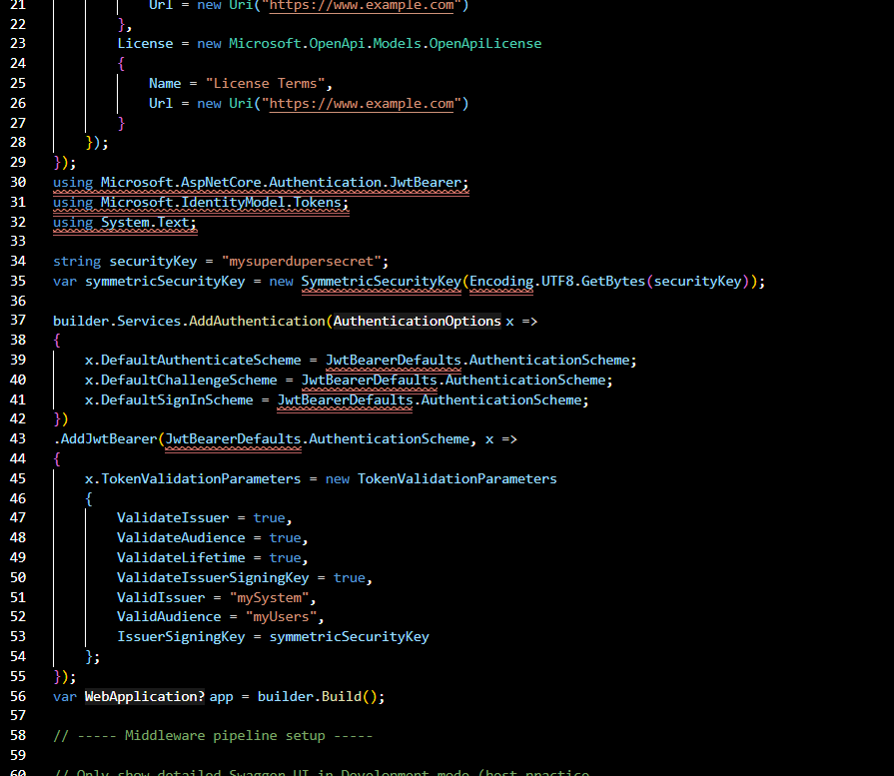

2. AuthController - Generating JWT Token
A new AuthController was created with [AllowAnonymous] so it can be accessed without authentication. The GenerateJSONWebToken private method creates a JWT token with Claims (Role = Admin, UserId), sets expiry to 10 minutes, and returns the signed token string.

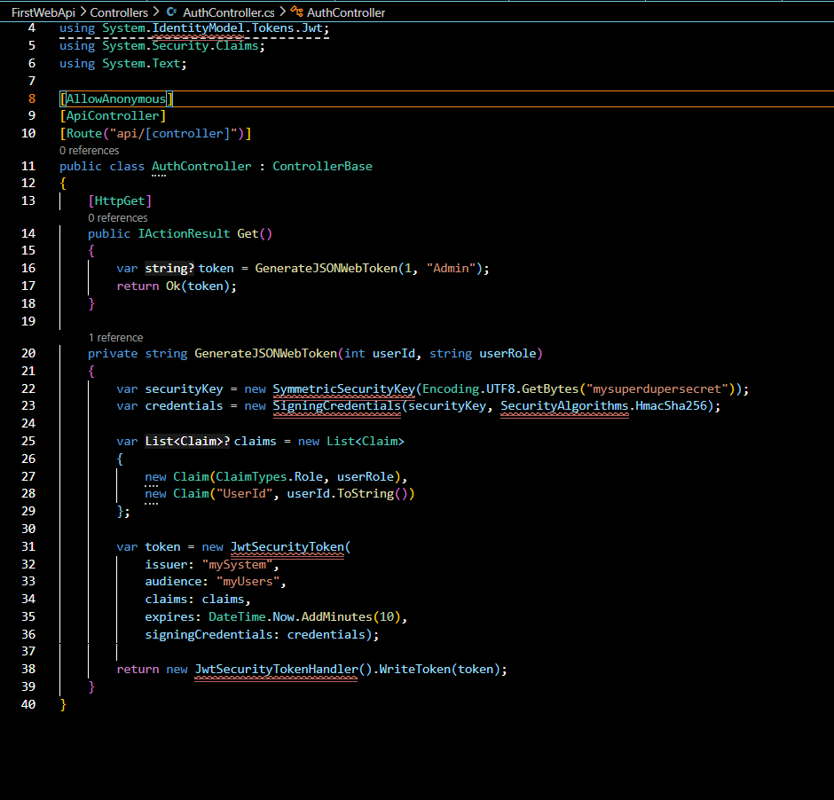

3. Application Build and Run
After adding JWT packages and configuring Program.cs and AuthController, the application was built and run successfully using dotnet run command.

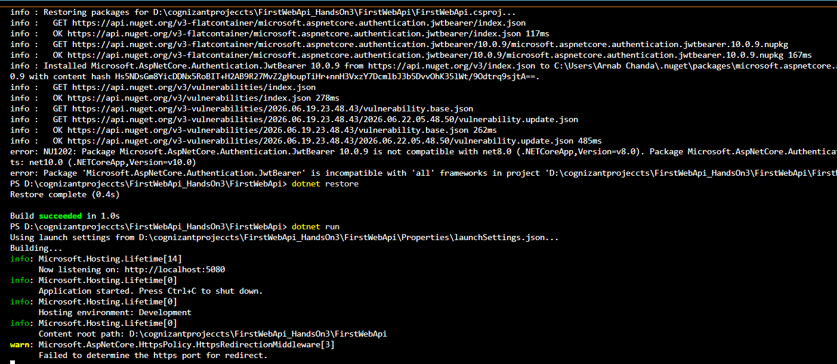

4. Swagger - Auth Endpoint Visible
After running the application, the Swagger UI shows the Auth section with the GET /api/Auth endpoint which is used to generate the JWT token.

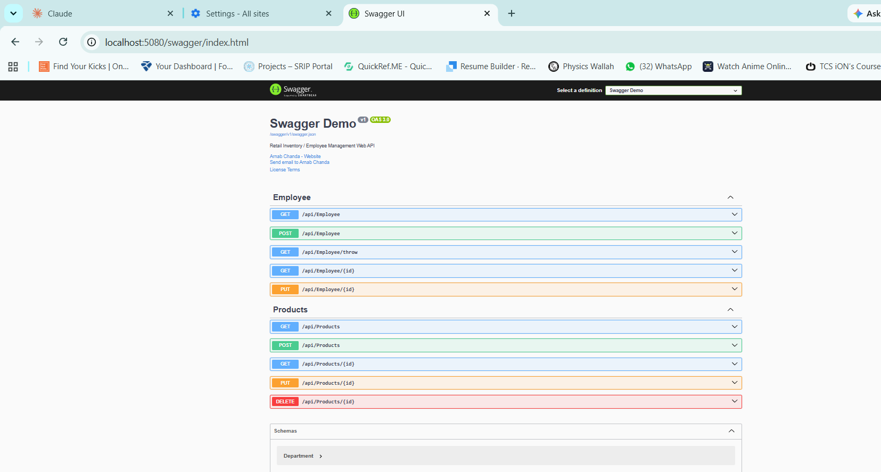

5. JWT Token Generated Successfully
Calling GET /api/Auth from Swagger returns a 200 OK response with the JWT token string in the response body. This token is then copied and used in Postman for authenticated requests.

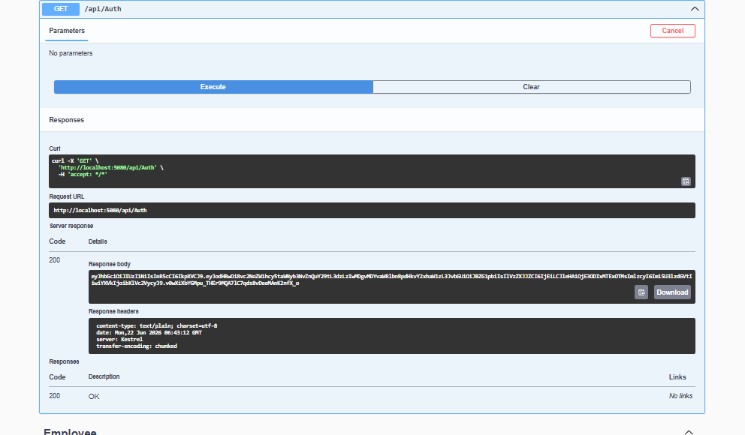

6. [Authorize] Attribute on EmployeeController
The [Authorize] attribute is applied at the top of EmployeeController. This ensures every request to the controller must include a valid JWT Bearer token in the Authorization header, otherwise a 401 Unauthorized is returned.

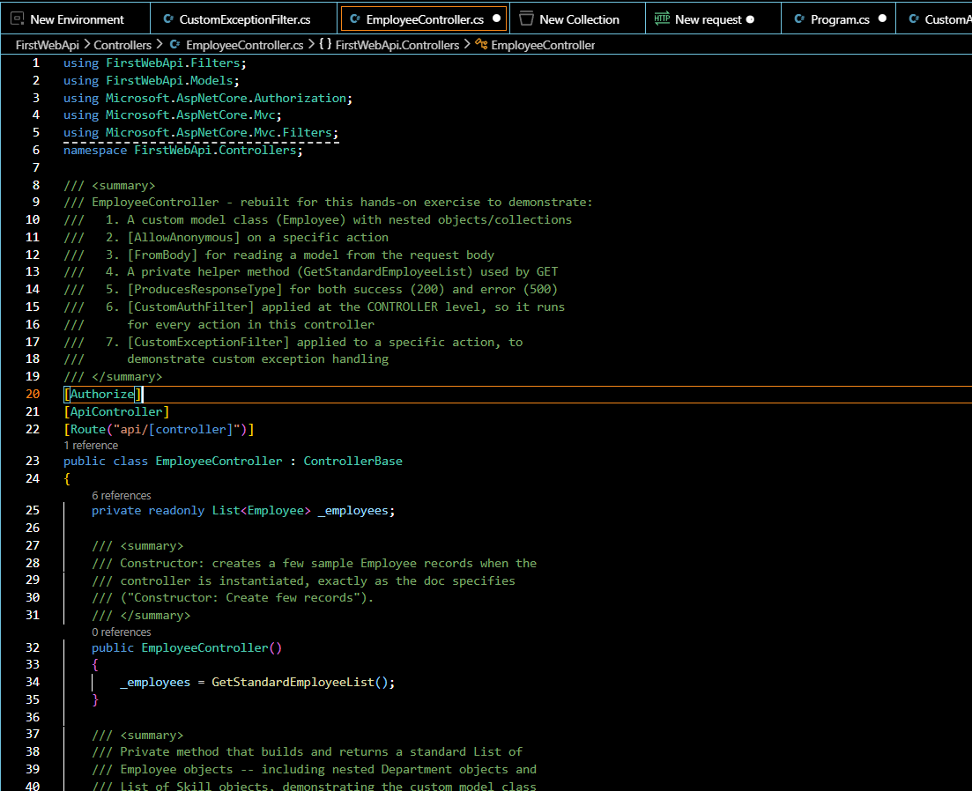

7. Testing with Invalid Token - 401 Unauthorized
When an invalid token is passed in Postman to GET /api/Employee, the API correctly returns 401 Unauthorized. This confirms the JWT validation is working. When the valid token from AuthController is used, the response is 200 OK.
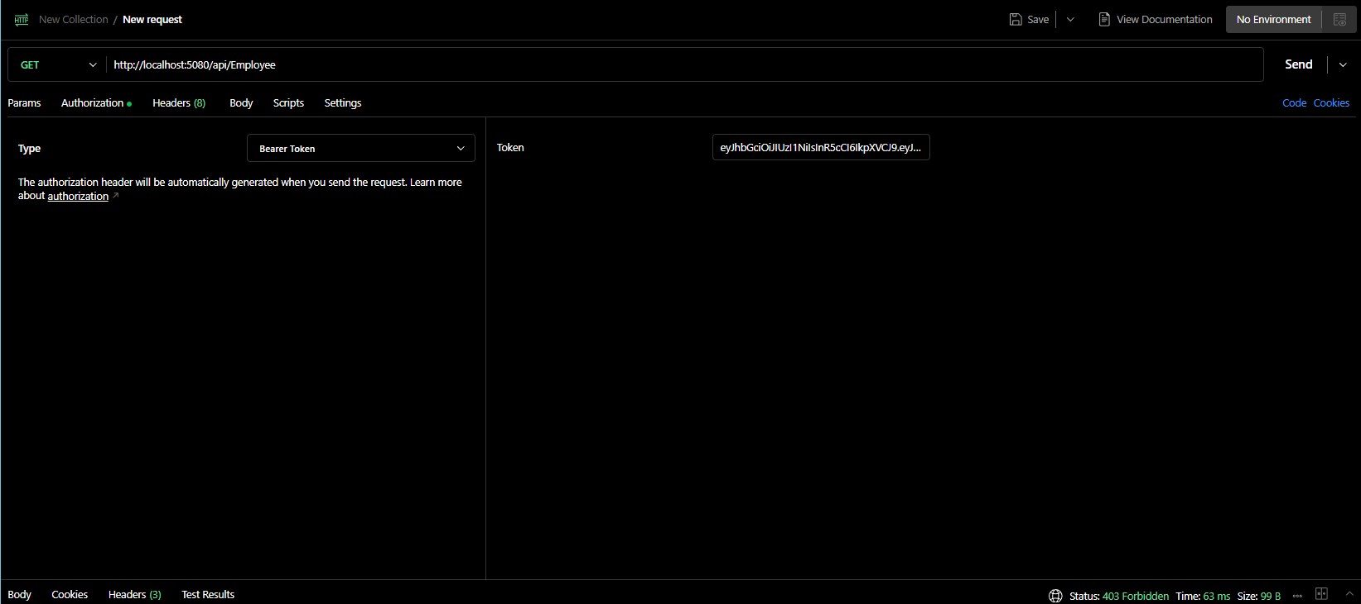
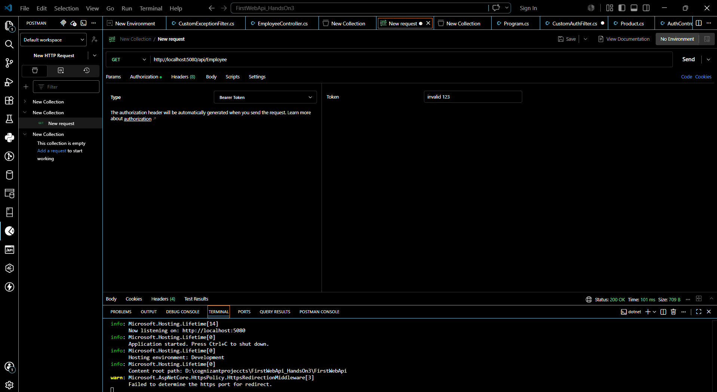

8. Role-Based Authorization
The Authorize attribute was changed to [Authorize(Roles = "POC")] - this returned 401 Unauthorized since the token carries the Admin role, not POC. When changed to [Authorize(Roles = "POC,Admin")], the request succeeded with 200 OK since Admin is now an accepted role.
