**Experiment No.1**

**Aim** :- Write Python program to find all prime numbers within a given range.

**Software Used** :- Spyder (Python 3.7)

**Flowchart**:- 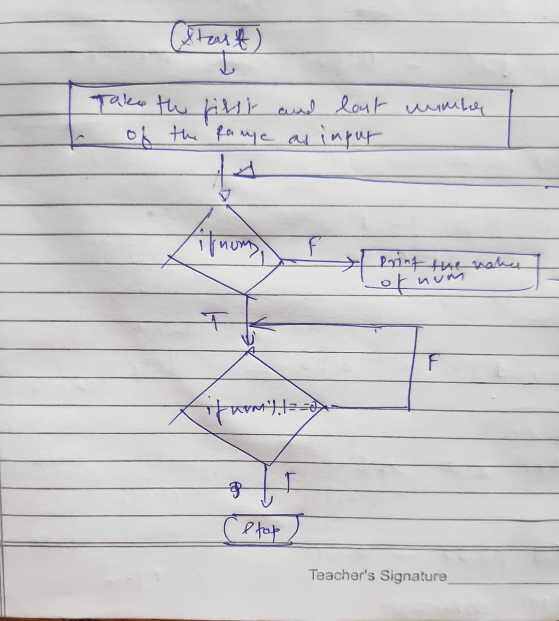

**Program**:-

low = int(input("Enter Lower Digit :"))

high = int(input("Enter Upper Digit :1"))

for num in range(low, high + 1):

if num > 1:

for i in range(2, num):

if (num % i) == 0:

break

else:

print(num)

Output:-

Enter lower Digit :10

Enter Upper Digit :100

11

13

17

19

23

29

31

37

41

43

47

53

59

61

67

71

73

79

83

89

97

Screenshot of Output:-

