1. **(1 pt.)** What is the primary splitting criterion in the famous C4.5 decision tree algorithm?

2. **(1 pt.)** What is the primary splitting criterion in SAS Enterprise Miner?

Use the trained decision tree below to answer the remaining questions.

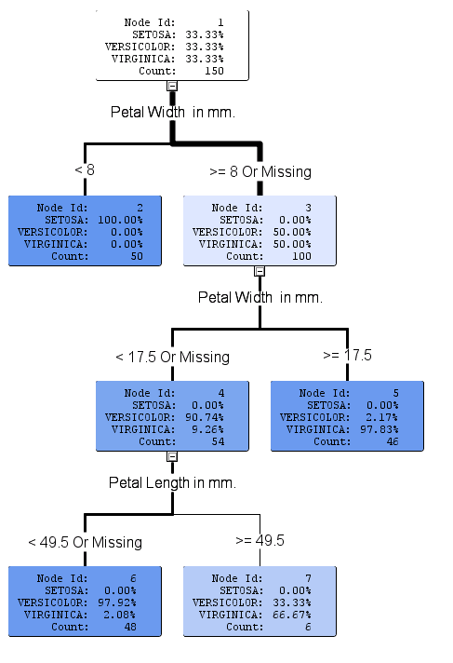

3. **(1 pt.)** Write out the English language rule defined by the top, left branch of this tree.

4. **(1 pt.)** What is the depth of this decision tree? (Do not include the root node in your count.)

5. **(1 pt.)** How many leaf nodes does it contain?

6. **(1 pt.)** State a tuning parameter setting that was obviously used in the training of this tree.

7. **(1 pt.)** What is the most important input variable to this tree?

8. **(1 pt.)** If a new record of datahas the following attributes:

|  |  |  |  |
| --- | --- | --- | --- |
| Petal Length (mm) | Petal Width (mm) | Sepal Length (mm) | Sepal Width (mm) |
| 20 | 15 | 14 | 18 |

How would it be classified by this tree?

9. **(2 pts.)** The presented tree is a maximal tree. Prune this tree manually given the leaf plot below. Draw an X over the nodes that should be removed.