**Names of the Students:**

**1. Study of a coaxial cable.**

1. Please observe the cables on your bench. Which shield configurations are implemented in each one?

Please confirm the answer by means of the two datasheet provided, in the. Comment the kind of material used in such shield configuration.

|  |  |  |
| --- | --- | --- |
|  | **Cable type 1** | **Cable Type 2** |
| ***Code/Reference:*** | 8216  (RG-174/U Type, 26 AWG Stranded) | 1694  (RG6/U Type, 18 AWG) |
| ***Shield***  ***configuration and Material*** | Braid  TC (Tinned Copper) | Capa 1: Duofoil® Tape, Aluminum Foil-Polyester 95 (100% coverage)  Capa 2: Braid, TC - Tinned Copper 95 |

1. Is the cable either flexible or semiflexible?

# Flexible

|  |  |  |
| --- | --- | --- |
|  | **Cable type 1** | **Cable Type 2** |
| ***Flexible/Semi flexible*** | Flexible | Flexible |

*3.* Find out the material used for the inner conductor of the cable, as well as the inner diameter (d) and fulfill the table. Please take into account the units (mm or inches considered within the datasheets)

# TC – Cobre estañado0,0355”

|  |  |  |
| --- | --- | --- |
|  | **Cable type 1** | **Cable Type 2** |
| ***Inner conductor material*** | BCCS - Bare Copper Covered Steel  (Acero recubierto de cobre desnudo) | BC - Bare Copper  (cobre desnudo) |
| ***Inner diameter (d)*** | .019 in. = 0,4826mm | 1.016 mm |

*4.* Now infer the type of material used as dielectric in the cables, as well as the inner diameter of the outer conductor (D). This information is available in the datasheets within **Insulation** paragraph. Please use S.I. units (conversion if required)

# PE-Polietileno Sólido

|  |  |  |
| --- | --- | --- |
|  | **Cable type 1** | **Cable Type 2** |
| ***DIELECTRIC MATERIAL*** | PE - Polyethylene | Gas-injected FHDPE - Foam High Density Polyethylene |
| ***NOM.***  ***DOD.(Insulation diameter)*** | .060 in. = 1.524 mm | 4.572 mm |

# 0,116”

*5.* Please consult both datasheets to get both Characteristic Impedance (Z0) and Capacity (C) parameters of the cable (**Nom Characteristic Impedance** and **Nom. Capacitance Conductor to Shield).** Based on these figures, please derive the dielectric constant parameter (ℰr) from the material used as a dielectric. Check that the calculated figure matches the expected one for the said material in the list of isolating materials provided by the teacher.

|  |  |  |
| --- | --- | --- |
|  | **Cable type 1** | **Cable Type 2** |
| ***NOMINAL IMPEDANCE*** | 50 Ohms | 75 Ohms |
| ***NOMINAL***  ***CAPACITANCE*** | 30.8 pF/ft = 10,16 pF/m | 53.1522 **pF/m** |
| ℰ***r (calculated)*** | $Er{=(\frac{60}{Z0}*ln(\frac{D}{d}))}^{2}$**=1.9** | $Er{=(\frac{60}{Z0}*ln(\frac{D}{d}))}^{2}$**=1.4478** |
| ℰ***r (theoretical)*** | 1.9-2.3 | 1.5-1.7 |

**Note - Range of** e***r (theoretical):***

*Polyethylene* [1,9 – 2,3] *Gas-Injected foam HDPE insulation: [1,5- 1,7]*

# anδ1=0.003

1. Now, taking into account the ℰ**r** obtained from the equation, please calculate now the propagation speed of the cable expressed in m/s as well as the temporal delay. Please also calculate the cut off frequency of the cable. Compared with the theoretical ones included in the datasheets. Are these values coherent?

|  |  |  |  |  |
| --- | --- | --- | --- | --- |
|  | **Cable type 1 (from equat.)** | **From Tables** | **Cable Type 2 (from equat.)** | **From Tables** |
| ***Propagation speed (m/s)*** | 21764 | Vp (%) [vp/c] | 24932.56 | Vp (%): |
| ***Time delay*** | 45.94us | Delay (ns/m): | 40.1us | Delay (ns/m): |
| ***Cut off***  ***Frequency*** | 69Mhz | N/A | 28.4MHz | N/A |

1. According to the cable catalog, please determine the isolation material used to protect the cable. This information can be found in the paragraph of the datasheets **Outer Jacket Material**.

|  |  |  |
| --- | --- | --- |
|  | **Cable type 1** | **Cable Type 2** |
| ***Jacket Material*** | PVC - Polyvinyl Chloride | PVC - Polyvinyl Chloride |

# P

*8.* Using the cable catalog, please identify the maximum alternate voltage level which can withstand (**MAX OPER VOLTAGE - UB**). Considering that, please provide the maximum recommended value it is able to withstand in continuous.

# 1.900V

|  |  |  |
| --- | --- | --- |
|  | **Cable type 1** | **Cable Type 2** |
| ***MAX OPER VOLTAGE UL (rms)*** | ***(from datasheet):***  30 V RMS | ***(from datasheet):***  300 V RMS |
| ***MAX OPER VOLTAGE (CC)*** | (***from criteria 2.1.7 Maximum voltage Level):***    90 V RMS | (***from criteria 2.1.7 Maximum voltage Level):***    900 V RMS |

*9.* Please take note of the recommended temperature range of functioning of the cable, and check that such range is within the temperature range of the material used as a dielectric.

# Para de -75ºC a +250ºC

|  |  |  |
| --- | --- | --- |
|  | **Cable type 1** | **Cable Type 2** |
| ***Recommended***  ***Temperature Range of CABLE*** | ***(from datasheet):***    -40°C To +75°C | ***(from datasheet):***    -30°C To +75°C |
| ***Recommended***  ***Temperature Range***  ***of Dielectric \**** | **(from catalogue):**  -75ºC-- 80ºC | -75ºC-- 80ºC |
| ***Coherent values***  ***(circle right answer)?*** | **YES / NO** | **YES / NO** |

*\*Please consider in this paragraph Polyethylene* *in both cases.*

1. **To identify and become familiar with a sample of a twisted pair cable.**

* 1. Which type of connector is used for this cable? Are all pins used for any purpose?

*RJ45. No*

* 1. How many wires are there within the twisted pair cable?

8

* 1. Which is each wire used for?

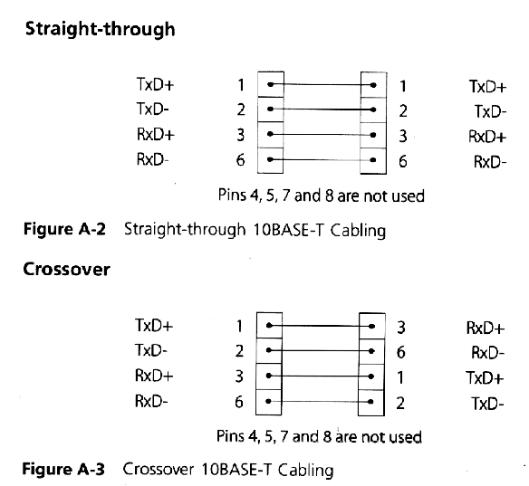

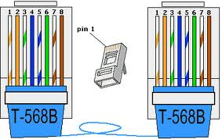

* 1. Which cable connection configuration, from the two one described in theory, is being used in the laboratory?

*Straight-through (sin cruzar)*

* 1. Which cable connection configuration would be used to connect two PC’s?

*Crossover (cruzado)*

1. **To identify several connectors.**

# 3.1. *CONNECTORS*

|  |  |
| --- | --- |
| **C1** | SMA Hembra |
| **C2** | N Hembra |
| **C3** | BNC Macho |
| **C4** | N Macho |
| **C5** | F Macho |
| **C6** | SMA Macho |
| **C7** | Antena TV Macho |
| **C8** | Antena TV Hembra |
| **C9** | BNC Hembra |

# 3.2. *TRANSITIONS*

|  |  |
| --- | --- |
| **T1** | SMA Macho – N Macho |
| **T2** | SMA Hembra – N Hembra |
| **T3** | F Macho – TV Hembra |
| **T4** | SMA Hembra – SMA Hembra |
| **T5** | F Hembra - F Hembra |
| **T6** | BNC Macho – F Hembra |
| **T7** | BNC Macho – 2 BNC Hembra |