- Practice 1 execution: First Part.

R₂ = Variable
R₁=1.2KΩ
V = 10V
V_{Ref}

R₂ | R₂=400Ω | R₂=600Ω | R₂=1.2KΩ | R₂=2KΩ
V_{ref}(V) | 2,5 | 3,33 | 5 | 6,25
P_{ref} (W) | 0,01562 | 0,01848 | 0,02083 | 0,01953
V_{ref}(dBu) | 10,17 | 12,66 | 16,19 | 18,13
P_{ref} (dBm) | 11,93 | 12,66 | 13,18 | 12,9
P_{ref} (dBm) - V_{ref}(dBu) | 1,76 | 0 | -3,01 | -5,2287
Factor Correc.  Teórico | 1,76 | 0 | -3,01 | -5,2287

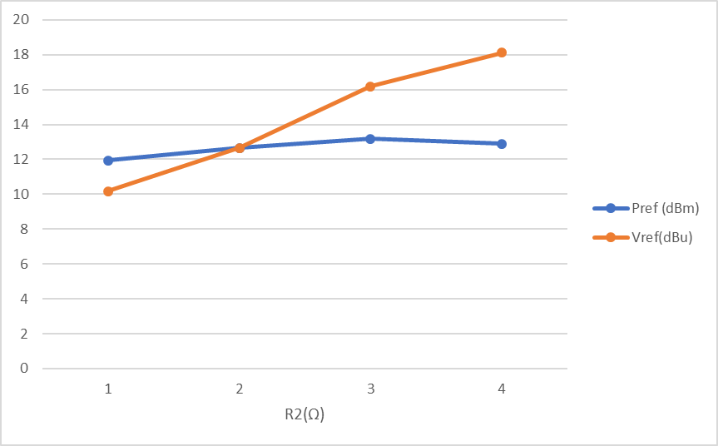

- Practice execution: Questions of Second Part.
:

50Ω
50Ω
V=20V_{pp}
A
FUNCT. GENERATOR
L= 10dB
L = 3dB
B
C

 | A | B | C
Vpp | 10 | 5,266 | 3,72
V_{ef} | 3,535 | 1,862 | 1,318
V(dBu) | 13,18 | 3,187 | 0,187
P(dBm0) | 23,98 | 23,98 | 23,98
P(dBm) | 23,98 | 13,98 | 10,98
P(dBr) | 0 | -10 | -13

 | A | B | C
Vpp | 10 | 5,266 | 3,72
V_{ef} | 5,535 | 1,862 | 1,318
V(dBu) | 13,18 | 3,187 | 0,187
P(dBm0) | 13,98 | 13,98 | 13,98
P(dBm) | 23,98 | 13,98 | 10,98
P(dBr) | 10 | 0 | -3

 | A | B | C
Vpp | 10 | 5,266 | 3,72
V_{ef} | 3,535 | 1,862 | 1,318
V(dBu) | 13,18 | 3,187 | 0,187
P(dBm0) | 10,98 | 10,98 | 10,98
P(dBm) | 23,98 | 13,98 | 10,98
P(dBr) | 10 | 3 | 0

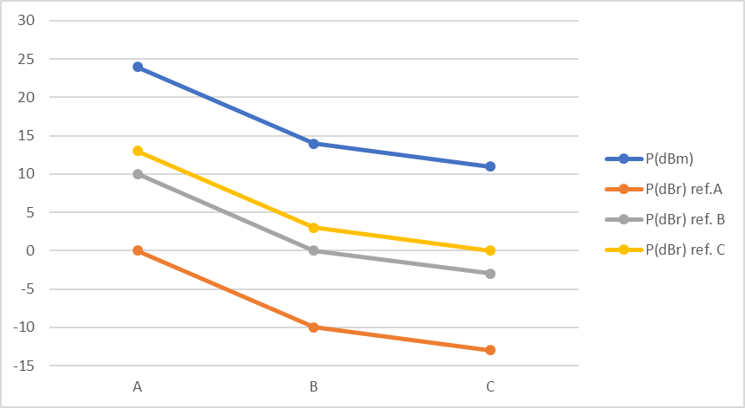

- Questions

This section will consist on several questions to verify whether the student has fully
understood topics of this practice or not.

For paragraph 3.1:

- At what point of the drawn plot the voltage figure expressed in dBu matches
the expressed dBm power? Why?

- What sign is the correction factor for resistors with a nominal value greater
than 600?

- And with a resistor value of less than 600?

For paragraph 3.2:

- What would the voltage be at point A of the circuit in case of disconnecting the
rest of components which are drawn to its right?

- When does values in dBr coincide with the attenuation in dB of the
attenuators?

- Propose a method to calculate the attenuation of an attenuator of unknown
value.

- Provided a dBm0 level in the circuit, does this figure change when measuring in
whichever other point of the circuit?

