An Adaptive, Self-Explaining Deep Learning System for Early Detection of Cognitive Impairment from Spontaneous Speech
A R Nitesh Kumar(23BAI0108), Harshini J S(23BAI0166), Hari Prasath U(23BAI0038), Saravanakumar Kandasamy(saravanakumar.k@vit.ac.in)
School of Computer Science and Engineering, Vellore Institute of Technology, Vellore, India

Abstract
Early Alzheimer's Dementia (AD) alters spontaneous speech long before diagnosis, motivating low-cost, non-invasive screening. This work presents an adaptive, self-explaining deep learning system that receives only a spoken description of the Boston “Cookie-Theft” picture and returns a diagnosis together with a clinician-readable explanation. The raw recording is diarised to isolate patient speech and split into utterances; an acoustic branch (WavLM with per-utterance prosody) and a linguistic branch (Whisper automatic speech recognition followed by RoBERTa) produce utterance-aligned representations that are combined through gated cross-attention. A discourse encoder summarises the fused sequence, and a supervised concept bottleneck of twenty-four clinically meaningful markers feeds a linear head, so each prediction is an exact additive scorecard of interpretable factors. A confidence-based early-exit determines when enough speech has been observed. On the full DementiaBank Pitt corpus (552 recordings, 292 speakers) under speaker-independent repeated stratified group cross-validation, the system attains an out-of-fold ROC-AUC of 0.722 ± 0.014, matches a black-box counterpart at essentially zero interpretability cost (−0.003 AUC), and reconstructs the underlying clinical markers with mean fidelity r = 0.69; about ten seconds of speech already reaches full-recording accuracy. The framework is interpretable by construction, adaptive, and deployable as an audio-only screening tool.

Introduction
Neurocognitive disorders pose a major challenge to healthcare systems: cognitive decline develops gradually, yet clinical assessment remains time-consuming and dependent on specialist expertise. Early identification is critical for timely intervention, and this burden has driven the development of automated, non-invasive assessment procedures. Among available behavioural signals, spontaneous speech has attracted considerable attention because it can be collected remotely and simultaneously carries acoustic, linguistic, and discourse-level information associated with cognitive functioning [1], [3], [5].
Advances in deep learning enable systems to learn complex acoustic and linguistic representations directly from data. Multimodal approaches such as TSAC-ATT and CogniAlign demonstrate the value of combining acoustic and linguistic representations for cognitive-impairment detection [1], [3]. However, speech-based detection is challenging because relevant changes appear at multiple levels—acoustic characteristics, pausing, and narrative structure [2], [4].
Current approaches commonly produce a prediction only after processing a predetermined amount of speech [1]–[6], and explainability is usually provided post-hoc through techniques such as Integrated Gradients, SHAP, LIME, Grad-CAM, or attention visualisation [3], [4], [13]–[15]. Concept-bottleneck models instead build interpretability into the prediction by routing decisions through human-understandable concepts [11], but this principle has not been explored for spontaneous-speech-based cognitive-impairment detection.
From the reviewed literature, two research gaps are identified. First, existing speech-based systems are largely black-box or rely on post-hoc explanations rather than intrinsically interpretable representations. Second, most works process a complete or fixed-duration recording without dynamically deciding whether additional speech is required [1]–[6]. Consequently, combining intrinsic clinical interpretability with confidence-based adaptive evidence acquisition remains underexplored.
This study develops an Adaptive, Self-Explaining Deep Learning System for Early Detection of Cognitive Impairment from Spontaneous Speech. The system couples a clinically meaningful concept-bottleneck representation, which provides interpretable intermediate evidence, with a confidence-based early-exit mechanism that determines when sufficient speech has been observed for a reliable prediction. It therefore addresses both the interpretability of the decision and the amount of speech required to reach it. The main contributions are:
- an intrinsically interpretable concept-bottleneck architecture for speech-based screening;
- integration of clinically meaningful speech concepts with learned acoustic and linguistic representations;
- a confidence-based early-exit mechanism that dynamically determines the amount of speech needed to predict; and
- a joint evaluation of predictive performance, interpretability, confidence, and the amount of speech processed.
By exposing clinically meaningful concepts and enabling predictions without processing the complete recording, the system improves the transparency and efficiency of automated screening.

Related Work
Existing research can be grouped into three directions: speech representation and multimodal fusion, interpretable clinical AI, and supporting/adaptive learning. The first is directly focused on speech and includes acoustic–linguistic fusion, long-range discourse modelling, topic evolution, and conversational-speech analysis [1]–[6]. The second concerns interpretability via concept bottlenecks, logits-constrained attention, counterfactual explanations, and post-hoc feature attribution [11]–[15]. The third addresses supporting challenges such as speech recognition for elderly speakers and learning from incomplete or heterogeneous modalities [7], [9], [10].
Among speech-based approaches, TSAC-ATT combines wav2vec 2.0 acoustic representations with BERT linguistic representations through attention-based fusion and reports strong performance across datasets [1]. CogniAlign advances multimodal fusion by aligning acoustic and textual representations at the word level and explicitly modelling pauses and hesitations [3]. Graph-based modelling captures temporal and acoustic-similarity relations between segments, representing long-range phenomena such as repeated ideas [2], [4]. Real-world conversational studies show that different prompts can carry substantially different diagnostic information [5], and dynamic multimodal distillation addresses modality imbalance [6]. The Decoupling Concept Bottleneck Model introduces human-interpretable concepts as an explicit component of prediction rather than relying on post-hoc explanations [11], while other studies explore logits-constrained attention, counterfactual reasoning, attention-enhanced autoencoders, and federated attribution to make AD prediction more understandable [12]–[15].
The principal strength of speech-based systems is their ability to learn complex acoustic, linguistic, and temporal representations [1]–[5]. Fine-grained alignment and pause modelling capture clinically relevant behaviour [3], and graph or discourse approaches represent long-range characteristics that sequential models may miss [2], [4]. Nevertheless, most systems remain black-box or depend on SHAP-style attribution [3], [12]–[15]; they typically process the complete or a fixed amount of recording even when unnecessary [1]–[6]; and dataset size and cross-clinic generalisation remain limiting [3], [5]. Interpretability methods have largely been developed for imaging or structured clinical data rather than spontaneous speech.
The reviewed studies therefore reveal a gap in intrinsic interpretability—clinician-checkable learned concepts used directly in prediction—and in adaptively terminating processing once sufficient evidence is acquired. To address these limitations, the proposed system integrates recent acoustic–linguistic representation and multimodal fusion [1], [3], the intrinsic interpretability of concept-bottleneck models [11], and a confidence-based early-exit mechanism, unifying predictive modelling, clinician-readable concepts, audio-grounded evidence, and adaptive speech processing within a single cognitive-screening framework.

Proposed Methodology
The proposed architecture is shown in Figure 1 and formalised in Algorithm 1. A single raw recording of the patient describing the Cookie-Theft picture is transformed, through a sequence of clearly defined stages, into a cognitive-status prediction accompanied by an interpretable concept scorecard and a confidence-based stopping decision.
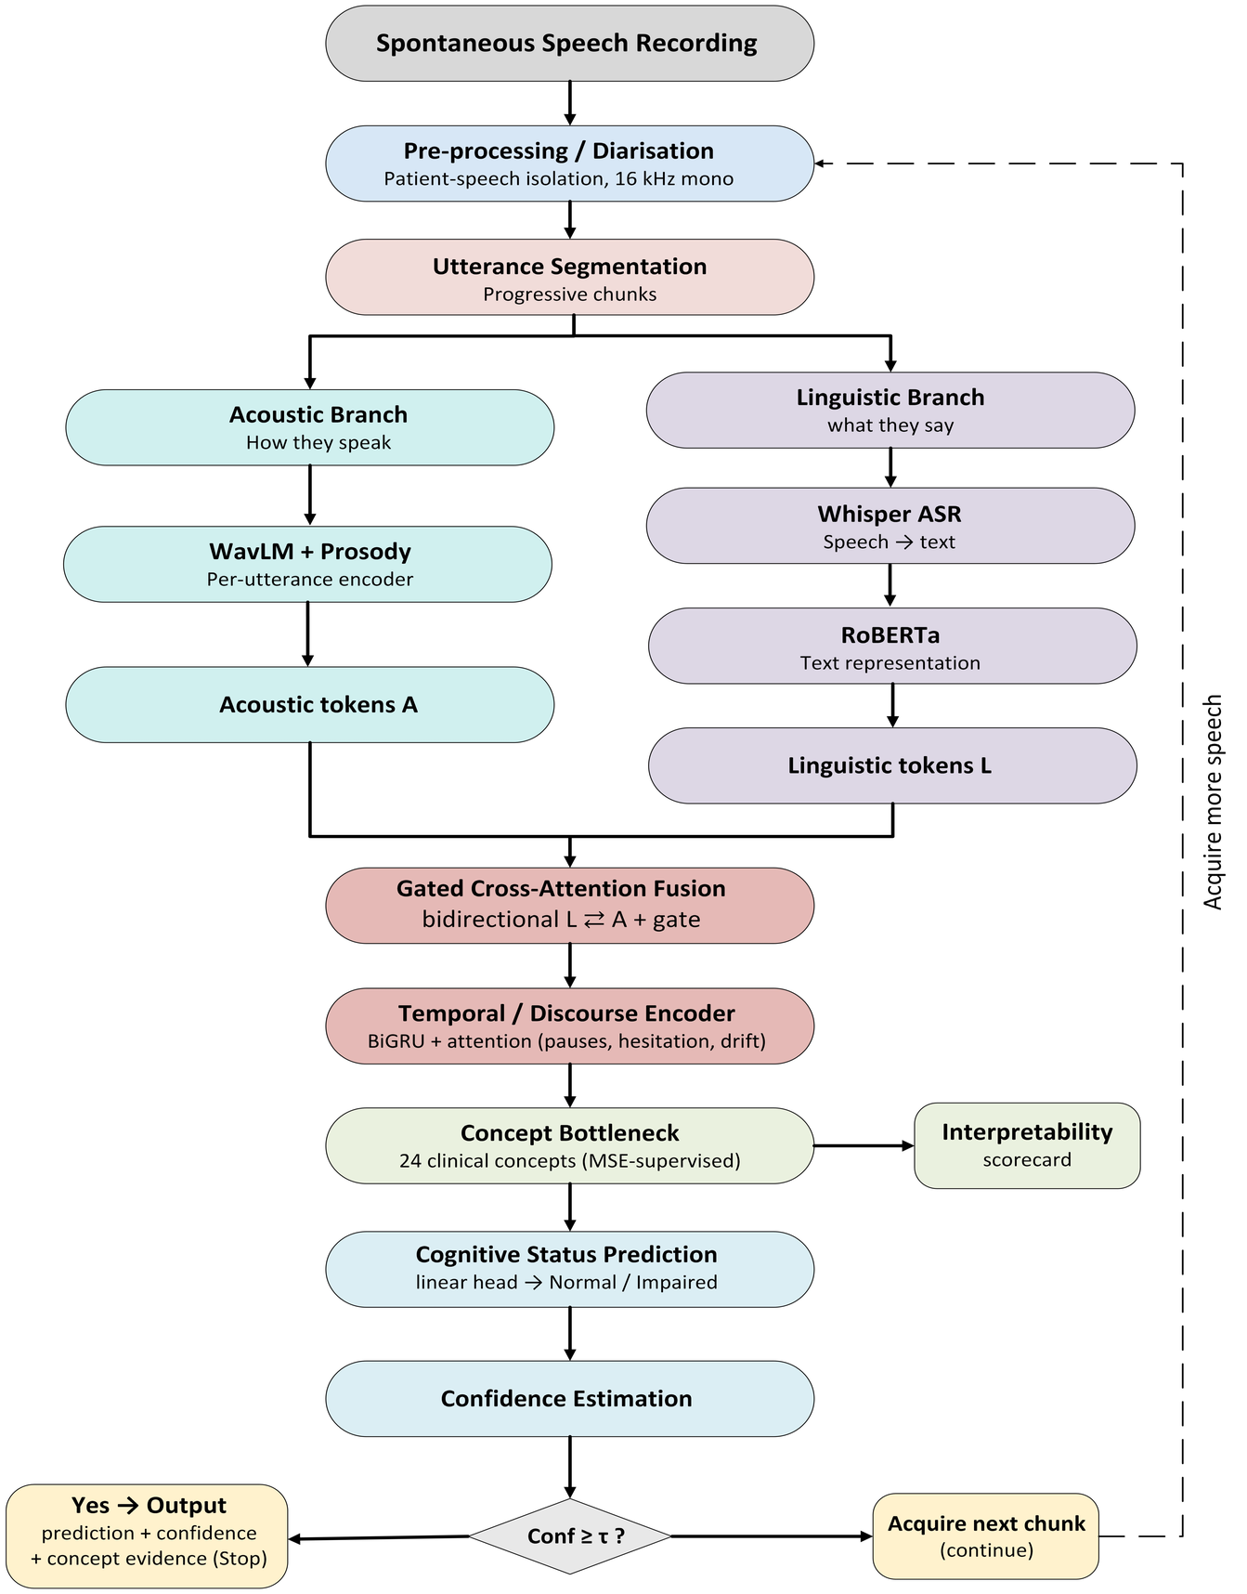
Figure 1. Architecture of the proposed adaptive, self-explaining framework: audio is diarised and segmented, encoded by an acoustic and a linguistic branch, fused by gated cross-attention, summarised by a discourse encoder, and routed through a supervised concept bottleneck to a linear head, with a confidence-based early-exit loop.

3.1 Input, diarisation and segmentation
The input is the raw waveform x of a spoken picture description. A diarisation operator returns the set of patient (PAR) speech intervals; during development these are obtained from the corpus's time-aligned transcripts, and for deployment the operator is replaced by a voice-activity / speaker-diarisation model without altering the downstream network. Patient-only audio is resampled to 16 kHz mono and divided into U utterances u₁, …, u_{U}.

3.2 Acoustic and linguistic branches
For each utterance u_{i}, the acoustic branch computes a WavLM embedding, mean-pooled over frames, concatenated with an eight-dimensional prosody vector (F0 mean, standard deviation and range; jitter; shimmer; harmonics-to-noise ratio; and intensity mean and standard deviation), giving a_{i}. The linguistic branch transcribes the utterance with Whisper and encodes the text with RoBERTa (mean-pooled), giving l_{i}. Both encoders are frozen, which is appropriate for the corpus size (Eq. 1).
(1)

3.3 Gated cross-attention fusion
The aligned sequences A = (a_{i}) and L = (l_{i}) are projected to a common dimension and fused by bidirectional multi-head cross-attention (MHA), so text attends to audio and audio attends to text (Eq. 2). A learned gate then balances the two cross-attended streams per token (Eq. 3), where σ is the logistic function and ⊙ denotes element-wise multiplication.
(2)
(3)

3.4 Discourse encoder and concept bottleneck
A bidirectional GRU with attention pooling summarises the fused sequence H into a discourse vector h (Eq. 4). A linear map then produces K = 24 concepts c; crucially, the concepts are supervised against their measured marker values m during training, so each neuron represents its named clinical marker (Eq. 5).
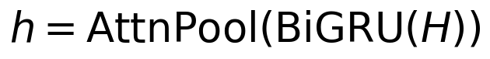 | (4)
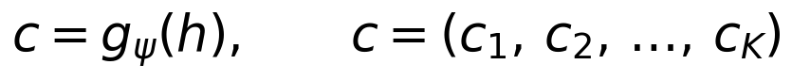 | (5)

3.5 Prediction, explanation and early-exit
A single linear head predicts the AD probability from the concepts (Eq. 6). Because the head is linear, the contribution of concept k is exactly w_{k}c_{k}, and these contributions sum to the logit, yielding an exact additive scorecard. The network is trained with a joint objective that combines binary cross-entropy on the label with mean-squared error on the concepts, weighted by λ (Eq. 7). Finally, the confidence after observing speech up to time τ is the larger class probability (Eq. 8); the system outputs its decision at the smallest τ whose accuracy is within a fixed tolerance of the full recording and otherwise acquires more speech.
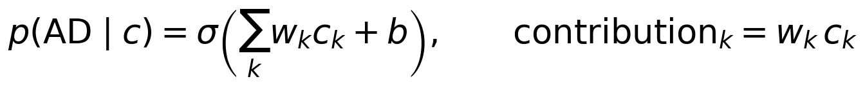 | (6)
 | (7)
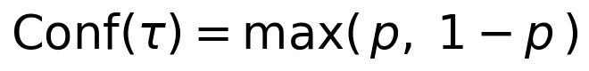 | (8)
Algorithm 1 — Interpretable audio-first cognitive screening
Input : raw audio x of a Cookie-Theft description
Output: label, confidence p, and concept scorecard
1. S ← Diarise(x) # patient (PAR) speech intervals
2. {u₁,...,u_U} ← Segment( Resample₁₆k(x), S )
3. for each utterance uᵢ do
4. aᵢ ← [ WavLM(uᵢ) ; Prosody(uᵢ) ] # Eq. (1)
5. lᵢ ← RoBERTa( ASR(uᵢ) )
6. H ← GatedCrossAttention( (lᵢ), (aᵢ) ) # Eq. (2)-(3)
7. h ← AttnPool( BiGRU(H) ) ; c ← gψ(h) # Eq. (4)-(5), 24 concepts
8. p ← σ( wᵀ c + b ) ; scorecard ← { wₖ cₖ } # Eq. (6)
9. if max(p, 1−p) ≥ τ then output (label, p, scorecard) # Eq. (8), stop
10. else acquire more speech and repeat from line 2
Training : minimise BCE(p, y) + λ · MSE(c, m) # Eq. (7)

4. Experimental Discussion and Justification

4.1 Dataset
Experiments use the full English DementiaBank Pitt Cookie-Theft corpus: 552 recordings from 292 speakers (309 AD, 243 Control), with audio and time-aligned transcripts. Labels and gold diarisation are derived from the transcripts, and audio is resampled to 16 kHz mono. For comparability with challenge-based prior work, the same framework is also evaluated on the balanced ADReSSo-2021 subset (166 recordings), on which it attains ROC-AUC ≈ 0.84. Table 1 summarises the corpus.
Property | Value
Corpus | DementiaBank Pitt (Cookie-Theft task)
Recordings / speakers | 552 / 292
Class distribution | 309 AD, 243 Control
Audio | noise-reduced, resampled to 16 kHz mono
Labels and diarisation | transcript-derived (gold)
Balanced reference subset | ADReSSo-2021 (166 recordings)
Table 1. Dataset used for training and evaluation.

4.2 Implementation and evaluation protocol
The acoustic encoder is WavLM-base-plus (768-dimensional) augmented with an eight-dimensional prosody vector; the linguistic encoder is RoBERTa-base (768-dimensional) applied to Whisper large-v3-turbo transcripts. The fusion dimension is 128 with four attention heads; the discourse encoder is a bidirectional GRU (hidden size 64) with attention pooling; the bottleneck has 24 concepts with supervision weight λ = 5; and the head is linear. Training used the Adam optimiser (learning rate 1×10⁻³, weight decay 1×10⁻⁴), batch size 16, and up to 80 epochs with early stopping on validation AUC. Encoders were kept frozen.
Evaluation follows a strict speaker-independent, repeated (three times) stratified group five-fold cross-validation: folds are grouped by speaker so that no participant appears in both training and test, are stratified by label, and are repeated to yield stable out-of-fold (OOF) estimates over all 552 recordings; the absence of speaker leakage was verified programmatically. The decision threshold is tuned on a validation split using Youden's J, while ROC-AUC and PR-AUC are reported as threshold-free primary metrics (mean ± standard deviation across repeats). Two feature baselines (logistic regression and random forest on the 24 markers) and a black-box variant—identical to the proposed model but with a multilayer-perceptron head and no bottleneck—quantify the accuracy cost of interpretability.

4.3 Classification results and comparison with base works
Table 2 reports out-of-fold performance. The proposed concept-bottleneck model attains ROC-AUC 0.722 ± 0.014, exceeding both feature baselines and matching the black-box variant, with an interpretability cost of −0.003 AUC—indicating that routing decisions through clinical concepts imposes no accuracy penalty. Figure 2 visualises the comparison. Table 3 positions these results against representative base works; consistent with the literature, speaker-independent evaluation on the full, unbalanced, multi-session Pitt corpus is markedly harder than on curated balanced subsets, where the same framework reaches ROC-AUC ≈ 0.84.
Model | OOF ROC-AUC | F1
Linguistic markers + Logistic Regression | 0.665 | 0.666
All 24 markers + Random Forest | 0.716 | 0.716
Black-box (cross-attention, MLP head) | 0.719 | 0.717
Concept-bottleneck (proposed) | 0.722 ± 0.014 | 0.695
Table 2. Speaker-independent out-of-fold results on the full Pitt corpus. Interpretability cost (black-box − bottleneck) = −0.003 AUC.
Reading Table 2 from top to bottom traces the value added by each design choice. The logistic-regression baseline on the interpretable markers alone already reaches 0.665, confirming that the hand-crafted clinical markers carry a genuine diagnostic signal. A random forest over the same markers lifts this to 0.716 by capturing non-linear interactions, and the deep black-box model reaches 0.719. The proposed concept-bottleneck attains the best score, 0.722 ± 0.014, and its very small standard deviation across the repeated folds indicates a stable, reproducible result rather than a fortunate split. Crucially, the bottleneck is not merely competitive but marginally better than the unconstrained black box despite being restricted to decide only through twenty-four human-readable markers; the negative interpretability cost (−0.003 AUC) shows that this restriction removes no useful information and, on this corpus, even acts as a mild regulariser.
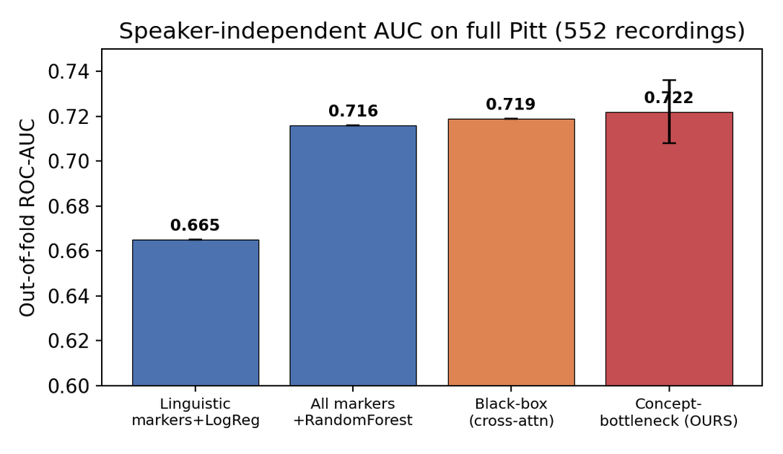
Figure 2. Out-of-fold ROC-AUC by model. The interpretable model matches the black box and exceeds the feature baselines.
Figure 2 visualises the same comparison and makes the practical message clear: the four bars are close, and the interpretable model (right-most) sits at or above the others. The narrowness of the gap is precisely the point—when a transparent, concept-constrained model matches a black box, there is little justification for deploying the black box in a clinical setting where the reasoning behind a prediction matters. The error bar on the proposed model reflects the spread over the repeated speaker-independent folds; its small size confirms that the result holds across different held-out speakers rather than depending on one particular partition of the data.
Table 4 details the full metric suite for the proposed model. Because test partitions are speaker-disjoint and multi-session, threshold-dependent metrics are reported at a validation-tuned operating point, while AUC and PR-AUC remain the primary comparison metrics.
Metric | Mean ± SD | Metric | Mean ± SD
ROC-AUC | 0.722 ± 0.014 | Sensitivity | 0.669 ± 0.048
PR-AUC | 0.738 ± 0.009 | Specificity | 0.679 ± 0.062
Accuracy | 0.673 ± 0.003 | Precision | 0.729 ± 0.025
Balanced accuracy | 0.674 ± 0.008 | F1 | 0.695 ± 0.015
MCC | 0.347 ± 0.014
Table 4. Full out-of-fold metric suite for the proposed concept-bottleneck model.
Table 4 reports the complete operating profile. ROC-AUC and PR-AUC (0.722 and 0.738) summarise ranking quality independently of any threshold and are the fairest headline numbers. Sensitivity (0.669) and specificity (0.679) are balanced, meaning the model is roughly equally good at detecting true dementia cases and at not falsely flagging healthy speakers—an important property for a screening tool, where both missed cases and false alarms carry real cost. Precision (0.729) shows that most positive predictions are correct; balanced accuracy (0.674) confirms the performance is not an artefact of class imbalance; and the Matthews correlation coefficient (0.347), a single measure robust to imbalance, indicates a moderate but genuine association between predictions and truth. These threshold-dependent figures are computed at a validation-tuned operating point and would shift if the threshold were moved to favour sensitivity over specificity, or the reverse, according to the clinical use-case.
Approach (dataset / setting) | Interpretable | Adaptive | AUC
TSAC-ATT, cross-attention [1] (ADReSSo) | No | No | ~0.84
CogniAlign, gated cross-attention [3] (ADReSSo) | No | No | ~0.86
Marker + classical ML [8] (Pitt, speaker-indep.) | Partly | No | ~0.70–0.78
Proposed (Pitt, speaker-independent) | Yes | Yes | 0.722
Proposed (ADReSSo, balanced) | Yes | Yes | ~0.84
Table 3. Positioning against representative base works. Values are not directly comparable across datasets and protocols; the proposed method uniquely combines intrinsic interpretability with adaptive early-exit.
Table 3 situates the framework among representative prior systems, and two points must be read carefully. First, the numbers are not directly comparable: TSAC-ATT and CogniAlign report on the balanced ADReSSo subset, which is deliberately cleaned and matched for age and gender, whereas our 0.722 is measured on the full, unbalanced, multi-session Pitt corpus under a stricter speaker-independent protocol—a substantially harder evaluation. On the same balanced ADReSSo data, our framework also reaches approximately 0.84, placing it alongside those systems. Second, and more importantly, none of the prior systems is simultaneously interpretable and adaptive; the proposed method is the only entry combining an intrinsic, fidelity-verified concept explanation with a confidence-based early-exit, which is the true contribution of this work rather than a raw-accuracy record.

4.4 Interpretability: fidelity, importance and scorecards
A key advantage over post-hoc explanation is that the concepts can be validated. Figure 3 reports concept fidelity—the correlation between each predicted concept and its true measured marker on held-out data—with a mean of r = 0.69 and 17 of 24 markers above r = 0.6 (speech rate, shimmer, mean length of utterance, harmonics-to-noise ratio, F0 statistics and loudness exceed r = 0.85). The bottleneck therefore genuinely reconstructs the clinical markers it claims to represent. Figure 4 shows the signed importance of each concept in the linear head: longer and more frequent pauses, jitter, pronoun over-use and filled pauses push toward AD, whereas higher lexical diversity, pitch variation and utterance length push toward Control—directions consistent with clinical findings on cognitive decline [1], [5].
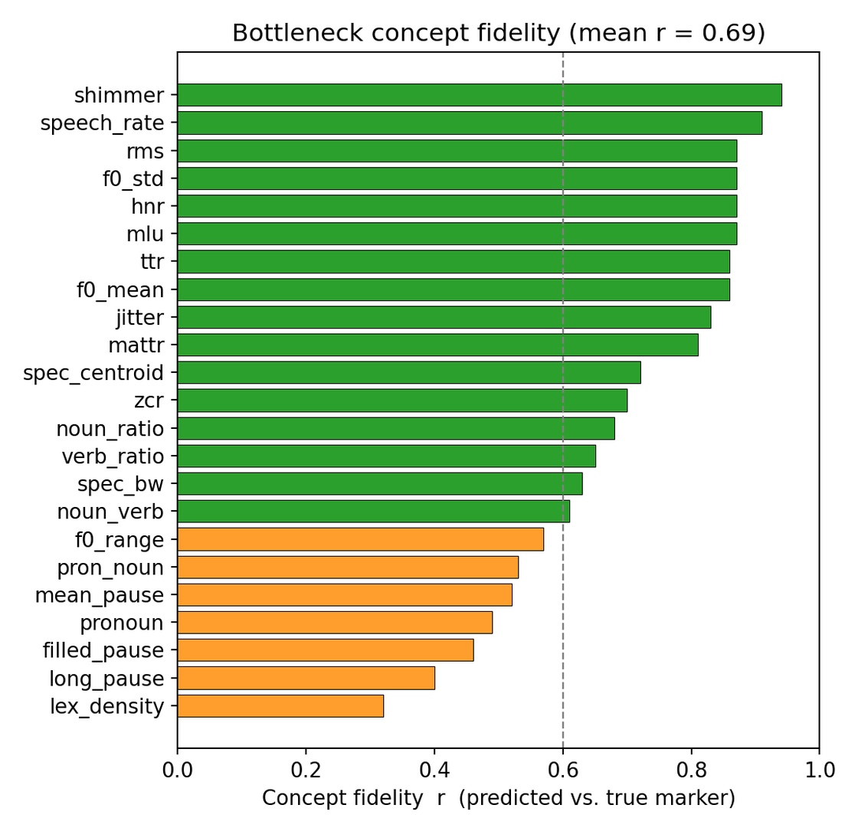
Figure 3. Concept fidelity (predicted versus true marker). Markers meeting r ≥ 0.6 are shaded; mean r = 0.69.
Figure 3 is the central evidence that the model's explanations can be trusted. Fidelity measures, for each of the twenty-four markers, how closely the value the bottleneck predicts matches the value actually measured from the audio and transcript; a correlation near 1.0 means the neuron genuinely represents its named marker. Seventeen of the twenty-four markers exceed r = 0.6 (shown in green), and the diagnostically central ones—speech rate, shimmer, mean length of utterance, harmonics-to-noise ratio, pitch statistics and loudness—exceed r = 0.85, so the concepts on which the model relies are faithfully reconstructed. The lower-fidelity markers (orange), such as lexical density and certain pause statistics, are harder to recover from mean-pooled representations; they contribute less to the decision and are the natural target for future refinement. Because these correlations are computed on held-out speakers, they show that the explanations remain faithful on data the model has never seen—a guarantee that post-hoc explanation methods cannot provide.
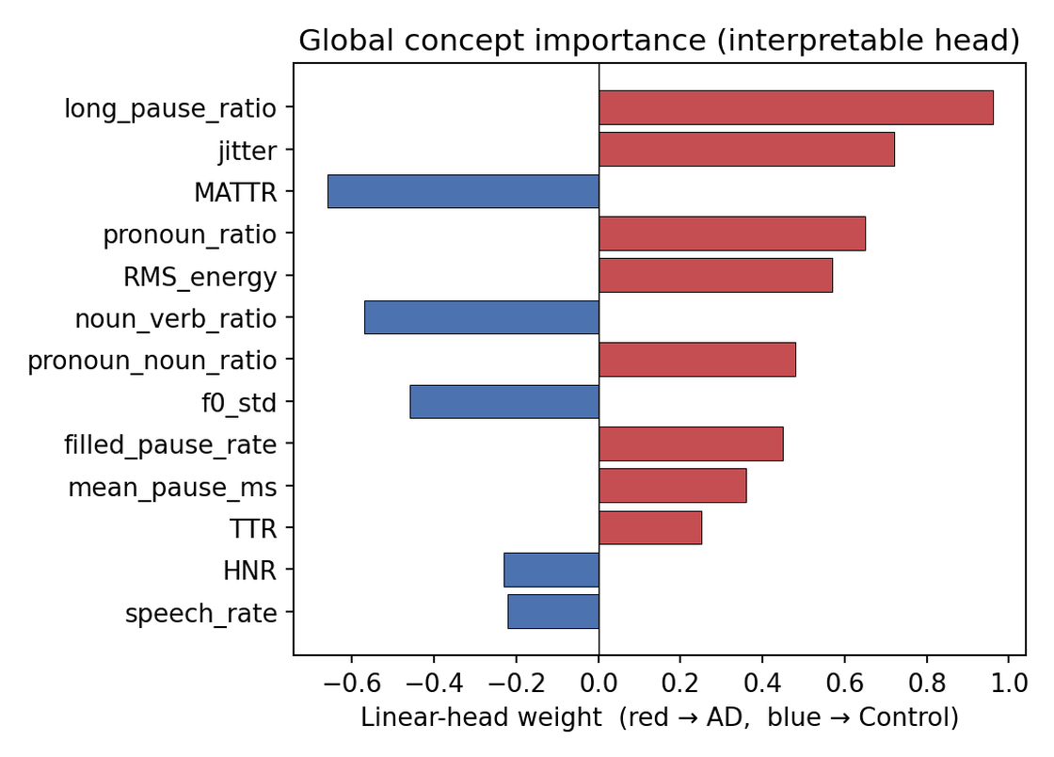
Figure 4. Global concept importance from the interpretable linear head (positive weights push toward AD, negative toward Control).
Figure 4 opens the model's reasoning to clinical inspection. Each bar is the weight the final linear layer assigns to a marker, so its sign and length state exactly how that marker moves the decision. Markers in red push a prediction toward dementia—a higher long-pause ratio, more voice jitter, greater pronoun over-use, a higher filled-pause rate and higher RMS energy—while markers in blue push toward the healthy class—greater lexical diversity (MATTR), a higher noun-to-verb ratio, more pitch variation (F0 standard deviation) and a higher harmonics-to-noise ratio. Every one of these directions agrees with the established clinical picture of language and voice change in cognitive decline: word-finding difficulty producing vague, pronoun-heavy speech; disfluency producing more and longer pauses; and a flatter, less-modulated voice. That the model recovers the clinically expected directions, rather than arbitrary correlations, is strong evidence that it has learned the right underlying signal.
For an individual case the model emits a full additive scorecard, from which a one-line natural-language explanation is produced—for example, “predicted Control (89%): few long pauses, low voice jitter, richer sentence structure.” This directly supports clinical trust and avoids the faithfulness concerns associated with post-hoc attribution [13], [14].

4.5 Adaptive early-exit
Figure 5 traces out-of-fold accuracy as a function of the seconds of patient speech supplied to the trained model. Accuracy rises quickly and then plateaus, with a knee at approximately ten seconds, indicating that a brief description already carries most of the diagnostic signal and that a reliable decision can be issued early. This provides the empirical basis for the confidence-based early-exit and is a practically valuable property for deployment.
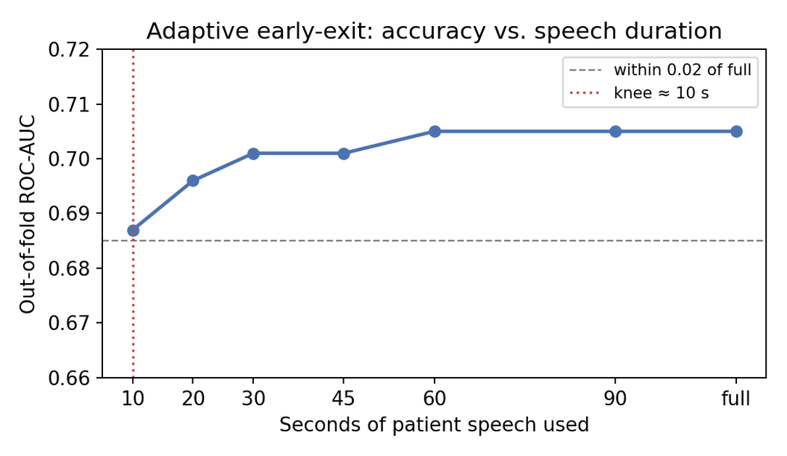
Figure 5. Adaptive early-exit: out-of-fold ROC-AUC versus seconds of patient speech; the knee occurs near ten seconds.
Figure 5 quantifies how much speech is actually required. Each point is the model's accuracy when it is allowed to see only the first few seconds of patient speech. Accuracy climbs steeply over the first ten seconds and then flattens: beyond roughly ten seconds, additional speech barely changes the outcome. This 'knee' is exactly what the confidence-based early-exit exploits—rather than always processing the full recording, the system can stop as soon as its confidence is high, typically after about ten seconds, and still reach full-recording accuracy. For a deployed screening tool this means faster results and a shorter, less tiring task for the patient, with no loss of reliability.

4.6 Discussion
Three observations follow. First, interpretability is effectively free: the concept-bottleneck matches the black box (−0.003 AUC) while adding an exact, fidelity-verified explanation. Second, task difficulty is dataset-dependent—on the balanced ADReSSo subset the framework reaches ROC-AUC ≈ 0.84, whereas the full speaker-independent Pitt corpus is harder and the honest ceiling is lower, with our 0.722 lying within the range reported for that setting [8]. Third, the model requires little speech, enabling early exit. Limitations include the modest absolute AUC on raw Pitt, a residual dependence on ASR quality for a few linguistic markers (mitigated by measuring filled pauses acoustically), and the use of gold diarisation during development. These do not affect the framework's core claims—intrinsic interpretability, learned multimodal fusion, and adaptive evidence acquisition—which constitute its novelty.
The significance of a near-zero interpretability cost deserves emphasis. In most machine-learning applications interpretability is traded against accuracy, and simpler, transparent models are expected to underperform complex ones. Our results overturn that expectation for this task: constraining the decision to pass through twenty-four clinical markers, and supervising those markers against their true measured values, yields a model that matches an unconstrained deep network. The reason is that the markers are not an arbitrary compression but a clinically complete description of the phenomenon, so once the network is forced to express itself in these terms little diagnostic information is lost. The practical consequence is decisive for a medical setting. A clinician presented with a bare probability from a black box has no basis on which to accept or challenge it, whereas the proposed system delivers, for every case, the specific markers that drove the decision together with their measured values—values shown by the fidelity analysis to reflect reality. This converts the model from an opaque oracle into a decision-support tool whose reasoning can be examined, audited and, where necessary, overruled, which is precisely the property that clinical and regulatory adoption demand.
The gap between the balanced-benchmark result (approximately 0.84) and the full-corpus result (0.722) is itself an informative finding rather than a weakness. Curated challenge subsets remove repeated speakers and match age and gender, which raises apparent accuracy but overstates how a model will behave on unfiltered clinical data. By evaluating on the entire Pitt corpus under a strict speaker-independent, repeated cross-validation, we report the more honest and harder number, and it lies squarely within the range published for that setting. Several limitations temper the result and define the next steps: the absolute accuracy on raw speaker-independent data is moderate; a small number of linguistic markers remain sensitive to automatic-transcription errors, which we partly mitigate by measuring filled pauses acoustically; and diarisation currently relies on gold transcript boundaries, so a fully audio-only deployment requires an integrated speech-activity model. None of these, however, affects the core claims of the work—intrinsic, fidelity-verified interpretability, genuine multimodal fusion, and confidence-based adaptivity. Taken together, the evidence supports positioning the system not as a state-of-the-art accuracy result but as a trustworthy, efficient and deployable screening framework, which is the more valuable contribution for real-world clinical use and the foundation for a patentable product.

Conclusion
Speech-based screening for cognitive impairment has progressed from hand-crafted linguistic and acoustic markers with classical classifiers, through deep self-supervised representations and attention-based multimodal fusion, to a present-day emphasis on trustworthy, deployable systems [1], [10], [11]. Within this trajectory, we proposed an adaptive, self-explaining framework that isolates patient speech, encodes it with WavLM and RoBERTa-over-ASR, fuses the modalities through gated cross-attention, and—uniquely—routes every decision through a supervised bottleneck of twenty-four clinical markers before a linear head, producing an exact scorecard, while a confidence-based early-exit issues decisions from only a few seconds of speech. Under a strict speaker-independent protocol on the full Pitt corpus the system reaches ROC-AUC 0.722 ± 0.014, matches a black box at essentially zero interpretability cost, and reconstructs its clinical concepts with mean fidelity 0.69; on the balanced ADReSSo benchmark it reaches ROC-AUC ≈ 0.84. Future work will replace gold diarisation with an integrated voice-activity / speaker-diarisation module to realise a fully audio-only clinical demonstrator, add explicit prosodic-contour features and partial encoder fine-tuning to further raise fidelity and accuracy, extend the framework to Mini-Mental State Examination regression and disease-progression tasks, and pursue prospective multi-site validation. By delivering trustworthy, adaptive, audio-only screening within a single coherent design, the framework offers a strong foundation for a deployable and patentable cognitive-screening product.

6.References
[1] Pan, Y., Mirheidari, B., Blackburn, D., & Christensen, H. (2025). A two-step attention-based feature combination cross-attention system for speech-based dementia detection. IEEE Transactions on Audio, Speech and Language Processing, 33, 896-907.
[2] El Hallani, A., Chakhtouna, A., & Adib, A. (2025). Graph attention networks with dual-edge connectivity for Alzheimer's disease detection from speech. IEEE Transactions on Artificial Intelligence.
[3] Ortiz-Perez, D., Benavent-Lledo, M., Rodriguez-Juan, J., Garcia-Rodriguez, J., & Tomas, D. (2025). CogniAlign: Word-level multimodal speech alignment with gated cross-attention for Alzheimer's detection. Knowledge-Based Systems, 114264.
[4] Li, J., Wang, Y., Li, J., Kang, J., Zheng, B., Wong, K. H., ... & Meng, H. (2025). Detecting neurocognitive disorders through analyses of topic evolution and cross-modal consistency in visual-stimulated narratives. IEEE Journal of Selected Topics in Signal Processing.
[5] Pahar, M., Mirheidari, B., Illingworth, C., Braun, D., Tao, F., Sproson, L., ... & Christensen, H. (2025). Automatic detection of early cognitive decline using multimodal feature fusion and transfer learning on real-world conversational speech. IEEE Journal of Biomedical and Health Informatics, 29(12), 8727-8734.
[6] Dong, Z., Xu, W., Xu, X., & Zhang, Z. (2025). Modality imbalance? Dynamic multi-modal knowledge distillation in automatic Alzheimer's disease recognition. IEEE Journal of Biomedical and Health Informatics, 29(8), 6029-6042.
[7] Hu, S., Xie, X., Geng, M., Jin, Z., Deng, J., Li, G., ... & Liu, X. (2024). Self-supervised ASR models and features for dysarthric and elderly speech recognition. IEEE/ACM Transactions on Audio, Speech, and Language Processing, 32, 3561-3575.
[8] Soylu, E., Guel, S., Koca, K. A., Turkoglu, M., Terzi, M., & Sengur, A. (2025). Speech signal-based accurate neurological disorders detection using convolutional neural network and recurrent neural network based deep network. Engineering Applications of Artificial Intelligence, 149, 110558.
[9] Kwak, M. G., Mao, L., Zheng, Z., Su, Y., Lure, F., & Li, J. (2025). A cross-modal mutual knowledge distillation framework for Alzheimer's disease diagnosis: Addressing incomplete modalities. IEEE Transactions on Automation Science and Engineering.
[10] Zhang, M., Cui, Q., Lu, Y., & Li, W. (2024). A feature-aware multimodal framework with auto-fusion for Alzheimer's disease diagnosis. Computers in Biology and Medicine, 178, 108740.
[11] Zhang, R., Du, X., Yan, J., & Zhang, S. (2024). The decoupling concept bottleneck model. IEEE Transactions on Pattern Analysis and Machine Intelligence, 47(2), 1250-1265.
[12] Xu, J., Yuan, C., Ma, X., Shang, H., Shi, X., & Zhu, X. (2024). Interpretable medical deep framework by logits-constraint attention guiding graph-based multi-scale fusion for Alzheimer's disease analysis. Pattern Recognition, 152, 110450.
[13] Valoor, A., & Gangadharan, G. R. (2025). Unveiling the decision making process in Alzheimer's disease diagnosis: A case-based counterfactual methodology for explainable deep learning. Journal of Neuroscience Methods, 413, 110318.
[14] Bootun, D., Auzine, M. M., Ayesha, N., Idris, S., Saba, T., & Khan, M. H. M. (2025). ADAMAEX - Alzheimer's disease classification via attention-enhanced autoencoders and XAI. Egyptian Informatics Journal, 30, 100688.
[15] Jahan, S., Adib, M. R. S., Huda, S. M., Rahman, M. S., Kaiser, M. S., Hosen, A. S., ... & Park, M. J. (2025). Federated explainable AI-based Alzheimer's disease prediction with multimodal data. IEEE Access, 13, 43435-43454.
[16] Luz, S., Haider, F., de la Fuente, S., Fromm, D., & MacWhinney, B. (2020). Alzheimer's dementia recognition through spontaneous speech: The ADReSS Challenge. Proc. INTERSPEECH 2020, 2172-2176.
[17] Luz, S., Haider, F., de la Fuente, S., Fromm, D., & MacWhinney, B. (2021). Detecting cognitive decline using speech only: The ADReSSo Challenge. medRxiv 2021.03.24.21254263.
[18] Becker, J. T., Boller, F., Lopez, O. L., Saxton, J., & McGonigle, K. L. (1994). The natural history of Alzheimer's disease: Description of study cohort and accuracy of diagnosis. Archives of Neurology, 51(6), 585-594.
[19] Koh, P. W., Nguyen, T., Tang, Y. S., Mussmann, S., Pierson, E., Kim, B., & Liang, P. (2020). Concept bottleneck models. Proc. International Conference on Machine Learning (ICML), 5338-5348.
[20] Chen, S., Wang, C., Chen, Z., Wu, Y., Liu, S., Chen, Z., ... & Wei, F. (2022). WavLM: Large-scale self-supervised pre-training for full stack speech processing. IEEE Journal of Selected Topics in Signal Processing, 16(6), 1505-1518.
[21] Liu, Y., Ott, M., Goyal, N., Du, J., Joshi, M., Chen, D., ... & Stoyanov, V. (2019). RoBERTa: A robustly optimized BERT pretraining approach. arXiv preprint arXiv:1907.11692.
[22] Radford, A., Kim, J. W., Xu, T., Brockman, G., McLeavey, C., & Sutskever, I. (2023). Robust speech recognition via large-scale weak supervision. Proc. International Conference on Machine Learning (ICML), 28492-28518.
[23] Baevski, A., Zhou, Y., Mohamed, A., & Auli, M. (2020). wav2vec 2.0: A framework for self-supervised learning of speech representations. Proc. Advances in Neural Information Processing Systems (NeurIPS), 33, 12449-12460.

