Assignment -1

Avinash Ravipudi

2023-03-01

# Loading the required libraries   
library(ISLR)  
library(dplyr)

##   
## Attaching package: 'dplyr'

## The following objects are masked from 'package:stats':  
##   
## filter, lag

## The following objects are masked from 'package:base':  
##   
## intersect, setdiff, setequal, union

library(glmnet)

## Loading required package: Matrix

## Loaded glmnet 4.1-6

library(caret)

## Loading required package: ggplot2

## Loading required package: lattice

# Load the Carseats dataset from ISLR package  
data("Carseats")  
#The Data() function is used to load the 'dataset' from the ISLR package  
  
# Summarize the Carseats dataset  
summary(Carseats)

## Sales CompPrice Income Advertising   
## Min. : 0.000 Min. : 77 Min. : 21.00 Min. : 0.000   
## 1st Qu.: 5.390 1st Qu.:115 1st Qu.: 42.75 1st Qu.: 0.000   
## Median : 7.490 Median :125 Median : 69.00 Median : 5.000   
## Mean : 7.496 Mean :125 Mean : 68.66 Mean : 6.635   
## 3rd Qu.: 9.320 3rd Qu.:135 3rd Qu.: 91.00 3rd Qu.:12.000   
## Max. :16.270 Max. :175 Max. :120.00 Max. :29.000   
## Population Price ShelveLoc Age Education   
## Min. : 10.0 Min. : 24.0 Bad : 96 Min. :25.00 Min. :10.0   
## 1st Qu.:139.0 1st Qu.:100.0 Good : 85 1st Qu.:39.75 1st Qu.:12.0   
## Median :272.0 Median :117.0 Medium:219 Median :54.50 Median :14.0   
## Mean :264.8 Mean :115.8 Mean :53.32 Mean :13.9   
## 3rd Qu.:398.5 3rd Qu.:131.0 3rd Qu.:66.00 3rd Qu.:16.0   
## Max. :509.0 Max. :191.0 Max. :80.00 Max. :18.0   
## Urban US   
## No :118 No :142   
## Yes:282 Yes:258   
##   
##   
##   
##

#'Summary()' function to get a quick summary of the dataset.

# QB1) Build a Lasso regression model to predict Sales based on all other attributes (“Price”, “Advertising”, “Population”, “Age”, “Income” and “Education”). What is the best value of lambda for such a lasso model?

# Taking all the input attributes into Carseats_Filtered and then scaling the input attributes.  
Carseats_Filtered <- Carseats %>% select("Price", "Advertising", "Population", "Age", "Income", "Education") %>% scale(center = TRUE, scale = TRUE) %>% as.matrix()  
  
# using glmnet library to convert the input attributes to matrix format.  
x <- Carseats_Filtered  
  
# storing the response variable into y in matrix format  
y <- Carseats %>% select("Sales") %>% as.matrix()  
  
## building the model  
fit = glmnet(x, y)   
summary(fit)

## Length Class Mode   
## a0 62 -none- numeric  
## beta 372 dgCMatrix S4   
## df 62 -none- numeric  
## dim 2 -none- numeric  
## lambda 62 -none- numeric  
## dev.ratio 62 -none- numeric  
## nulldev 1 -none- numeric  
## npasses 1 -none- numeric  
## jerr 1 -none- numeric  
## offset 1 -none- logical  
## call 3 -none- call   
## nobs 1 -none- numeric

plot(fit)

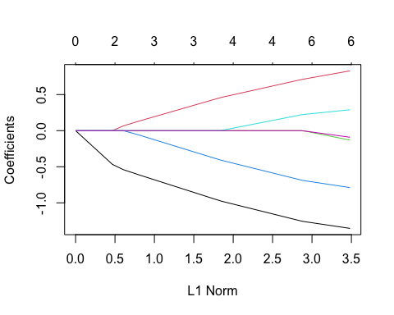

print(fit)

##   
## Call: glmnet(x = x, y = y)   
##   
## Df %Dev Lambda  
## 1 0 0.00 1.25500  
## 2 1 3.36 1.14400  
## 3 1 6.15 1.04200  
## 4 1 8.47 0.94940  
## 5 1 10.39 0.86500  
## 6 1 11.99 0.78820  
## 7 2 14.62 0.71820  
## 8 3 18.08 0.65440  
## 9 3 21.12 0.59620  
## 10 3 23.64 0.54330  
## 11 3 25.73 0.49500  
## 12 3 27.46 0.45100  
## 13 3 28.91 0.41100  
## 14 3 30.10 0.37450  
## 15 4 31.12 0.34120  
## 16 4 32.13 0.31090  
## 17 4 32.97 0.28330  
## 18 4 33.67 0.25810  
## 19 4 34.25 0.23520  
## 20 4 34.73 0.21430  
## 21 4 35.13 0.19520  
## 22 4 35.46 0.17790  
## 23 4 35.74 0.16210  
## 24 4 35.97 0.14770  
## 25 4 36.16 0.13460  
## 26 4 36.31 0.12260  
## 27 4 36.45 0.11170  
## 28 4 36.55 0.10180  
## 29 4 36.64 0.09276  
## 30 6 36.75 0.08451  
## 31 6 36.86 0.07701  
## 32 6 36.95 0.07017  
## 33 6 37.02 0.06393  
## 34 6 37.09 0.05825  
## 35 6 37.14 0.05308  
## 36 6 37.18 0.04836  
## 37 6 37.21 0.04407  
## 38 6 37.24 0.04015  
## 39 6 37.27 0.03658  
## 40 6 37.29 0.03333  
## 41 6 37.30 0.03037  
## 42 6 37.32 0.02767  
## 43 6 37.33 0.02522  
## 44 6 37.34 0.02298  
## 45 6 37.35 0.02094  
## 46 6 37.35 0.01908  
## 47 6 37.36 0.01738  
## 48 6 37.36 0.01584  
## 49 6 37.37 0.01443  
## 50 6 37.37 0.01315  
## 51 6 37.37 0.01198  
## 52 6 37.38 0.01092  
## 53 6 37.38 0.00995  
## 54 6 37.38 0.00906  
## 55 6 37.38 0.00826  
## 56 6 37.38 0.00752  
## 57 6 37.38 0.00686  
## 58 6 37.38 0.00625  
## 59 6 37.38 0.00569  
## 60 6 37.38 0.00519  
## 61 6 37.38 0.00472  
## 62 6 37.38 0.00430

# performing cross-validation to find the optimal lambda value  
cv_fit <- cv.glmnet(x, y, alpha = 1)  
  
# finding the minimum lambda value  
best_lambda <- cv_fit$lambda.min  
best_lambda

## [1] 0.004305309

# plotting the cross-validation results  
plot(cv_fit)

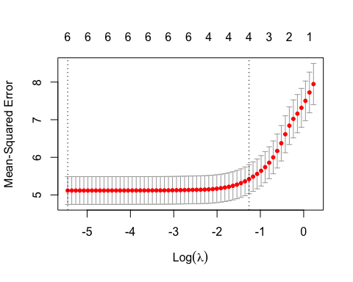 So, based on the above findings, we can see that there is only 37.38% variation in the goal variable, sales with regularization, and a best lambda value of 0.0043.

# QB2. What is the coefficient for the price (normalized) attribute in the best model (i.e. model with the optimal lambda)?

best_model <- glmnet(x, y, alpha = 1, lambda = best_lambda)  
coef(best_model)

## 7 x 1 sparse Matrix of class "dgCMatrix"  
## s0  
## (Intercept) 7.49632500  
## Price -1.35384596  
## Advertising 0.82808291  
## Population -0.13062237  
## Age -0.78855156  
## Income 0.28931642  
## Education -0.09102494

The Price attribute’s coefficient, which has the greatest lambda value, is -1.35384596.

# QB3. How many attributes remain in the model if lambda is set to 0.01? How that number changes if lambda is increased to 0.1? Do you expect more variables to stay in the model (i.e., to have non-zero coefficients) as we increase lambda?

# Let us see the coefficients of the attributes that are still remaining if lambda is set to 0.01.  
best_model <- glmnet(x, y, alpha = 1, lambda = 0.01)  
coef(best_model)

## 7 x 1 sparse Matrix of class "dgCMatrix"  
## s0  
## (Intercept) 7.49632500  
## Price -1.34733223  
## Advertising 0.82026088  
## Population -0.12187685  
## Age -0.78190633  
## Income 0.28488631  
## Education -0.08502707

The independent attribute variable with a lambda value of 0.01. No coefficients are removed in this.

# Let us see the coefficients of the attributes that are still remaining if lambda is set to 0.1.  
best_model <- glmnet(x, y, alpha = 1, lambda = 0.1)  
coef(best_model)

## 7 x 1 sparse Matrix of class "dgCMatrix"  
## s0  
## (Intercept) 7.4963250  
## Price -1.2447745  
## Advertising 0.7007230  
## Population .   
## Age -0.6775428  
## Income 0.2139222  
## Education .

The above findings show that the values of the independent attributes have shrunk to some degree and that two of the attribute coefficients are eliminated when the lambda is set to 0.1.

# Let us see the coefficients of the attributes that are still remaining if lambda is set to 0.3.  
best_model <- glmnet(x, y, alpha = 1, lambda = 0.3)  
coef(best_model)

## 7 x 1 sparse Matrix of class "dgCMatrix"  
## s0  
## (Intercept) 7.49632500  
## Price -1.02298693  
## Advertising 0.50192192  
## Population .   
## Age -0.45635365  
## Income 0.03900787  
## Education .

We can see from the findings above that when lambda is 0.3, two of the attribute coefficients are removed, and the independent attributes have shrunk even more.

# Let us see the coefficients of the attributes that are still remaining if lambda is set to 0.5.  
best_model <- glmnet(x, y, alpha = 1, lambda = 0.5)  
coef(best_model)

## 7 x 1 sparse Matrix of class "dgCMatrix"  
## s0  
## (Intercept) 7.4963250  
## Price -0.7929743  
## Advertising 0.2947434  
## Population .   
## Age -0.2337276  
## Income .   
## Education .

When the lambda number is 0.5, three of the attribute coefficients are removed, and the independent attributes shrink even more.

# QB4. Build an elastic-net model with alpha set to 0.6. What is the best value of lambda for such a model?

# Building an Elastic Net model with alpha = 0.6  
el_net <- glmnet(x, y, alpha = 0.6)  
  
# Plotting coefficients against different values of lambda  
plot(el_net, xvar = "lambda")

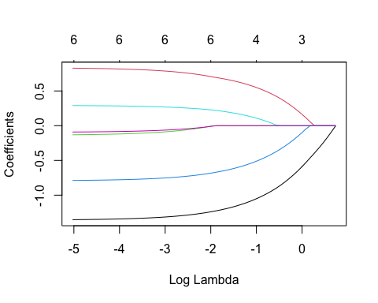

# Generating a plot of cross-validation results for the Elastic Net model  
plot(cv.glmnet(x, y, alpha = 0.6))

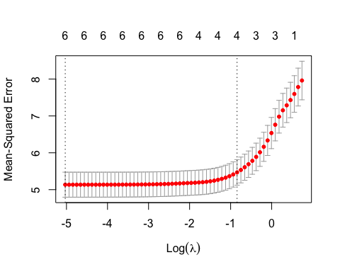

# Displaying a summary of the Elastic Net model  
summary(el_net)

## Length Class Mode   
## a0 63 -none- numeric  
## beta 378 dgCMatrix S4   
## df 63 -none- numeric  
## dim 2 -none- numeric  
## lambda 63 -none- numeric  
## dev.ratio 63 -none- numeric  
## nulldev 1 -none- numeric  
## npasses 1 -none- numeric  
## jerr 1 -none- numeric  
## offset 1 -none- logical  
## call 4 -none- call   
## nobs 1 -none- numeric

# Printing the Elastic Net model  
print(el_net)

##   
## Call: glmnet(x = x, y = y, alpha = 0.6)   
##   
## Df %Dev Lambda  
## 1 0 0.00 2.09200  
## 2 1 2.67 1.90600  
## 3 1 5.03 1.73700  
## 4 1 7.09 1.58200  
## 5 1 8.90 1.44200  
## 6 1 10.47 1.31400  
## 7 2 12.89 1.19700  
## 8 3 16.00 1.09100  
## 9 3 18.95 0.99370  
## 10 3 21.49 0.90540  
## 11 3 23.67 0.82500  
## 12 3 25.55 0.75170  
## 13 3 27.15 0.68490  
## 14 3 28.52 0.62410  
## 15 4 29.75 0.56860  
## 16 4 30.91 0.51810  
## 17 4 31.89 0.47210  
## 18 4 32.72 0.43020  
## 19 4 33.43 0.39190  
## 20 4 34.02 0.35710  
## 21 4 34.52 0.32540  
## 22 4 34.93 0.29650  
## 23 4 35.29 0.27020  
## 24 4 35.58 0.24620  
## 25 4 35.83 0.22430  
## 26 4 36.04 0.20440  
## 27 4 36.21 0.18620  
## 28 4 36.36 0.16970  
## 29 4 36.48 0.15460  
## 30 6 36.60 0.14090  
## 31 6 36.73 0.12830  
## 32 6 36.84 0.11690  
## 33 6 36.93 0.10660  
## 34 6 37.01 0.09709  
## 35 6 37.07 0.08846  
## 36 6 37.12 0.08060  
## 37 6 37.17 0.07344  
## 38 6 37.20 0.06692  
## 39 6 37.23 0.06097  
## 40 6 37.26 0.05556  
## 41 6 37.28 0.05062  
## 42 6 37.30 0.04612  
## 43 6 37.31 0.04203  
## 44 6 37.33 0.03829  
## 45 6 37.34 0.03489  
## 46 6 37.34 0.03179  
## 47 6 37.35 0.02897  
## 48 6 37.36 0.02639  
## 49 6 37.36 0.02405  
## 50 6 37.37 0.02191  
## 51 6 37.37 0.01997  
## 52 6 37.37 0.01819  
## 53 6 37.37 0.01658  
## 54 6 37.38 0.01510  
## 55 6 37.38 0.01376  
## 56 6 37.38 0.01254  
## 57 6 37.38 0.01143  
## 58 6 37.38 0.01041  
## 59 6 37.38 0.00949  
## 60 6 37.38 0.00864  
## 61 6 37.38 0.00788  
## 62 6 37.38 0.00718  
## 63 6 37.38 0.00654

We can see from the above findings that the variance in the dependent variable (Sales) is 37.38, which is explained by the provided attributes to implement regularization by putting the alpha value to 0.6 and the best lambda value is 0.00654.