Accommodation

# H1: Your Home Away From Home

## We have 3 individual luxury en suites to choose from namely Pansy and Periwinkle located on the ground level and Nautilus on the upper level. All suites have their own private entrances and come fully equipped and stylishly furnished for a real "home from home" experience.

## H2: Eco-friendly

Waverly Guest House take actions to conserve heat, conserve water, install eco-friendly lighting, reduce oil/gas carbon emissions, use renewable natural furnishings, source food locally, offer local employment, conserve as well as care for animals & wildlife. We re-cycle plastic, glass & paper.

We also produce our own home-grown herbs that's organically grown, using no harmful pesticides. Our ingredients are always fresh including free-range farm eggs & milk. Other organic products are locally sourced such as vegetables, fruits, beef, lamb & poultry.

# Sidebar

Main image = waverly-accommodation.png  
Alt = Luxury beach accommodation

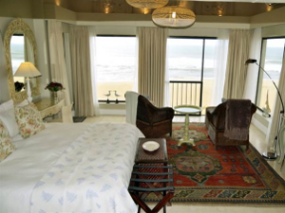

### Testimonial

Ingrid and I greatly enjoyed our week with you at Waverly. It was all wonderful. All of you were very kind and helpful. We have nothing but the highest praise. Many thanks.

- Alec

Pic: testimonial-alec.png