Home

# H1: Welcome to Waverly Guest House

Waverly Guest House is situated just after the naval port and picturesque village of Simons Town.

This warm and friendly guest house with its relaxed and homely atmosphere offers spacious, luxurious, and affordable accommodation all in one. With fabulous sea views from the balconies and walking distance to kilometres of endless white beaches makes this serene and tranquil guesthouse the ideal retreat for weekend getaways, family holidays, business travellers or those just looking for an intimate relaxed atmosphere.

## H2: Boulder Beach

The beach is situated in a small cove, well protected from the wind by the granite boulders. This is a quaint little beach which has calm water to swim in and snorkelling is a very popular activity.

## C:\Users\Brendon Hatcher\Google Drive\Courses\Varsity College\WEDE5010 development\My Assignment\images\aa-award.pngH2: Latest news

We are thrilled to announce that we have won the prestigious AA / SAA Award for Best Hotel / Guest House in the Cape for 2012!

This marks the third consecutive year in which we have won this award.

Come visit us and see why!

Pic: aa-award.png

## H2: Weekday special

We now offer special weekday rates for out of season! Stay with us Monday to Friday from 12 Feb to 17 April and enjoy a **50% discount** on your accommodation.

# Sidebar

Main image = waverly-landscape.png  
Alt = View of Waverly Guest House from Boulder Beach

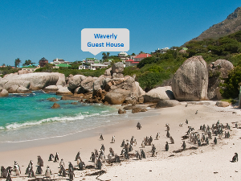

### Testimonial

Tranquillity, good service, wonderful room.

- Colleen Smith

Pic: testimonial-colleen-smith.png, height 67px