QUESTION1

Code 1.1:

package com.selenium.test1.selenium1;

import org.openqa.selenium.By;

import org.openqa.selenium.WebDriver;

import org.openqa.selenium.chrome.ChromeDriver;

import org.openqa.selenium.chrome.ChromeOptions;

import io.github.bonigarcia.wdm.WebDriverManager;

public class TASK1 {

public static void main( String[] args ) throws InterruptedException

{

WebDriverManager.chromedriver().setup();

ChromeOptions co=new ChromeOptions();

co.addArguments("--remote-allow-origins=*");

WebDriver driver=new ChromeDriver(co);

driver.get("https://www.amazon.in/");

driver.manage().window().maximize();

String actualTitle=driver.getTitle();

System.out.println("Page title is : " + driver.getTitle());

String expectedTitle = "Online Shopping site in India: Shop Online for Mobiles, Books, Watches, Shoes and More - Amazon.in";

if(actualTitle.equalsIgnoreCase(expectedTitle))

System.out.println("Title Matched");

else

System.out.println("Title didn't match");

driver.get("https://www.amazon.in/Amazon-Brand-Tealight-Candles-Unscented/dp/B0744P71Y9/ref=sr_1_1?pd_rd_r=c06ef2b7-59da-457e-aa77-aaf7ebd414a2&pd_rd_w=kVt55&pd_rd_wg=vANIH&pf_rd_p=4901d125-0f33-48fa-87d3-a07efd7793cd&pf_rd_r=VSEXK1W6N5BTXD0J3B0H&qid=1681290806&refinements=p_n_format_browse-bin%3A19560799031&s=kitchen&sr=1-1");

driver.findElement(By.id("add-to-cart-button")).submit();

String t=driver.getTitle();

System.out.println("Added to cart");

}

}

OUTPUT:  
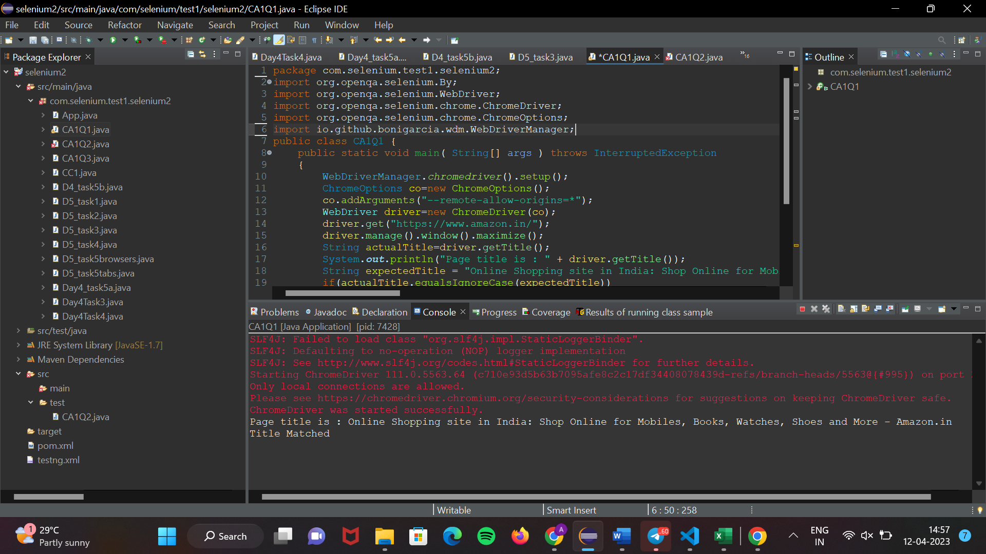

1.2

Code:

package com.selenium.test1.selenium2;

import org.openqa.selenium.By;

import org.openqa.selenium.WebDriver;

import org.openqa.selenium.chrome.ChromeDriver;

import org.openqa.selenium.chrome.ChromeOptions;

import io.github.bonigarcia.wdm.WebDriverManager;

public class CA1Q2 {

public static void main(String[] args) {

// **TODO** Auto-generated method stub

WebDriverManager.*chromedriver*().setup();

ChromeOptions co = new ChromeOptions();

co.addArguments("--remote-allow-origins=*");

WebDriver driver = new ChromeDriver(co);

driver.manage().window().maximize();

driver.get("https://www.amazon.in/DR-VAKU-Adapter-Charger-Black/dp/B09KN43PW1/ref=sr_1_1_sspa?crid=3GMJKRSPW2K0J&keywords=iphone+charger&qid=1681291277&sprefix=ip+hone+c%2Caps%2C432&sr=8-1-spons&sp_csd=d2lkZ2V0TmFtZT1zcF9hdGY&psc=1");

driver.findElement(By.*id*("add-to-cart-button")).submit();

String t = driver.getTitle();

System.***out***.println(t);

// Click on Cart Icon

driver.findElement(By.*id*("nav-cart-count-container")).click();

// Verify Item is in Cart

String cartTitle = driver.getTitle();

if (cartTitle.equals("Amazon.in Shopping Cart")) {

System.***out***.println("Item is in the Cart");

// Click on "Delete" button to remove the item from cart

driver.findElement(By.*cssSelector*("[value='Delete']")).click();

// Verify if the item has been removed from the cart

String emptyCartTitle = driver.getTitle();

if (emptyCartTitle.equals("Amazon.in Shopping Cart")) {

System.***out***.println("Item is NOT removed from the Cart");

} else {

System.***out***.println("Item is removed from the Cart");

}

} else {

System.***out***.println("Item is NOT in the Cart");

}

}

}

OUTPUT:

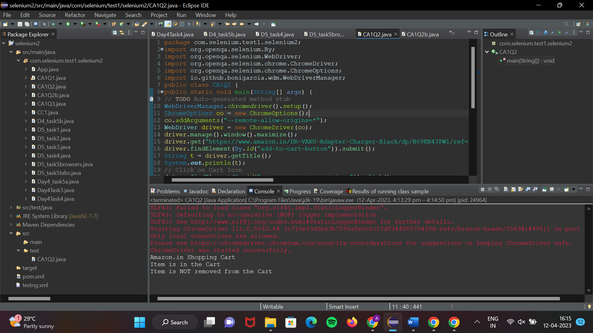

1.3

Code:

package com.selenium.test1.selenium2;

import java.util.List;

import org.openqa.selenium.By;

import org.openqa.selenium.JavascriptExecutor;

import org.openqa.selenium.WebDriver;

import org.openqa.selenium.WebElement;

import org.openqa.selenium.chrome.ChromeDriver;

import org.openqa.selenium.chrome.ChromeOptions;

import org.openqa.selenium.edge.EdgeDriver;

import org.openqa.selenium.interactions.Actions;

import org.openqa.selenium.support.ui.Select;

import dev.failsafe.internal.util.Assert;

import io.github.bonigarcia.wdm.WebDriverManager;

public class CA1Q2 {

public static void main( String[] args ) throws InterruptedException

{

WebDriverManager.*chromedriver*().setup();

ChromeOptions co=new ChromeOptions();

co.addArguments("--remote-allow-origins=*");

WebDriver driver=new ChromeDriver(co);

driver.manage().window().maximize();

driver.get("https://www.amazon.in/Anne-Diamond-Analog-Womens-Watch-AK3686BKGB/dp/B0968Q7L3M/ref=sr_1_1_sspa?crid=293FS4VHUVN6K&keywords=watches&qid=1681287782&sprefix=watches%2Caps%2C323&sr=8-1-spons&sp_csd=d2lkZ2V0TmFtZT1zcF9hdGY&psc=1");

driver.findElement(By.*id*("add-to-cart-button")).submit();

String t=driver.getTitle();

System.***out***.println(t);

String cart=driver.findElement(By.*xpath*("//*[@id=\"NATC_SMART_WAGON_CONF_MSG_SUCCESS\"]/span")).getText();

if(cart.equals("Added to cart"));

System.***out***.println("1. Verified that Product added to cart ");

driver.navigate().back();

WebElement sort1=driver.findElement(By.*xpath*("//*[@id=\"quantity\"]"));

sort1.click();

Select select=new Select(sort1);

select.selectByIndex(1);

String drop=driver.findElement(By.*xpath*("//*[@id=\"quantity\"]")).getText();

if(drop.equals("2"));

System.***out***.println("3. Verified that Product is updated to cart ");

}

}

Output:

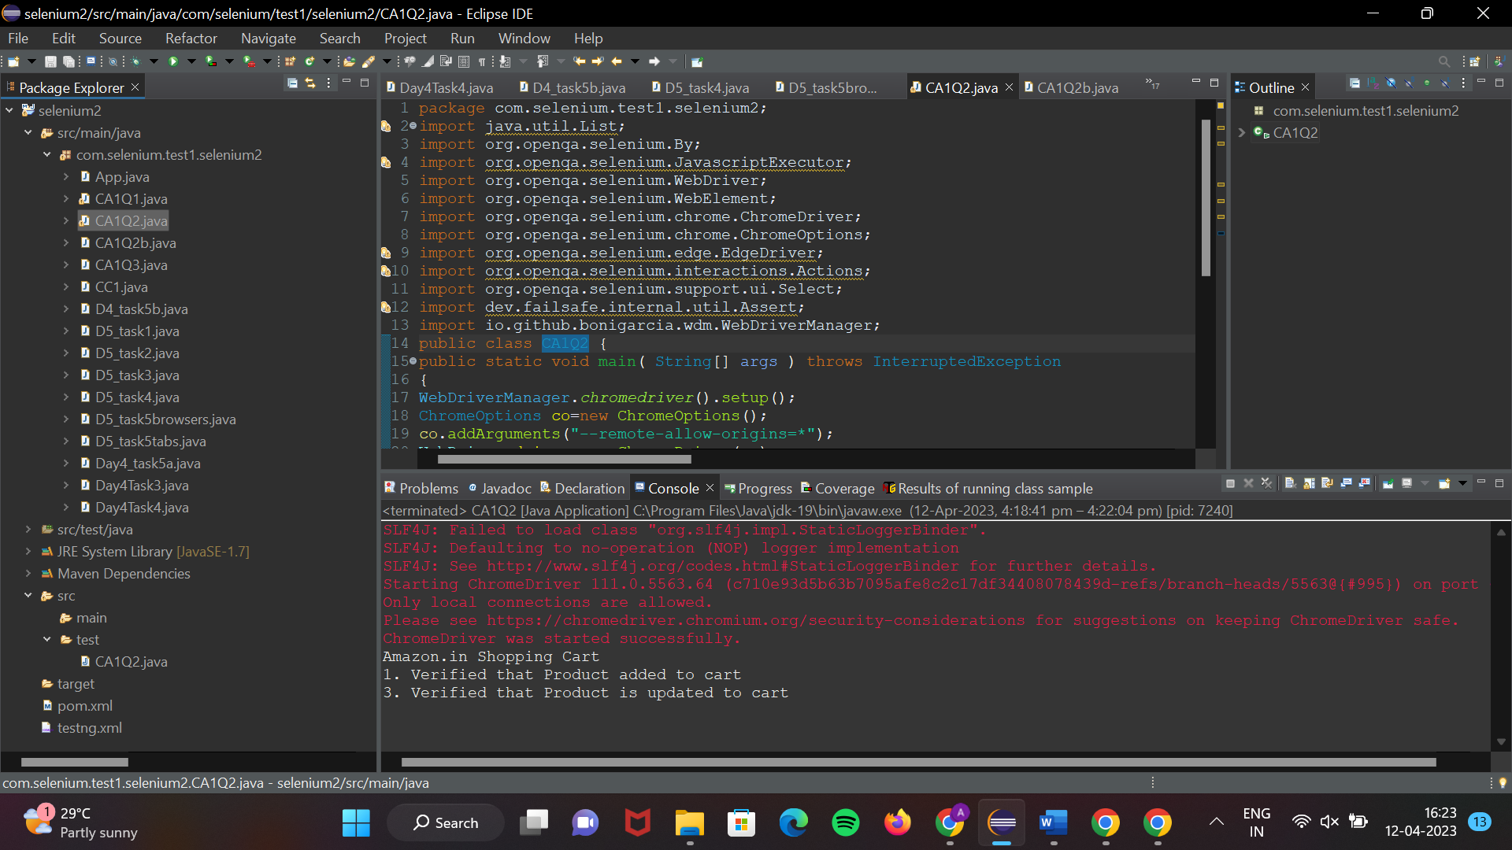

Q2

Code:

2.1:

package com.selenium.test1.selenium2;

import org.openqa.selenium.By;

import org.openqa.selenium.Keys;

import org.openqa.selenium.WebDriver;

import org.openqa.selenium.WebElement;

import org.openqa.selenium.chrome.ChromeDriver;

import org.openqa.selenium.chrome.ChromeOptions;

import io.github.bonigarcia.wdm.WebDriverManager;

public class CA1Q2

{

public static void main( String[] args ) throws InterruptedException

{

WebDriverManager.chromedriver().setup();

ChromeOptions co=new ChromeOptions();

co.addArguments("--remote-allow-origins=*");

WebDriver driver=new ChromeDriver(co);

driver.get("https://www.amazon.in/");

driver.manage().window().maximize();

String actualTitle=driver.getTitle();

System.out.println("Page title is : " + driver.getTitle());

String expectedTitle = "Online Shopping site in India: Shop Online for Mobiles, Books, Watches, Shoes and More - Amazon.in";

if(actualTitle.equalsIgnoreCase(expectedTitle))

System.out.println("Title Matched");

else

System.out.println("Title didn't match");

WebElement txt1=driver.findElement(By.id("twotabsearchtextbox"));

txt1.sendKeys("Watch");

driver.findElement(By.id("twotabsearchtextbox")).sendKeys(Keys.ENTER);

}

}

Output:

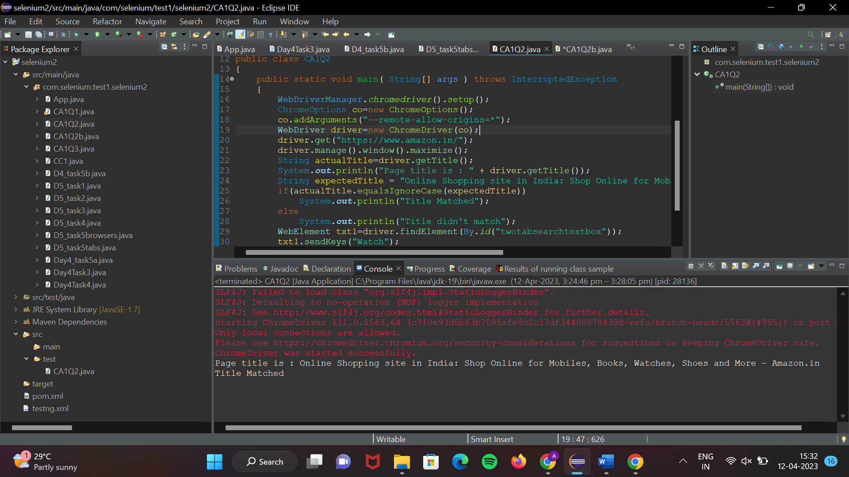

2.2

Code:

package com.selenium.test1.selenium2;

import java.util.List;

import org.openqa.selenium.By;

import org.openqa.selenium.JavascriptExecutor;

import org.openqa.selenium.Keys;

import org.openqa.selenium.WebDriver;

import org.openqa.selenium.WebElement;

import org.openqa.selenium.chrome.ChromeDriver;

import org.openqa.selenium.chrome.ChromeOptions;

import io.github.bonigarcia.wdm.WebDriverManager;

public class CA1Q2b

{

public static void main( String[] args ) throws InterruptedException

{

WebDriverManager.chromedriver().setup();

ChromeOptions co=new ChromeOptions();

co.addArguments("--remote-allow-origins=*");

WebDriver driver=new ChromeDriver(co);

driver.get("https://www.amazon.in/");

driver.manage().window().maximize();

String actualTitle=driver.getTitle();

System.out.println("Page title is : " + driver.getTitle());

String expectedTitle = "Online Shopping site in India: Shop Online for Mobiles, Books, Watches, Shoes and More - Amazon.in";

if(actualTitle.equalsIgnoreCase(expectedTitle))

System.out.println("Title Matched");

else

System.out.println("Title didn't match");

WebElement txt1=driver.findElement(By.id("twotabsearchtextbox"));

txt1.sendKeys("Watch");

driver.findElement(By.id("twotabsearchtextbox")).sendKeys(Keys.ENTER);

JavascriptExecutor js=(JavascriptExecutor) driver;

js.executeScript("window.scrollBy(0,1000)","");

List<WebElement> l1=driver.findElements(By.xpath("//h5[@class='s-line-clamp-1']"));

for(WebElement link:l1)

{

System.out.println(link.getText());

}

js.executeScript("window.scrollBy(0,1000)","");

List<WebElement> l2=driver.findElements(By.xpath("//h5[@class='s-line-clamp-1']"));

for(WebElement link:l2)

{

System.out.println(link.getText());

}

}

}

OUtPUT:

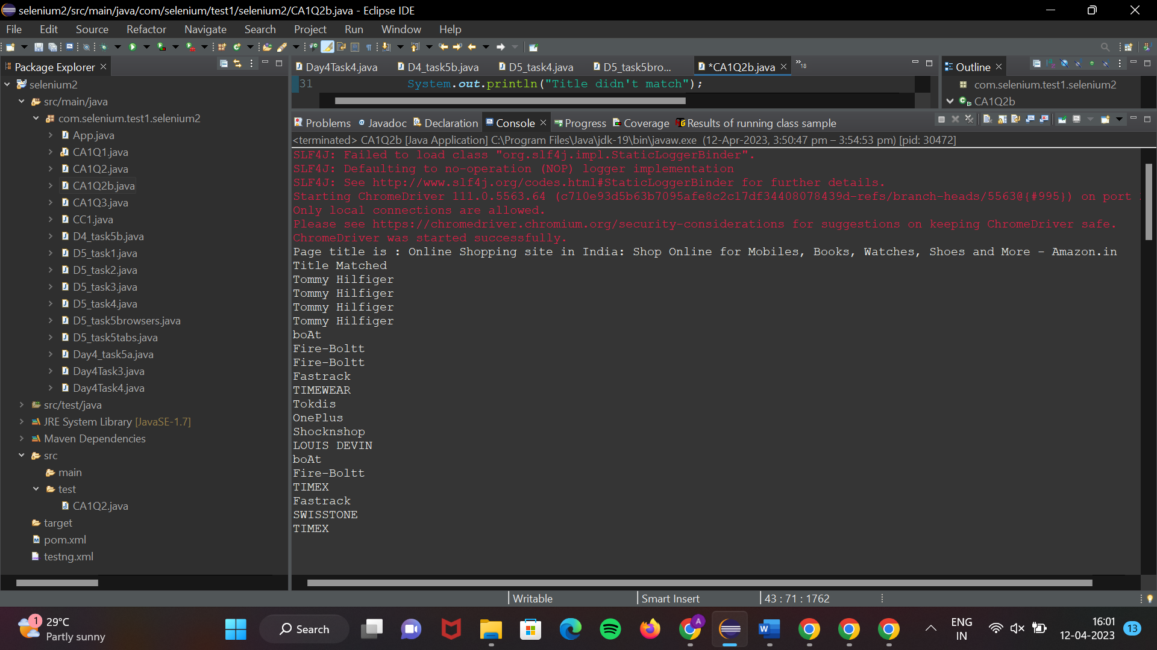

2.3

Code:

package com.selenium.test1.selenium2;

import java.util.List;

import org.openqa.selenium.By;

import org.openqa.selenium.Keys;

import org.openqa.selenium.WebDriver;

import org.openqa.selenium.WebElement;

import org.openqa.selenium.chrome.ChromeDriver;

import org.openqa.selenium.chrome.ChromeOptions;

import io.github.bonigarcia.wdm.WebDriverManager;

public class CA1Q2{

public static void main( String[] args ) throws InterruptedException

{

WebDriverManager.*chromedriver*().setup();

ChromeOptions co = new ChromeOptions();

co.addArguments("--remote-allow-origins=*");

WebDriver driver=new ChromeDriver(co);

driver.get("https://www.amazon.in/ref=nav_logo");

driver.manage().window().maximize();

String title=driver.getTitle();

System.***out***.println(title);

if(title.equals("Online Shopping site in India: Shop Online for Mobiles, Books, Watches, Shoes and More - Amazon.in")) {

System.***out***.println("Verified title of the page");

}else {

System.***out***.println("Title not matched");

}

driver.findElement(By.*id*("twotabsearchtextbox")).sendKeys("phone");

driver.findElement(By.*id*("twotabsearchtextbox")).sendKeys(*Keys*.***ENTER***);

System.***out***.println("Searched Item successfully");

driver.findElement(By.*id*("a-autoid-0-announce")).click();

List<WebElement>li=driver.findElements(By.*xpath*("//*[@id=\"octopus-dlp-asin-stream\"]/ul/li[2]/span/div/div[2]/div[1]/a"));

for(WebElement link:li) {

System.***out***.println(link.getText());

}

System.***out***.println("User is able to filter by search");

System.***out***.println("Testing Ended");

driver.quit();

}

}

OUTPUT:  
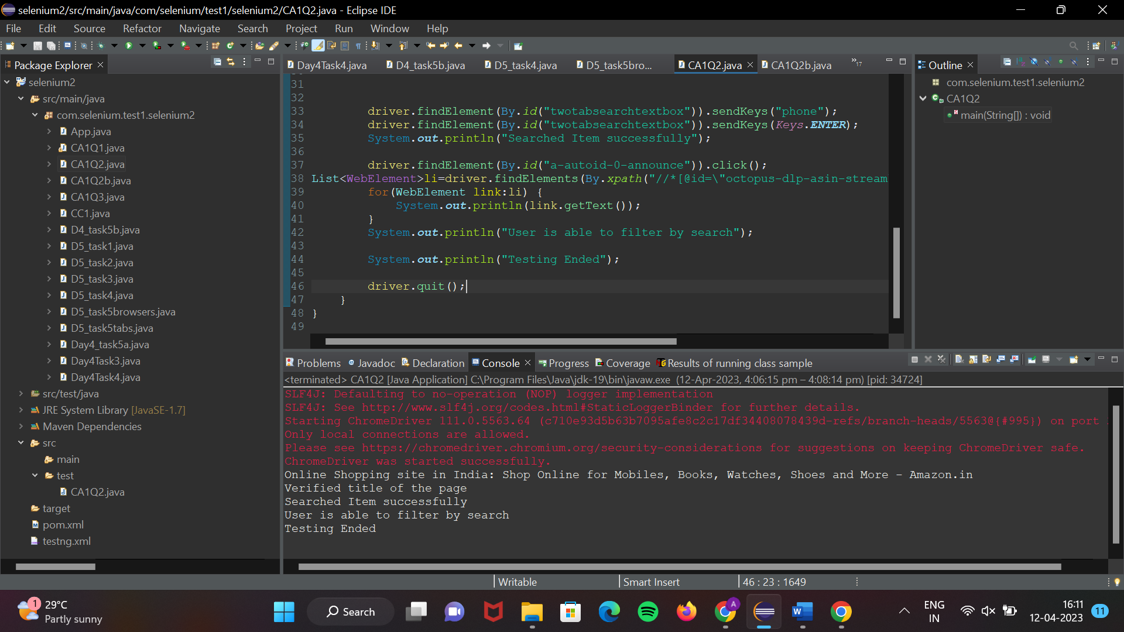

QUESTION:3

Code:

package com.selenium.test1.selenium1;

import java.util.List;

import org.openqa.selenium.By;

import org.openqa.selenium.JavascriptExecutor;

import org.openqa.selenium.Keys;

import org.openqa.selenium.WebDriver;

import org.openqa.selenium.WebElement;

import org.openqa.selenium.chrome.ChromeDriver;

import org.openqa.selenium.chrome.ChromeOptions;

import org.openqa.selenium.support.ui.Select;

import io.github.bonigarcia.wdm.WebDriverManager;

/**

* Hello world!

*

*/

public class TASK_3

{

public static void main( String[] args ) throws InterruptedException

{

WebDriverManager.*chromedriver*().setup();

ChromeOptions co = new ChromeOptions();

co.addArguments("--remote-allow-origins=*");

WebDriver driver=new ChromeDriver(co);

driver.get("https://www.amazon.in/ref=nav_logo");

driver.manage().window().maximize();

String title=driver.getTitle();

System.***out***.println(title);

if(title.equals("Online Shopping site in India: Shop Online for Mobiles, Books, Watches, Shoes and More - Amazon.in")) {

System.***out***.println("Verified title of the page");

}else {

System.***out***.println("Title not matched");

}

driver.findElement(By.*id*("nav-link-accountList")).click();

driver.findElement(By.*id*("ap_email")).sendKeys("abc@gmail.com");

driver.findElement(By.*id*("ap_email")).sendKeys(*Keys*.***ENTER***);

driver.findElement(By.*id*("ap_password")).sendKeys("fgteww");

driver.findElement(By.*id*("ap_password")).sendKeys(*Keys*.***ENTER***);

Thread.*sleep*(2000);

String name=driver.findElement(By.*id*("nav-link-accountList-nav-line-1")).getText();

if(name.equals("Hello, abc")) {

System.***out***.println("Successfully, signed in");

}else {

System.***out***.println("Sign in failed");

}

System.***out***.println("Testing Ended");

driver.quit();

}

}

OUTPUT:

