Assignment ( III Internal)
Subject: Soft Computing
Subject Code: IC-812A
Course: MCA
Semester: VIII
Session: Jan - May 2026
Max Marks: 20
Date of Submission: 28/04/2026 at 2:30 PM
Note: Write the answers, in a notebook. Make all entries like Roll Number, Name,
Class, Subject Name, Date of Submission and signature on the assignment sheet.

1. State the difference between supervised learning and unsupervised learning.
2. Use Mc Cullon Pitts neuron to design logic Networks of AND and OR logic function.
3. Write down at least one unique application area for each of the
following learning process.
i) Fuzzy logic
ii) Neural Network
iii) Genetic algorithm
iv) PSO
4. Explain the architecture and algorithm of Counter Propagation Network with diagram.
5. Explain Kohonen SoM Network.
6. Define Population, Chromosome, Gene, Allele, Genetype and Phenotype.
7. Discuss Ant colony optimization methods.

8. Explain the following term:
i) Artificial Neural Network
ii) Fuzzy Inference System
iii) Adaline/Madaline
9. Consider Two Fuzzy sets : A1 = 0.2/x1 + 0.9/x2 and A2=0.3/y1+0.5y2+1/y3
DetermineA1–A2 or A1+A2
10. Name and explain different Fuzzy Membership Functions with a diagram.
11. A two layer Network has two neurons in each layer, three inputs, including on augmentation input and two outputs with back propagation algorithm. How will you find weights, slopes, error signals, output and the updated weights.
12. A realtor wants to classify the houses he offers to his clients. One indicator of comfort of these houses is the number of bedrooms in them. Let the available types of houses be represented by the following set.
U = {1, 2, 3, 4, 5, 6, 7, 8, 9, 10}
The houses in this set are described by u number of bedrooms in a house. The realtor wants to describe a "comfortable house for a 4-person family," using a fuzzy set.
13. Suppose you are asked to define the set of natural numbers close to 6. There are a number of different ways in which you could accomplish this using fuzzy sets.
14. On the basis of six jobs, your task is to choose the job that will give you the highest Salary, given the constraints that the job should be interesting and close to your home, The fuzzy sets are:
Interest = { ( 1, 0.4 ), ( 2, 0.6 ), ( 3, 0.7 ), ( 4, 0.9 ), ( 5, 0.3 ), ( 6, 0.8 ) }
Drive = { ( 1, 0.1 ), ( 2, 0.9 ), ( 3, 0.6 ), ( 4, 1.0 ), ( 5, 0.2 ), ( 6, 0.3 ) }
Salary = { ( 1, 0.785 ), ( 2, 0.312 ), ( 3, 0.723 ), ( 4, 0.129 ), ( 5, 0.345 ), ( 6, 0.823 ) }
Highest membership shows highest interest, lowest drive and highest salary also draw graph.
15. What is a Genetic Algorithm? What are the main components of a GA?
16. What are common selection methods and common crossover techniques in GAs?
…………………………………………………………………………………….
Q1) State the difference between supervised learning and unsupervised learning
Supervised learning and unsupervised learning are two fundamental ways in which a machine learns from data, but the major difference between them lies in whether the data contains correct answers during training. In supervised learning, every training example comes with a known output label, so the model is taught by example: it sees an input and also sees the expected output. Over many examples, it gradually learns the relationship between input and output so that it can predict the output for new unseen data. In unsupervised learning, the model receives only input data without labels, so there is no direct answer key. The objective then is not prediction of a known target but discovery of hidden structure, such as grouping similar samples together or finding compact patterns.
A simple way to understand this is to compare it with classroom learning. Supervised learning is like practicing with solved questions where the teacher has already provided the right answer, and the student tries to learn the method that maps question to answer. Unsupervised learning is like receiving a pile of documents with no headings and being asked to organize them meaningfully; the learner must detect patterns, similarity, or structure on its own.
In supervised learning, the typical tasks are classification and regression. Classification is used when the output is a category, such as spam or not spam, disease present or absent, fraud or normal transaction. Regression is used when the output is continuous, such as house price, temperature forecast, or demand estimation. Because labelled outputs are available, supervised models can be evaluated clearly using metrics such as accuracy, precision, recall, F1 score, and mean squared error depending on the task type.
In unsupervised learning, common tasks include clustering, dimensionality reduction, and association analysis. Clustering is used to divide data into groups of similar items, such as customer segmentation in marketing. Dimensionality reduction methods like PCA help represent high-dimensional data in fewer dimensions while preserving important information. Association methods discover co-occurrence patterns, such as products frequently purchased together. Since there is no ground-truth label, evaluation is more indirect and often relies on internal measures or domain interpretation.
Another practical difference is data preparation cost. Supervised learning usually requires labelled data, and creating labels can be expensive and time-consuming because experts may need to annotate thousands of examples. Unsupervised learning can work directly with raw unlabelled data, which is often easier to collect at scale. However, interpreting the discovered patterns can require expert judgment, because a mathematically valid cluster is not always meaningful in business or scientific context.
From an application perspective, supervised learning is preferred when the goal is accurate prediction of a known target variable. For example, email filtering, credit risk scoring, medical diagnosis support, and stock demand forecasting are naturally supervised tasks. Unsupervised learning is preferred when the goal is exploration, structure discovery, or feature extraction, such as grouping users by behaviour, visualizing complex datasets, or detecting unusual activity patterns.
In summary, supervised learning is label-driven and prediction-oriented, while unsupervised learning is structure-driven and discovery-oriented. Both are essential in machine learning practice, and modern systems often combine them. A common pipeline first uses unsupervised techniques to learn useful representations from raw data and then applies supervised learning to produce accurate final predictions.
Q2) Use McCulloch-Pitts neuron to design logic networks of AND and OR logic function
The McCulloch-Pitts neuron is one of the earliest mathematical models of an artificial neuron. It is a binary threshold unit that accepts binary inputs and produces a binary output. The neuron first computes a weighted sum of the inputs, and then compares that sum with a threshold value. If the sum is greater than or equal to the threshold, the output becomes 1; otherwise, the output remains 0. This simple mechanism is enough to realize basic Boolean logic functions such as AND and OR.
For a two-input neuron, let the inputs be x1 and x2, the corresponding weights be w1 and w2, and the threshold be theta. The net activation is computed as net = w1x1 + w2x2. The output rule is y = 1 if net is at least theta, otherwise y = 0. To implement a logical gate, we choose suitable values of weights and threshold so that the neuron output matches the truth table of that gate.
To construct an AND gate, the output should become 1 only when both inputs are 1. A direct parameter choice is w1 = 1, w2 = 1, and theta = 2. With these values, net equals x1 + x2. When the inputs are (0,0), net is 0, so output is 0. For (0,1) and (1,0), net is 1, still below threshold, so output is 0. Only for (1,1), net becomes 2, reaching threshold, and the output becomes 1. Therefore the neuron behaves exactly like an AND gate.
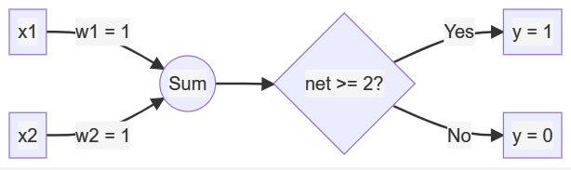
To construct an OR gate, the output should become 1 whenever at least one input is 1. We can keep the same weights w1 = 1 and w2 = 1, but reduce threshold to theta = 1. Then net is again x1 + x2. For input (0,0), net is 0, so output is 0. For (0,1) and (1,0), net is 1, which meets threshold, so output is 1. For (1,1), net is 2, so output remains 1. This exactly reproduces the OR function.
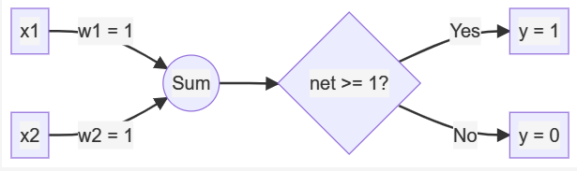
In network form, both implementations use two input nodes connected directly to one McCulloch-Pitts neuron that acts as the output node. No hidden layer is required because AND and OR are linearly separable logic functions. This is an important conceptual point: a single threshold neuron can realize linearly separable Boolean operations, which made the McCulloch-Pitts model foundational in the development of neural computation.
Thus, with carefully selected threshold values, the same two-input neuron structure can implement different logic gates. Setting a higher threshold enforces stricter activation (AND), while setting a lower threshold permits activation by any single input (OR).
Q3) Write down at least one unique application area for each of the following learning process
(i) Fuzzy Logic
(ii) Neural Network
(iii) Genetic Algorithm
(iv) PSO
Fuzzy logic is uniquely effective in intelligent control systems where inputs are uncertain, gradual, or linguistically described rather than sharply measured. A classic and still highly relevant application is automatic washing machine control. In such systems, factors like cloth dirtiness, fabric type, and load level are not naturally binary or exact; they are better interpreted as low, medium, or high. Fuzzy rules can translate this human-like reasoning into machine control, so wash time, water usage, spin speed, and detergent quantity adapt continuously instead of switching rigidly between fixed programs. This makes operation both efficient and user-friendly.
Neural networks are especially suitable for pattern recognition problems where relationships are complex and difficult to hand-code. A distinctive application area is medical image diagnosis, such as detecting pneumonia from chest X-rays or identifying tumours from MRI scans. In these tasks, deep neural models can automatically learn hierarchical visual features from large image datasets and produce highly reliable predictions. Their ability to learn subtle patterns that may be hard to define manually makes them valuable as decision-support tools in clinical workflows.
Genetic algorithms are naturally suited to constrained combinatorial optimization, where many possible configurations exist and traditional exact search can become expensive. A practical unique application is university timetable generation. The algorithm treats each timetable as a candidate solution and iteratively improves it using selection, crossover, and mutation while optimizing constraints such as classroom availability, faculty schedules, and conflict-free course allocation. Because educational scheduling includes both hard constraints and preference-based soft constraints, genetic algorithms provide flexible near-optimal solutions in realistic time.

Particle Swarm Optimization, or PSO, is highly effective for continuous parameter optimization where gradient information is unavailable or costly. A notable application area is optimal placement and sizing of distributed energy resources in smart power grids. Each particle represents a candidate plan for where to place distributed generators and what capacities to assign. Through cooperation between personal best and global best experiences, the swarm converges toward solutions that improve voltage stability, reduce power losses, and lower operational cost. This makes PSO particularly attractive in modern energy planning and engineering optimization.
Q4) Explain the architecture and algorithm of Counter Propagation Network with diagram
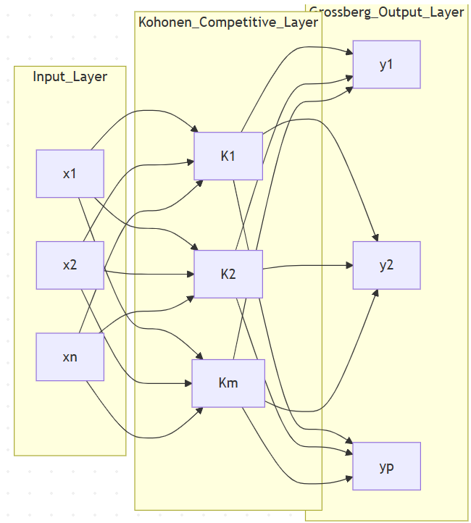
The Counter Propagation Network, commonly abbreviated as CPN, is a hybrid neural architecture designed to combine fast clustering behaviour with supervised input-output mapping. It was introduced as an efficient alternative for tasks where we want both pattern organization and direct association with target outputs. Conceptually, CPN blends two ideas: competitive learning in the hidden region and associative learning in the output region.
The architecture is usually described as a three-layer structure. The first layer is the input layer, which accepts the feature vector. The second layer is the Kohonen competitive layer, where neurons compete to represent the presented input. The winning neuron in this layer acts as a symbolic representative of the input pattern. The third layer is the Grossberg output layer, which stores the mapping from that winner neuron to the desired output vector.
When an input vector is presented, each neuron in the Kohonen layer compares its prototype weight with the input. The neuron whose weight vector is most similar to the input, often measured by minimum Euclidean distance, is declared the winner. This winner-take-all behavior is central to CPN because it discretizes the input space into regions represented by different hidden neurons.
Learning then proceeds in two coordinated updates. First, the input-to-Kohonen weights of the winning neuron are shifted toward the current input. This is the competitive or self-organizing part and helps the hidden prototypes become good representatives of the data distribution. Second, the weights from that same winning neuron to the output layer are moved toward the target output vector. This is the supervised association part and allows the network to produce correct outputs when similar inputs appear in the future.
Mathematically, if Wj denotes the prototype weight vector of hidden neuron j and X is the current input, the winner j* is selected by finding the smallest distance between X and Wj. The winner prototype is then updated using Wj*(new) = Wj*(old) + alpha(X - Wj*(old)), where alpha is the learning rate for the competitive stage. If Vkj denotes the weight from hidden neuron j to output neuron k, and Tk is the target component, then output mapping is learned through Vkj*(new) = Vkj*(old) + beta(Tk - Vkj*(old)), where beta is the output learning rate.
The algorithm can be understood as a repeated cycle over training pairs. For each input-target pair, the network identifies the winning hidden neuron, updates that neuron's prototype toward the input, and updates its output links toward the target. Over many epochs, the Kohonen layer becomes an organized codebook of input regions, while the Grossberg layer stores the associated output response for each region.
During testing, only the input is needed. The hidden winner is found exactly as in training, and the output is read from the winner-associated output weights. This gives CPN a very fast recall stage because inference mainly involves nearest-prototype search and lookup-style output generation.
CPN is attractive for tasks such as rapid classification, associative memory, and sensor-to-response mapping because training can be computationally lighter than deep gradient-based models in many moderate-size problems. At the same time, performance depends on proper selection of the number of hidden competitive neurons and learning-rate scheduling; if the representation capacity is too low, distinct patterns may collapse into the same winner region.

Q5) Explain Kohonen SoM Network
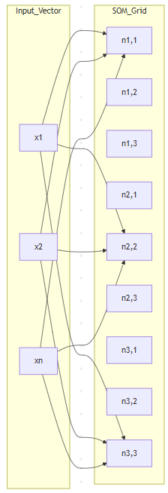
The Kohonen Self-Organizing Map, usually called SOM, is an unsupervised neural network model used to organize complex high-dimensional data into a low-dimensional map, most often a two-dimensional grid. The central purpose of SOM is not direct classification with labels, but discovery of natural structure in data while preserving neighborhood relationships. In practical terms, samples that are similar in the original feature space tend to be mapped to nearby neurons on the SOM grid.
A SOM has an input side and a competitive map side. The input vector is connected to every neuron in the map, and each map neuron carries a weight vector of the same dimension as the input. When a sample is presented, each neuron measures how close its weight is to the sample. The neuron with the smallest distance is called the Best Matching Unit, or BMU. This competitive step identifies which part of the map currently best represents the sample.
The key feature that differentiates SOM from simple winner-take-all clustering is neighborhood adaptation. Not only the BMU but also its neighboring neurons on the grid are updated toward the current input. The BMU receives the strongest update, nearby neurons receive weaker updates, and far neurons may receive almost none. Over time, both the learning rate and neighborhood radius are reduced. Early training therefore promotes broad global ordering, while later training performs fine local adjustment.
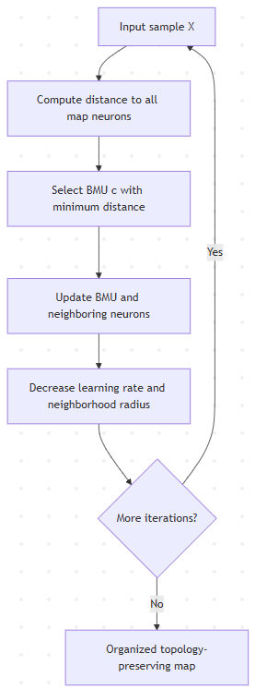
The standard update equation can be read as follows: a neuron's new weight equals its old weight plus a correction term that depends on learning rate, neighborhood influence, and the difference between input and current weight. This repeated adaptation causes the map to self-organize into regions, where each region becomes specialized for a certain pattern family in the data.
Because SOM preserves topological relationships, it is highly useful for exploratory data analysis. It can reveal clusters, transitions between clusters, and latent structure that may not be obvious in raw tabular form. This is why SOM has been widely used in customer segmentation, biomedical data exploration, anomaly pattern discovery, document organization, and industrial process monitoring.
One way to appreciate SOM is to compare it with classical clustering. Methods such as k-means can partition data into clusters, but they do not naturally provide an ordered neighborhood map of prototype vectors. SOM, by contrast, places prototypes on a structured lattice, so geometric proximity on the map itself carries interpretive meaning. This visual interpretability is one of SOM's strongest practical advantages.
At the same time, SOM performance depends on careful selection of grid size, initialization strategy, and training schedule. If the map is too small, distinct structures may merge; if too large, the representation may become sparse and unstable. Nevertheless, with proper design, SOM remains one of the most instructive and useful unsupervised neural methods for converting high-dimensional complexity into human-readable structure.
Q6) Define Population, Chromosome, Gene, Allele, Genotype and Phenotype
Population refers to the complete set of candidate solutions available in one generation of the algorithm. Instead of improving a single solution, a genetic algorithm evolves an entire group simultaneously. This diversity allows the search process to explore multiple regions of the solution space in parallel and helps prevent early trapping in poor local optima.
A chromosome is one complete candidate solution within that population. It is the encoded form that the algorithm manipulates. Depending on problem type, a chromosome may be represented as a binary string, an integer vector, a real-valued vector, or a permutation. In scheduling, for example, one chromosome can represent one full schedule arrangement.
A gene is an individual position or component inside the chromosome. Each gene usually corresponds to one decision variable or one part of the final solution. If the chromosome is viewed as a full blueprint, genes are the individual fields of that blueprint.
An allele is the actual value currently stored in a gene. In binary encoding, common alleles are 0 and 1. In real-valued encoding, an allele can be any allowed numeric value within range. So gene identifies the slot, while allele identifies the content of that slot.
Genotype means the internal encoded representation of the solution as processed by the algorithm. It is the machine-level form used during crossover and mutation. Phenotype, in contrast, is the interpreted real-world meaning of that encoding in the original problem domain. If a genotype encodes parameter values, the phenotype is the actual parameterized solution behavior those values produce.
Consider a simple example where a manufacturing process is controlled by temperature, pressure, and speed. A chromosome such as [78, 21, 130] can be treated as genotype. Here each component is a gene, and each numeric value is its allele. The phenotype is the real process configuration: temperature 78, pressure 21, and speed 130. Fitness is evaluated on this phenotype because optimization objectives always belong to the problem domain, not just the encoding.

Q7) Discuss Ant Colony Optimization methods
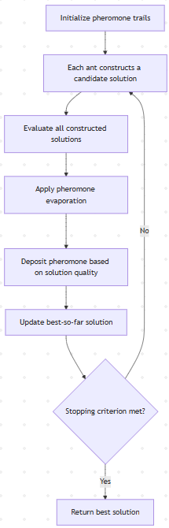
Ant Colony Optimization, commonly known as ACO, is a bio-inspired optimization framework based on how real ants discover efficient routes between their nest and food sources. In nature, ants deposit pheromone while moving. Paths that lead to food quickly are traversed more often, so pheromone concentration on those paths becomes stronger. Over time, this positive feedback guides more ants to the better route. ACO translates this collective behavior into an algorithm for solving hard optimization problems.
In computational form, a population of artificial ants incrementally constructs candidate solutions. At each decision point, an ant does not choose deterministically; instead it selects the next move probabilistically using two influences. The first is pheromone intensity, which represents learned historical quality of past decisions. The second is heuristic desirability, which represents immediate local attractiveness such as inverse distance in routing problems. A parameterized balance between these two factors controls exploration versus exploitation.
After all ants complete their solutions in one iteration, the algorithm evaluates solution quality and updates pheromone values. Evaporation is applied first, reducing previous pheromone intensity so that outdated information gradually fades and the search does not become rigid too early. Then pheromone is deposited again, usually in proportion to solution quality, so better solutions reinforce their components more strongly. This repeated cycle gradually increases the probability of constructing high-quality solutions.
The original variant, called Ant System, introduced this general mechanism with global pheromone update from all ants. Although foundational, it can converge slowly on difficult instances. To improve search pressure, Elitist Ant System gives extra reinforcement to the best-so-far solution so that promising structures are emphasized more quickly. Rank-based Ant System refines this idea further by allowing only top-ranked ants to deposit pheromone with different strengths according to rank.
Ant Colony System, or ACS, is one of the most influential improvements. It introduces a stronger exploitation strategy through a pseudo-random proportional decision rule and also applies local pheromone updates during solution construction. This reduces overuse of the same edges within a single iteration and encourages diversity. In practice, ACS often provides a better balance of speed and robustness for routing-style combinatorial problems.
MAX-MIN Ant System, known as MMAS, addresses stagnation by explicitly bounding pheromone values between lower and upper limits. Usually only the best ant deposits pheromone, and the bounds prevent any path from becoming overwhelmingly dominant too soon. This controlled reinforcement frequently improves stability and prevents premature convergence in large search spaces.
Beyond these classical forms, ACO has also been extended to continuous optimization and multi-objective optimization. In continuous variants, solution construction is adapted from graph traversal to probabilistic sampling in real-valued spaces. In multi-objective variants, pheromone handling is combined with Pareto concepts so that trade-offs among conflicting goals can be explored effectively.
ACO is widely used in traveling salesman problems, vehicle routing, scheduling, telecommunication path design, and several engineering optimization contexts. Its strengths include distributed search, positive feedback, and good compatibility with hybrid local search methods. Its limitations include sensitivity to parameter tuning and computational cost on very large instances if implementation is not optimized.
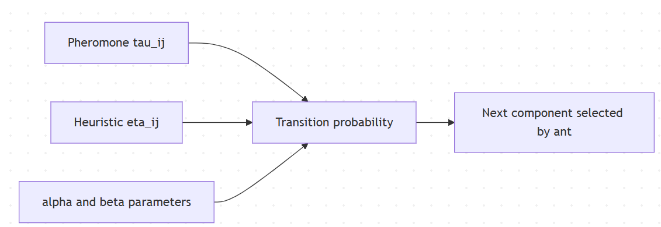

Q8) Explain the following term:
i) Artificial Neural Network
ii) Fuzzy Inference System
iii) Adaline/Madaline
Artificial Neural Network, commonly called ANN, is a computational model inspired by the way biological neurons process information. An ANN is made of interconnected processing units called neurons, arranged in layers. The input layer accepts raw features, one or more hidden layers transform those features into higher-level representations, and the output layer produces the final prediction or decision. Each connection carries a weight, and learning happens by adjusting these weights so that the network output becomes closer to the target output. In modern applications, ANNs are widely used for image recognition, speech processing, medical diagnosis support, forecasting, and many other nonlinear mapping tasks where simple rule-based methods are insufficient.
A Fuzzy Inference System, or FIS, is a rule-based framework that maps inputs to outputs using fuzzy logic instead of crisp true-false logic. It is designed for situations where boundaries are not sharp and linguistic reasoning is more natural, such as low, medium, and high. A standard FIS has four main internal stages: fuzzification, rule evaluation, aggregation, and defuzzification. In fuzzification, crisp inputs are converted into membership degrees. In rule evaluation, IF-THEN fuzzy rules are fired. In aggregation, contributions from all active rules are combined. Finally, defuzzification converts the fuzzy result back into a crisp output value. FIS is very effective in control systems, decision support, and systems that need human-like approximate reasoning.
Adaline stands for Adaptive Linear Neuron. It is an early neural model introduced by Widrow and Hoff and trained using the Least Mean Squares learning rule. Even though it may produce binary decisions after thresholding, the training itself minimizes a continuous error between target and linear output, which gives Adaline smoother learning behavior compared with a hard-threshold perceptron. Madaline, which stands for Multiple Adalines, extends this concept by combining several Adaline units in a multilayer arrangement. It was one of the earliest multilayer adaptive systems and became important historically for pattern recognition and adaptive filtering tasks. In short, Adaline and Madaline are foundational bridges between simple perceptrons and modern trainable neural networks.

Q9) Consider two fuzzy sets:
A1 = 0.2/x1 + 0.9/x2
A2 = 0.3/y1 + 0.5/y2 + 1.0/y3
Determine A1-A2 or A1+A2.
Because A1 and A2 are defined on different universes (x elements and y elements), ordinary union and intersection are not directly defined in the same way as for one common universe. In many soft computing assignments, this notation is interpreted as a fuzzy relation built over the Cartesian product X x Y. With that interpretation, two common constructions are shown below so you can match your faculty convention.
First, if A1-A2 means the fuzzy Cartesian product using minimum operator, then the relation R has membership
mu_R(xi, yj) = min(mu_A1(xi), mu_A2(yj)).
Using the given values:
mu_A1(x1) = 0.2, mu_A1(x2) = 0.9
mu_A2(y1) = 0.3, mu_A2(y2) = 0.5, mu_A2(y3) = 1.0

So the min-based matrix becomes:
R =[x1: 0.2 0.2 0.2][x2: 0.3 0.5 0.9]

In ordered-pair form this is:
R = {((x1,y1),0.2), ((x1,y2),0.2), ((x1,y3),0.2), ((x2,y1),0.3), ((x2,y2),0.5), ((x2,y3),0.9)}.

Second, if A1+A2 is interpreted as algebraic sum on X x Y, then
mu_S(xi, yj) = mu_A1(xi) + mu_A2(yj) - mu_A1(xi)*mu_A2(yj).

This gives:
S(x1,y1) = 0.44, S(x1,y2) = 0.60, S(x1,y3) = 1.00,
S(x2,y1) = 0.93, S(x2,y2) = 0.95, S(x2,y3) = 1.00.

So the algebraic-sum matrix is:
S =[x1: 0.44 0.60 1.00][x2: 0.93 0.95 1.00]

Q10) Name and explain different Fuzzy Membership Functions with a diagram
A fuzzy membership function is a mapping that assigns each input x a membership value in the interval [0,1]. This value represents how strongly x belongs to a linguistic concept such as low temperature, medium speed, or high risk. Different membership function shapes are used depending on smoothness requirement, interpretability, and computational efficiency.
The triangular membership function is one of the most common because it is simple and easy to tune. It is defined by three parameters (a, b, c). Membership rises linearly from 0 at a to 1 at b, and then falls linearly back to 0 at c. It is widely used when rule bases are designed manually by experts.
The trapezoidal membership function extends triangular shape by adding a flat top where membership remains 1 for a range of values. It is defined by four parameters (a, b, c, d). This shape is useful when a whole interval should be treated as fully belonging to a fuzzy set.
The Gaussian membership function is smooth and differentiable everywhere. It is defined by center c and spread sigma as mu(x) = exp(-((x-c)^2)/(2*sigma^2)). Because of its smoothness, it is preferred in adaptive and optimization-based fuzzy systems.
The generalized bell membership function is another smooth parametric form with flexible width and slope control. It can model gradual transitions better than piecewise linear functions when data behavior is soft and continuous.
The sigmoid membership function is an open curve that transitions from low membership to high membership, or vice versa if mirrored. It is useful for concepts like large or small where one side of the domain should saturate.
Singleton membership function is a special case where full membership is assigned at one exact point and zero elsewhere. It appears in some Sugeno-type systems and discrete fuzzy modeling scenarios.
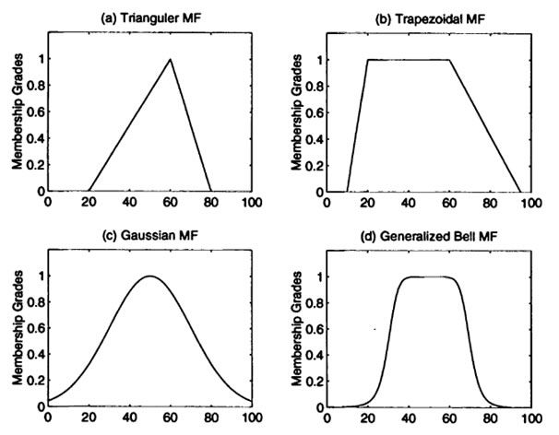
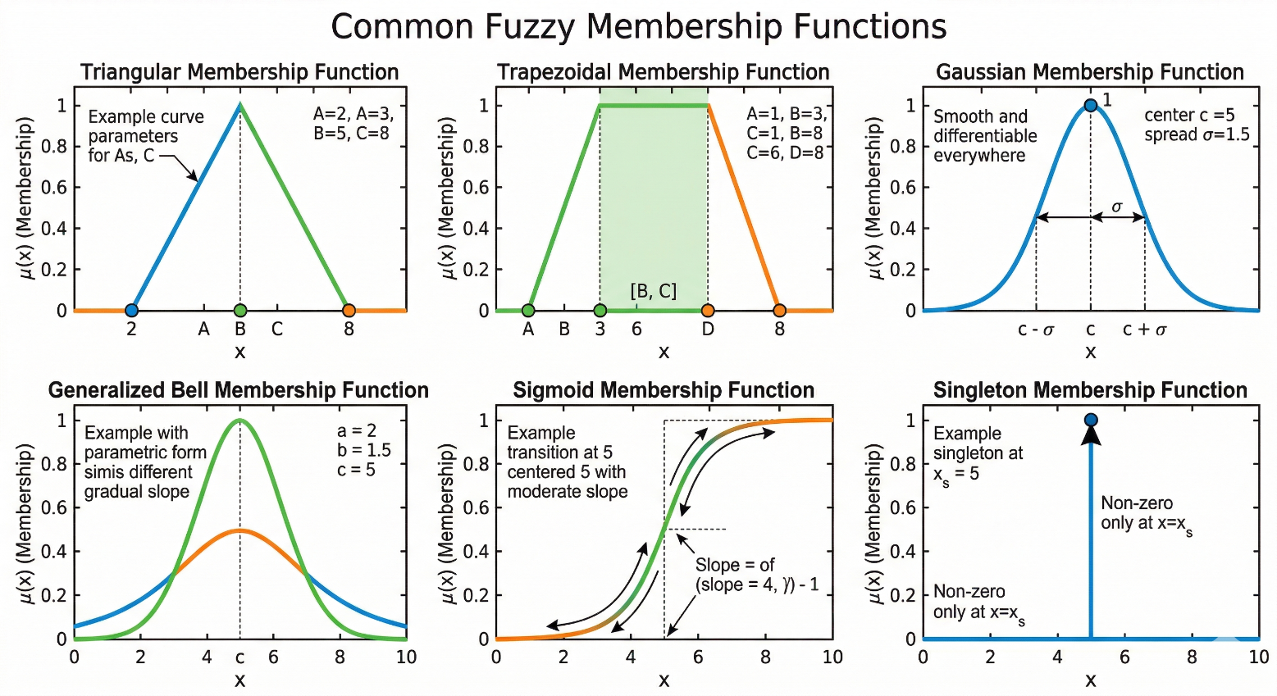
Q11) A two-layer network has two neurons in each layer, three inputs including one augmentation input, and two outputs. How do we find weights, slopes, error signals, outputs, and updated weights using backpropagation?
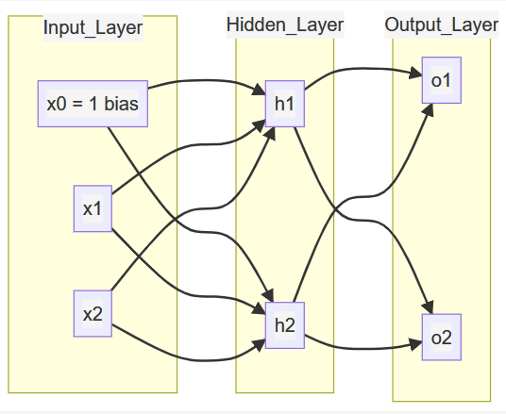
For this network, let the input vector be [x0, x1, x2], where x0 = 1 is the augmentation or bias input. The hidden layer has two neurons h1 and h2. The output layer has two neurons o1 and o2. Let wji denote weight from input xi to hidden neuron hj, and let vkj denote weight from hidden neuron hj to output neuron ok. Include output-layer bias by defining h0 = 1 with weights vk0.

In forward propagation, each hidden neuron first computes its net input. For hidden neuron hj, net_hj = wj0*x0 + wj1*x1 + wj2*x2. Apply activation function f, usually sigmoid, to get hj = f(net_hj). Then each output neuron computes net_ok = vk0*h0 + vk1*h1 + vk2*h2 and output ok = f(net_ok). At this point the network output vector [o1, o2] is available.

If target outputs are [t1, t2], define total error as E = 0.5*((t1-o1)^2 + (t2-o2)^2). The slope or gradient is obtained through chain rule.

For output-layer error signals, delta_ok = (tk - ok)*f'(net_ok). With sigmoid activation, f'(z) = f(z)*(1-f(z)), so delta_ok = (tk-ok)*ok*(1-ok).

For hidden-layer error signals, each hidden unit receives backpropagated error from both output neurons. The hidden delta is

delta_hj = f'(net_hj)*(delta_o1*v1j + delta_o2*v2j).

With sigmoid activation this becomes

delta_hj = hj*(1-hj)*(delta_o1*v1j + delta_o2*v2j).

Once deltas are known, slopes of the error surface follow directly. For output weights, the gradient magnitude is proportional to delta_ok and hidden activation hj. For input-to-hidden weights, it is proportional to delta_hj and input xi.

The standard gradient-descent update equations are:

vkj(new) = vkj(old) + eta*delta_ok*hj
vk0(new) = vk0(old) + eta*delta_ok*h0
wji(new) = wji(old) + eta*delta_hj*xi

where eta is learning rate.

Q12) A realtor wants to classify the houses he offers to his clients. One indicator of comfort of these houses is the number of bedrooms in them. Let the available types of houses be represented by the following set.
U = {1, 2, 3, 4, 5, 6, 7, 8, 9, 10}
The houses in this set are described by u number of bedrooms in a house. The realtor wants to describe a "comfortable house for a 4-person family," using a fuzzy set.
Given universe U = {1,2,3,4,5,6,7,8,9,10}, where each value denotes number of bedrooms, the idea of comfort for a 4-person family is not crisp. A 4-bedroom house may be ideal, but 3 and 5 bedrooms can still be quite comfortable. Very small or very large bedroom counts are usually less suitable. This makes fuzzy modeling appropriate.
One reasonable fuzzy set C for Comfortable House can be defined as:
C = {(1,0.0),(2,0.2),(3,0.7),(4,1.0),(5,0.9),(6,0.6),(7,0.3),(8,0.1),(9,0.0),(10,0.0)}
This definition means 4 bedrooms has full comfort membership, 5 bedrooms is also highly comfortable, 3 bedrooms is reasonably comfortable, and comfort gradually decreases as bedroom count moves far away from the family requirement.
If required, the same concept can also be represented with a triangular or trapezoidal membership function centered around 4 to 5 bedrooms. The exact membership values may vary slightly depending on local housing norms, but the fuzzy shape should always reflect this idea: highest comfort near the ideal family capacity and lower comfort at extremes.
Q13) Suppose you are asked to define the set of natural numbers close to 6. There are a number of different ways in which you could accomplish this using fuzzy sets.
The phrase close to 6 is inherently vague, which is exactly why fuzzy sets are useful. There is no single correct membership function; instead, we can model closeness with different assumptions about tolerance.
Assume a practical universe U = {0,1,2,3,4,5,6,7,8,9,10,11,12}. Below are three valid constructions.
A narrow interpretation gives high membership only to numbers very near 6:
A_narrow = {
(0,0.0),(1,0.0),(2,0.0),(3,0.1),(4,0.4),(5,0.8),(6,1.0),(7,0.8),(8,0.4),(9,0.1),(10,0.0),(11,0.0),(12,0.0)
}
A broader interpretation allows a wider neighborhood to still be considered close:
A_broad = {
(0,0.0),(1,0.0),(2,0.1),(3,0.3),(4,0.6),(5,0.85),(6,1.0),(7,0.85),(8,0.6),(9,0.3),(10,0.1),(11,0.0),(12,0.0)
}
A smooth Gaussian-style interpretation can be written by formula:
mu(n) = exp(-((n-6)^2)/(2*sigma^2)).
For example, taking sigma = 1.5 yields a bell-shaped notion of closeness where membership decays smoothly rather than piecewise linearly.
These three versions are all correct fuzzy models of close to 6. The best choice depends on context. If strict precision is needed, use narrow membership. If human tolerance is wider, use broad membership. If smooth differentiable behaviour is required for optimization, use Gaussian membership.

Q14) On the basis of six jobs, your task is to choose the job that will give you the highest Salary, given the constraints that the job should be interesting and close to your home, The fuzzy sets are:
Interest = { ( 1, 0.4 ), ( 2, 0.6 ), ( 3, 0.7 ), ( 4, 0.9 ), ( 5, 0.3 ), ( 6, 0.8 ) }
Drive = { ( 1, 0.1 ), ( 2, 0.9 ), ( 3, 0.6 ), ( 4, 1.0 ), ( 5, 0.2 ), ( 6, 0.3 ) }
Salary = { ( 1, 0.785 ), ( 2, 0.312 ), ( 3, 0.723 ), ( 4, 0.129 ), ( 5, 0.345 ), ( 6, 0.823 ) }
Highest membership shows highest interest, lowest drive and highest salary also draw graph.
Given fuzzy sets:
Interest = {(1,0.4),(2,0.6),(3,0.7),(4,0.9),(5,0.3),(6,0.8)}
Drive = {(1,0.1),(2,0.9),(3,0.6),(4,1.0),(5,0.2),(6,0.3)}
Salary = {(1,0.785),(2,0.312),(3,0.723),(4,0.129),(5,0.345),(6,0.823)}
Because the requirement is low drive, we first convert drive into closeness to home:
Close = 1 - Drive.
So:
Close = {(1,0.9),(2,0.1),(3,0.4),(4,0.0),(5,0.8),(6,0.7)}.
Now combine constraints using fuzzy AND with min operator.
First feasibility for interest and closeness:
F(i) = min(Interest(i), Close(i)).
This gives:
F(1)=0.4, F(2)=0.1, F(3)=0.4, F(4)=0.0, F(5)=0.3, F(6)=0.7.
Now include salary as third requirement:
Score(i) = min(F(i), Salary(i)).
So final scores become:
Score(1)=min(0.4,0.785)=0.4
Score(2)=min(0.1,0.312)=0.1
Score(3)=min(0.4,0.723)=0.4
Score(4)=min(0.0,0.129)=0.0
Score(5)=min(0.3,0.345)=0.3
Score(6)=min(0.7,0.823)=0.7
The highest final membership is for Job 6 with score 0.7, so Job 6 is the best fuzzy decision under the given constraints.
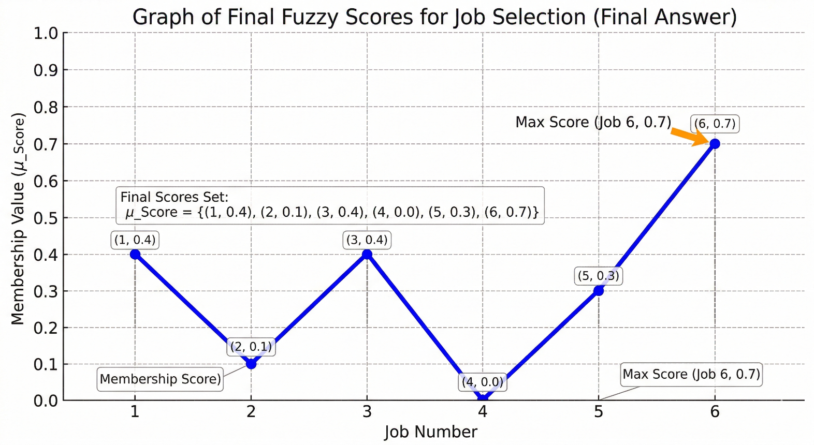

Q15) What is a Genetic Algorithm? What are the main components of a GA?
A Genetic Algorithm, or GA, is a population-based optimization technique inspired by Darwinian evolution. Instead of improving one solution directly, a GA evolves a set of candidate solutions over multiple generations. In each generation, better solutions are favored for reproduction, and new candidate solutions are created using crossover and mutation. Over time, this evolutionary search tends to discover high-quality or near-optimal solutions for complex problems where exact optimization may be difficult.
The first main component is representation, which defines how a candidate solution is encoded as a chromosome. Depending on problem type, this can be binary strings, real-valued vectors, integer arrays, or permutations.
The second component is population initialization, where a starting set of chromosomes is generated, often randomly or with heuristics. Diversity at this stage is important because it improves exploration of search space.
The third component is the fitness function. This is the objective measure that evaluates solution quality. Fitness drives all evolutionary pressure, so its design strongly affects convergence behavior.
The fourth component is selection, which chooses parent chromosomes based on fitness. Better individuals get higher probability of contributing to the next generation.
The fifth component is crossover, where two parents exchange chromosome segments to produce offspring that inherit traits from both. This is a major source of structured search.
The sixth component is mutation, where small random changes are introduced to genes. Mutation preserves diversity and helps escape local optima.
The seventh component is replacement or survivor selection, which decides which individuals remain in the population after offspring are created.
The final component is the termination condition, such as reaching a maximum number of generations, achieving a target fitness, or observing no meaningful improvement for several iterations.
Together, these components create a robust search process that balances exploration and exploitation and is applicable to scheduling, design optimization, feature selection, routing, and many real-world engineering tasks.
Q16) What are common selection methods and common crossover techniques in GAs?
Selection and crossover are the two central operators that drive evolution in a genetic algorithm. Selection determines which solutions get to reproduce, and crossover determines how parental information is mixed to create new candidates.
Among selection methods, roulette-wheel selection is one of the earliest and most widely known approaches. Here, each chromosome gets a selection probability proportional to fitness, so stronger individuals are more likely to be chosen but weaker ones are not completely excluded. Tournament selection is also very popular in practice. It repeatedly picks a small random subset of chromosomes and selects the best among them. This method is easy to implement and gives direct control over selection pressure through tournament size. Rank selection avoids excessive dominance by assigning probabilities based on sorted rank instead of raw fitness values, which is useful when fitness values are highly skewed. Stochastic universal sampling is a low-variance improvement over roulette-wheel sampling because it distributes parent picks more evenly. Elitism, though often treated as a survivor strategy, is commonly used alongside selection to guarantee that top individuals are preserved unchanged into the next generation.
For crossover techniques, one-point crossover splits parent chromosomes at a single cut point and swaps tail segments. Two-point crossover uses two cuts and exchanges the middle section, often improving mixing compared with one-point crossover. Uniform crossover decides gene by gene, usually with a fixed swap probability, and can generate highly diverse offspring. In real-coded GAs, arithmetic or blend crossover creates offspring as weighted combinations of parent gene values, making it suitable for continuous optimization. Simulated Binary Crossover, or SBX, is another popular real-valued operator designed to mimic useful properties of binary crossover. For permutation-encoded problems such as routing and scheduling, specialized crossovers are required to preserve valid orderings. Common examples include PMX (Partially Matched Crossover), OX (Order Crossover), and CX (Cycle Crossover).
In practical GA design, no single method is universally best. Tournament selection with moderate elitism is often robust, while crossover choice should match chromosome encoding. Binary and real-valued encodings usually work well with point, uniform, or arithmetic forms, whereas permutation problems require order-preserving crossovers.

