Alor Shohor – Puja Navigator
(Durga Puja Pandal Hopping System)

📖 1. Introduction
Durga Puja is one of the most celebrated festivals in India, particularly in West Bengal, where thousands of pandals are set up across cities. Visitors often face challenges in planning efficient routes, discovering nearby facilities, and managing time effectively.
Alor Shohor – Puja Navigator is a full-stack web platform designed to solve these problems by providing a structured, role-based, and navigation-enabled system for exploring pandals and planning visits efficiently.

🎯 2. Objectives
- Provide a structured and categorized list of pandals
- Enable real-time navigation using map-based directions
- Integrate nearby services (restaurants, metro, transport)
- Implement a role-based approval system for data authenticity
- Ensure secure access using JWT-based authentication
- Build a scalable and modular system architecture

⚙️ 3. Tech Stack

🖥️ Frontend
- React.js
- Tailwind CSS
- Framer Motion
- JavaScript
- Lucide Icons

⚙️ Backend
- Spring Boot
- JWT Authentication (Role-Based Access Control)
- Swagger & Postman (API Testing)

🗄️ Database
- PostgreSQL
(Initially MySQL → migrated for better deployment support)

🚀 Deployment
- Dockerized Backend
- Full-stack deployment on Render
🔗 Live Application:
https://durga-puja-pandel-hopping-app.onrender.com

🧩 4. System Architecture
Frontend (React.js)
↓
Backend (Spring Boot APIs + JWT Security)
↓
Database (PostgreSQL)

🔍 Description
- Frontend → Handles UI, routing, API communication
- Backend → Handles business logic, RBAC, authentication
- Database → Stores users, pandals, ownership, status

👥 5. Role-Based System Design (CORE FEATURE)
The system operates on three roles:
Role | Description
USER | End user who explores pandals
AUTHORITY | Creates and manages pandals
ADMIN | Moderates and approves pandals

🚀 6. Features

👤 USER FEATURES
- View approved pandals only
- Explore pandals zone-wise
- Navigate to:
  - 🏮 Pandals
  - 🍽️ Restaurants
  - 🚇 Transport (Metro/Bus/Rail)
- Map-based exploration of nearby locations

🏢 AUTHORITY PANEL
- Submit new pandal requests
- View own pandals
- Update own pandals
- Delete own pandals

🔐 Ownership Logic
- Each pandal is linked to its creator
- Only the owner can modify it

🛠️ ADMIN PANEL
- View all pending pandal requests
- Approve pandals → becomes visible to users
- Reject/delete pandals
- Maintain system integrity

🔐 AUTHENTICATION SYSTEM
- Sign Up / Login
- JWT-based authentication
- Role extracted from token
- Protected routes based on role

📍 UNIFIED NAVIGATION SYSTEM
Navigation is not limited to pandals — it works across:
- Pandals
- Restaurants
- Transport

Flow:
- User selects location
- Authentication check
- Fetch user location
- Google Maps API → shortest route

🔁 7. WORKFLOW DIAGRAM

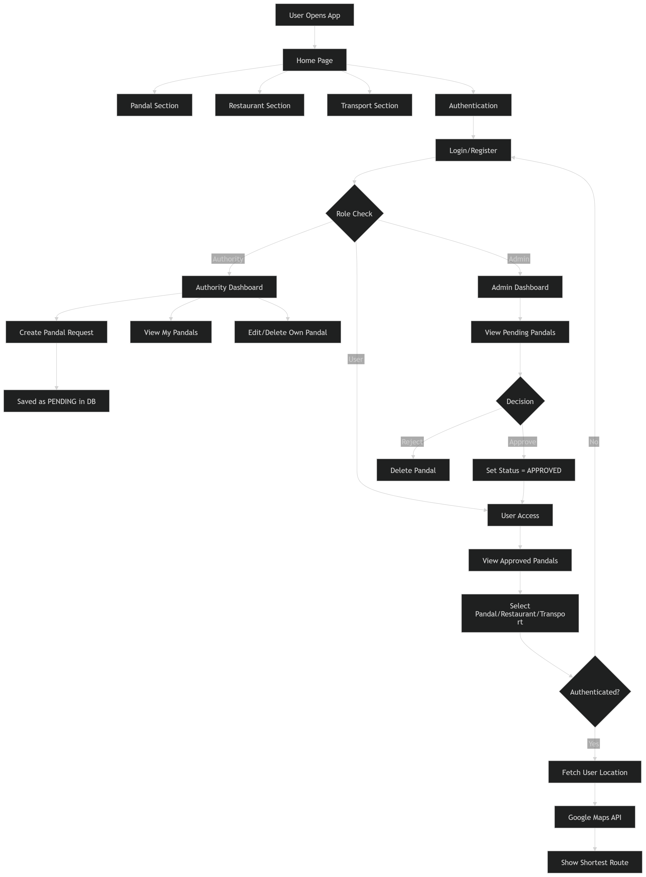

🔄 8. SYSTEM WORKFLOW

🏢 Authority Flow
- Authority submits pandal → stored as PENDING
- Ownership linked via createdBy
- Can only edit their own data

🛠️ Admin Flow
- Admin reviews pending pandals
- Approves → visible to users
- Rejects → removed

👤 User Flow
- Users can only see approved pandals
- Navigation available across all modules

🧠 9. Future Enhancements
- 🤖 AI-based route optimization
- 🗺️ Personalized pandal hopping planner
- 🍽️ Smart restaurant recommendation system
- 📊 Crowd density prediction
- 📶 Offline navigation support

⚠️ 10. Challenges Faced
- Limited free APIs for restaurant data
- Migration from MySQL → PostgreSQL
- Deployment issues (Docker + Render)
- JWT inconsistency (403 errors, token handling)
- Designing secure RBAC system

