1. Setup a Local Repo - Git init

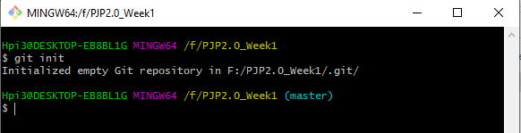

1. Setup a remote Repo –

Git remote add origin “https://github.com/ARPIT3010/PJP2.0_Week1.git”



Setup a remote Repo - Git remote -v

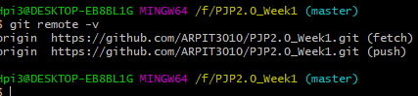

1. Creating the local Branches

**git branch feature**

**git branch dev**

**git branch QA**

**git branch Prod**

**git branch delivery**

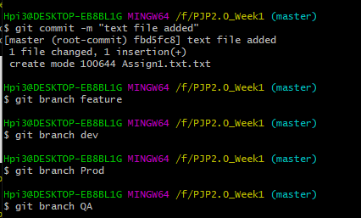 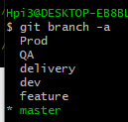

1. Create Remote Branches

**git checkout feature**

**git push –u origin feature**

**git checkout dev**

**git push –u origin dev**

**git checkout QA**

**git push –u origin QA**

**git checkout Prod**

**git push –u origin Prod**

**git checkout delivery**

**git push –u origin delivery**

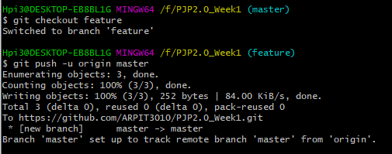

1. **Add Files and add folders**

**Echo temp1.txt vim temp1.txt mkdir newfolder**

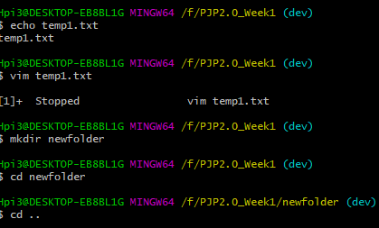

1. **Check in, Stage, Commit and push file into feature branch**

**git checkout feature**

**echo temp2.txt**

**vim temp2.txt**

**git add .**

**git commit –m “changes at feature branch”**

**git push --set-upstream origin feature**

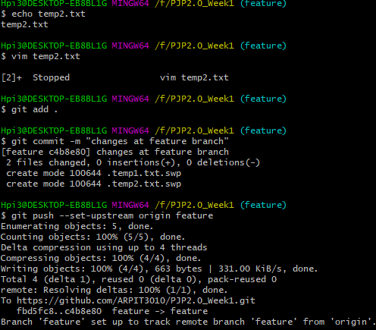

1. **Promote code from feature branch to dev branch via pull request**

**git checkout dev**

**git pull origin feature**

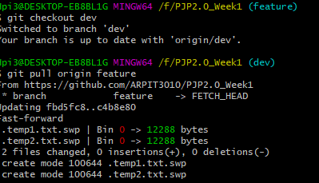

1. **Check out the latest code from remote branch to local branch**

**Git checkout delivery**

**Git branch -r**

**Git branch -a**

**Git checkout QA**

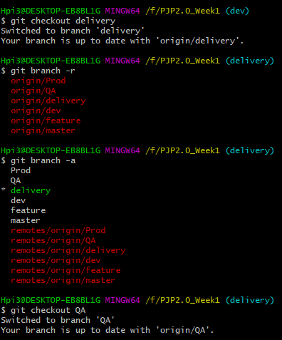

1. **Difference between Checkout and pull**

**git pull contacts the remote repository identified by origin and looks for updates. It fetches any updates and then merges the changes into the target branch. It does not create a new branch.**

**git checkout -b <branch> origin/<branch> creates a new branch based on origin/<branch>, and does not contact the remote repository. It looks at origin/<branch> as it currently exists in your local repository.**

**The two commands perform very different actions; spending some quality time with the git-pull and git-checkout man pages might help clarify things.**

**GUI**

