**NoSQL(MongoDB)**

Configurations:

Download and install MongoDB from Mongodb.com.

Practice

1. Create a database called mongotest

Use mongoset

1. Change to mongotest db
2. Create collection Employee which has id, fname, salary array for 12months(jan..dec), city

db.employee.insertOne({"_id":101, "fname" :"Anurag", "Salary" : [15000,80000,36000,7800,36000,27000,69500,14000,65000,69000,10000], "City" :"Kota" })

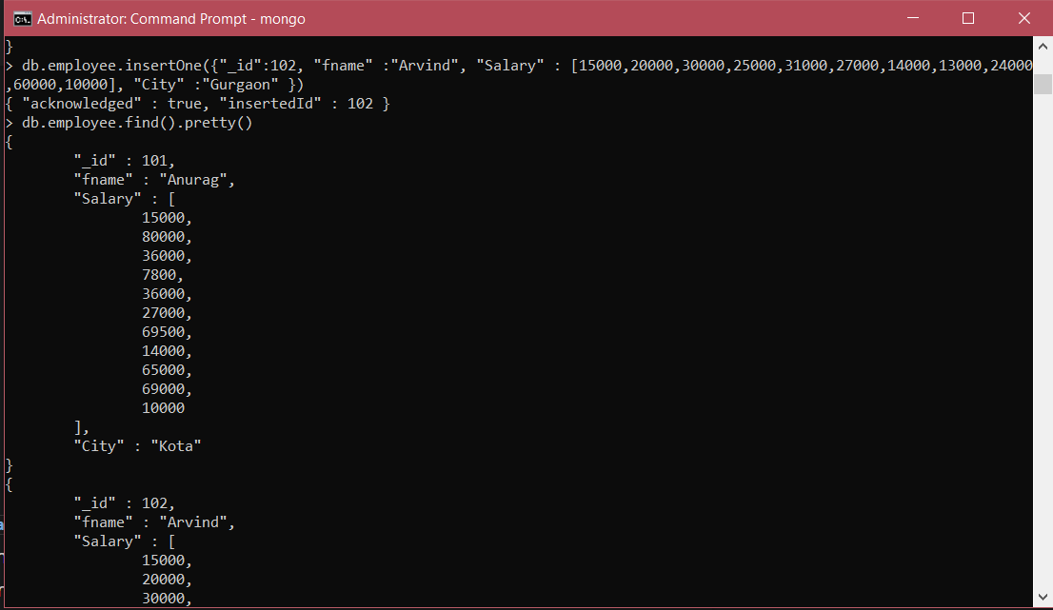

1. Insert data at list 12 data into Employee collection
2. Practice CRUD operations.

CRUD Operations

* Creat -InsertOne()
* Update – updateOne(), replaceOne

db.employee.updateOne({_id : 102} ,{$set : {fname : "Rajesh"}} )

* Delete – db.employee.deleteOne({_id : 101})



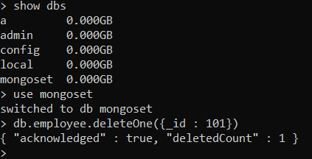

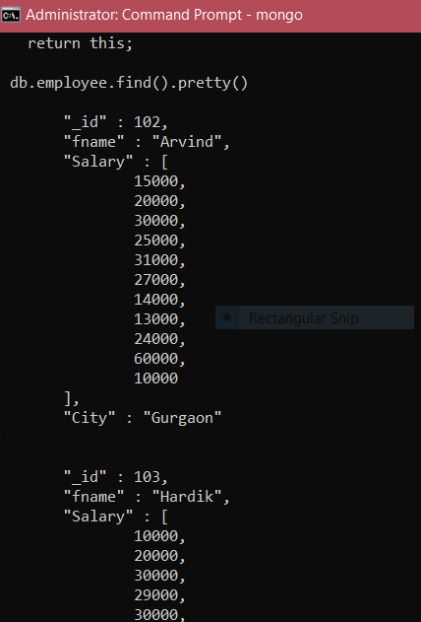

Write a MongoDB query on Employee collection

1) to display all the documents in the collection.

db.employee.find().pretty()

2.  to display the fields _id, fname for all the documents in the collection.

db.employee.find({},{fname : 1})

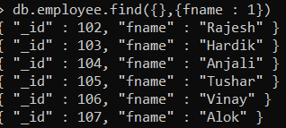

3.  to display the all fields but exclude the field id for all the documents in the collection.

db.employee.find({},{fname : 1,Salary :1, City : 1, _id : 0 })

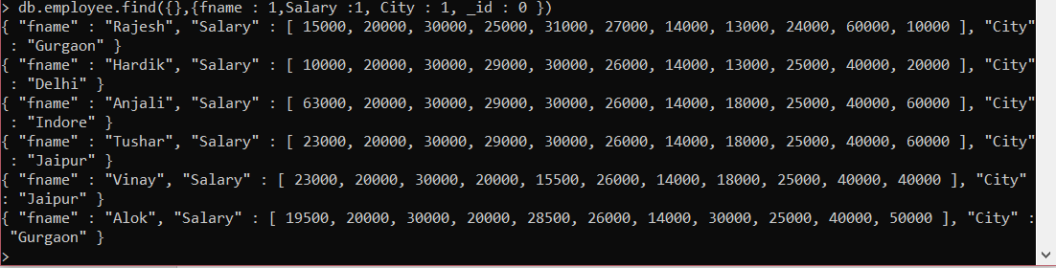

4 to display the first 5 Employees

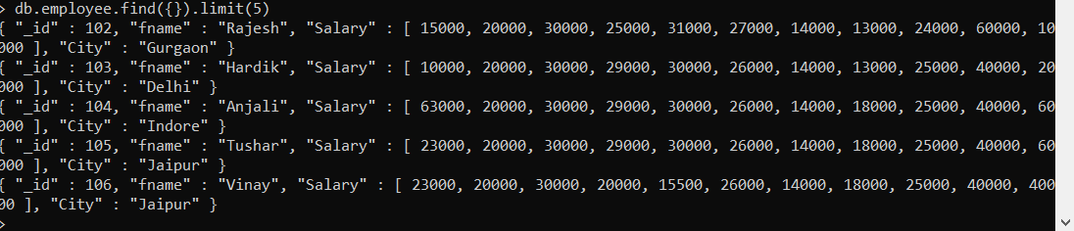

5. to display the next 5 Employees after skipping first 5

db.employee.find({}).skip(5).limit(5)

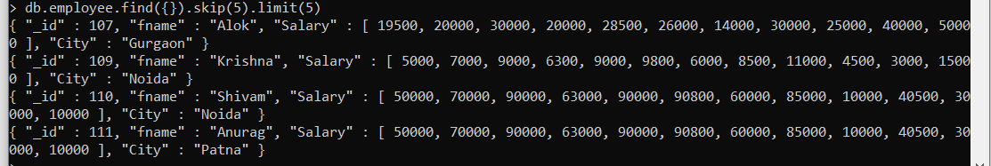

6.  to find the Employee who stay in Gurgaon city

db.employee.find({City : “Gurgaon”})

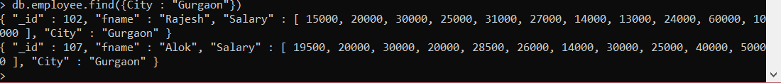

7.  to find the Employee who jan salary is less than 20000

Indexing is used here to show corresponding month

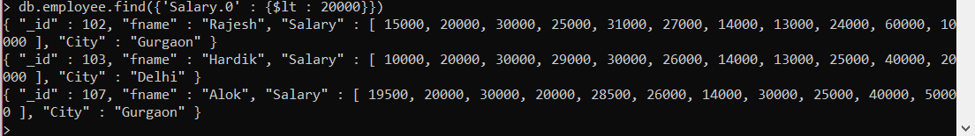

8.  to find the Employee who jan salary is less than 20000 and who stay in Gurgaon city.

Ans - **db.employee.find({'Salary.0' : {$lt : 20000}, "City" : "Gurgaon"})**

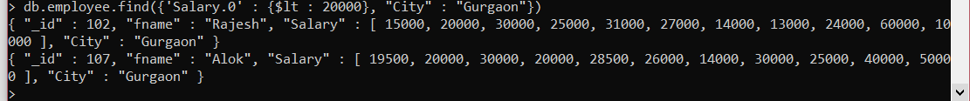

10. count how any employee stay in Gurgaon city.

db.employee.find({"City" : "Gurgaon"}).count()

