Practice

1. **Login to PostgreSQL (command prompt)**

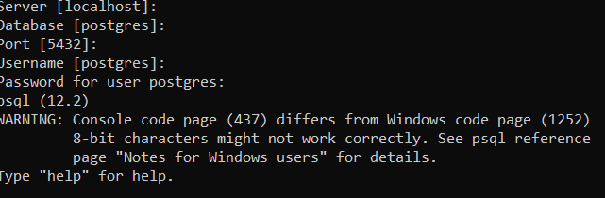

1. **Create a Database PJPpractice**



1. **Display all the database**

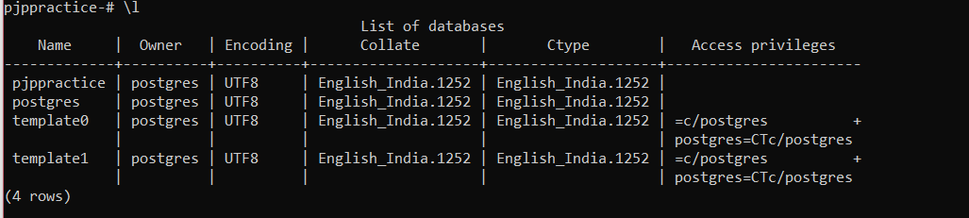

1. **Change the data base to PJPpractice**



1. **Create a table test ( id integer fname character(30);**

**create table test(id integer,fname varchar(30));**

**After creating the table do the following**

1. **Add a column lanme to the table test**

* **alter table test add lname varchar(30);**

1. **Rename the column name lanme to last_name**

* **Alter table test rename lname to last_name;**

1. **Add the constraint primary key to the column id**

* **Alter table test add constraint pk_name primary key(id);**

1. **Drop the column last_name**

* **Alter table test drop column last_name**

1. **Rename the table name to test1.**

* **Alter table test rename to test1**

**Question EFddl, efdml and efques file are attached along with this. Create the tables as givne in efddl, and insert the data as shown in the efdml finally execute all the query given in efques file.**

**1.Write a query which displays the module code and the duration for modules whose duration is less than 6.**

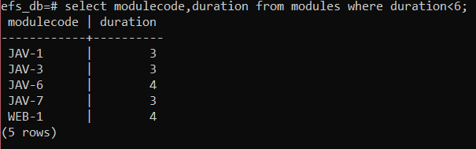

**2.Write a query which will display the BATCHCODE, TRAINERID, COURSECODE, STARTDATE, CAPACITY and BATCHSTRENGTH of the batches handled by the trainer KRISHNAN.**

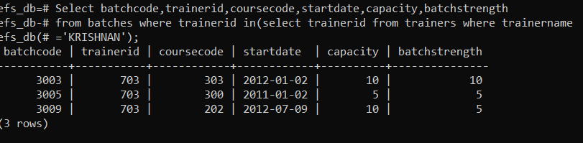

**3.Write a query which displays all the module names of the course code 100.**

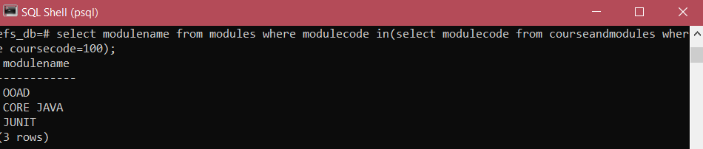

**4.Write a query which displays the module names and course code for the course code 100.**

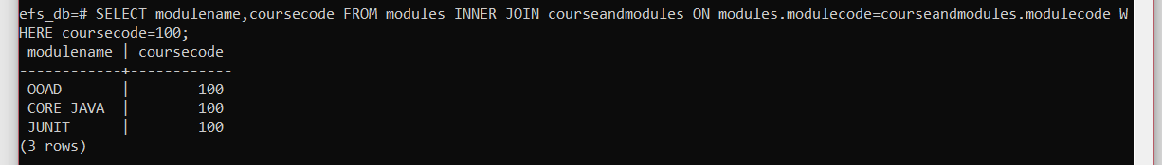

**5."Write a query which will display the number of modules present in the course code 100.**

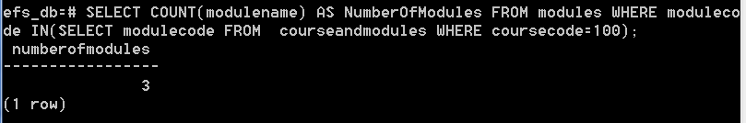

**6."Write a query which will display all the course code and the number of modules present**

**in that particular course.**

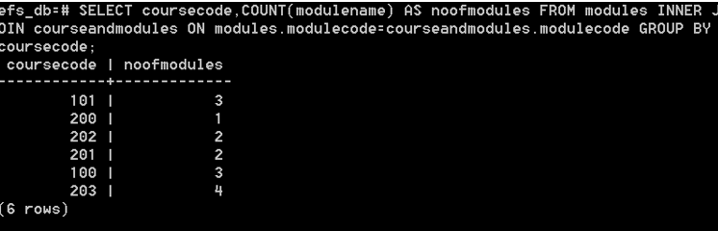

**7.Write a query which will display the course title and fees which has the maximum fees.**

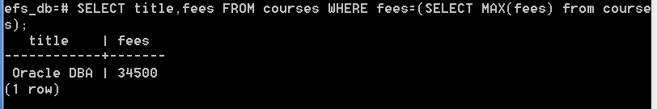

**8.Write a query which will display the student id, student name, batch code, place and**

**phone number of the students who belongs to Batch '3001'.**

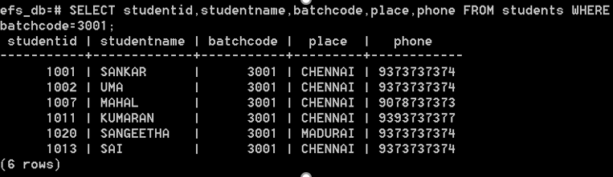

**9.Write a Query which will display the student ID, Student name, Batch code, place and phone number who are from CHENNAI.**

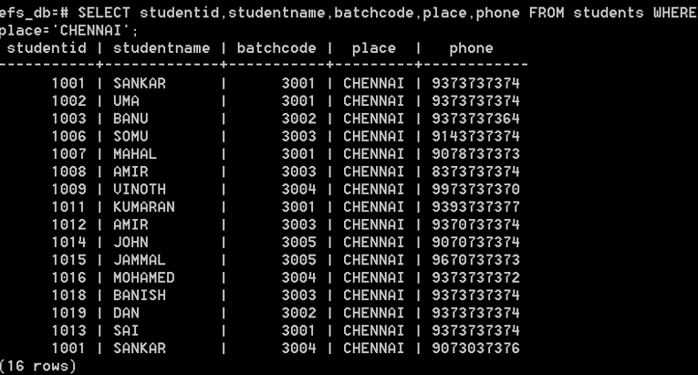

**10.Write a query which displays the total number of modules which has less than 6 days duration.**

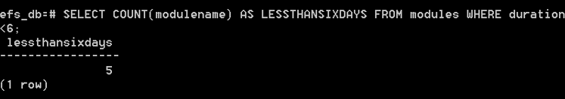

**11.Write a query to display the batch code, course title, start date of the batches for the month of May and year 2012.**

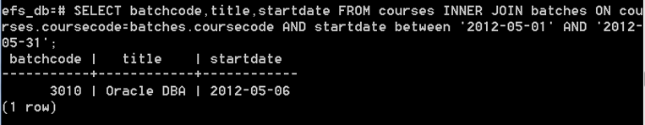

**12.Write a query to display courses code, course title, course fees of the courses for which**

**no batches/training has been planned in the month of January and year 2012.**

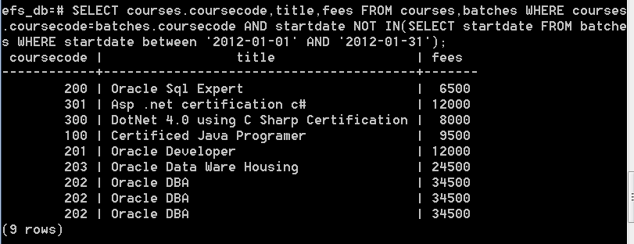

**13.Write a query which displays the names of all the modules of the course titled 'Oracle DBA'**

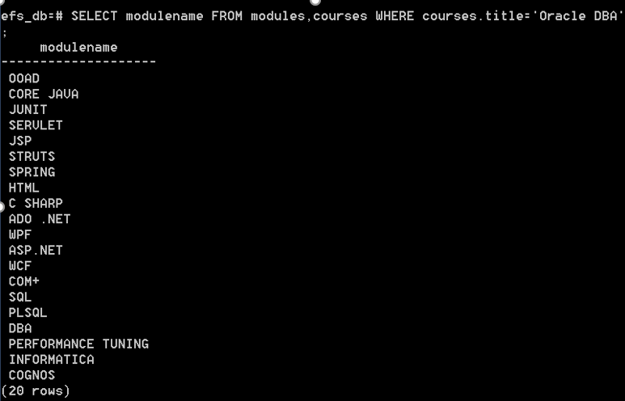

**14.Write a Query which displays the student ID, Student name, Batch code, place and phone number**

**of the student's who took training from CHENNAI in the year 2012.**

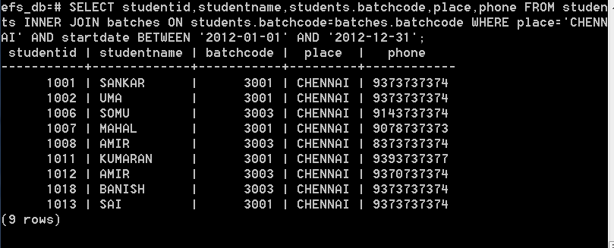

**15.Write a query which will display the student id, student names who are enrolled for the course code 200?**

