SANJEEV AGRAWAL GLOBAL EDUCATIONAL UNIVERSITY, BHOPAL
SCHOOL OF COMPUTER TECHNOLOGY

ASSIGNMENT PROJECT REPORT
BTech CSE (Hons) AI | V Semester | Autumn 2026-27
Project Title
AGENTIC AI SOCIAL MEDIA VIDEO AUTOMATION
Submission Details
Submitted By | ARPITA DUBEY
Enrollment No. | BTE24ARI100014
Branch / Course | BTECH CSE HONS AI 5th SEM
Semester | V Semester
Project Type | Individual Assignment Project
Project Domain | Artificial Intelligence / Agentic AI / Workflow Automation
Guide | Mr. Sahil Singh, School of Computer Technology
Academic Session | Autumn 2026-27
Submission Date | 30th September 2026
Submitted as an individual Assignment Project to the School of Computer Technology, Sanjeev Agrawal Global Educational University, Bhopal.

SANJEEV AGRAWAL GLOBAL EDUCATIONAL UNIVERSITY, BHOPAL
SCHOOL OF COMPUTER TECHNOLOGY

Certificate
This is to certify that the assignment project entitled "Agentic AI Social Media Video Automation" has been completed and submitted by ARPITA DUBEY (Enrollment No. BTE24ARI100014), student of BTECH CSE HONS AI 5th SEM, under the guidance of Mr. Sahil Singh, School of Computer Technology, during the academic session Autumn 2026-27.
This report describes the individual assignment work carried out by the student, including the design, implementation and testing of a working software prototype.

Field | Details
Guide Name | Mr. Sahil Singh
Designation
Department / School | School of Computer Technology
Signature with Date

Field | Details
Head of Department | Dr Gourav Shrivastava
Signature with Date

SANJEEV AGRAWAL GLOBAL EDUCATIONAL UNIVERSITY, BHOPAL
SCHOOL OF COMPUTER TECHNOLOGY

Certificate of Approval
The assignment project report entitled "Agentic AI Social Media Video Automation" submitted by ARPITA DUBEY (Enrollment No. BTE24ARI100014) is presented for examination and academic evaluation. Approval, where signed below, is for academic evaluation only and does not necessarily imply endorsement of all statements, opinions or conclusions presented in the report.

Role | Name | Signature | Date
Internal Examiner
External Examiner
Guide | Mr. Sahil Singh
Head of Department | Dr Gourav Shrivastava

Student Declaration
I declare that the work presented in this assignment project report entitled "Agentic AI Social Media Video Automation" is my own academic work, carried out under the guidance of Mr. Sahil Singh, School of Computer Technology, Sanjeev Agrawal Global Educational University, Bhopal. This report has not been submitted elsewhere for the award of any degree, diploma, certificate or academic credit.
I further declare that:
- All external tools, frameworks, libraries, models and documentation used in the project (including n8n, Docker, Ollama, Llama 3.2, Python, FFmpeg and Windows System.Speech) are acknowledged in this report.
- Generative AI tools were used as assistants for ideation, debugging, code assistance, documentation and report drafting. This use is disclosed in Appendix C, and I have reviewed and verified the submitted content.
- I understand the academic integrity requirements of the University, and any similarity check required by the institution will be recorded as per the prescribed procedure.
- The submitted source code and report do not contain passwords, API keys, private tokens, confidential credentials, malicious code or copied proprietary material.

Student Name | Enrollment No. | Signature | Date
ARPITA DUBEY | BTE24ARI100014

Acknowledgement
I express my sincere gratitude to my guide, Mr. Sahil Singh, School of Computer Technology, Sanjeev Agrawal Global Educational University, Bhopal, for his valuable guidance, feedback and encouragement throughout this assignment project. His suggestions helped me shape the idea into a working prototype.
I also thank Dr Gourav Shrivastava, Head of Department, School of Computer Technology, for providing an academic environment that encourages practical learning in Artificial Intelligence.
I am thankful to the faculty members of the School of Computer Technology for the knowledge shared in the classroom, and to the laboratory and support staff for their help with computing facilities.
I would also like to acknowledge the open-source communities behind n8n, Ollama, the Llama model family, FFmpeg, Python and Docker, whose publicly available tools and documentation made this prototype possible.
Finally, I thank my peers and my family for their constant support and motivation during the course of this work.

Student Name: ARPITA DUBEY
Enrollment Number: BTE24ARI100014
Signature: ______________________

Abstract
Short-form vertical videos have become one of the most widely consumed formats on social media, but producing them by hand is slow and requires several skills: planning the idea, writing a script, dividing it into scenes, preparing visuals, recording a voiceover and editing everything into a final file. For students, small creators and small organisations, repeating this process for every video is time-consuming and difficult to scale.
The objective of this assignment project is to design and build a working prototype that converts a single content idea into a short-form social media video with minimal manual effort. The proposed system follows an agentic AI approach in which the overall task is divided among specialised agents. A user prompt is received by an n8n webhook, and the n8n workflow passes it through a Planning Agent, a Script Agent and a Scene Agent. Each agent uses the Llama 3.2 language model, which runs locally through the Ollama runtime, so text generation does not depend on a paid cloud API.
The media stage is implemented with Python scripts. The video script uses the generated scene content and FFmpeg to render a vertical 1080 × 1920 video. Narration for each scene is converted into speech offline using the Windows System.Speech engine, which was adopted after an online text-to-speech service faced connectivity problems. FFmpeg then joins the scene audio and merges it with the video.
The prototype successfully produced a five-scene vertical MP4 video with AI-generated narration and an integrated offline voiceover (final_ai_video_with_voice.mp4). The results show that local language models, workflow automation and standard media tools can be combined into a practical, low-cost content automation pipeline. The system is a prototype; automated publishing, advanced visuals and neural voices are identified as future work.

Abstract Metadata
Keywords | Agentic AI, AI Automation, n8n, Ollama, Llama 3.2, Video Generation
Project Type | Development / Implementation / Prototype / Assignment Project
Primary Outcome | Working software prototype

Table of Contents
Section | Page No.
Certificate | i
Certificate of Approval | ii
Student Declaration | iii
Acknowledgement | iv
Abstract | v
List of Figures | viii
List of Tables | ix
Project Development Record | x
Chapter 1: Introduction | 1
1.1 Background and Motivation | 1
1.2 Problem Statement | 2
1.3 Objectives | 3
1.4 Scope of the Project | 3
1.5 Expected Outcomes | 3
1.6 Report Organization | 4
Chapter 2: Literature Review / Background Study | 5
2.1 Generative AI and Large Language Models | 5
2.2 Agentic AI | 5
2.3 Workflow Automation and n8n | 5
2.4 Local Inference with Ollama and Llama 3.2 | 6
2.5 FFmpeg for Video and Audio Processing | 6
2.6 Text-to-Speech | 6
2.7 Short-Form Video Automation | 6
2.8 Comparative Study | 6
2.9 Research Gap and Positioning | 7
Chapter 3: Requirement Analysis and Planning | 8
3.1 Stakeholders and Users | 8
3.2 Functional Requirements | 8
3.3 Non-Functional Requirements | 9
3.4 Hardware Requirements | 9
3.5 Software Requirements | 10
3.6 Project Development Plan | 10
Chapter 4: System Design and Methodology | 12
4.1 Proposed Methodology | 12
4.2 System Architecture | 13
4.3 Data / File Model | 14
4.4 Algorithm / Workflow | 15
4.5 Security, Privacy and Ethical Considerations | 16
Chapter 5: Implementation | 18
5.1 Technology Stack | 18
5.2 Source Code and Repository Details | 18
5.3 Module-Wise Implementation | 19
5.4 Screenshots / Output | 21
Chapter 6: Testing, Results and Discussion | 25
6.1 Test Strategy | 25
6.2 Test Case Summary | 25
6.3 Results and Evaluation | 26
6.4 Discussion | 27
Chapter 7: Conclusion and Future Scope | 29
7.1 Conclusion | 29
7.2 Limitations | 29
7.3 Future Scope | 29
References | 31
Appendix A: Installation and User Manual | 32
Appendix B: Individual Contribution / Responsibility | 34
Appendix C: Academic Integrity and Tool Disclosure | 34

List of Figures
Figure No. | Figure Title | Page No.
1.1 | Overall Problem Context | 2
4.1 | Proposed System Architecture | 13
4.2 | Agentic AI Workflow | 14
4.3 | Project Folder Structure | 15
5.1 | Docker Containers Supporting the AI Automation Environment | 21
5.2 | Llama 3.2 Model Available in Ollama | 22
5.3 | n8n Agentic AI Workflow | 22
5.4 | AI-Generated Video Planning Output | 22
5.5 | AI-Generated Script and Scene Structure | 23
5.6 | Successful AI Video Generation Using Python, Ollama and FFmpeg | 23
5.7 | Successful Offline AI Voiceover Generation | 23
5.8 | Final Generated Social Media Video Output | 24
5.9 | Final Video with Integrated AI Voiceover | 24
6.1 | Final Generated Video | 27

List of Tables
Table No. | Table Title | Page No.
2.1 | Comparative Study of Related Technologies and Approaches | 7
3.1 | Functional Requirements | 8
3.2 | Non-Functional Requirements | 9
3.3 | Project Development Plan | 10
4.1 | System Workflow | 16
4.2 | Security, Privacy and Ethical Measures | 17
5.1 | Technology Stack | 18
5.2 | Project Modules | 19
6.1 | Test Case Summary | 25
6.2 | Results Summary | 26
6.3 | Feature Status: Implemented, Tested and Future | 27

Project Development Record
The following record summarises the major stages of development of this individual assignment project. Dates and supervisor signatures are to be filled in by the student and guide at the time of review.
Field | Details
Academic Session | Autumn 2026-27
Project Title | Agentic AI Social Media Video Automation
Student | ARPITA DUBEY (BTE24ARI100014)
Branch / Course | BTECH CSE HONS AI 5th SEM
Semester | V Semester
Guide | Mr. Sahil Singh

Sr. No. | Date | Work Completed | Issues / Decisions | Guide Sign.
1 |  | Topic finalisation and study of agentic AI and automation tools | Decided to use local AI to avoid paid API dependency
2 |  | Environment setup: Python, Git, project folder structure | Created D:\agentic-social-media-ai with separate folders for each output type
3 |  | Docker installation and container setup for n8n | Containerised services for easier setup and restart
4 |  | Ollama installation and Llama 3.2 model download | Chose Llama 3.2 as a lightweight model suitable for a local PC
5 |  | n8n workflow: Webhook, Planning, Script and Scene Agents | Split the task into role-specific agents
6 |  | create_video.py: scene content and FFmpeg video rendering | Fixed vertical 1080 × 1920 format and five scenes
7 |  | Voice generation (generate_voice.py) | Online TTS (Edge-TTS) faced connectivity issues; switched to offline Windows System.Speech
8 |  | Audio-video integration (combine_audio.py) | Used FFmpeg to join scene audio and merge with video
9 |  | Testing of each stage and final output playback | Verified five scenes, audio files and final MP4
10 |  | Report preparation and documentation | Prepared report, user manual and tool disclosure

Guide Signature | Head of Department Signature

Chapter 1: Introduction

1.1 Background and Motivation
Short-form vertical video has become one of the most important formats on social media. Platforms such as Instagram Reels, YouTube Shorts and similar feeds reward creators who publish short, engaging videos regularly. For students, small businesses, educators and independent creators, this creates constant pressure to produce new content quickly.
Creating even a 30–60 second video by hand involves many separate activities. The creator must choose an idea, plan what to say, write a script, break it into scenes, find or design visuals, record a clear voiceover and finally edit and export the video in the correct vertical format. Each step needs different skills and often a different software tool. When this has to be repeated for every video, the process becomes slow, tiring and hard to scale.
Recent progress in Generative AI offers a way to reduce this effort. Large Language Models (LLMs), built on the Transformer architecture [1] and trained on very large text collections [2], can generate plans, scripts and structured descriptions from a short instruction. However, a single prompt to a single model is usually not enough to produce a complete video. The work has to be organised into stages, and the output of one stage must be passed correctly to the next.
This is where Agentic AI becomes useful. In an agentic system, the overall goal is divided among several AI "agents", each with a clear role, and their work is coordinated as a pipeline [3], [4]. When such agents are connected through a workflow automation platform and combined with standard media-processing tools, it becomes possible to build an automated content pipeline that turns a simple idea into a finished video file.
The motivation for this assignment project is to explore this idea practically: to build a working prototype that uses local AI models, workflow automation and open-source media tools to automate the main steps of short-form video creation on an ordinary Windows computer.
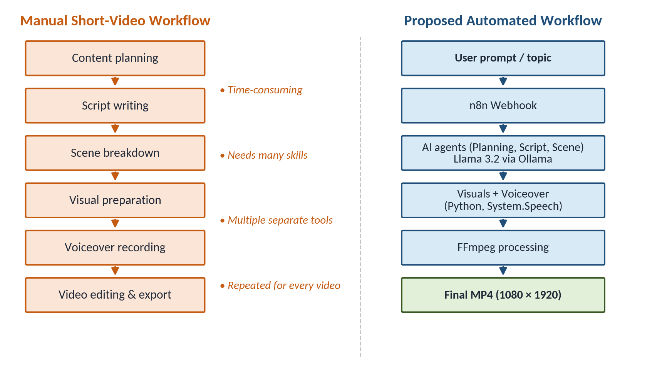
Figure 1.1 – Overall Problem Context
Figure 1.1 compares the traditional manual workflow with the proposed automated workflow. The manual process contains six separate stages that each require time and skill, while the proposed system automates the same stages after a single user prompt.

1.2 Problem Statement
Producing a short-form social media video manually requires the creator to perform the following tasks one after another:
- Content planning – deciding the angle, message and flow of the video.
- Script writing – writing short, spoken-style narration that fits a limited duration.
- Scene generation – dividing the script into logical scenes.
- Visual preparation – designing or collecting visuals for every scene.
- Voiceover – recording or generating narration audio for each scene.
- Video processing – rendering scenes, synchronising audio and exporting a vertical video.
These tasks are repetitive, depend on multiple tools and demand skills in writing, design and editing. Many existing AI video services are paid, depend on cloud APIs and send user content to external servers. There is therefore a need for a low-cost, understandable system that can automate these steps end to end, preferably using locally running AI.
Problem statement: To design and implement an agentic AI system that accepts a content idea from the user and automatically plans, scripts, divides into scenes, visualises, narrates and assembles a vertical social media video, using a local language model and open-source tools, so that manual production effort is reduced.
The proposed system addresses this problem by (i) receiving the user prompt through an n8n webhook, (ii) passing it through Planning, Script and Scene agents powered by Llama 3.2 running in Ollama, (iii) rendering scene-based video with Python and FFmpeg, (iv) generating offline narration with Windows System.Speech and (v) merging audio and video into a final MP4 file.

1.3 Objectives
The objectives of this assignment project are:
- To automate the main stages of social media video creation.
- To generate video content (plan and script) using a Large Language Model.
- To divide the generated content into a fixed number of scenes (five in the prototype).
- To generate scene-specific visual content for each scene.
- To generate narration text and convert it into voice audio.
- To combine audio and video automatically using FFmpeg.
- To produce a vertical social media video in 1080 × 1920 resolution and MP4 format.
- To reduce the manual effort required for producing a short video.
- To demonstrate a working agentic AI workflow using n8n and a local LLM.

1.4 Scope of the Project
The scope of the current prototype includes the following areas:
- AI content generation: planning and script generation using Llama 3.2 through Ollama.
- Workflow automation: an n8n workflow triggered by a webhook that chains the Planning, Script and Scene agents.
- Scene planning: splitting the content into five scenes, each with narration and a visual idea.
- Video generation: rendering scene-based visuals into a vertical 1080 × 1920 video using Python and FFmpeg.
- Voice generation: offline narration for each scene using Windows System.Speech.
- Local AI inference: all language-model processing runs on the local machine.
The following are outside the current scope and are treated as future work:
- Automatic publishing to Instagram, YouTube or other social platforms.
- Scheduling of posts and analytics collection.
- Integration with commercial stock-media or image-generation APIs.
- Neural or cloud-based voices, background music and automatic subtitles.
- Cloud-scale deployment, multi-user access and production-grade content moderation.

1.5 Expected Outcomes
The expected outcome of the project was a working prototype that can take a topic and produce a playable vertical video with narration. The outcomes actually achieved are summarised below:
Expected Outcome | Achieved in Prototype
AI-generated video plan and script | Achieved – generated by Llama 3.2 via Ollama
Content divided into scenes | Achieved – five scenes generated
Scene-based visual content | Achieved – rendered locally with Python and FFmpeg
AI narration and voiceover | Achieved – offline voice using Windows System.Speech
Automatic audio-video combination | Achieved – FFmpeg merge
Vertical MP4 output | Achieved – 1080 × 1920, final_ai_video_with_voice.mp4
Automatic social media publishing | Not in scope – future work

1.6 Report Organization
The remainder of this report is organised as follows:
- Chapter 2 reviews the background technologies – Generative AI, LLMs, agentic AI, n8n, Ollama, Llama 3.2, FFmpeg and text-to-speech – and compares related approaches.
- Chapter 3 analyses stakeholders, functional and non-functional requirements, hardware and software requirements and the development plan.
- Chapter 4 presents the methodology, system architecture, file model, workflow algorithm and security and ethical considerations.
- Chapter 5 explains the implementation, technology stack, modules and actual project outputs.
- Chapter 6 describes the test strategy, test cases, results and discussion.
- Chapter 7 concludes the report and outlines limitations and future scope.
- Appendices provide the installation and user manual, the individual contribution statement and the academic integrity and tool disclosure.

Chapter 2: Literature Review / Background Study
This chapter explains the main concepts and technologies on which the project is built. It then compares related approaches and identifies the gap that this prototype addresses.

2.1 Generative AI and Large Language Models
Generative AI refers to models that create new content such as text, images, audio or video, instead of only classifying existing data. In text generation, the most important development has been the Transformer architecture introduced by Vaswani et al. [1]. The Transformer uses self-attention, which lets the model relate every word in a sequence to every other word. This made it practical to train very large models on large text datasets.
Large Language Models (LLMs) are Transformer-based models with billions of parameters trained to predict the next token in text. Brown et al. [2] showed that sufficiently large models can perform new tasks from only a natural-language instruction and a few examples, without retraining. This "prompting" ability is what allows an LLM to act as a planner, a scriptwriter or a scene designer simply by changing the instructions it receives.
For this project, the key property of an LLM is that it can turn a short user idea into structured text – a plan, a script and a scene list – that later stages of the pipeline can use.

2.2 Agentic AI
In classical AI, an agent is something that perceives its environment and takes actions to achieve a goal [3]. In the context of LLMs, an agent is usually an LLM given a specific role, instructions and sometimes tools, whose output is used to take the next step in a task. Surveys by Wang et al. [4] and Xi et al. [5] describe LLM-based agents as systems that combine a model with planning, memory and action components.
Several well-known works show how LLMs can be used in an agentic way:
- ReAct [6] interleaves reasoning steps and actions, allowing a model to plan and then act on external information.
- HuggingGPT [7] uses an LLM as a controller that plans a task, selects specialised models, executes them and summarises the results.
- AutoGen [8] builds applications from multiple agents that communicate with each other to solve a task.
This project uses a simple and transparent form of agentic design: a fixed pipeline of role-specific agents (Planning, Script and Scene) where each agent receives the previous agent's output. This design is easier to understand, test and explain than a fully autonomous multi-agent system, which makes it suitable for an academic prototype.

2.3 Workflow Automation and n8n
Workflow automation tools connect different applications and services into a sequence of automated steps. n8n is a workflow automation platform in which workflows are built visually from connected nodes [9]. A workflow can be started by a trigger – such as a Webhook node that receives an HTTP request – and can then call APIs, transform data and pass results from node to node. n8n can be self-hosted, for example in a Docker container, which keeps data on the user's own machine.
In this project n8n acts as the orchestrator of the agentic pipeline: it receives the user's prompt and sends it through the Planning, Script and Scene agents in order.

2.4 Local Inference with Ollama and Llama 3.2
Ollama is an open-source tool for downloading and running language models locally [10]. It provides a command-line interface (for example ollama pull and ollama list) and a local REST API (by default on port 11434) that other programs, including n8n and Python scripts, can call.
Llama is a family of openly available language models released by Meta [11]. Llama 3.2, released in September 2024, includes lightweight text-only models with 1 billion and 3 billion parameters that are intended for on-device use, as well as larger vision models [12]. The lightweight models are designed for tasks such as summarisation, instruction following and rewriting while running locally. This makes Llama 3.2 a practical choice for generating plans and scripts on a normal PC without a paid API.

2.5 FFmpeg for Video and Audio Processing
FFmpeg is a widely used open-source command-line framework for recording, converting and processing audio and video [13]. It can generate video from images or colour sources, draw text, scale frames, encode to formats such as MP4 (H.264 video with AAC audio), concatenate files and combine separate audio and video streams. Because FFmpeg is scriptable, it is well suited to automated pipelines controlled from Python.

2.6 Text-to-Speech
Text-to-Speech (TTS) converts written text into spoken audio. On Windows, the .NET System.Speech.Synthesis namespace provides a speech synthesizer that uses voices installed on the operating system and can save speech to an audio file [14]. It works fully offline, although its voices sound less natural than modern neural voices.
Edge-TTS is an open-source Python tool that uses Microsoft Edge's online text-to-speech service to produce more natural neural voices [15]. Because it depends on an internet connection to an online service, it can fail when that connection is unavailable or blocked. In this project Edge-TTS was tried first, and the offline System.Speech engine was adopted after connectivity problems (see Section 6.4).

2.7 Short-Form Video Automation
Automated video creation generally follows a common pattern: generate text content, split it into segments, attach visuals to each segment, add narration and render the final video. Commercial AI video platforms offer this pattern as a paid cloud service, but their internal implementation is not public and they usually require uploading content to external servers. Open-source building blocks – LLM runtimes, workflow tools, TTS engines and FFmpeg – make it possible to build a transparent version of the same pipeline that runs locally.

2.8 Comparative Study
Table 2.1 compares representative sources, tools and approaches that are relevant to this project.
Table 2.1 – Comparative Study of Related Technologies and Approaches
Source / System | Technology | Method | Key Findings | Gap / Limitations | Relevance to Proposed System
Vaswani et al. [1] | Transformer | Self-attention based sequence model | Enabled efficient training of large language models | Architecture only; not an application pipeline | Foundation of Llama 3.2 used in the project
Brown et al. [2] | Large language model (GPT-3) | Few-shot prompting | LLMs can perform new tasks from instructions | Very large model; cloud access needed | Supports using prompts to define agent roles
Yao et al., ReAct [6] | LLM agent | Interleaved reasoning and acting | Better task solving when reasoning is combined with actions | Research framework, not a media pipeline | Inspires step-by-step agent design
Shen et al., HuggingGPT [7] | LLM controller + specialised models | Task planning, model selection, execution | An LLM can coordinate multiple AI models | Depends on external model hosting | Similar idea: LLM plans, tools execute
Wu et al., AutoGen [8] | Multi-agent framework | Conversing agents | Complex tasks can be split among agents | Requires programming framework; not visual | Supports role-based agent decomposition
n8n [9] | Workflow automation | Visual node-based workflows, webhooks | Easy integration of APIs and services; self-hostable | General-purpose; no built-in video pipeline | Used as the orchestrator
Ollama + Llama 3.2 [10], [12] | Local LLM runtime and model | On-device inference via local API | Lightweight models run on consumer hardware | Smaller models are less capable than large cloud models | Used for all agent text generation
FFmpeg [13] | Media framework | Command-line audio/video processing | Reliable rendering, encoding and merging | No content intelligence of its own | Used for rendering and audio-video merge

2.9 Research Gap and Positioning
The reviewed works show that (a) LLMs can generate structured content from prompts, (b) dividing work among role-specific agents is an effective design, and (c) mature open-source tools exist for automation and media processing. However, research agent frameworks usually do not produce finished media, and commercial video tools are closed and cloud-dependent.
This assignment project positions itself between these two: it combines a local LLM, a visual workflow orchestrator and standard media tools into a small, transparent pipeline that produces an actual MP4 video on a personal computer. The goal is not to compete with commercial platforms, but to demonstrate clearly how an agentic AI pipeline for video creation can be built and understood.

Chapter 3: Requirement Analysis and Planning

3.1 Stakeholders and Users
The system has one primary user group and several supporting stakeholders:
- Primary user – content creator / student / social media content producer: provides a topic or prompt and receives a finished video. This user needs a simple way to start the process and a playable output.
- System administrator / developer: installs Docker, Ollama, Python and FFmpeg, configures the n8n workflow, runs the scripts and maintains the project folders. In this project, this role is performed by the student.
- AI model / service (Llama 3.2 via Ollama): an external component that receives prompts and returns generated text.
- Workflow automation system (n8n): receives the request and coordinates the agent sequence.

3.2 Functional Requirements
Functional requirements describe what the system must do. They are listed in Table 3.1 with priority (H = High, M = Medium, L = Low) and acceptance criteria.
Table 3.1 – Functional Requirements
Req. ID | Requirement | Priority | Acceptance Criteria
FR-01 | Accept a user video topic / prompt | H | n8n webhook receives the prompt and starts the workflow
FR-02 | Generate a content plan | H | Planning Agent returns a plan for the given topic
FR-03 | Generate a video script | H | Script Agent returns narration text based on the plan
FR-04 | Generate scenes | H | Scene Agent returns five scenes with narration and visual idea
FR-05 | Generate visual content | H | A visual is produced for each scene
FR-06 | Generate narration | H | Narration text is available for each scene
FR-07 | Generate voiceover | H | One audio file is produced per scene (five in total)
FR-08 | Combine video and audio | H | Audio track is merged with the rendered video
FR-09 | Generate final MP4 | H | Playable MP4 at 1080 × 1920 is created
FR-10 | Store generated files | M | Outputs are saved in the correct project folders

3.3 Non-Functional Requirements
Non-functional requirements describe the quality of the system. Since this is a prototype, targets are stated qualitatively; no numerical benchmark was performed.
Table 3.2 – Non-Functional Requirements
Category | Requirement | How it is Addressed
Performance | The pipeline should complete on a normal Windows PC within a practical time for a short video | Lightweight Llama 3.2 model; FFmpeg for efficient encoding
Reliability | Each stage should produce a valid output or a clear error | Stages run separately, so a failed stage can be re-run without repeating others
Usability | A user should be able to start the process with a single prompt and a few commands | Webhook input and simple run commands (Appendix A)
Security | No credentials or API keys should be stored in source code | Local model inference; no paid API keys required
Maintainability | Components should be easy to change independently | Modular scripts and separate agents in n8n
Scalability | Design should allow more scenes, agents or outputs later | Agent chain and folder structure can be extended
Portability | Setup should be reproducible on another machine | Docker for services; standard Python and FFmpeg tools

3.4 Hardware Requirements
The prototype was developed and run on a Windows personal computer. Running a language model locally is the most demanding part of the system, so memory (RAM) is the most important hardware requirement. The following is practical guidance for reproducing the prototype; these values are not measured benchmarks.
- Processor: 64-bit multi-core CPU with hardware virtualisation enabled (required by Docker Desktop).
- Memory (RAM): at least 8 GB; 16 GB or more is recommended for smoother local inference with Llama 3.2.
- Storage: around 10 GB of free space for Docker images, the Llama 3.2 model and generated media; an SSD is recommended.
- GPU: not mandatory, because Ollama can run the lightweight model on the CPU; a supported GPU can speed up generation.
- Audio / display: speakers or headphones and a display for playback testing of the final video.
- Development machine used: [Student to record the CPU, RAM and GPU of the actual machine].

3.5 Software Requirements
The software used in the prototype is listed below along with the command that can be used to check the installed version on the development machine.
- Windows 10/11 (64-bit) – host operating system; also provides the System.Speech voices (check: winver).
- Docker Desktop – runs containerised services such as n8n [16] (check: docker --version).
- n8n – workflow automation and agent orchestration (version shown in n8n settings or container image tag).
- Ollama – local model runtime and REST API (check: ollama --version).
- Llama 3.2 – language model used by the agents (check: ollama list).
- Python 3 – automation and video-processing scripts [17] (check: python --version).
- FFmpeg – video rendering, audio joining and audio-video merging (check: ffmpeg -version).
- Windows System.Speech – offline text-to-speech, available through Windows and the .NET Framework.
- Git / GitHub (if used) – version control and code sharing (check: git --version).
- Media player (for example the Windows media player or VLC) – playback testing of the final MP4.

3.6 Project Development Plan
The project was developed in twelve milestones, moving from environment setup to documentation. Each milestone produced a deliverable that the next milestone depended on.
Table 3.3 – Project Development Plan
No. | Milestone | Deliverable | Status
1 | Environment setup | Python, Git and project folder structure at D:\agentic-social-media-ai | Completed
2 | Docker setup | Docker Desktop installed; service containers running | Completed
3 | Ollama setup | Ollama installed; Llama 3.2 model downloaded | Completed
4 | n8n workflow | Webhook-triggered workflow created | Completed
5 | AI planning | Planning Agent producing a content plan | Completed
6 | Script generation | Script Agent producing narration | Completed
7 | Scene generation | Scene Agent producing five scenes | Completed
8 | Video generation | create_video.py rendering vertical video via FFmpeg | Completed
9 | Voice generation | generate_voice.py producing five scene audio files | Completed
10 | Audio-video integration | combine_audio.py producing final MP4 with voice | Completed
11 | Testing | Stage-wise and end-to-end tests (Chapter 6) | Completed
12 | Final documentation | Assignment report and user manual | Completed

Chapter 4: System Design and Methodology

4.1 Proposed Methodology
The system follows a pipeline methodology. The complex task of "make a video about this topic" is broken into small, well-defined stages. Each stage has one responsibility, a clear input and a clear output. The complete pipeline is:
User Prompt → n8n Webhook → Planning Agent → Script Agent → Scene Agent → Visual Generation → Voice Generation → FFmpeg → Final Video
Each stage is explained below.

4.1.1 User Prompt
The user provides a short topic or idea for a video, for example a subject they want to explain to their audience. This is the only manual creative input needed to start the pipeline.

4.1.2 n8n Webhook
The prompt is sent to an n8n Webhook node as an HTTP request. The webhook is the entry point of the workflow; receiving a request starts the execution of the connected nodes.

4.1.3 Planning Agent
The Planning Agent receives the topic and asks Llama 3.2 to produce a content plan: what the video should communicate and how it should flow. Planning first helps the later agents stay focused on one clear message instead of producing random content.

4.1.4 Script Agent
The Script Agent converts the plan into short, spoken-style narration suitable for a short-form video. The instructions given to this agent focus on simple language and a length that fits a short video.

4.1.5 Scene Agent
The Scene Agent divides the script into five scenes. For each scene it provides the narration line and an idea of what should appear on screen. This scene list is the bridge between the text stages and the media stages.

4.1.6 Visual Generation
For every scene a visual is created locally. In the current prototype, visual content is produced by the Python script create_video.py, which uses the scene content obtained from Llama 3.2 and renders scene frames with FFmpeg. A commercial stock-media or image-generation API is not used.

4.1.7 Voice Generation
The narration of each scene is converted to speech by generate_voice.py using the offline Windows System.Speech engine, producing one audio file per scene.

4.1.8 FFmpeg Processing and Final Video
FFmpeg renders the scene video in vertical 1080 × 1920 resolution, joins the five scene audio files into one narration track and merges this track with the video. The final result is saved as final_ai_video_with_voice.mp4.
In the current prototype, the text-generation stages are orchestrated by n8n, while the media stages are executed by running the three Python scripts in sequence from the command line. Triggering the media scripts automatically from n8n is part of the future work (Section 7.3).

4.2 System Architecture
The architecture is organised into five layers, shown in Figure 4.1. Separating the system into layers makes it easier to understand, test and replace individual parts.
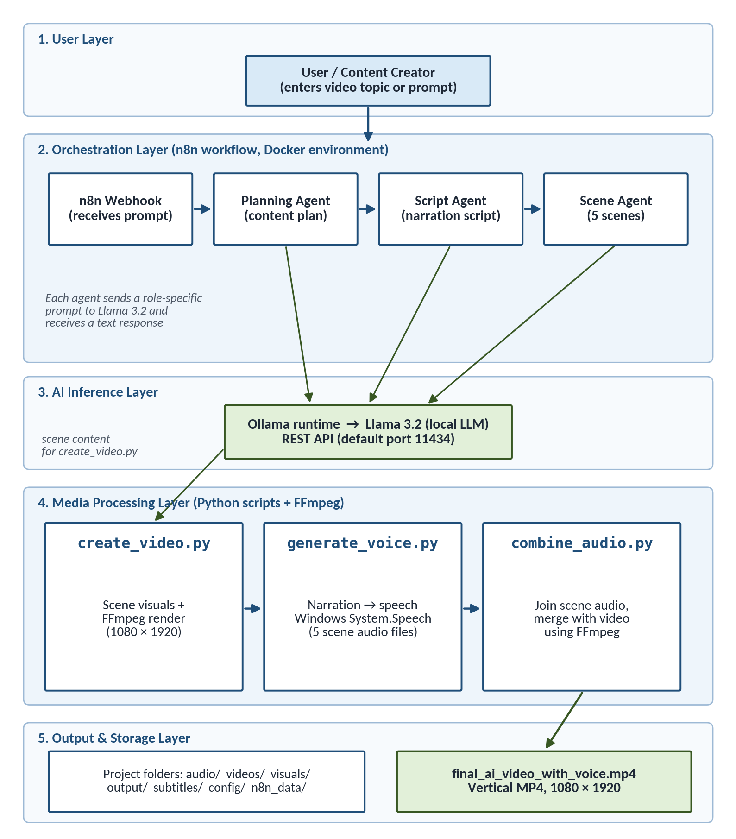
Figure 4.1 – Proposed System Architecture
- User Layer: the content creator who supplies the topic.
- Orchestration Layer: the n8n workflow running in the Docker environment. It contains the Webhook node and the Planning, Script and Scene agents.
- AI Inference Layer: the Ollama runtime serving the Llama 3.2 model through a local REST API. All agents, and the video script, send prompts to this layer.
- Media Processing Layer: three Python scripts – create_video.py, generate_voice.py and combine_audio.py – that use FFmpeg and Windows System.Speech to create video and audio.
- Output and Storage Layer: the project folders where intermediate and final files are saved, including the final MP4.
Figure 4.2 shows the agentic part of the workflow in more detail. The three agents share the same local model, but each has its own role and instructions, and each consumes the output of the previous agent.
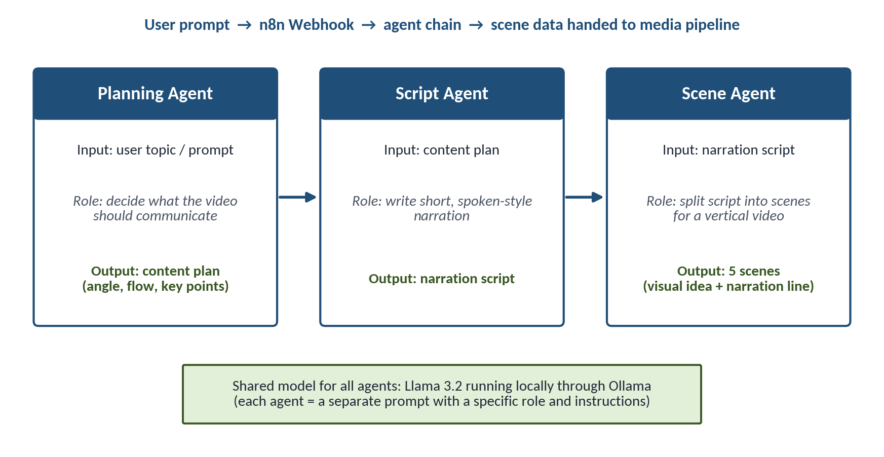
Figure 4.2 – Agentic AI Workflow

4.3 Data / File Model
The prototype does not use a traditional relational database, so an ER diagram is not applicable. Instead, data moves between stages as text (in the workflow) and as files on disk (in the media stages). The project is organised as a folder structure under D:\agentic-social-media-ai, shown in Figure 4.3 and described below.
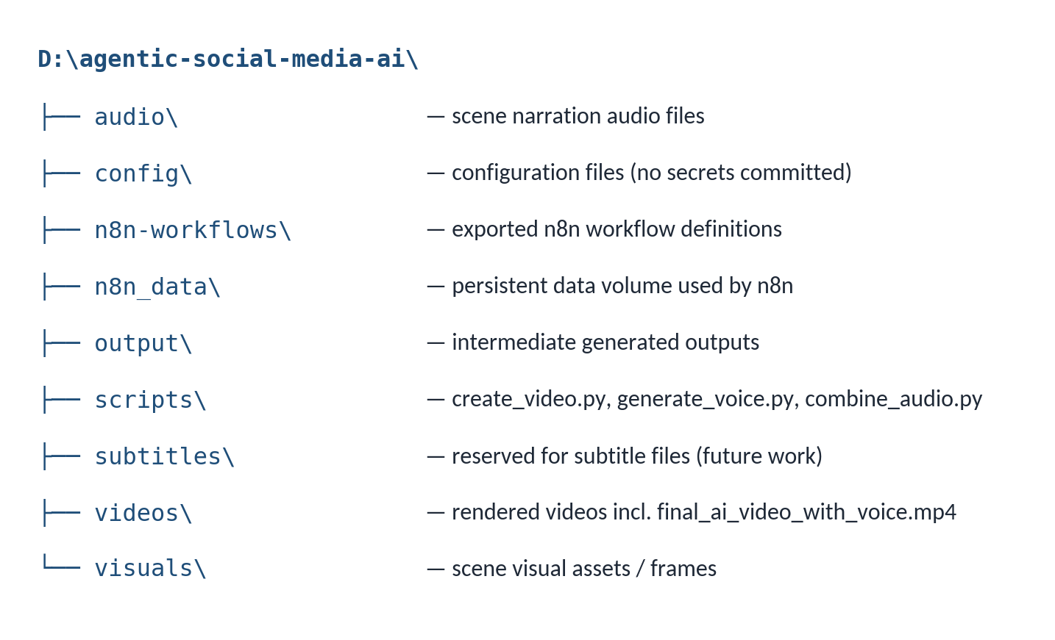
Figure 4.3 – Project Folder Structure
The role of each folder is as follows:
- audio/ – narration audio generated for each scene and the combined narration track.
- config/ – configuration settings used by the project; secrets are not stored here.
- n8n-workflows/ – exported n8n workflow definitions (JSON) so the workflow can be re-imported.
- n8n_data/ – persistent data folder used by the n8n container so workflows and settings survive restarts.
- output/ – intermediate generated outputs of the pipeline.
- scripts/ – Python source code: create_video.py, generate_voice.py and combine_audio.py.
- subtitles/ – reserved for subtitle files; automatic subtitle generation is future work.
- videos/ – rendered video files, including the final final_ai_video_with_voice.mp4.
- visuals/ – scene visual assets / frames used for video rendering.
Note: folder purposes describe their role in the prototype; the student should confirm them against the final project contents.

4.4 Algorithm / Workflow
The complete workflow can be written as a step-by-step algorithm. Table 4.1 lists the input, processing and output of each step.
Table 4.1 – System Workflow
Step | Input | Processing | Output
1. User prompt | Topic / idea from the user | Prompt sent as an HTTP request to the n8n webhook | Workflow execution started
2. Planning | User topic | Planning Agent sends a planning prompt to Llama 3.2 | Content plan
3. Script generation | Content plan | Script Agent generates spoken-style narration | Narration script
4. Scene generation | Narration script | Scene Agent splits the script into five scenes | Five scene descriptions
5. Visual generation | Scene content | create_video.py prepares a visual for each scene | Scene visuals / frames
6. Narration generation | Scene list | Narration text taken for each scene | Five narration texts
7. Text-to-speech | Narration texts | generate_voice.py uses Windows System.Speech | Five scene audio files (MP3)
8. Video rendering | Scene visuals | FFmpeg encodes scenes at 1080 × 1920 and joins them | Silent MP4 video
9. Audio-video merge | Video + scene audio | combine_audio.py joins audio and merges with video via FFmpeg | Video with voice track
10. Final MP4 | Merged output | File saved in videos/ folder | final_ai_video_with_voice.mp4
Algorithm (pseudo-steps):
- Receive topic T through the n8n webhook.
- plan ← LLM(PlanningPrompt + T).
- script ← LLM(ScriptPrompt + plan).
- scenes[1..5] ← LLM(ScenePrompt + script).
- For each scene i: render visual clip Vi (1080 × 1920) with FFmpeg.
- Join V1…V5 into one video file.
- For each scene i: Ai ← TTS(narration_i) using System.Speech.
- Join A1…A5 into one narration track and merge it with the video using FFmpeg.
- Save final_ai_video_with_voice.mp4 and stop.

4.5 Security, Privacy and Ethical Considerations
Although the prototype is small, it deals with AI-generated content and synthetic voice, so security and ethics were considered from the design stage. Table 4.2 summarises the measures; the claims are limited to what the prototype actually does.
Table 4.2 – Security, Privacy and Ethical Measures
Concern | Consideration in This Project
API key protection | The core pipeline uses a local model, so no paid AI API key is needed. If keys are added in future, they must be kept in environment variables or n8n credentials, not in code.
No credentials in source code | Scripts and exported workflows are kept free of passwords and tokens before submission or sharing.
Local model inference | Prompts and generated text are processed by Llama 3.2 on the local machine, so user ideas are not sent to an external AI service.
User input validation | The prompt should be checked for empty or overly long input before processing. Basic validation is a recommended improvement; strict validation is not claimed.
Webhook exposure | The n8n webhook is intended for local use. Exposing it to the internet would require authentication and rate limiting.
Responsible AI use | Generated scripts may contain errors or bias, so a human should review every video before publishing.
Copyright | Visuals are generated locally rather than copied from the internet. Any future stock media, fonts or music must be used according to their licences.
Voice / content misuse and deepfakes | The system uses a generic Windows synthetic voice and does not clone any real person's voice. Cloning voices without consent would be unethical and is not part of the design.
Misinformation | LLMs can produce confident but incorrect statements. Factual content must be verified by the user before publishing.
Data privacy | No personal user data is collected or stored; generated files stay in local folders.
Generated content verification | A human approval step is recommended before any public release; an automated quality-control agent is future work.

Chapter 5: Implementation
This chapter describes how the design was implemented: the technology stack, the source code organisation, each module and the actual outputs of the prototype.

5.1 Technology Stack
Table 5.1 – Technology Stack
Layer | Technology | Purpose
Workflow Automation | n8n | Receives the prompt through a webhook and chains the Planning, Script and Scene agents
Containerization | Docker (Docker Desktop) | Runs services such as n8n in isolated, reproducible containers
AI Model Runtime | Ollama | Downloads and serves the language model through a local REST API
Language Model | Llama 3.2 | Generates plans, scripts and scene content
Programming | Python | Implements video generation, voice generation and audio-video integration scripts
Video Processing | FFmpeg | Renders vertical video, joins audio files and merges audio with video
Voice Generation | Windows System.Speech | Offline text-to-speech for scene narration
Output | MP4 (1080 × 1920) | Final vertical social media video format
Operating System | Windows | Host OS for development and execution

5.2 Source Code and Repository Details
The source code of the prototype is stored in the project directory D:\agentic-social-media-ai. Repository details that were not available at the time of writing are left as placeholders and must be filled in before submission.
- Repository URL: [To be added]
- Branch: [To be added]
- Commit ID: [To be added]
- License: [To be specified]
- Project directory: D:\agentic-social-media-ai
- Final output: D:\agentic-social-media-ai\videos\final_ai_video_with_voice.mp4
Setup and run commands (Windows Command Prompt):
REM Setup: move to the project directory
cd /d D:\agentic-social-media-ai

REM Run: generate AI video (scenes + FFmpeg render)
python scripts\create_video.py

REM Voice generation (offline System.Speech)
python scripts\generate_voice.py

REM Audio/Video merge (FFmpeg)
python scripts\combine_audio.py

5.3 Module-Wise Implementation
The system is divided into eight modules. Table 5.2 gives an overview, and each module is explained after the table.
Table 5.2 – Project Modules
Module | Responsibility | Key Files / Components | Status
1. n8n Webhook | Receive user prompt and start workflow | n8n Webhook node | Implemented
2. Planning Agent | Generate content plan | n8n node calling Llama 3.2 (Ollama) | Implemented
3. Script Agent | Generate narration script | n8n node calling Llama 3.2 (Ollama) | Implemented
4. Scene Agent | Split script into five scenes | n8n node calling Llama 3.2 (Ollama) | Implemented
5. Visual Generation | Create visual for each scene | scripts/create_video.py | Implemented (local prototype visuals)
6. Video Generation | Render and join scenes at 1080 × 1920 | scripts/create_video.py + FFmpeg | Implemented
7. Voice Generation | Convert narration to speech | scripts/generate_voice.py + System.Speech | Implemented
8. Audio-Video Integration | Join audio and merge with video | scripts/combine_audio.py + FFmpeg | Implemented

Module 1 – n8n Webhook
The workflow starts with an n8n Webhook node. When an HTTP request containing the video topic reaches the webhook URL, n8n starts an execution and passes the request data to the next node. During development, the n8n editor (opened in a browser, by default at http://localhost:5678) was used to test the webhook and inspect the data at each node.

Module 2 – Planning Agent
The Planning Agent is an n8n node configured to send a planning prompt, together with the user topic, to the local Llama 3.2 model through Ollama. Its response is the content plan. Because Ollama exposes a simple HTTP API, the same model can be used by every agent by changing only the instructions.
The request format used to call a model through the Ollama API is illustrated below. This is an illustrative example of the documented API format [10]; the exact prompts and field values in the project workflow may differ.
POST http://localhost:11434/api/generate
{
"model": "llama3.2",
"prompt": "<role instructions> + <input from previous step>",
"stream": false
}

When n8n runs inside a Docker container, the host machine is usually reached as host.docker.internal instead of localhost.

Module 3 – Script Agent
The Script Agent receives the content plan and asks the model to write narration in a short, spoken style. Keeping sentences short makes the text easier for the speech engine to read clearly and keeps the video short.

Module 4 – Scene Agent
The Scene Agent converts the script into a structured list of five scenes. Each scene contains a narration line and a description of what should appear on screen. A fixed number of scenes keeps the output predictable and simplifies the later media stages.

Module 5 – Visual Generation
Visual generation is handled inside create_video.py. The script obtains the scene content from Llama 3.2 through Ollama and prepares a visual for each of the five scenes. In this prototype, the visuals are produced locally rather than fetched from a stock-media service, which keeps the system free of external API keys and licensing issues.

Module 6 – Video Generation
create_video.py also uses FFmpeg to render each scene in vertical 1080 × 1920 resolution and to join the scenes into one MP4 video. It is run with:
cd /d D:\agentic-social-media-ai
python scripts\create_video.py

Module 7 – Voice Generation
generate_voice.py converts the narration of each scene into speech using the Windows System.Speech synthesizer, which works offline with voices installed on Windows. It produces five scene-level MP3 audio files. It is run with:
python scripts\generate_voice.py

Module 8 – Audio-Video Integration
combine_audio.py uses FFmpeg to join the five scene audio files into a single narration track and to merge that track with the rendered video, producing final_ai_video_with_voice.mp4 in the videos/ folder. It is run with:
python scripts\combine_audio.py

For understanding, the type of FFmpeg operations involved are shown below. These are illustrative standard FFmpeg commands [13], not a copy of the project script:
# join scene audio files listed in a text file
ffmpeg -f concat -safe 0 -i audio_list.txt -c copy narration.mp3

# merge narration with the video (video stream copied, audio encoded as AAC)
ffmpeg -i video.mp4 -i narration.mp3 -c:v copy -c:a aac -shortest final.mp4

5.4 Screenshots / Output
This section presents the outputs of the working prototype. Each figure is a screenshot taken from the actual project environment. The dashed boxes mark where each actual screenshot is to be inserted; no screenshots have been simulated or recreated.
[ INSERT ACTUAL PROJECT SCREENSHOT HERE ]
Docker containers running
Capture Docker Desktop (Containers tab) or the output of: docker ps
Figure 5.1 – Docker Containers Supporting the AI Automation Environment
This screenshot shows the Docker containers used by the project in the running state. It demonstrates that the containerised services, such as n8n, were set up and active on the development machine. Running services in containers keeps the setup reproducible and isolated from the rest of the system.
[ INSERT ACTUAL PROJECT SCREENSHOT HERE ]
Ollama model list
Capture the terminal output of: ollama list (showing llama3.2)
Figure 5.2 – Llama 3.2 Model Available in Ollama
This screenshot shows the Llama 3.2 model listed in the local Ollama installation. It confirms that the language model used by all agents was downloaded and available for local inference, without any cloud API.
[ INSERT ACTUAL PROJECT SCREENSHOT HERE ]
n8n workflow
Capture the n8n editor showing Webhook → Planning Agent → Script Agent → Scene Agent
Figure 5.3 – n8n Agentic AI Workflow
This screenshot shows the n8n workflow canvas. The Webhook node is connected in sequence to the Planning, Script and Scene agents, which is the agentic chain described in Chapter 4. It demonstrates how the task is divided into role-specific steps inside a visual workflow.
[ INSERT ACTUAL PROJECT SCREENSHOT HERE ]
Planning Agent output
Capture the output panel of the Planning Agent node after an execution
Figure 5.4 – AI-Generated Video Planning Output
This screenshot shows the content plan returned by the Planning Agent for a sample topic. It demonstrates that Llama 3.2 received the user topic through the workflow and produced a plan that the next agent can use.
[ INSERT ACTUAL PROJECT SCREENSHOT HERE ]
Script / Scene Agent output
Capture the output of the Script Agent and/or Scene Agent showing the five scenes
Figure 5.5 – AI-Generated Script and Scene Structure
This screenshot shows the generated narration script and its division into five scenes. It demonstrates that the Script and Scene agents turned the plan into structured, scene-wise content ready for the media stages.
[ INSERT ACTUAL PROJECT SCREENSHOT HERE ]
Successful video generation terminal
Capture the terminal after running: python scripts\create_video.py
Figure 5.6 – Successful AI Video Generation Using Python, Ollama and FFmpeg
This screenshot shows the terminal output of create_video.py completing successfully. It demonstrates that the script obtained content from the local model and used FFmpeg to render the five-scene vertical video.
[ INSERT ACTUAL PROJECT SCREENSHOT HERE ]
Successful voice generation terminal
Capture the terminal after running: python scripts\generate_voice.py
Figure 5.7 – Successful Offline AI Voiceover Generation
This screenshot shows generate_voice.py completing and creating the scene audio files. It demonstrates that narration for all five scenes was converted to speech offline using Windows System.Speech.
[ INSERT ACTUAL PROJECT SCREENSHOT HERE ]
Final video folder / output
Capture File Explorer showing the videos\ folder with final_ai_video_with_voice.mp4 (and audio\ files)
Figure 5.8 – Final Generated Social Media Video Output
This screenshot shows the project output folder containing the final video file final_ai_video_with_voice.mp4. It demonstrates that the complete pipeline produced and saved a final MP4 file on disk.
[ INSERT ACTUAL PROJECT SCREENSHOT HERE ]
Final video playback
Capture the final MP4 playing in a media player, showing a vertical scene frame
Figure 5.9 – Final Video with Integrated AI Voiceover
This screenshot shows the final video being played in a media player. It demonstrates that the output is a playable vertical video; during playback the scene visuals were accompanied by the integrated AI voiceover.

Chapter 6: Testing, Results and Discussion

6.1 Test Strategy
Testing was carried out manually at several levels, moving from individual components to the complete output. The aim was to confirm that each implemented feature works and that the stages connect correctly. No automated test framework or performance benchmark was used in this prototype.
- Unit-level testing: each component was checked on its own – for example, confirming that Ollama responds to a prompt, that each Python script runs without errors and that each script creates its expected files.
- Workflow testing: the n8n workflow was executed with sample topics, and the output of each node (Webhook, Planning, Script and Scene agents) was inspected in the n8n editor.
- Integration testing: the output of one stage was used as the input of the next, for example scene content → video rendering, narration → audio files, and audio + video → final MP4.
- Output validation: generated files were checked for existence, correct count (five scenes, five audio files), correct format (MP4) and correct resolution (1080 × 1920).
- Manual playback testing: the final video was played in a media player to confirm that visuals and voiceover play together.

6.2 Test Case Summary
Table 6.1 lists the test cases executed on the implemented functionality. The "Evidence" column refers to the screenshots in Section 5.4.
Table 6.1 – Test Case Summary
Test ID | Scenario | Expected Result | Actual Result | Evidence | Pass / Fail
TC-01 | Ollama connectivity | Llama 3.2 model responds to a prompt | Model available and responding | Fig. 5.2 | PASS
TC-02 | Docker services running | Required containers in running state | Containers running | Fig. 5.1 | PASS
TC-03 | n8n webhook and agent chain | Workflow runs through all agents | Workflow executed | Fig. 5.3 | PASS
TC-04 | AI planning | Content plan generated for topic | Plan generated | Fig. 5.4 | PASS
TC-05 | AI script generation | Narration script generated | Script generated | Fig. 5.5 | PASS
TC-06 | Five-scene generation | Five scenes produced | Five scenes produced | Fig. 5.5 | PASS
TC-07 | Video rendering | MP4 video generated at 1080 × 1920 | MP4 generated at 1080 × 1920 | Fig. 5.6, 6.1 | PASS
TC-08 | Voice generation | Five scene audio files created | Five MP3 files created | Fig. 5.7 | PASS
TC-09 | Audio-video integration | Final MP4 contains video and voice | final_ai_video_with_voice.mp4 generated | Fig. 5.8 | PASS
TC-10 | Manual playback | Video plays with narration | Played with voiceover | Fig. 5.9 | PASS
Numerical accuracy or speed metrics were not measured; results are recorded as functional pass/fail observations.

6.3 Results and Evaluation
The prototype achieved all of its core functional objectives. The demonstrated results are:
- Llama 3.2, running locally through Ollama, generated the video content (plan, script and scene content).
- Five scenes were generated for the video.
- FFmpeg successfully generated the video from the scene visuals.
- The final resolution was 1080 × 1920 (vertical, suitable for short-form platforms).
- The voiceover was generated successfully using offline Windows System.Speech.
- Five MP3 scene audio files were created.
- The audio and video were combined using FFmpeg.
- The final MP4 file final_ai_video_with_voice.mp4 was produced and played back correctly.
Table 6.2 – Results Summary
Objective / Item | Observed Result | Status
Local LLM content generation | Llama 3.2 via Ollama generated plan, script and scene content | Achieved
Agentic workflow | Webhook → Planning → Script → Scene agents executed in n8n | Achieved
Number of scenes | 5 | Achieved
Video resolution and format | 1080 × 1920, MP4 | Achieved
Scene audio files | 5 MP3 files | Achieved
Voice engine | Windows System.Speech (offline) | Achieved
Final output | final_ai_video_with_voice.mp4 in videos/ folder | Achieved
Playback | Video and voiceover play together | Achieved
Automatic publishing to social platforms | Not implemented | Future work
Production readiness | Working prototype, not production-ready | Prototype

[ INSERT ACTUAL PROJECT SCREENSHOT HERE ]
Final generated video
Capture a frame of the final vertical video or its file properties (Details tab) showing 1080 × 1920
Figure 6.1 – Final Generated Video
This screenshot shows the final generated video used to evaluate the results. It is used to confirm the vertical 1080 × 1920 output format and the presence of the rendered scene visuals in the final MP4.
Table 6.3 separates what is implemented, what has been tested, and what is planned for the future, so that the scope of the prototype is clear.
Table 6.3 – Feature Status: Implemented, Tested and Future
A. Implemented Features | B. Tested Features | C. Future Features (not implemented)
• n8n webhook workflow  • Planning, Script and Scene agents  • Ollama with Llama 3.2  • Python video generation with FFmpeg  • Offline voice with System.Speech  • Audio-video combination  • Final MP4 generation | • Ollama connectivity (TC-01)  • Workflow and agents (TC-03 to TC-06)  • Video rendering (TC-07)  • Voice files (TC-08)  • Audio-video merge (TC-09)  • Playback (TC-10) | • Social media publishing and scheduling  • Neural TTS and multi-language voices  • Whisper-based subtitles  • Quality-control and SEO agents  • Advanced visual asset APIs  • Cloud / GPU deployment

6.4 Discussion

What Worked
Dividing the task among Planning, Script and Scene agents made the output of the language model more organised than a single "make a video" prompt would. Each agent had a small, clear job, and it was easy to inspect the output of each step in the n8n editor. The local Llama 3.2 model was capable enough to produce useful plans and short scripts, and FFmpeg handled all rendering and merging reliably.

Technical Challenges
- Edge-TTS connectivity issue: Edge-TTS was first used for voice generation because it offers natural neural voices. However, it depends on an online Microsoft service, and during development it faced connectivity problems that prevented audio from being generated reliably.
- Switch to offline Windows System.Speech: to remove the dependency on the internet, voice generation was changed to Windows System.Speech. This engine runs entirely on the local machine and produced all five scene audio files successfully. The trade-off is that its voices sound more robotic than neural voices.
- FFmpeg processing: FFmpeg commands must use the correct resolution, codecs and file paths. Ensuring that all scenes use the same 1080 × 1920 format made joining them straightforward, and merging a separate audio track required matching the audio and video streams correctly.
- Connecting containers to the local model: when n8n runs inside Docker, it cannot reach the host using "localhost"; the Docker host address (for example host.docker.internal) is needed to call Ollama.

Benefits of Local AI
Running Llama 3.2 locally meant that no paid API or API key was needed, user ideas stayed on the local machine, and the system could run without depending on an external AI provider. For an academic prototype, this also keeps costs at zero and makes the system easy to demonstrate.

Limitations Observed
The smaller local model can produce generic or occasionally inaccurate text, so human review is still necessary. The offline voice is clear but not natural-sounding, and the local visuals are simpler than professional stock footage. The media stages are run as separate commands rather than being triggered automatically by n8n. These are discussed further in Section 7.2.

Lessons Learned
- Breaking a large AI task into small agents with clear inputs and outputs makes the system easier to build, debug and explain.
- Local AI models are practical for prototypes and protect privacy, but model size limits output quality.
- A fallback plan is important when relying on online services, as shown by the switch from Edge-TTS to System.Speech.
- Standard tools such as FFmpeg and Docker save a great deal of effort compared with building media processing or deployment from scratch.

Chapter 7: Conclusion and Future Scope

7.1 Conclusion
This assignment project successfully demonstrates a working prototype of an AI-powered social media video automation pipeline. Starting from a single content idea, the system uses an n8n workflow to pass the request through three role-based agents – agent-based planning, script writing and scene generation – all powered by a local LLM (Llama 3.2 running through Ollama).
The generated scenes are turned into a vertical video by Python and FFmpeg, voice generation is performed offline with Windows System.Speech, and video processing with FFmpeg combines the audio and video into an automated final output: a five-scene, 1080 × 1920 MP4 file named final_ai_video_with_voice.mp4.
The project shows that an agentic AI workflow for content creation can be built with openly available tools on a personal computer, without paid APIs. It also provided practical experience in prompt design, workflow automation, containerisation, local AI inference and media processing.

7.2 Limitations
The following points describe the current boundaries of the prototype. They are not failures but define what this version is designed to do:
- Visuals are generated using a local prototype approach rather than a full commercial stock-media or image-generation pipeline.
- Automated publishing to Instagram, YouTube or other platforms is not implemented.
- There is no cloud-scale deployment; the system runs on a single Windows machine.
- Voice quality depends on the local Windows speech engine and is less natural than neural voices.
- Generated content requires human review for accuracy and suitability.
- There is no production-grade content moderation system.
- No large-scale performance benchmark has been carried out.
- The media scripts are run as separate command-line steps rather than being triggered end-to-end from the n8n workflow.

7.3 Future Scope
The following items are FUTURE WORK and are not implemented in the current prototype.
Area | Planned Improvement (Future Work)
Visual assets | Integrate stock-media or image-generation APIs for richer scene visuals
Voice quality | Use better neural TTS voices with an offline fallback
Subtitles | Whisper-based speech-to-text for subtitle generation and automatic subtitle synchronisation
Quality control | An AI quality-control agent to check script accuracy, tone and scene consistency
Discoverability | An SEO agent to generate titles, descriptions and hashtags
Publishing | YouTube and Instagram automation with post scheduling
End-to-end automation | Trigger the Python media scripts directly from the n8n workflow
Deployment | Cloud deployment and GPU acceleration for faster generation
Languages | Multi-language video generation
Audio | Background music with automatic volume balancing
Thumbnails | Automated thumbnail generation
Governance | Human approval workflow and content safety validation before publishing

References
[1] A. Vaswani, N. Shazeer, N. Parmar, J. Uszkoreit, L. Jones, A. N. Gomez, Ł. Kaiser, and I. Polosukhin, "Attention is all you need," in Advances in Neural Information Processing Systems 30 (NeurIPS 2017), 2017, pp. 5998–6008.
[2] T. B. Brown et al., "Language models are few-shot learners," in Advances in Neural Information Processing Systems 33 (NeurIPS 2020), 2020, pp. 1877–1901.
[3] S. Russell and P. Norvig, Artificial Intelligence: A Modern Approach, 4th ed. Hoboken, NJ, USA: Pearson, 2020.
[4] L. Wang et al., "A survey on large language model based autonomous agents," Frontiers of Computer Science, vol. 18, no. 6, Art. no. 186345, 2024.
[5] Z. Xi et al., "The rise and potential of large language model based agents: A survey," arXiv preprint arXiv:2309.07864, 2023.
[6] S. Yao, J. Zhao, D. Yu, N. Du, I. Shafran, K. Narasimhan, and Y. Cao, "ReAct: Synergizing reasoning and acting in language models," in Proc. Int. Conf. Learning Representations (ICLR), 2023.
[7] Y. Shen, K. Song, X. Tan, D. Li, W. Lu, and Y. Zhuang, "HuggingGPT: Solving AI tasks with ChatGPT and its friends in Hugging Face," in Advances in Neural Information Processing Systems 36 (NeurIPS 2023), 2023.
[8] Q. Wu et al., "AutoGen: Enabling next-gen LLM applications via multi-agent conversation," arXiv preprint arXiv:2308.08155, 2023.
[9] n8n GmbH, "n8n Documentation." [Online]. Available: https://docs.n8n.io/ (accessed Sep. 2026).
[10] Ollama, "Ollama" and "Ollama API documentation." [Online]. Available: https://ollama.com/ and https://github.com/ollama/ollama (accessed Sep. 2026).
[11] Llama Team, AI @ Meta, "The Llama 3 herd of models," arXiv preprint arXiv:2407.21783, 2024.
[12] Meta AI, "Llama 3.2: Revolutionizing edge AI and vision with open, customizable models," Meta AI Blog, Sep. 25, 2024. [Online]. Available: https://ai.meta.com/blog/llama-3-2-connect-2024-vision-edge-mobile-devices/
[13] FFmpeg Developers, "FFmpeg Documentation." [Online]. Available: https://ffmpeg.org/documentation.html (accessed Sep. 2026).
[14] Microsoft, "System.Speech.Synthesis Namespace," Microsoft Learn (.NET API reference). [Online]. Available: https://learn.microsoft.com/en-us/dotnet/api/system.speech.synthesis (accessed Sep. 2026).
[15] rany2, "edge-tts," GitHub repository. [Online]. Available: https://github.com/rany2/edge-tts (accessed Sep. 2026).
[16] Docker Inc., "Docker Documentation." [Online]. Available: https://docs.docker.com/ (accessed Sep. 2026).
[17] Python Software Foundation, "Python 3 Documentation." [Online]. Available: https://docs.python.org/3/ (accessed Sep. 2026).

Appendix A: Installation and User Manual
This appendix explains how to set up and run the prototype on a Windows computer. Commands are for the Windows Command Prompt unless stated otherwise.

A.1 Installation Steps
- Install Docker: install Docker Desktop for Windows (WSL 2 backend) and confirm with docker --version.
- Install Python: install Python 3 and tick "Add Python to PATH"; confirm with python --version.
- Install Git: install Git for Windows and confirm with git --version (needed only if the code is cloned from a repository).
- Install Ollama: install Ollama for Windows and confirm with ollama --version.
- Download / use Llama 3.2: run ollama pull llama3.2, then check with ollama list. A quick test is ollama run llama3.2.
- Install FFmpeg: download FFmpeg for Windows, add its bin folder to PATH and confirm with ffmpeg -version.
- Start Docker services: open Docker Desktop and start the project containers (for example from the Containers tab, or with docker compose up -d if the project uses a compose file). Check with docker ps.
- Open n8n: open the n8n editor in a browser (by default http://localhost:5678).
- Configure the workflow: import the workflow file from the n8n-workflows/ folder, check that the Ollama address is correct (host.docker.internal:11434 when n8n runs in Docker) and activate or test the webhook.

A.2 Running the Prototype
After the workflow has generated the content, run the media scripts in order:
cd /d D:\agentic-social-media-ai

python scripts\create_video.py
python scripts\generate_voice.py
python scripts\combine_audio.py

- Run Python video generator: create_video.py generates scene content and renders the vertical video.
- Generate voiceover: generate_voice.py creates the five scene audio files.
- Combine audio and video: combine_audio.py merges the narration with the video.
- Locate final output: D:\agentic-social-media-ai\videos\final_ai_video_with_voice.mp4

A.3 Troubleshooting
Problem | Likely Cause | Solution
n8n cannot reach Ollama | localhost inside a container refers to the container itself | Use http://host.docker.internal:11434 as the Ollama address
"ffmpeg is not recognized" | FFmpeg not on PATH | Add the FFmpeg bin folder to PATH and reopen the terminal
Model not found | Llama 3.2 not downloaded | Run ollama pull llama3.2 and check with ollama list
Voice generation fails with online TTS | No or unstable internet connection | Use the offline Windows System.Speech engine (as in the prototype)
Containers not running | Docker Desktop not started | Start Docker Desktop and check with docker ps

Appendix B: Individual Contribution / Responsibility
This is an individual assignment project. All work described in this report was carried out by the student named below.
Student Name | Enrollment No. | Responsibilities | Contribution % | Signature
ARPITA DUBEY | BTE24ARI100014 | • Project planning  • Environment setup  • n8n workflow development  • AI model integration  • Python implementation  • Video generation  • Voice generation  • FFmpeg integration  • Testing  • Documentation | 100%

Appendix C: Academic Integrity and Tool Disclosure
The following table transparently discloses the tools, models and assistance used in this assignment project. The student has reviewed and verified all submitted work.
No. | Tool / Item | Purpose | Where Used / Notes
1 | Generative AI assistants (Claude by Anthropic for report drafting; [add any other assistants used]) | Assistance with ideation, debugging, code assistance, documentation and report drafting | Outputs were reviewed, edited and verified by the student
2 | Ollama / Llama 3.2 | Local AI content generation | Planning, Script and Scene agents; create_video.py
3 | n8n | Workflow automation | Webhook and agent orchestration
4 | Python | Implementation and automation | create_video.py, generate_voice.py, combine_audio.py
5 | FFmpeg | Audio/video processing | Rendering, audio joining and audio-video merge
6 | Windows System.Speech | Offline voice generation | generate_voice.py
7 | Docker | Containerised services | Running n8n
8 | External Python libraries | Supporting functions in scripts | [List exact third-party packages from the source code, if any]
9 | Similarity report | Plagiarism / similarity check | [Tool, date and similarity % to be added after institutional check]
10 | Credentials and secrets | Security confirmation | No passwords, API keys, private tokens or personal data are included in the submission

