Q1)

SRS:

Title: Employee Recruitment system for abc ltd.

Team Members: Mr. ABC(CTO), Mr.DEF(Technical lead), Mr. GHI (team lead-2), Mr. JKL(member1)

Objective(purpose): create a website that will smoothly run 24\*7 for the betterment of both organization and also the potential candidates will be able to easily source the job and if they found to be competent enough, they will get hired in our organization.

Scope: The website will be able to handle the traffic load 24X7, so the candidate can easily login to the website and can apply for the job I which he/she finds himself suitable and also the internal employees(HR and all) will be also able to access their details and can contact them directly through the linker pages deployed in the website(like gmail to mail directly) only.

Q2)

Functional requirements of ERS:

1. For candidates:
2. The site must handle the load properly
3. Candidates must be able to see their applied positions
4. Candidates must be to apply for new jobs easily
5. Candidates should be able to change their filled entities (only specific)
6. For employees of abc ltd.

(like HR,Ceo,etc)

1. Employees must be able to scrutnify the candidates for the applied job.
2. Employees must be able to look for potential candidates
3. Employees should be able to send a mail directly through the site to a candidate telling that whether he/she is applicable for the job or not.
4. HR must be able to forward the name and details of the pooled candidate to its senior for further approval.

Q3)

1. Business entities
2. Employee login and log out
3. Candidate log in and log out
4. Candidate should be able to upload their resume
5. Emloyees must be able to post for new vacancies on the job portal
6. Business operations:
7. Must be able to directly notify the candidate about his/her selection or rejection.
8. Candidate must be able to upload their resume on official site.
9. Employee must be able to look for all available candidates for the job as per their company requirements.
10. Employee can even send sms and mail to the contact details of the candidate.

Q4)

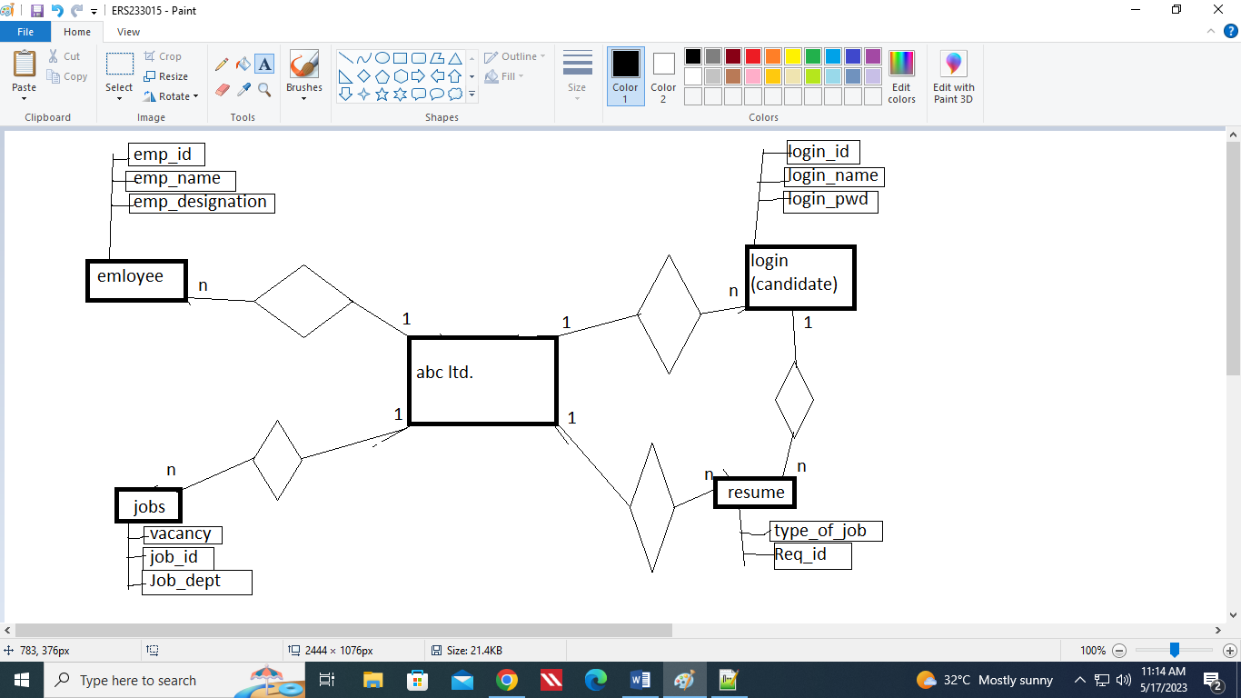

Q5)