Adding a Table to the DET

TOC

1. Add the new table 2

1.1. Before adding the table: 2

1.2. Adding the table 2

2. Adding Drop Downs (data validation) 3

3. Adding Value Domains 7

4. Adding Validation Data 7

5. Update the Instructions Tab. 8

6. Add new table name to TablesOverview 10

7. Final cleanup: 11

# Change Log

|  |  |  |  |
| --- | --- | --- | --- |
| Author | Date | Version | Change |
| Roger M. | 2019-07-16 | V001 | Initial Draft |
| Roger M. | 2019-07-22 | V002 | Updated section 5 to clarify right-clicking on the checkbox |

# Add the new table

## Before adding the table:

All critical pieces of information should be there for data validation columns (Exp Unit ID, Treatment ID). If other columns are required such as Growth Stage, Crop, Plant Fraction, Sample Start-Stop Interval are required, I recommend that you target and copy an existing table that has these fields.

In either case, I will outline the process of adding these columns in and linking them to the appropriate named fields later.

## Adding the table

Navigate to the position in the DET on the tab bar where the new table should be inserted.

Right click the tab bar and click move or copy.

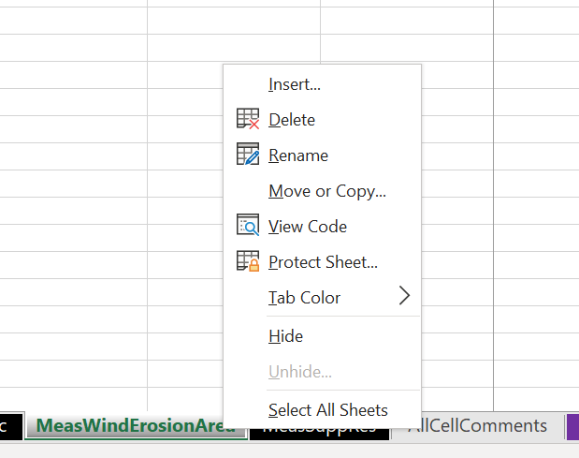

I recommend using an existing table similar to what is being added.

Note: make sure to check the “Create a copy” box.

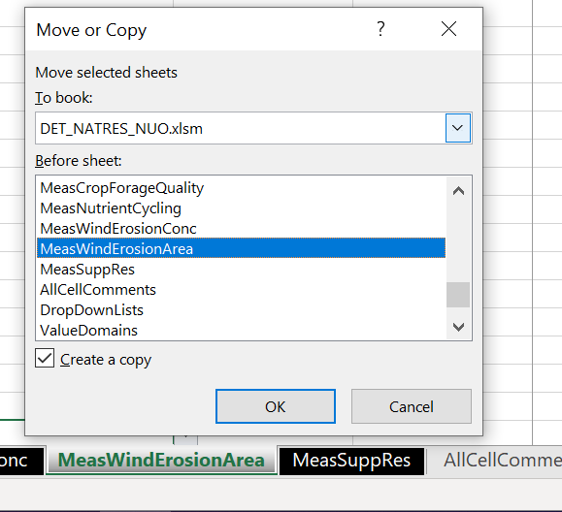

The DET should now contain something similar to this:

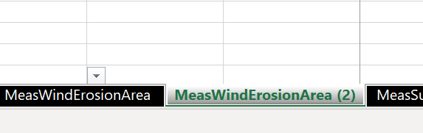

Rename the tab to the required name for the new table. Remember to prepend Mgt or Meas depending on the new table type.

# Adding Drop Downs (data validation)

Adding list columns is easy as long as the correct process is followed. Any new list of valid options created in the DropDownList tab should be named as in the following process:

1. Go to the end of the current dropdown rows and insert a new column after the last column:

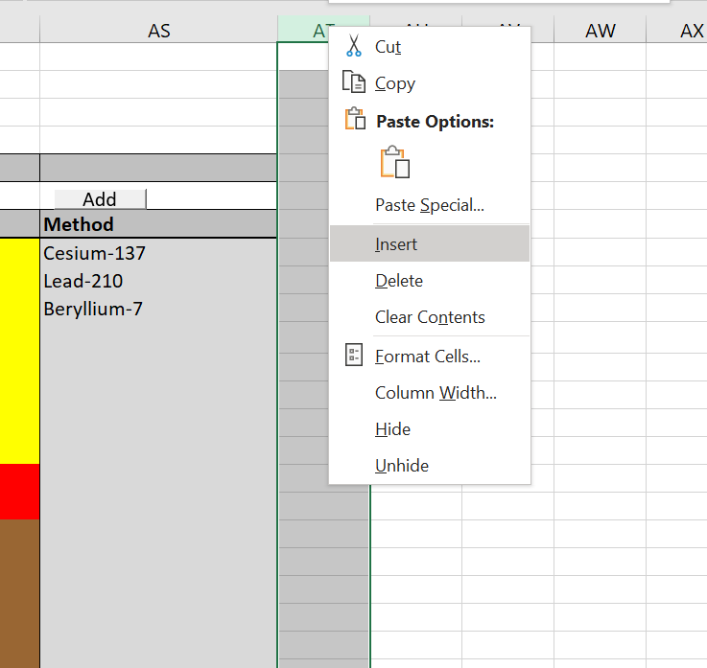

1. Next copy the “add” button and add it to your new column at row 6, and add a title for the new list
   1. Note – no spaces or special characters in the title for the list. Use underscores for spaces if necessary.

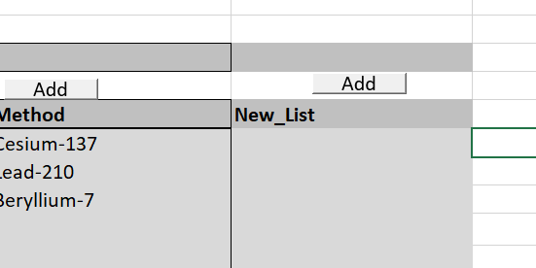

1. Click the Add button to add a value to the list one at a time:

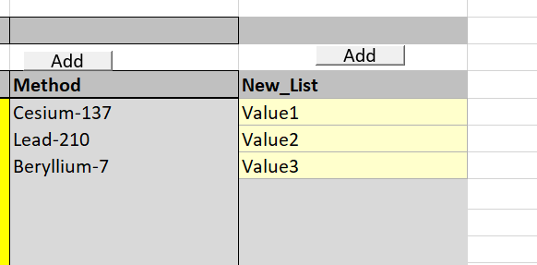

The new list is now available for use as a named reference for the name provided in step 2.

To use this list, return to the new tab created in section 1.2.

1. Create the column in the data table that will reference the new list:

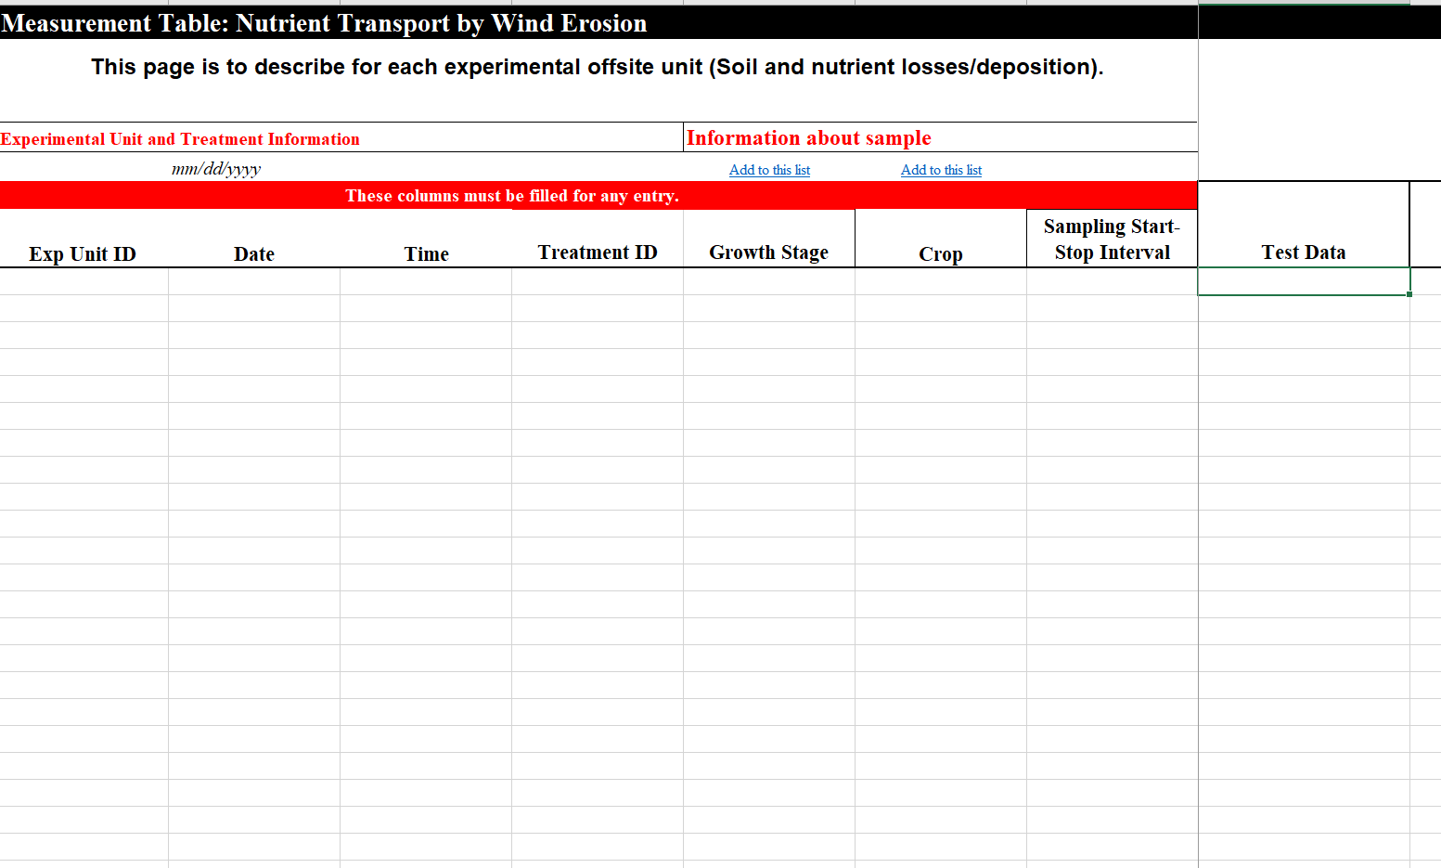

1. Highlight some # of rows in the column (150-200 will be good enough) for the new column and open the data validation option:

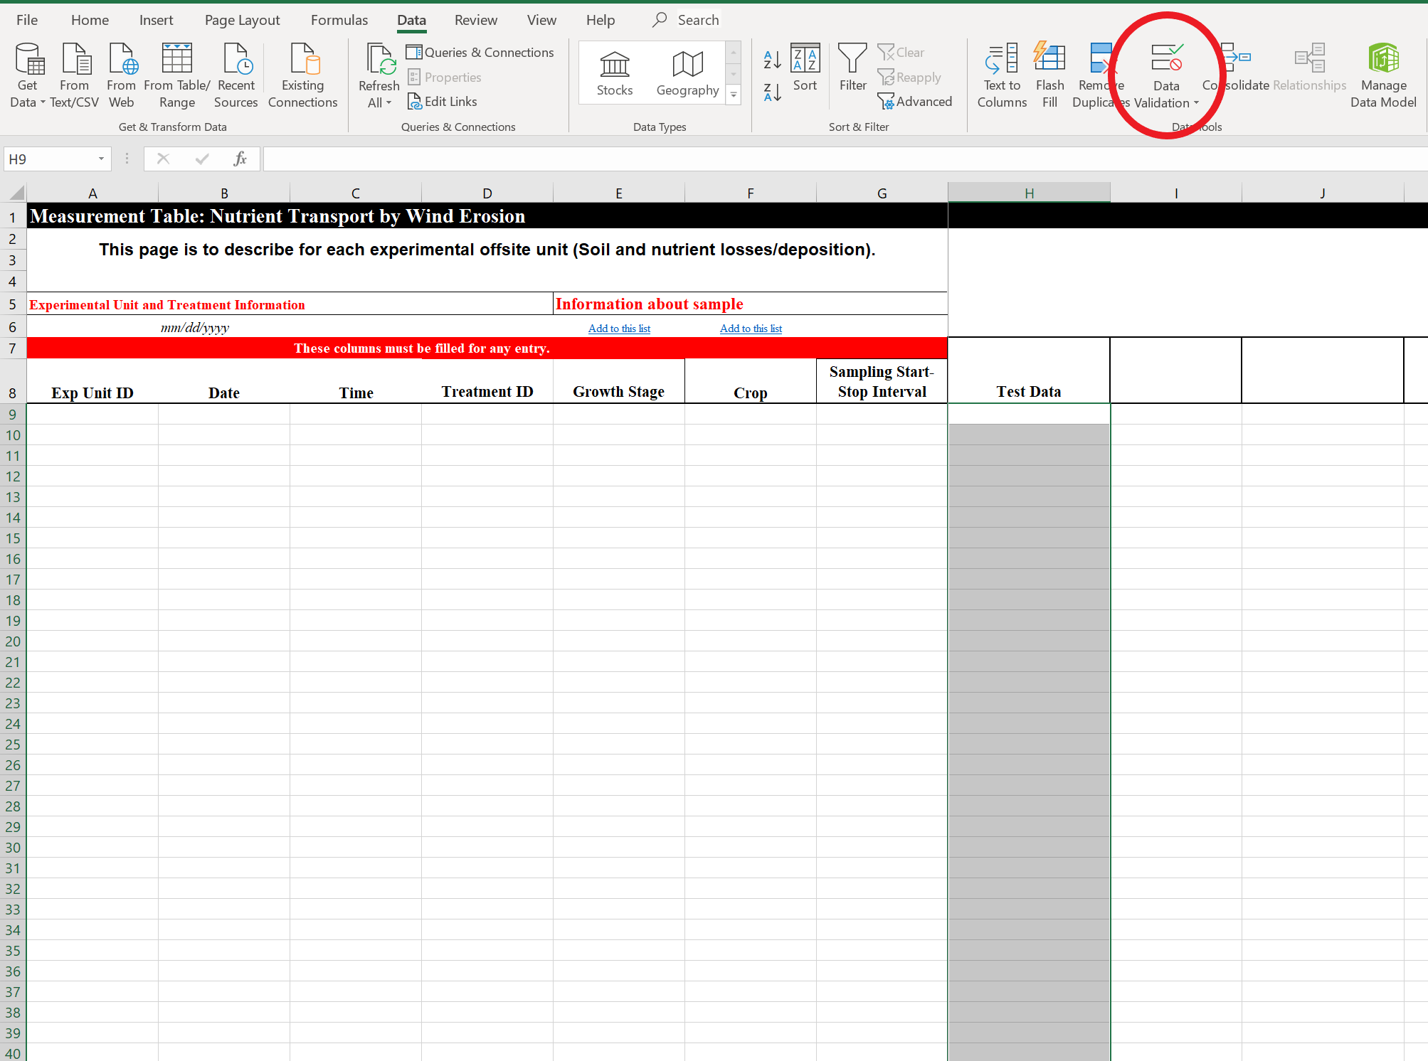

1. Configure the data validation for the new list as follows:

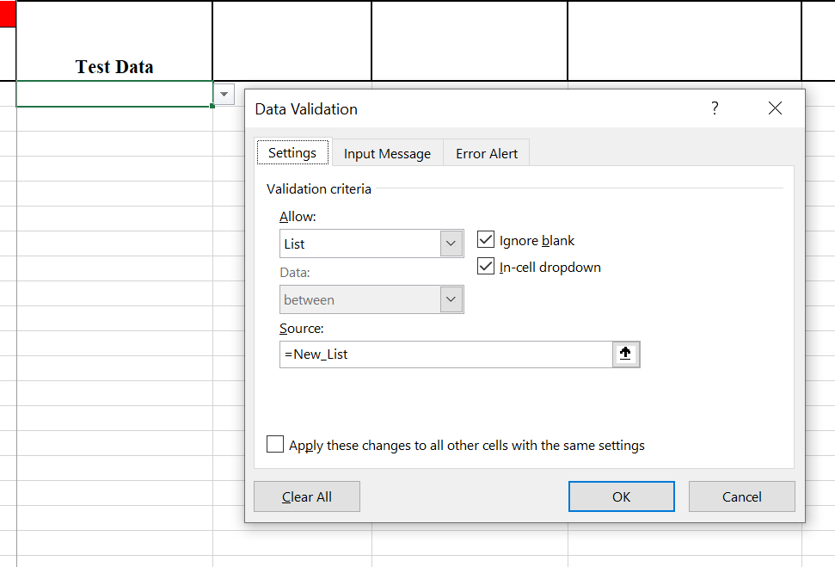

Note: make the source “=<new list name>” exactly as it appeared in the DropDownList tab added column.

1. After this the column should now have a dropdown:

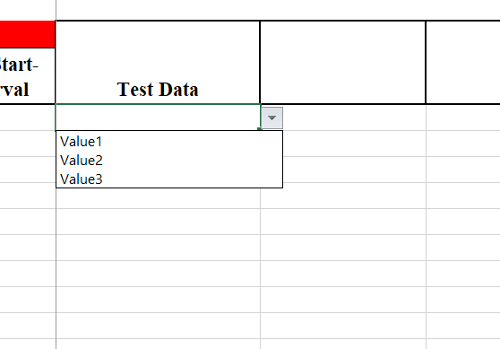

1. Add a link to allow users to add additional content to the list.

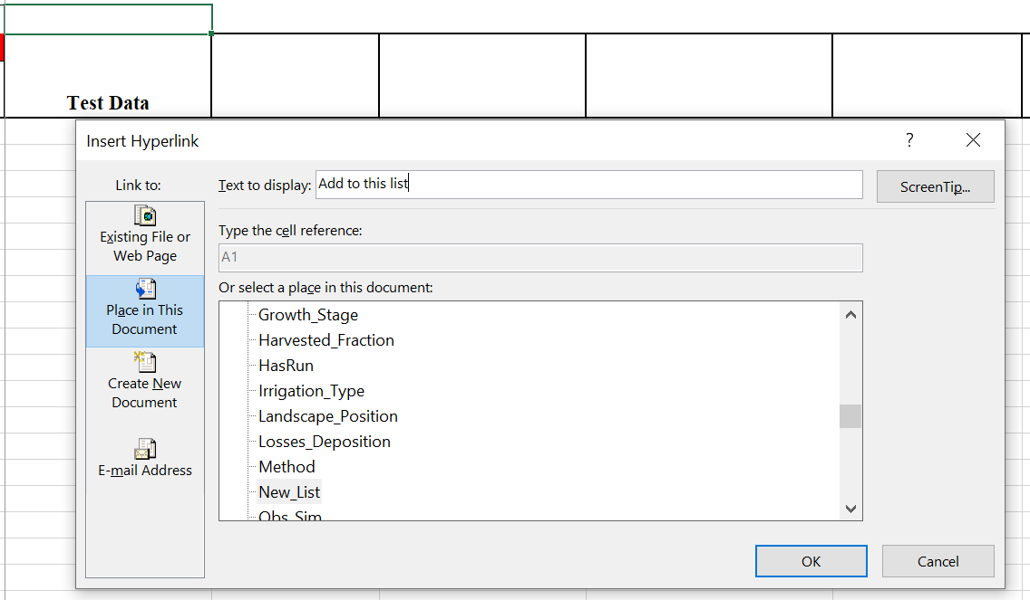

1. Final product:

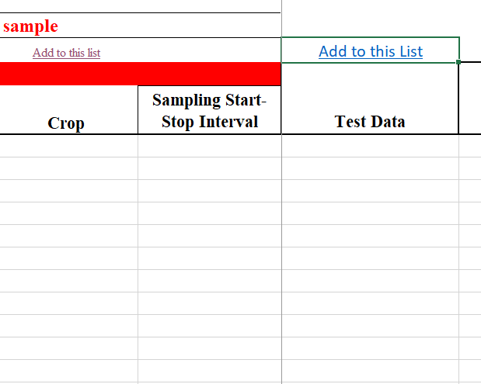

1. Repeat this process for any columns that require a fixed list. Adding a link to update the list depends upon the data represented and if it should be modified by normal users.

# Adding Value Domains

On the value domains tab, add a new section in the appropriate spot for the new table. Ensure that all of the data columns are represented and definitions provided as outlined:

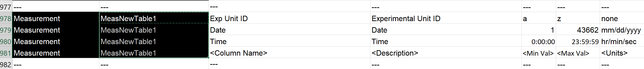

# Adding Validation Data

Navigate to the ValidationData tab. This tab is used to check for validation errors for data that is entered in the corresponding tab.

1. Navigate through the tabs to the location where the new table was inserted.

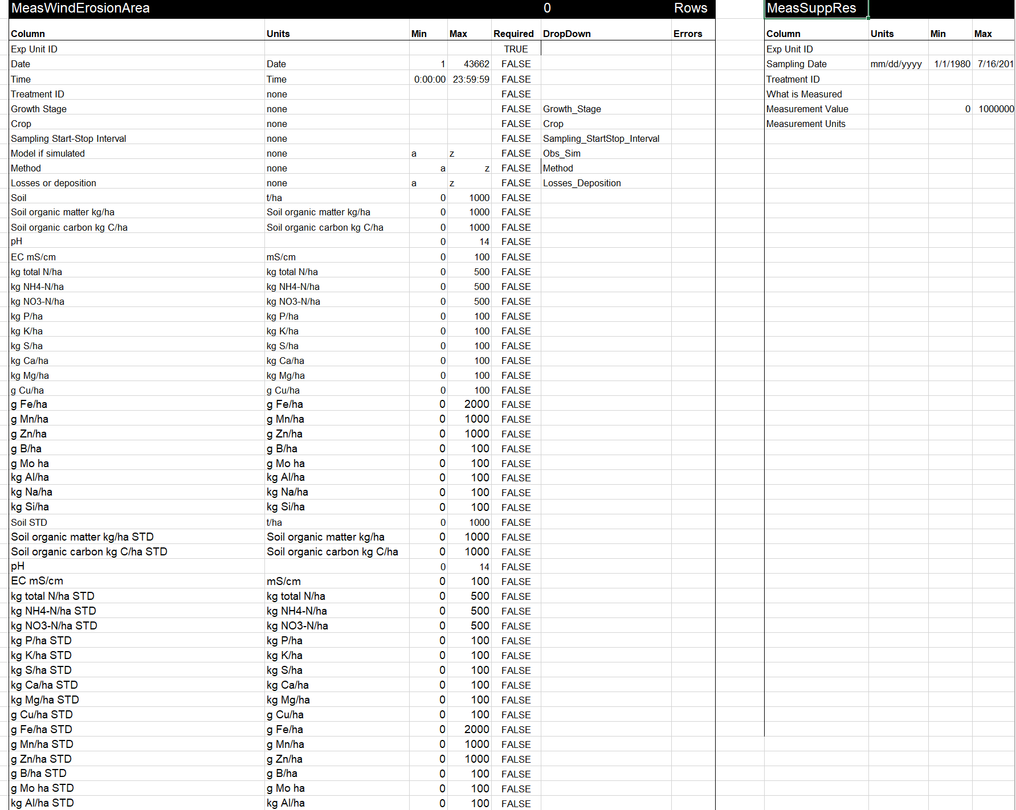

1. Copy one of the surrounding tables and insert it between the two existing tables.

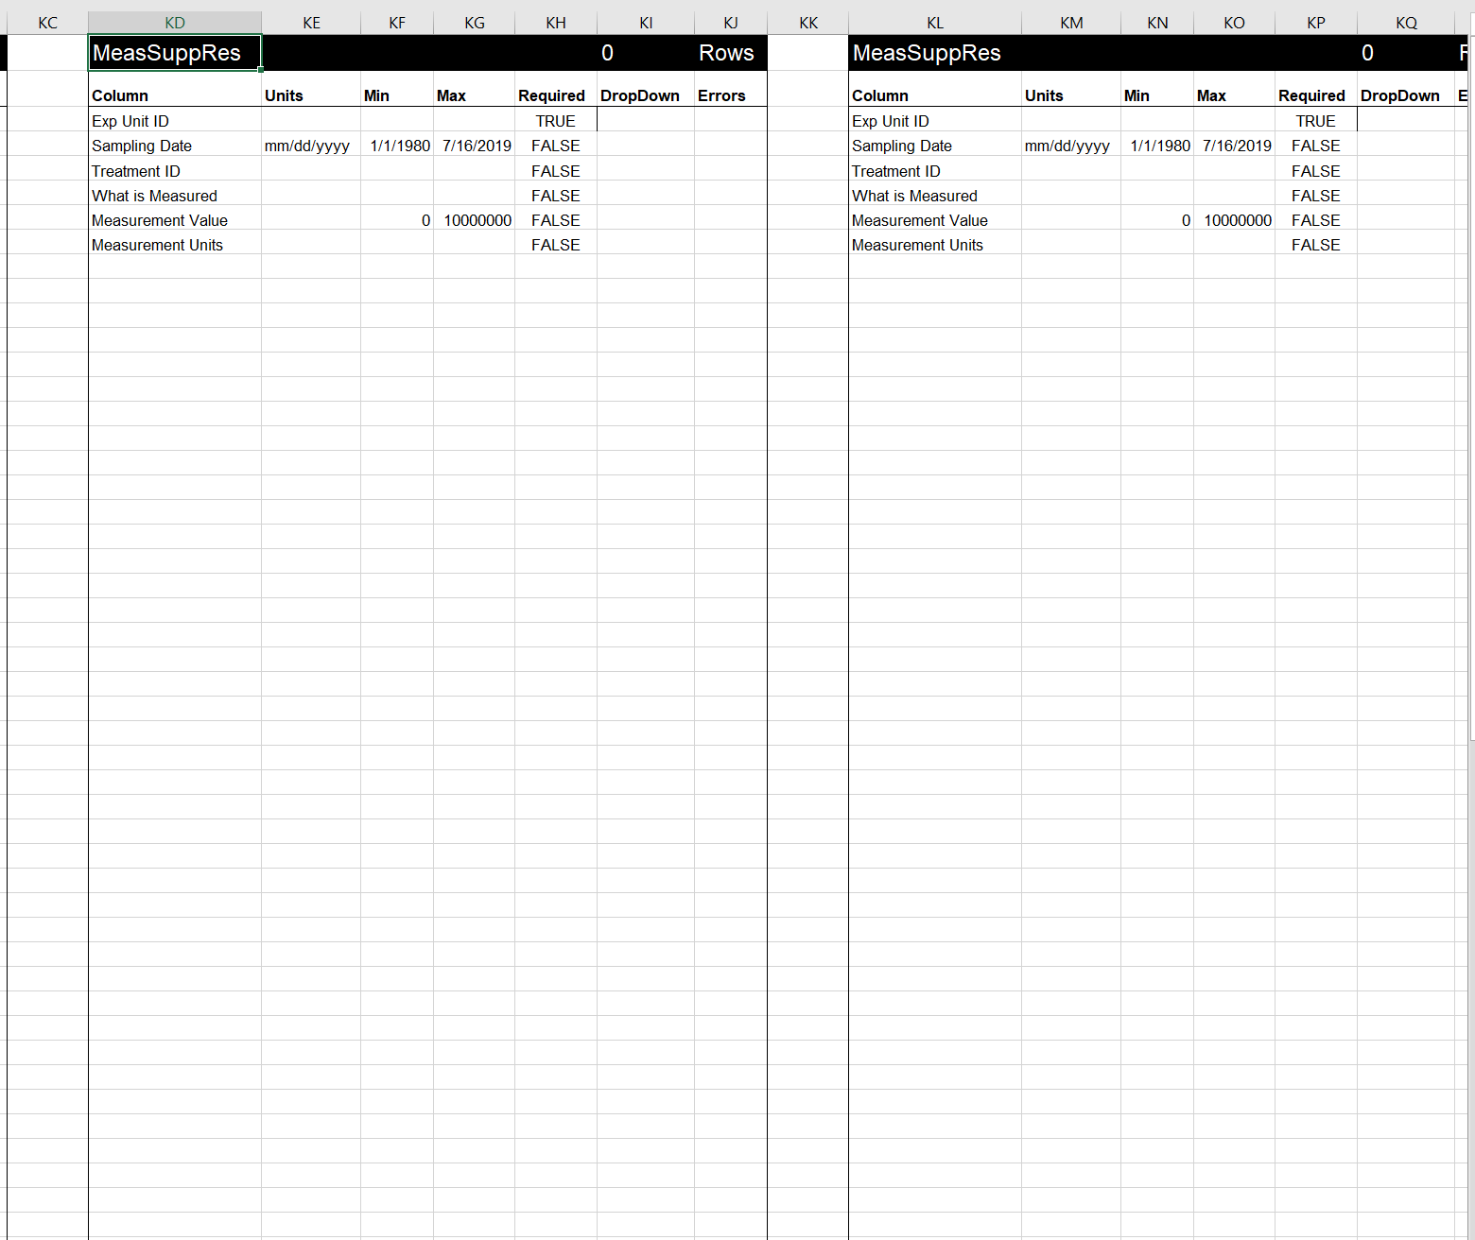

1. Update pasted content to match the newly added/populated table tab. Ensure that all columns are represented, min and max values provided, and where the field is required or not (TRUE/FALSE) are populated.

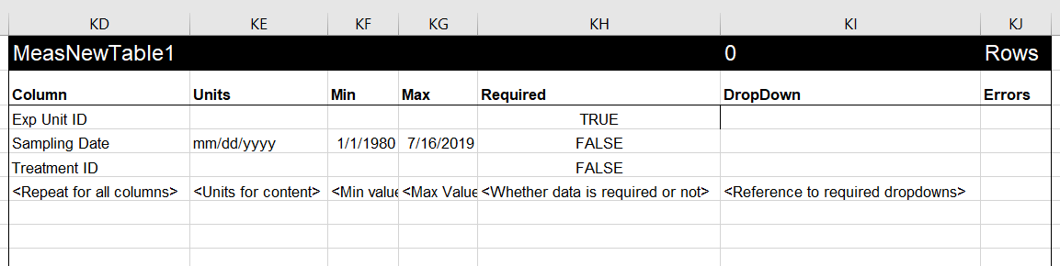

# Update the Instructions Tab.

1. Navigate to the instructions tab and locate the table names before and after the newly added table. Copy one of the existing rows and insert it where it should fit in the order of the tabs.



1. Update the table name and ensure that the checkbox is sized to fit in the cell:



1. Update the checkbox formula to reference the existing row: (NOTE: use right click to get access to the properties)

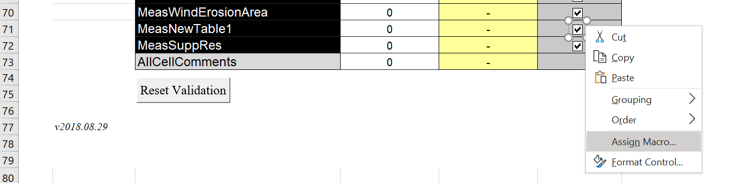

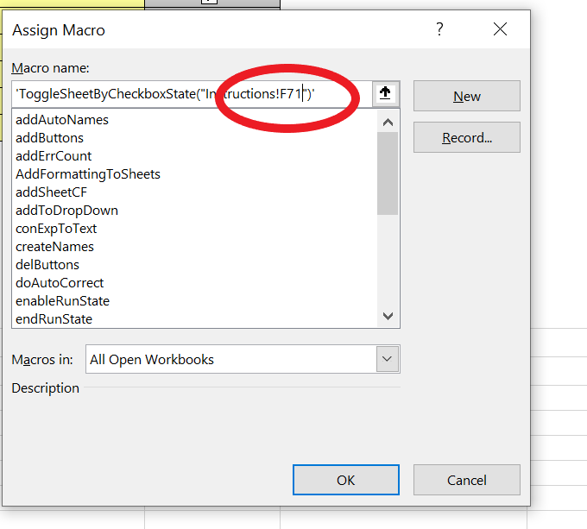

Note: the cell reference must be for the newly added row.

1. Update check box format control properties: (NOTE: use right click to get access to the properties)

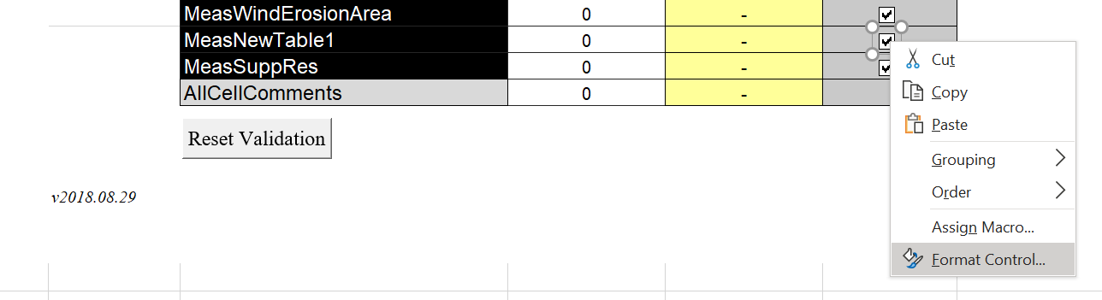

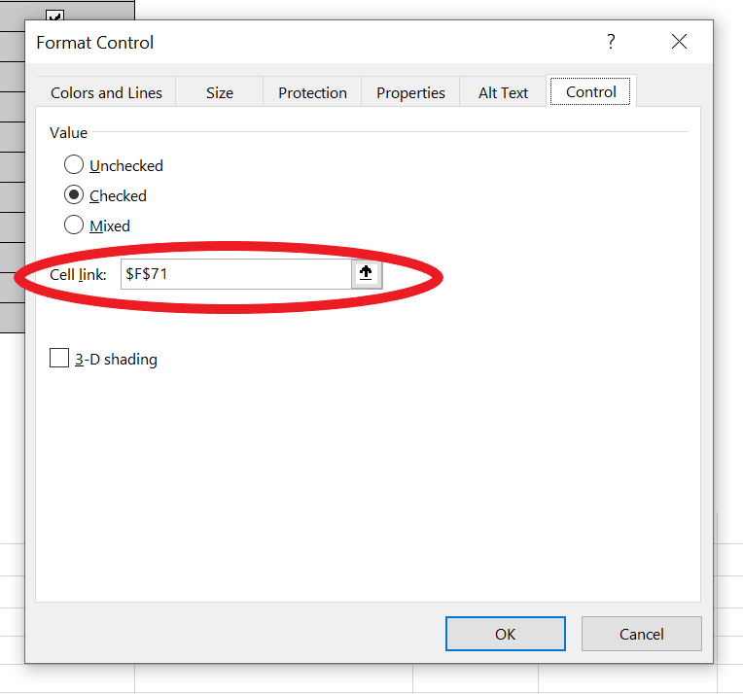

Note: the cell reference must be for the newly added row.

1. Update the checkbox macro values and format controls using the above process for all displaced tables:



# Add new table name to TablesOverview

Add a new row and name/describe the new table in the TablesOverview tab.

# Final cleanup:

I usually save and close the DET on the Instruction tab with a cell highlight near the top of the page. This will mean all people who open that particular copy of the file will open it up to the Instructions tab.

Another thing I like to do for each tab is to set it to some consistent cell, so the top corner cell in each tab for instance. This again makes sure the feel is the same for anyone going into each tab.