Research Insights in
Semiarid Ecosystems
RISE

Recent research at the USDA-ARS Walnut Gulch Experimental Watershed (WGEW) and the University of Arizona Santa Rita Experimental Range (SRER)

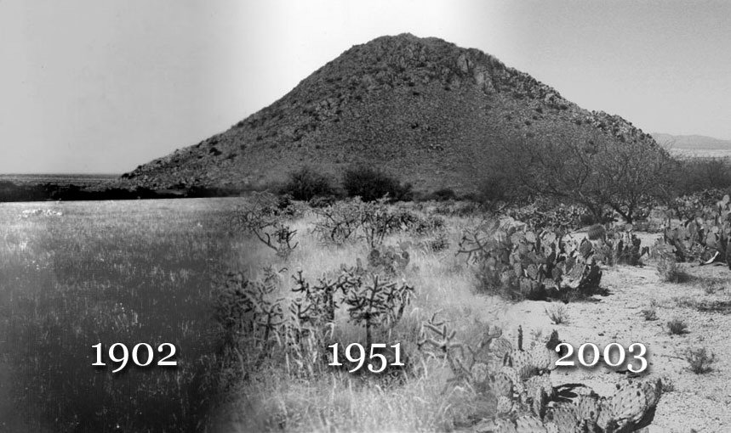

RISE Program

University of Arizona, Tucson, Marley Building, Rm. 230
Saturday, 13 November 2004, 9AM to 4:30PM
Post-symposium BBQ, UA Mall, 4:30-6:30 PM

Purpose: The objectives of the symposium are to share recent results of scientific research at WGEW and SRER, to encourage future research activities at the WGEW and the SRER, and to promote the WGEW and the SRER as outdoor scientific laboratories.

Research Insights in Semiarid Ecosystems (RISE) Symposium
13 November 2004

Marley Building, Room 230
8:30-9:00 | Registration
9:00-9:10 | Mitch McClaran  Susan Moran | RISE Welcome
9:10-9:30 | Steve Archer  UA SNR | Woody plant proliferation in grasslands: new perspectives on an old problem
9:30-9:50 | Judith Bronstein  UA EEB | Linking plant and insect physiology in the Datura wrightii-Manduca sexta interaction
9:50-10:10 | Dave Goodrich  USDA ARS SWRC | Selected Research from the WGEW and looking to the Future
10:10-10:30 | Poster introductions | Poster teasers provided by poster authors
10:30-11:10 | Poster Session I  (See List Below) | Authors will be with their posters in the hall outside the conference room
P1 | Ross Bryant  USDA ARS SWRC | Measuring surface roughness to parameterize radar backscatter models for retrieval of surface soil moisture
P2 | Dawn Browning  UA SNR | Land use history and soils: Impacts on woody cover assessments
P3 | Jessie Cable  UA EEB | Respiration in a semi-arid grassland in Southeastern Arizona: the role of precipitation pulses
P4 | Bob Strain  City of Sierra Vista | Upper San Pedro Partnership
P5 | Adrian Vogl  UA SNR | Prickly Pear (Opuntia Engelmannii) Carbon Pools in a Desert Grassland
P6 | Theresa Mau-Crimmins  UA SNR | Effects of removing Lehmann lovegrass (Eragrostis lehmanniana) from grasslands in southeastern Arizona
P7 | C. Winston Wheeler  Stanford University | Soil carbon following woody encroachment: variation within soils of different textures and along a climatic gradient at the SRER
P8 | Hojin Kim  UA SWES | Drought and Water Content Analysis of Semiarid Vegetation Communities with Remotely Sensed Data and Eddy-flux Tower Measurement
11:10-11:30 | Dean Martens  USDA ARS SWRC | Impacts of grazing and shrub management on hydrologic attributes in semi-arid rangelands
11:30-11:50 | Alfredo Huete  UA SWES | Seasonal and interannual patterns of carbon and moisture variability with combined AVIRIS and MODIS satellite observations
11:50-1:00 | Lunch on your own | A food court is nearby in the UA Memorial Union
1:00-1:20 | Travis Huxman  UA EEB | Controls over carbon and water fluxes by vegetation, soils and climate
1:20-1:40 | Leonard Lane  USDA ARS (ret) | Proposed adaptive management experiments on small semiarid watersheds
1:40-2:00 | Russ Scott  USDA ARS SWRC | The differential response of transpiration and bare-soil evaporation to precipitation and their relation to carbon dioxide fluxes in a Chihuahuan Desert shrubland
2:00-2:20 | Poster introductions | Poster teasers provided by poster authors
2:30-3:10 | Poster Session II  (See List Below) | Authors will be with their posters in the hall outside the conference room
P1 | David Thoma  USDA ARS SWRC | Comparison of two methods for extracting surface soil moisture from C-band radar imagery
P2 | Heather Throop  UA SNR | Spatial patterns of soil organic carbon relative to tree size and canopy distribution at the Santa Rita Experimental Range
P3 | Enrico A. Yepez  UA SNR | Short-term dynamics of soil evaporation and transpiration following a moisture pulse in semiarid grassland: a chamber-based method using stable isotope tracers
P4 | Eric Anson  USDA ARS SWRC | Southwest Watershed Research Center Data Availability Project (DAP)
P5 | Pierre Deviche  ASU SLS | Supplementary information, not photoperiod, regulates Plasma luteinizing hormone in male Rufous-winged Sparrows, Aimophila carpalis
P6 | Jorry Kaurivi  UA SWES | Differentiating the phenology of Prosopis velutina from grassland with MODIS
P7 | Chandra Holifield Collins  USDA ARS SWRC | Estimating large scale daytime net carbon dioxide flux using instantaneous remote sensing measurements
P8
3:10-3:30 | Mark Nearing  USDA ARS SWRC | Sediment tracer studies at Walnut Gulch Experimental Watershed
3:30-3:50 | Mary Nichols  USDA ARS SWRC | Sediment transport in low-order channels on the Walnut Gulch Experimental Watershed
3:50-4:10 | Kris Havstad  USDA ARS JER | Synthesis and implications of 90 years of science at the Jornada
4:10-4:30 | Discussion | All speakers and poster authors will be in attendance

Bar-B-Que on the UA Mall 4:30-6:30

RISE Organizing Committee:
Mark Heitlinger, Mary Nichols, Mitch McClaran, Susan Moran
markh@Ag.arizona.edu
mnichols@tucson.ars.ag.gov
mcclaran@u.arizona.edu
smoran@tucson.ars.ag.gov

Acronyms:
ARS: Agricultural Research Service
ASU: Arizona State University
EEB: Ecology and Evolutionary Biology
JER: Jornada Experimental Range
SLS: School of Life Sciences
SNR: School of Natural Resources
SWES: Soil, Water and Environmental Science
SWRC: Southwest Watershed Research Center
UA: University of Arizona

Notes:

