Second Annual Symposium
Research Insights in
Semiarid Ecosystems
RISE

Recent research at the USDA-ARS Walnut Gulch Experimental Watershed (WGEW) and the University of Arizona Santa Rita Experimental Range (SRER)

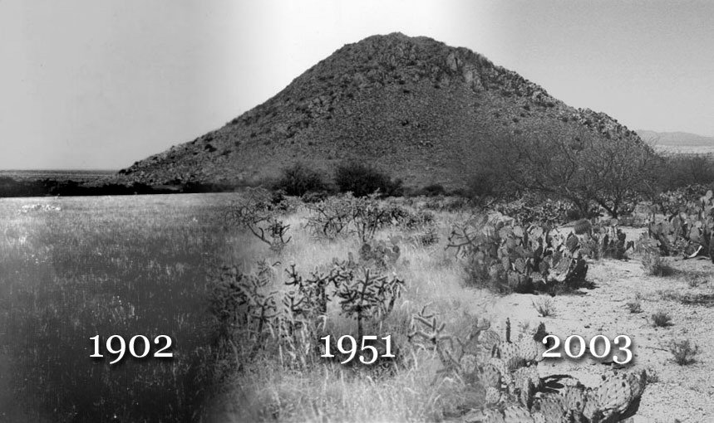

RISE Program

University of Arizona, Tucson, Marley Building, Rm. 230
Saturday, 8 October 2005, 9:00 AM to 2:30 PM
Lunch and Poster Session, 11:00-1:00 PM
Registration Fee: $5 Students; $15 All Other (includes lunch)

Purpose: The objectives of the symposium are to share recent results of scientific research at WGEW and SRER, to encourage future research activities at the WGEW and the SRER, and to promote the WGEW and the SRER as outdoor scientific laboratories.

2nd Research Insights in Semiarid Ecosystems (RISE) Symposium

8 October 2005

Marley Building, Room 230
8:30-9:00 | Registration
9:00-9:10 | Mitch McClaran and  Susan Moran | RISE Welcome
9:10-9:30 | Pierre Deviche,  Thomas Small,  Peter Sharp,  and Kazuyoshi Tsutsui,  ASU SLS, RIS, HUJ | Reproductive adaptations of Sonoran desert passerine birds to irregular precipitation patterns: A story of constraints and flexibility
9:30-9:50 | Heather Throop and Steve Archer  UA SNR | Land management and soil carbon pools: patterns and processes
9:50-10:10 | Dave Womack and Dan Robinett  USDA NRCS | Rangeland health, state and transition models and site descriptions for sandyloam, deep ecological site in Southern Arizona
10:10-10:30 | Debra Peters, Kris Havstad, Jin Yao, and Bob Gibbens  USDA ARS JER | Long term vegetation change at the Jornada: importance of spatial processes and landscape context
10:30-11:00 | Poster introductions | Poster teasers provided by poster authors
11:00-1:00 | Poster Session | Authors will be with their posters in the hall outside the conference room
P1 | M. Nichols and C. Shipek | Geomorphic change along the Walnut Gulch Channel
P2 | B. Yuill, M. Nichols, M. Schmeeckle | Mapping Bed Texture Evolution to Explain Variations in Observed Sediment Transport
P3 | M. Nearing, A. Kimoto, M. Nichols and J. Ritchie | Spatial patterns of soil erosion and deposition in two small, semiarid watersheds
P4 | R. Bryant amd D. Goodrich | LIDAR resolution, vegetation filters and preservation of topographic discontinuities
P5 | J. Finely, D. Sammataro, P. Segura and G. Wardell | Field Testing Protein Supplements for Strengthening European Honey Bee Colonies
P6 | T. Small | Rapid reproductive response of male Rufous-winged Sparrows to increased rainfall: a role for termites?
P7 | M. McClaran D. Martens, and S. Marsh | Organic carbon stocks in relation to grass, mesquite, and land use in the Desert Grassland
P8 | B. Collins, M. Pavao-Zuckerman and T. Huxman | The Effects of a Temporal Belowground Resident, Manduca sexta, on Soil Microbial Communities, Soil Nutrients, and Plant Growth
P9 | D. Ignace, D. Potts, E. Yepez-Gonzalez, J. Cable, M. Mason, A. Eilts, J. Weltzin, D. Williams and T. Huxman | The role of a native and non-native grass species in ecosystem CO2 and H2O exchange across two contrasting soil surfaces
P10 | J. Cable, D. Potts, R. Scott, M. Pavao-Zuckerman, D. Williams, D. Goodrich and T. Huxman | Controls on ecosystem respiration in a semi-arid watershed: seasonality and woody plant encroachment
P11 | M. Pavao-Zuckerman, J. Cable, E. Yepez, D. Potts, T. Huxman, and D. Williams | Mesquite cover mediates soil community structure response to precipitation pulses
P12 | J. Eilts, T. Huxman, D. Williams and J. Weltzin | Density dependant competition for water between exotic and native grass species.
P13 | C. Huang, S. Marsh, M. McClaran, and S. Archer | Cover-biomass relationships in woody plants: effects of fire and implications for remote sensing
P14 | A. Tyler, G. Barron-Gafford, J. Bronstein, G. Davidowitz and T. Huxman | Selfing reduces photosynthetic function in Datura wrightii (Solanaceae)
P15 | J. Graber, J. Bronstein, G. Davidowitz, T. Huxman and R. Alarcon | Summer flowering phenology in the foothills of the Santa Rita Mountains
P16 | H.J. Kim, A.R. Huete, P. Nagler, E. Glenn, W. Emmerich, R.L. Scott | Monitoring Riparian and Semi-Arid Upland Vegetation Using Vegetation and Water Indices from the MODIS Satellite Sensor
12:00-1:00 | Lunch w/ Posters | Provided by RISE
1:00-1:20 | Neil Cobb,  Amy Whipple,  Tom Whitham,  Bruce Hungate,  and Jane Marks  NAU MPCER | The importance of the greater Grand Canyon-Peaks ecosystem for the Arizona Ecological Transect
1:20-1:40 | David Thoma,  Susan Moran,  Ross Bryant,  Magfur Rahman,  Chandra Holifield-Collins,  and Susan Skirvin  USDA ARS SWRC | Lessons learned from mapping soil moisture with radar remote sensing at WGEW
1:40-2:00 | Bill Emmerich  USDA ARS SWRC | Shrub and grass land ecosystem water use efficiency on the Walnut Gulch Experimental Watershed
2:00-2:20 | Waite Osterkamp and Scott Miller  USGS & U. Wyoming | A synopsis of geologic and geomorphic studies in the Walnut Gulch Watershed, southeast Arizona
2:20-2:30 | Discussion | All speakers and poster authors will be in attendance

RISE Organizing Committee:  Mark Heitlinger, Mitch McClaran, Susan Moran  markh@Ag.arizona.edu  mcclaran@u.arizona.edu  smoran@tucson.ars.ag.gov | Acronyms:  ARS: Agricultural Research Service  ASU: Arizona State University  HUJ: Hiroshima Univ., Japan.  JER: Jornada Experimental Range  MPCER: Merriam-Powell Center for Environmental Research  NAU: Northern Arizona University  NRCS: Natural Resources Conservation Service  RIS: Roslin Institute, Scotland  SLS: School of Life Sciences  SNR: School of Natural Resources  SWRC: Southwest Watershed Research Center  UA: University of Arizona

