Third Annual Symposium

RISE
Research Insights in
Semiarid Ecosystems

Recent research at the USDA-ARS Walnut Gulch Experimental Watershed (WGEW) and the University of Arizona Santa Rita Experimental Range (SRER)

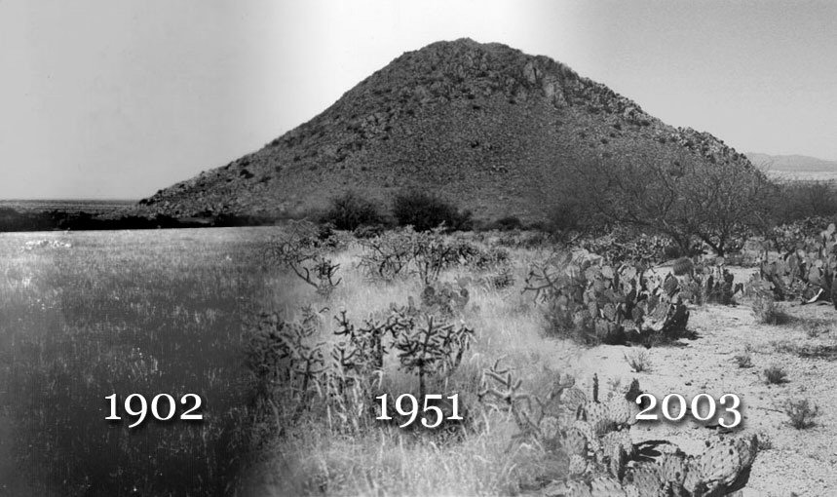

RISE Program

University of Arizona, Tucson, Marley Building, Rm. 230
Saturday, 7 October 2006, 9:00 AM to 2:30 PM
Lunch and Poster Session, 11:00-1:00 PM
Registration Fee: $7 Students; $20 All Other (includes lunch)

Purpose: The objectives of the symposium are to share recent results of scientific research at WGEW and SRER, to encourage future research activities at the WGEW and the SRER, and to promote the WGEW and the SRER as outdoor scientific laboratories.

3rd RISE Symposium (Research Insights in Semiarid Ecosystems)

7 October 2006

Marley Building, Room 230
8:30-9:00 | Registration
9:00-9:10 | Mitch McClaran and  Susan Moran | RISE Welcome
9:10-9:30 | Travis Huxman  UA EEB | Ecosystem response to precipitation pulses on the Santa Rita Experimental Range
9:30-9:50 | Jeannie McLain  USDA ARS ALARC | Rangeland management practices alter trace gas (CO2, N2O, CH4) fluxes at the Santa Rita Experimental Range
9:50-10:10 | George Ruyle  UA SNR | Developing, Implementing and Monitoring an Adaptive Management Grazing Plan for the Santa Rita Experimental Range
10:10-10:30 | Tim Keefer  USDA ARS SWRC | Comparing two types of weighing recording precipitation gauges on Walnut Gulch Experimental Watershed
10:30-11:00 | Poster introductions | Poster abstracts provided by poster authors
11:00-1:00 | Poster Session  (Accepting submissions) | Authors will be with their posters in the hall outside the conference room
12:00-1:00 | Lunch w/ Posters | Provided at the meeting by RISE
1:00-1:20 | Julio Betancourt  USGS DL | On-going research at the Desert Laboratory and opportunities for collaboration
1:20-1:40 | David D. Breshears, J.P. Field, C.B. Zou, and J.J. Whicker  UA SNR & LANL | Wind and Water Erosion under Alternate Land Uses: Insights from Ongoing Research at the Santa Rita Experimental Range
1:40-2:00 | Jeff Stone  USDA ARS SWRC | Hydrologic comparison of a brush and a grass ecosystem at a range of scales at the Walnut Gulch Experimental Watershed
2:00-2:30 | Discussion | All speakers and poster authors will be in attendance
Posters
P1 | C. Tewksbury, J. Root, C. Tewksbury, S. Archer and C. McMurtry  UA SNR | Woody Debris in Desert Grasslands?
P2 | C. McDonald  UA SNR | Restoring Native Semi-Arid Grassland Communities: Using Fire and Livestock Grazing to Reduce the Abundance of the Non-Native Lehmann Lovegrass
P3 | H. Throop, S. Archer, C. McMurtry and M. McClaran  UA SNR | Relationships between aboveground woody biomass and soil organic carbon in a semi-desert grassland
P4 | S. Woods and M. Lanning  UA SNR | Seedling establishment of woody plants: the first step in encroachment
P5 | A. Nafus, M. McClaran and C. McMurtry  UA SNR | Allometric equations to estimate biomass of perennial grasses
P6 | F. Mashiri, M. McClaran amd J. Fehmi  UA SNR | Comparing short and long-term effects of grazing systems, precipitation and mesquite on grass dynamics
Posters (continued)

P7 | S. Elliott  Dartmouth College | Relative roles of plant-animal interactions for seedling recruitment in a water-limited environment
P8 | C. Huang, S. Archer and S. Marsh  UA SNR | A top-down approach to understanding the biotic and abiotic characteristics of stable semi-arid savanna ecosystems
P9 | D. Browning and S. Archer  UA SNR | Spatial patterns and trends in woody plant (Prosopis velutina) biomass under contrasting grazing practices (1932 – 2006)
P10 | C. McMurtry, S. Archer, M. McClaran, D. Browning, and H. Throop  UA SNR | Estimating Prosopis velutina aboveground biomass: field and remote sensing approaches
P11 | E. Courtright, J. Herrick, B. Lavine and J. Repp  USDA-ARS JER | Rangeland Database and Field Data Entry System
P12 | A. Laliberte, A. Rango and A. Slaughter  USDA-ARS JER | Unmanned Aerial Vehicles (UAVs) for Rangeland Remote Sensing
P13 | C. Potenza, A. Slaughter, I. Reyes, R. Sedillo, M. Lucero and J. Barrow  USDA-ARS JER | Use of Gene Specific primers to Identify Fungal Endophytes of Native Grasses
P14 | D. Peters and C. Laney  USDA-ARS JER | Trends in Long-Term Ecological Data: a multi-agency synthesis project
P15 | W. Cable and R. Scott  USDA-ARS SWRC | Quantifying the hydrological significance of tree hydraulic redistribution in a savanna ecosystem.
P16 | M. Nichols, K. McReynolds and C. Reed  USDA-ARS SWRC | The use of rock check dams as a conservation practice in Southeastern Arizona
P17 | J. Field, D. Breshears, C. Zou and J. Whicker  UA SNR | Wind and Water Erosion: Competing Processes on the Santa Rita Experiment Range
P18 | E. vanderLeeuw, M. McClaran, S. Marsh, C. Wissler and W. van Leeuwen  UA SNR | Two Types of Residential Developments and their Impacts on the Santa Rita Experimental Range
P19 | C. Boodleman, D. Breshears and C. Zou  UA SNR | Near ground solar radiation as a function of woody canopy cover: Testing initial predictions and trends in mean and variance in the Santa Rita Experimental Range
P20 | M. Nearing, A. Kimoto, M. Nichols and J. Ritchie  USDA-ARS SWRC | Spatial patterns of soil erosion and deposition in two small, semiarid watersheds
P21 | C. Shipek and M. Nichols  USDA-ARS SWRC | Channel Response to Changes in the Runoff Regime along the Walnut Gulch Channel
Posters (continued)

P22 | J. Buono and J. Stone  USDA-ARS SWRC | Variation in Overland Flow Velocity: A Shrub Grass Comparison from Southern Arizona
P23 | S. Burns, S. Scott, D. Goodrich, M. Hernandez, L. Levick, A. Cate, W. Kepner, D. Semmens, S. Miller, P. Guertin  USDA-ARS SWRC | Automated Geospatial Watershed Assessment (AGWA): A GIS-based Hydrologic Modeling Tool for Watershed Management and Landscape Assessment
P24 | S. Moran, R. Scott, T. Keefer, G. Paige, W. Emmerich, M. Cosh and P. O’Neill  USDA ARS SWRC | Partitioning Evapotranspiration in Semiarid Grassland and Shrubland Ecosystems Using Diurnal Surface Temperature Variation

RISE Organizing Committee:  Mark Heitlinger, Mitch McClaran, Susan Moran  markh@Ag.arizona.edu  mcclaran@u.arizona.edu  smoran@tucson.ars.ag.gov | Acronyms:  ALARC: Arid-Land Agricultural Research Center  ARS: Agricultural Research Service  DL: Desert Laboratory  LANL: Los Alamos National Laboratory  SNR: School of Natural Resources  SWRC: Southwest Watershed Research Center  UA: University of Arizona

