An Introduction to WEPPCAT
The Water Erosion Prediction Project Climate Assessment Tool
Tutorial 1

Objective
-Familiarize yourself with the WEPPCAT interface.

1. Open your internet browser
2. Type www.weppcat.net into the address bar. You should now see the screen below.
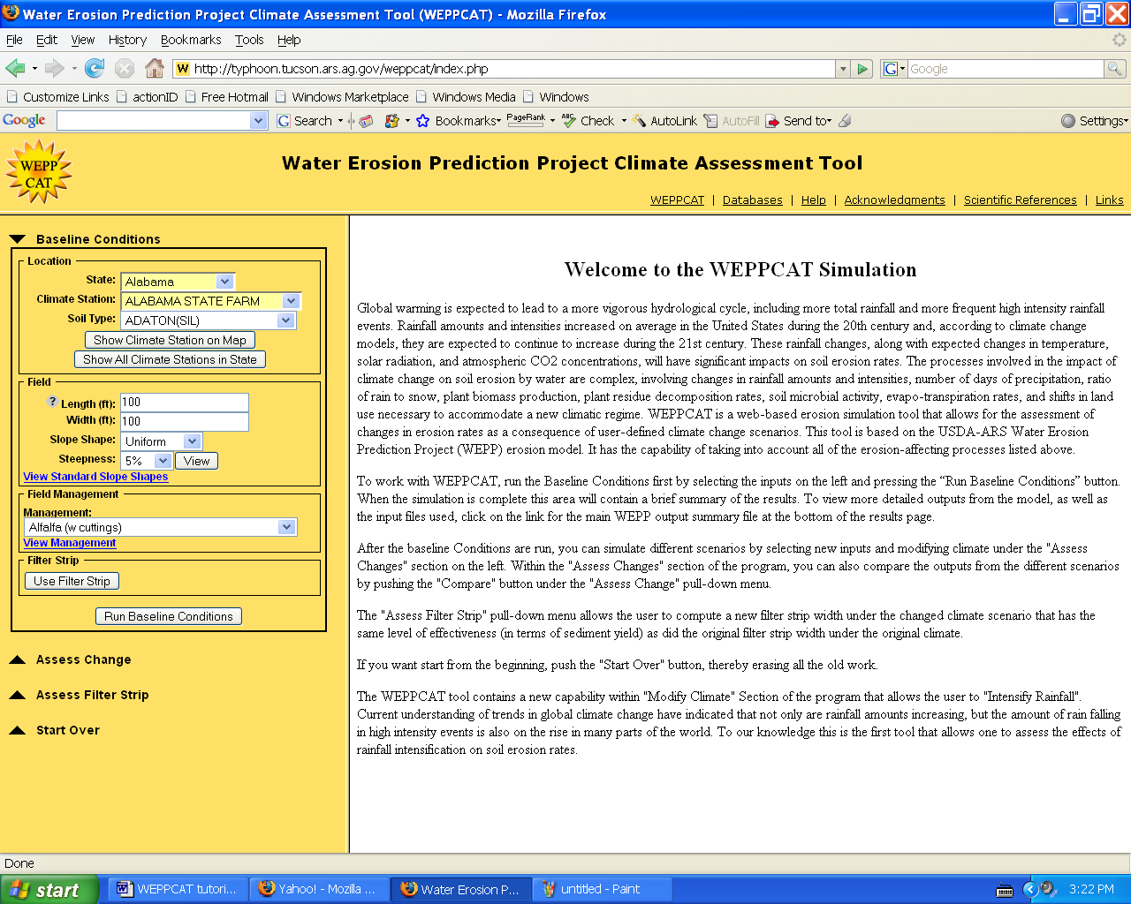

3. Find the tabs in the yellow top portion of the page. Click on Help. You should see the screen below.
4. Now click on the purple book logo next to the word WEPPCAT. You may wish to browse through the help topics that you now see listed.
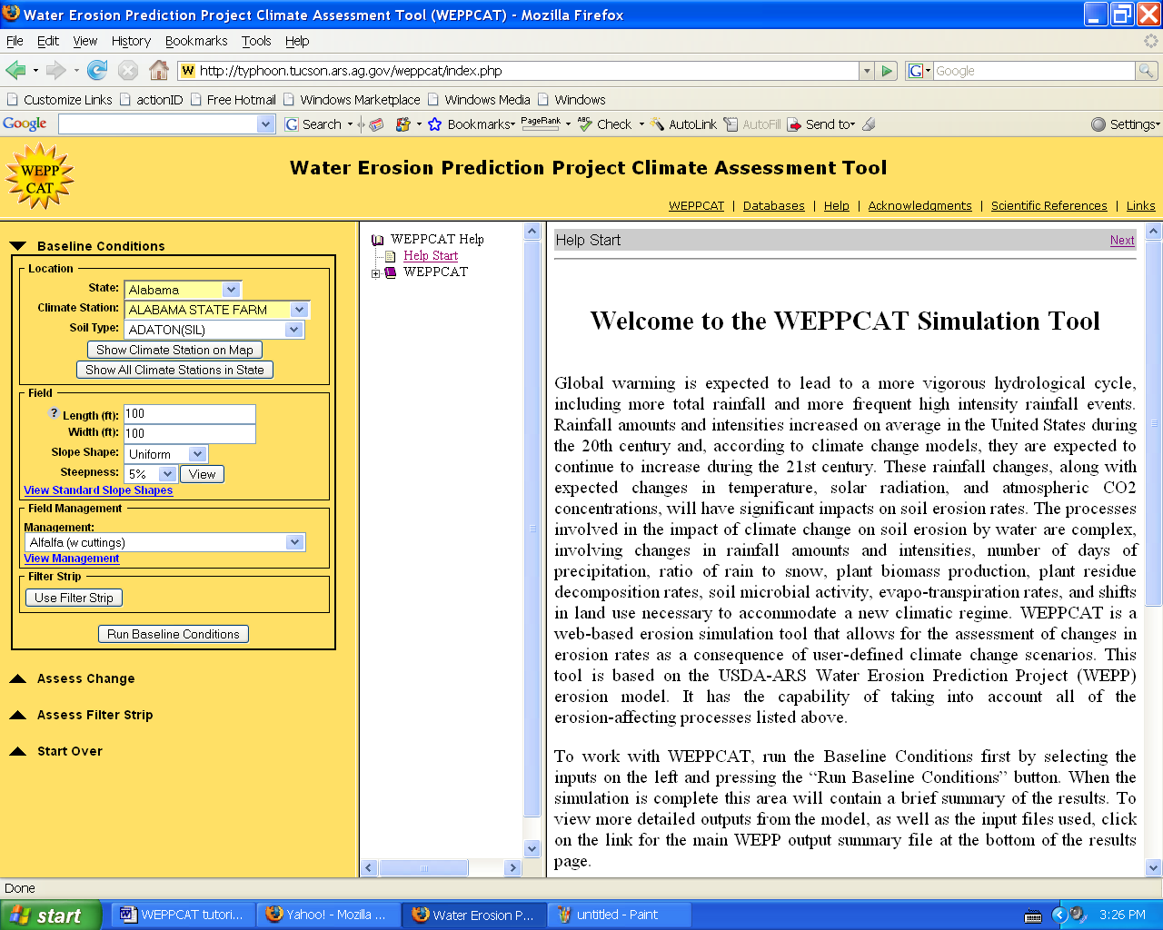

5. Next click on the Scientific References tab. You should see the screen below. If you click on one of the references, you will be linked to an online copy of the article.
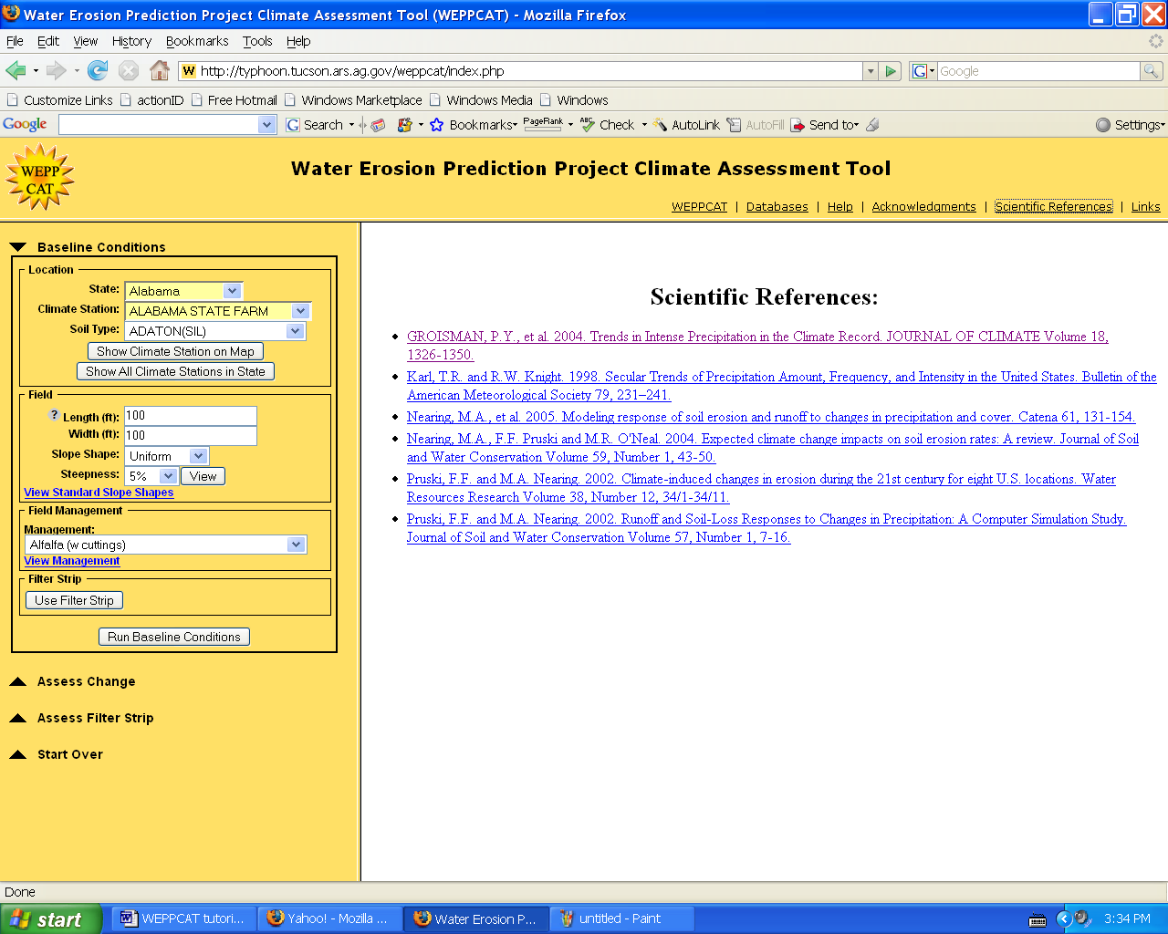

6. Next click on the Links tab. You should see the screen below.
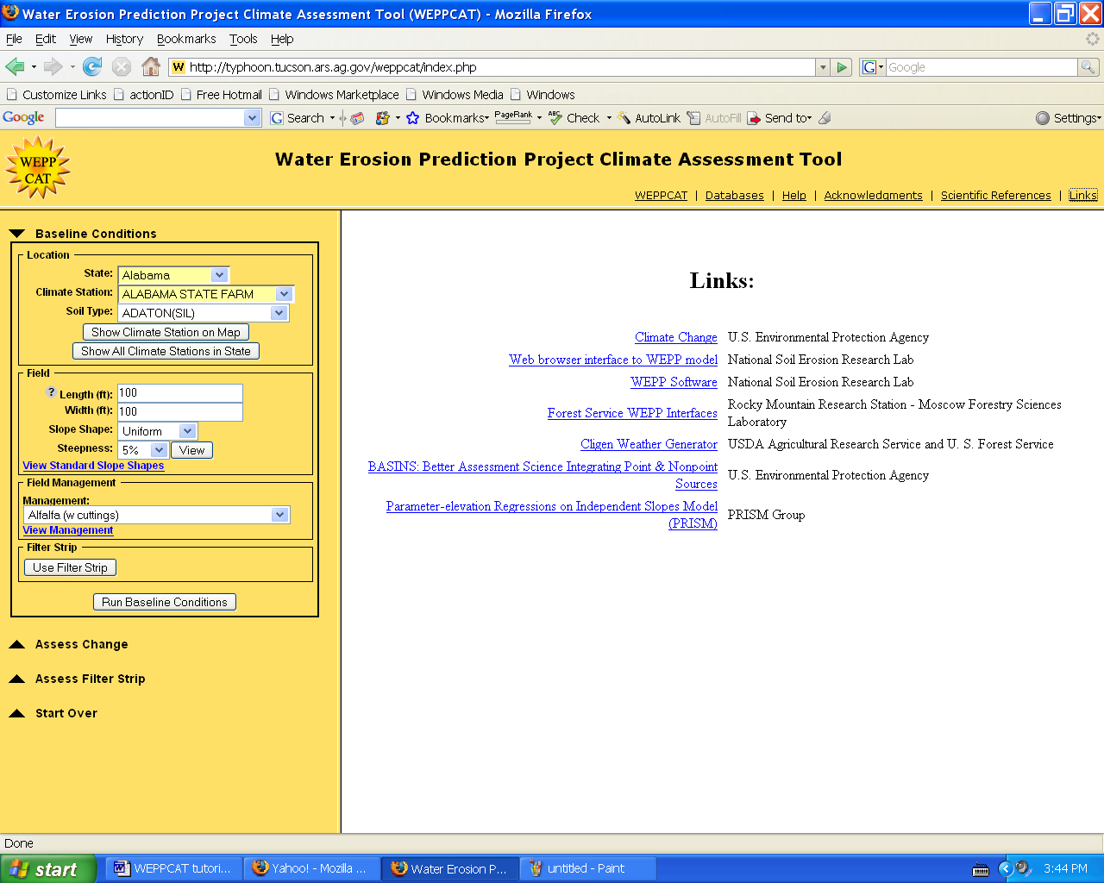
7. All of these links are worth exploring. Of particular interest to this tutorial is the documentation of the WEPP model. To reach this information click on the WEPP Software link.

8. Click on the WEPP Model Documentation button in the documentation box. You should now see the screen below. The pdf files linked to this page provide detailed information about how the WEPP model works.

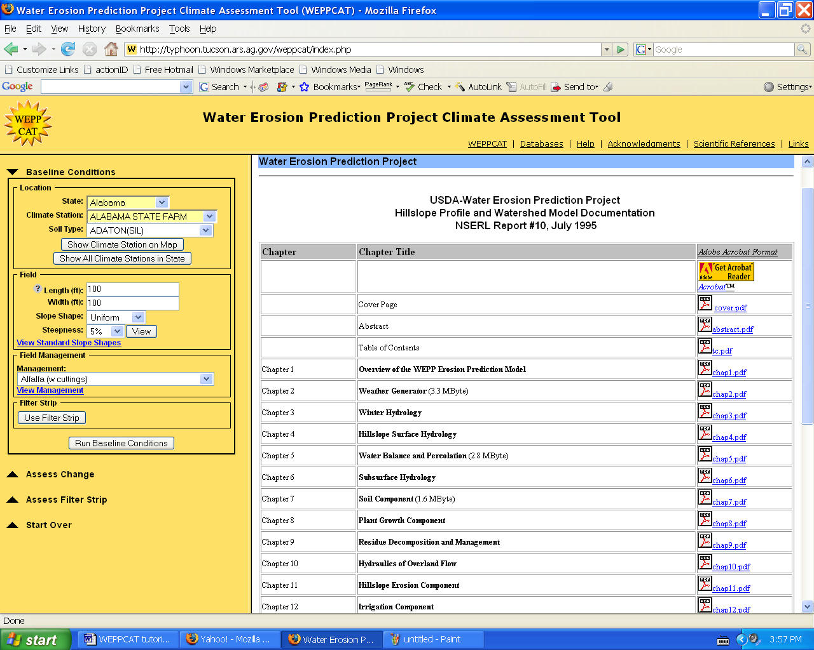

9. Next click on the Databases tab in the yellow top portion of the page. You should see the screen below. These databases represent the input data used to run WEPPCAT. You may want to take some time to explore the data in each of the three databases.
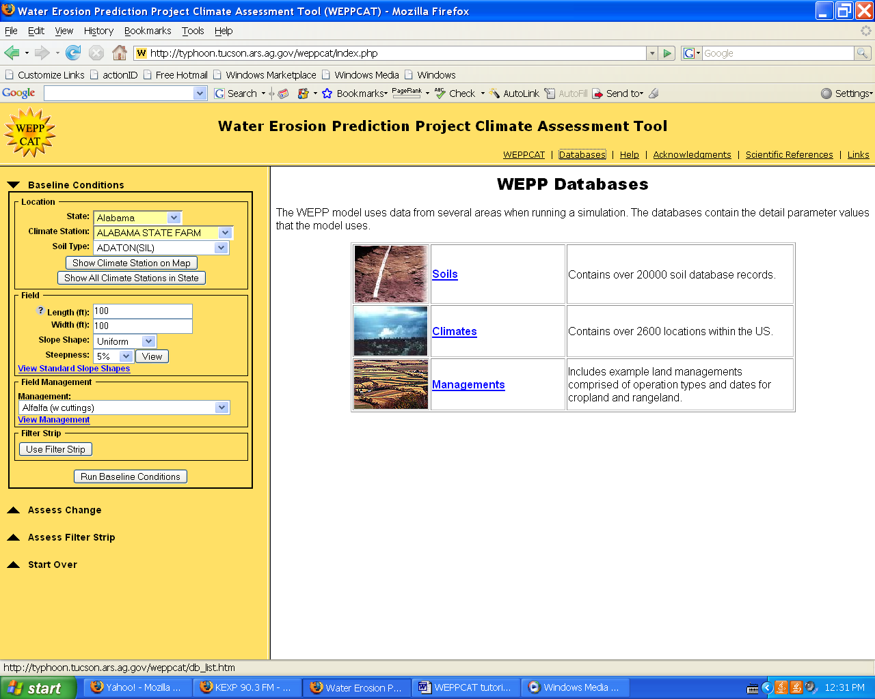

Selecting a Climate Station

Step 1. Select a state – In this example select Iowa.
Step 2. Select a climate station – A climate station is selected in one of two ways. Click on the Show All Climate Stations in State button. Move the curser to the red marker near the town of Marshalltown, as is illustrated in the picture below. Click on the red MARSHALLTOWN NO 2 marker. The other way to select a climate station is by using the dropdown Climate Station menu on the left side of the page. When you select a climate station it is important to select the station that is most representative of the climate on the piece of land you are interested in.

Step 3. Select a soil type – In this example select ARMSTER(L) loam from the drop down menu labeled Soil Type on the left hand side of the screen.
If you do not know what soil you are working with you can identify soils at
http://websoilsurvey.nrcs.usda.gov/app/WebSoilSurvey.aspx. The WEPPCAT soil list is static and does not attempt to update with changing soil names. If you cannot find the name of the soil you are working with in WEPPCAT’s list of soils, select a soil that has similar soil properties to the soil you are working with.
WEPPCAT does not allow fields to be categorized as having more than one soil type. If the field you are interested in has more than one soil, you may want to consider changing the field size and running the model for each soil separately.

WEPPCAT Tutorial
Part 2

Objective – Learn to select baseline conditions.
Step 4. Selecting field dimension – In this example leave the slope length and width at 100ft. Slope length runs parallel to the direction of the slope and slope width runs perpendicular to the direction of the slope.
Step 5. Selecting slope shape – In this example use an s-shaped slope.
Step 6. Selecting steepness – In this example use a steepness of 4%
Step 7. Selecting a field management – In this example use a winter wheat conventional tillage. We will not use a filter strip for the baseline run. You should see the image below.

Step 8. Press the Run Baseline Conditions button.
Step 9. View your baseline results. You should see the results listed below.

Step 8. Press Run Baseline Conditions you should see the image below.

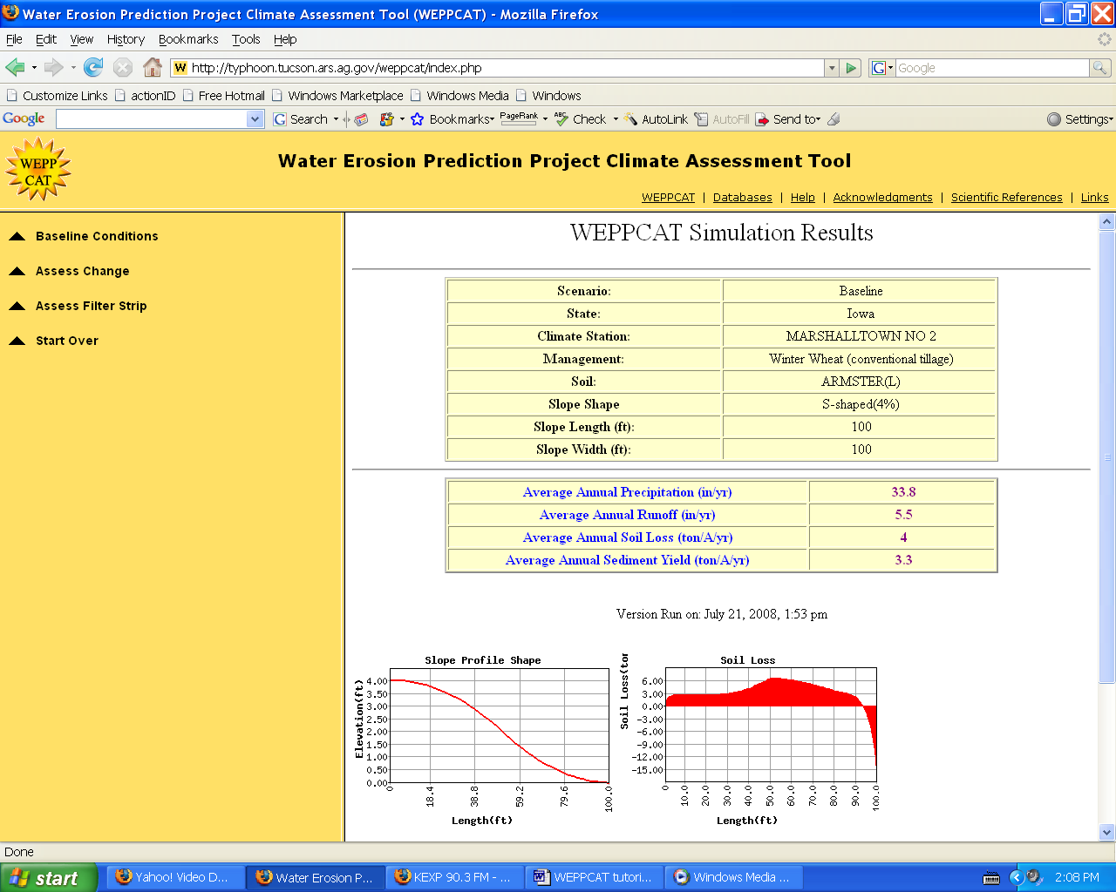

The results should include a list of the inputs that you used, the average annual precipitation, the average annual runoff, the average annual soil loss and the average annual sediment yield.
Notice that the soil loss values are different than the sediment yield values. Soil loss can be defined as the amount of soil displaced from its position at the start of each year. Sediment yield refers to the amount of soil that actually leaves the plot of land being modeled. In this case soil loss is higher than soil yield because we used an S-shaped slope. This is illustrated nicely by the soil loss graph at the bottom of the page. Notice that once the slope decreases to a certain point soil loss becomes negative, meaning that there is net deposition along that length of the field.
The soil loss graph also tells the user what type of erosion is taking place. Between 0ft and 30ft the soil loss is constant. This indicates that the erosion that is taking place in the upper 30ft of the graph is due to splash and sheet erosion. After 30ft the graph becomes steeper, this indicates that rill erosion has begun.

Step 9. Press the start over drop down arrow then press the Start Over button that appears. When asked if you really want to erase all of your work press OK. Re-enter all of the same conditions that we used earlier, but try changing slope characteristics such as shape and steepness. Try to interpret the graphs that appear in your results.

Note: You can scroll down and click on input files to see the data being used.

Tutorial 3
Objective- Learn to alter rainfall inputs for the Cligen weather generator
If you would like to learn more about how Cligen works, please consult the WEPP model documentation.

Step 1. Redo steps 1-8 of tutorial 2.
Step 2. Click the Assess Change dropdown arrow on the left side of the screen. Then click the Modify Climate button that appears.
Step 3. Change the Name field to “Intensity 10%.”
Step 4. Find the Intensify Rainfall box at the bottom of the climate parameters section. You may read the help information to learn how WEPPCAT adjusts intensity, by clicking on the question marks near the Intensify Rainfall box.
Step 5. Enter 10% in the Intensify Rainfall box.
Step 6. Click the Use these values button at the bottom of the screen.
Step 7. Click the Run Assess Change Scenario button on the left side of the screen. View the results.

Step 8. Click the Compare button to view the new results next to the baseline results. Notice that the average annual runoff, sediment yield and soil loss all increased as a result of more intense rainfall events.

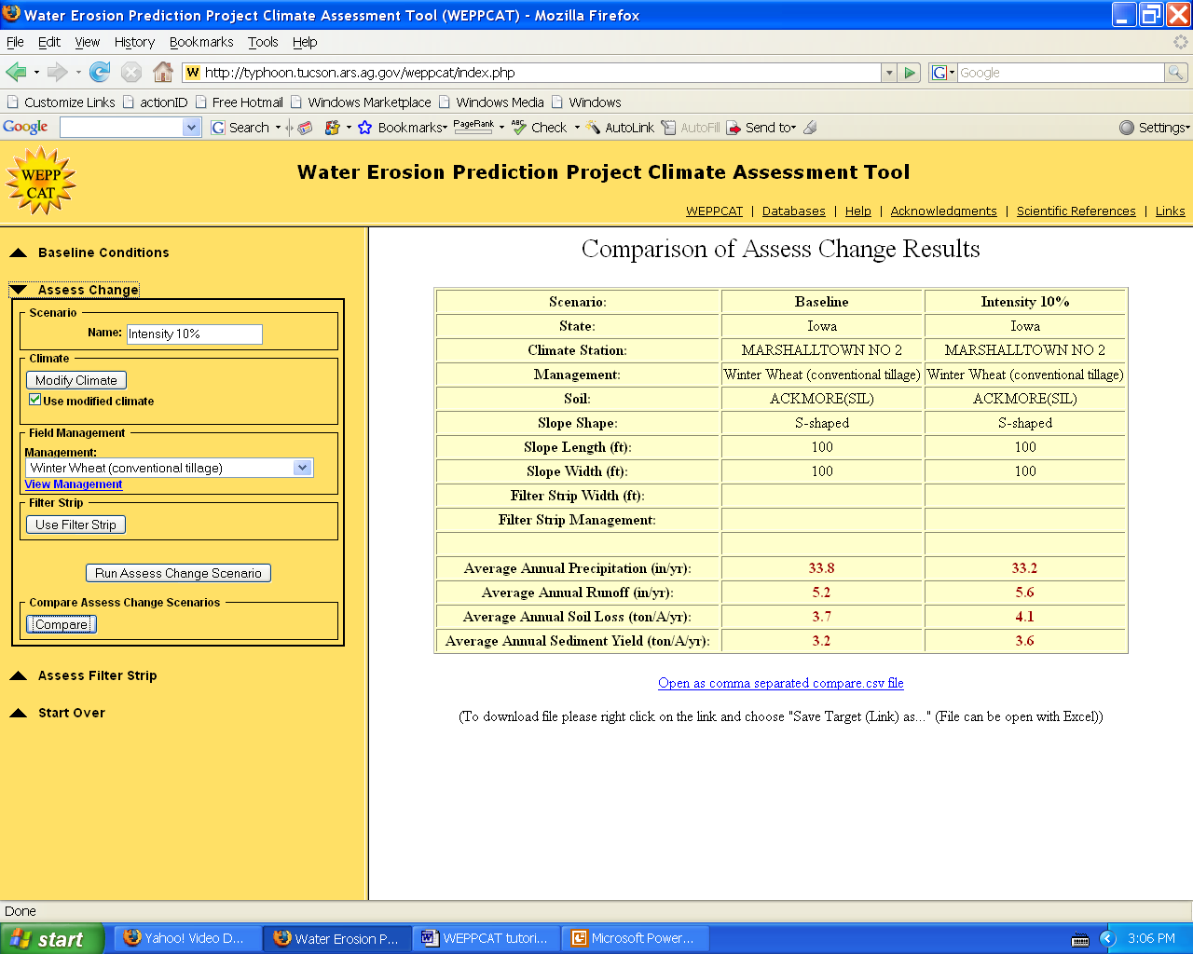

Adjusting total precipitation

Step 1. Type “Total Precip 10%” into the Name field.
Step 2. Press the Modify Climate button. Check to ensure that the use modified climate box is checked.
Step 3. Find the Mean Precipitation column at the right side of the screen. In the bottom box change the value from 0% to 10%.
Step 4. Find the Number of Wet Days column. In the bottom box change the value from 0% to 5%. By increasing the number of wet days by half the amount of the increase in total precipitation, the effect of increasing intensity as a result of increasing total precipitation is minimized. (Pruski and Nearing, 2002)
Step 5. Click the Use these values button at the bottom of the screen.
Step 6. Click the Run Assess Change Scenario button on the left side of the screen. View the results. You should see the results listed below.
Step 7. Click the Compare button to compare the results.

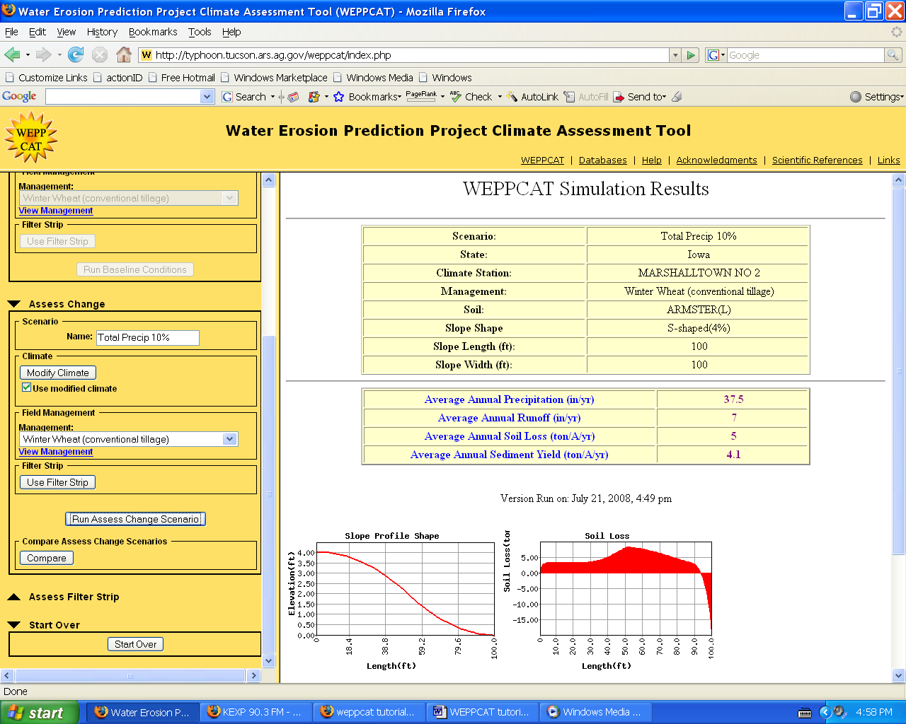

Adjusting total precipitation and intensity

Step 1. Click the Modify Climate button on the left side of the screen.
Step 2. Change the Name field to “TP and Intensity 10%.”
Step 3. Enter 10% in the Intensify Rainfall box.
Step 4. Enter 10% into the Total Mean Precipitation box. Enter 5% into the Total Number of Wet Days box.
Step 5. Click the Use these values button at the bottom of the screen.
Step 6. Click the Run Assess Change Scenario button on the left side of the screen. View the results. You should see the results below.

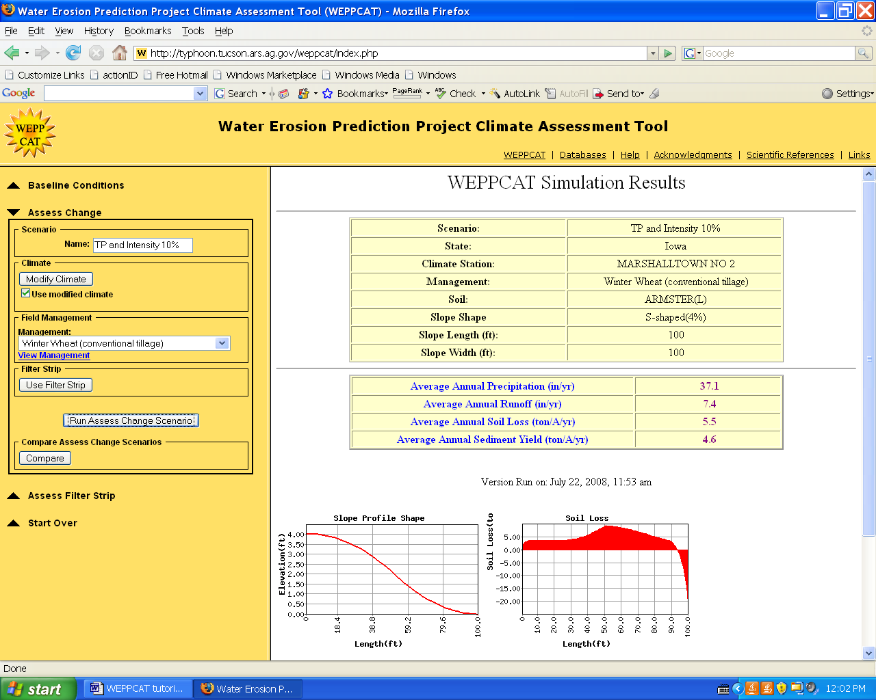

Exporting results to Excel

Step 1. Click the Compare button to view the new results next to the baseline results.
Step 2. Scroll to the bottom of the screen. Click on Open as a comma separated CSV file.
Step 3. At the prompt, make sure that the Open with bubble is filled in. Then click OK.
Step 4. A Microsoft Excel worksheet with your data on it should have opened up. In the upper left hand corner of your document you click on the File tab. Click on Save As.
Step 5. Click on the create new folder icon in the upper right hand corner of the pop up window. Title the new folder WCtutorial.
Step 6. Change the file name at the bottom of the page to Tutorial3.
Step 7. Change the Save as type to Microsoft Excel 97-2002 & 5.0/95 Workbook.
Step 8. Click Save

Step 9. It is much easier to organize and analyze data in Excel or other data analysis programs. You may want to try making a graph to see what it reveals about the data.

Tutorial 4
Objective – Learn to use the filter strip optimization tool

Adding a Filter Strip

Step 1. Click the Start Over drop down tab on the left side of the screen. Then press the Start Over button. Click OK at the prompt that appears.
Step 2. Set the baseline conditions to be exactly the same as they were on the first run. (See image at left)
Step 3. Before running the scenario click Use Filter Strip. Leave the filter strip at ten feet wide with a bluegrass management.
Step 4. Click Run Baseline Conditions.
Step 5. View your results.

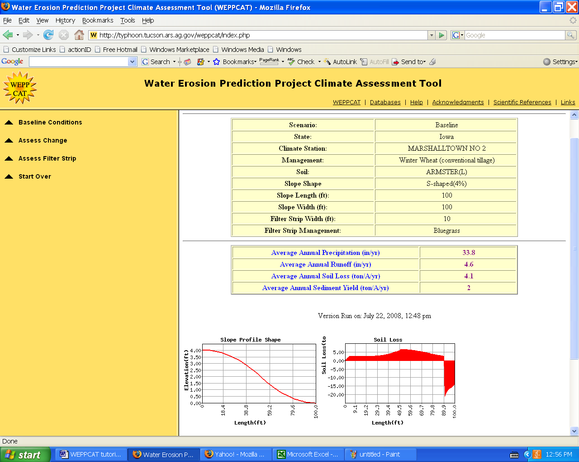

Notice that the soil loss is negative over the length of the buffer strip. If the buffer strip had not been used sediment yield would have been 3.3t/ac/yr, as it was in the second tutorial instead of 2t/ac/yr as it is now.
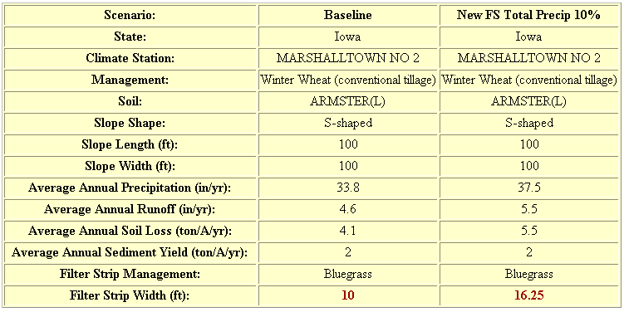

Optimizing a Buffer Strip for Climate Changes

Step 1. Click on the Assess Filter Strip drop down menu, on the left side of the screen.
Step 2. Type “New FS + Total Precip 10%” into the Name field.
Step 3. Press the Modify Climate button. Check to ensure that the use modified climate box is checked.
Step 4. Find the Mean Precipitation column at the right side of the screen. In the bottom box change the value from 0% to 10%.
Step 5. Find the Number of Wet Days column. In the bottom box change the value from 0% to 5%.
Step 6. Click the Use these values button at the bottom of the screen.
Step 7. Click the Compute New Filter Strip button on the left side of the screen. View the results. Note that the new filter strip is 16.25ft wide, but the sediment yield is held constant.
Step 8. Click the Compare button to view the new results next to the baseline results. You should see the results listed below.

Tutorial 5
Objective – Learn to use PRISM to adjust temperature and precipitation for elevation
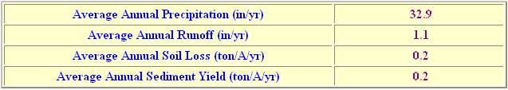
Selecting Baseline Conditions

Step 1. Select a state – In this example select Oregon.
Step 2. Select a climate station – In this examples select ROSEBURG AP.
Step 3. Select a soil type – In this example use ABERT SL.
Step 4. Selecting field dimension – In this example leave the slope length and width at 100ft.
Step 5. Selecting slope shape – In this example use an s-shaped slope.
Step 6. Selecting steepness – In this example use a steepness of 5%
Step 7. Selecting a field management – In this example use fescue.
Step 8. Press the Run Baseline Conditions button.
Step 9. View your baseline results. You should see the results listed below.

When using WEPPCAT in areas that have significantly localized elevations and climates it is important that climate data is adjusted as closely as possible to the actual climate. WEPPCAT uses the PRISM Model to adjust weather patterns to be more like the real climate. This tutorial teaches users how to use the Prism application in WEPPCAT.

Adjusting Total Precipitation and Temperature for Elevation

Step 1. Click on the Assess Change drop down menu, on the left side of the screen.
Step 2. Type “1430ft” into the Name field.
Step 3. Press the Modify Climate button. Check to ensure that the use modified climate box is checked.
Step 4. Click on the PRISM logo in the upper right corner of the screen. You should now see the screen below.

Step 5. Find the elevation grid in the lower right hand corner of the screen. The number in the center box is the elevation of the plot being modeled.
Step 6. Click on 1430 so that it becomes the new elevation of the plot, as is illustrated at right. Note that the PRISM mean precipitation values have changed to account for the new elevation

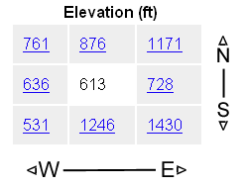 → 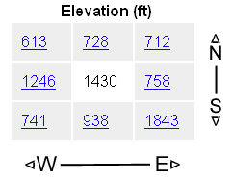
Step 7. Click the Use PRISM values button at the bottom of the screen.
Step 8. Note that the temperature values have not changed with the precipitation values. In order to change the temperature values, check the Adjust temperature for elevation by lapse rate box. The temperature values should change when this box is clicked.
Step 9. Click the Use these values button.
Step 10. Click the Run Assess Change Scenario button on the left side of the screen. Compare your results. You should see the results listed below.
