

**Document: SAP WP2 Early Covid-Vaccine Monitoring**

|  |  |  |  |
| --- | --- | --- | --- |
| **Version** | **Date** | **Authors** | **Changes** |
| 0.1 | 9 Febr 2021 | Rosa Gini | First draft, based on version 0.1 of document DocumentOutputtablesEarly-Covid-Vaccine-MonitorWp2 (4 Feb 2021) |
| 0.3 | 28 Mar 2021 | Rosa Gini | Draft based on agreed output to be produced for WP3 (enclosed as an appendix to this document)  Restricted to what is needed to create the DOSES_BIRTHCOHORTS output table |
|  |  |  |  |
|  |  |  |  |

# Glossary/abbreviations

****ECVM** Early Covid Vaccine Monitoring project**

****AESI** Adverse Events of Special Interest**

*List of AESI*

|  |  |  |
| --- | --- | --- |
| Abbreviation | AESI |  |
|  |  |  |
|  |  |  |
|  |  |  |
|  |  |  |
|  |  |  |
|  |  |  |
|  |  |  |
|  |  |  |
|  |  |  |
|  |  |  |
|  |  |  |
|  |  |  |
|  |  |  |
|  |  |  |
|  |  |  |
|  |  |  |
|  |  |  |
|  |  |  |
|  |  |  |

*List of vaccines*

|  |  |  |
| --- | --- | --- |
| **Abbreviation** | **Vaccine** | **MAH** |
| Pfizer | Comirnaty | BioNTech Manufacturing GmbH |
| Moderna | Covid-19 vaccine Moderna | Moderna |
| AstraZeneca | Covid-19 vaccine AstraZeneca | AstraZeneca |
| J&J | Ad26.COV2.S | Janssen Pharmaceutica |
|  |  |  |

# Contents

1. Data quality
2. Population

2.1 Data Model of main analytical tables (D4) , and transformations from main tables D3 to main tables D4 (T3)

2.2 Data Model of main study variable tables (D3), and transformations from CDM to main tables D3 (T2)

1. Doses

3.1 Data Model of main analytical tables (D4), and transformations from main tables D3 to main tables D4 (T3)

3.2 Data Model of main study variable tables (D3), and transformations from CDM to main tables D3 (T2)

1. Coverage

4.1 Data Model of main analytical tables (D4), and transformations from main tables D3 to main tables D4 (T3)

4.2 Data Model of main study variable tables (D3), and transformations from CDM to main tables D3 (T2)

1. Risk

….

1. Benefit

…

Appendix 1: list of concept sets

Appendix 2: Data model of output for WP3

1. Quality

**D4_code_counts_instance_*conceptset***

**Data model**

Unit of observation: year, code and meaning

Variable(s) representing the unit of observation: year, codevar, meaning

Description: For each concept set, for each complete year YYYY in the study period, this table counts the occurrence of each code, stratified per meaning, in the instance of the CDM

|  |  |  |  |
| --- | --- | --- | --- |
| Variable name | Dictionary of variable name | Dictionary of variable | Description |
| year |  | 2020, 2021 |  |
| codvar |  | All the codes in the concept set |  |
| meaning |  | the dictionary is the dictionary of the ‘meaning’ column of the datasource instance | Could be a concept set of vaccines, drug, or diagnosis |
| count_n |  |  | Number of occurrences of the combination code/meaning |

**Transformation from the CDM**

T2.1 : create the concept set datasets

T2.2 : associate to each record its year of recording and its meaning, and aggregate

**D4_code_counts_study_population_*conceptset***

Unit of observation: year, code and meaning

Variable(s) representing the unit of observation: year, codevar, meaning

Description: For each concept set, for each complete year YYYY in the study period, this table counts the occurrence of each code, stratified per meaning, in the instance of the CDM, associated to a person who is in the study population at least for one day

|  |  |  |  |
| --- | --- | --- | --- |
| Variable name | Dictionary of variable name | Dictionary of variable | Description |
| year |  | 2020, 2021 |  |
| codvar |  | All the codes in the concept set |  |
| meaning |  | the dictionary is the dictionary of the ‘meaning’ column of the datasource instance | Could be a concept set of vaccines, drug, or diagnosis |
| count_n |  |  | Number of occurrences of the combination code/meaning |

**Transformation from the CDM**

T2.1 : create the concept set datasets

*create the study population, see below section ‘Population’*

T2.2 : associate to each record its year of recording and its meaning, discard records not belonging to the study population, and aggregate**D4_ components_*OUTCOME***

…

## 2. Population

## 2.1 Data Model of main analytical tables (D4)

## 

**D4_** **study_population_doses (not to be shared)**

*Unit of observation*: persons in the study population for dose counting, and for all other objectives

*Variable(s) representing the unit of observation*: person_id

*Description:* this table contains the basic information about the study population: demographic characteristics, and date of entry and exit from the study

*Tables that generate this*: D3_selection_criteria_doses

*Transformation (T3):*  the exclusion criteria of D3_selection_criteria_doses

are applied in cascade, in the order listed in the table ; only persons which are negative to all the binary variables are finally included in D4_study_population; the number of persons excluded by each exclusion criterion is included in flowchart (suggestion: use the function CreateFlowchart)

|  |  |  |  |
| --- | --- | --- | --- |
| **Name** | **Description** | **Format/Vocabulary** | **Comments** |
| person_id | unique person identifier | from cdm |  |
| sex | sex at instance creation | from cdm |  |
| date_of_birth | date of birth | yyyymmdd |  |
| date_of_death | date of death | yyyymmdd |  |
| study_entry_date | date when the person enters the study | yyyymmdd |  |
| study_exit_date | date when the person exit the study | yyyymmdd |  |

## flowchart

*Unit of observation*: exclusion criteria

*Variable(s) representing the unit of observation:* A_sex_or_birth_date_missing, B_birth_date_absurd, C_no_observation_periods, D_observation_periods_not_overlapping, E_insufficient_run_in

*Description:* this table describes how many persons each criterion excludes from the study population. The exclusion criteria are applied in cascade, therefore the first line of this table contains only 0’s, and the last contains only 1’s

*Tables that generate this*: D3_selection_criteria_doses

*Transformation (T3):*  the exclusion criteria of D3_selection_criteria_doses

are applied in cascade, in the order listed in the table ; only persons which are negative to all the binary variables are finally included in D4_study_population; the number of persons excluded by each exclusion criterion is included in flowchart (suggestion: use the function CreateFlowchart)

|  |  |  |  |
| --- | --- | --- | --- |
| **Name** | **Description** | **Format/Vocabulary** | **Comments** |
| A_sex_or_birth_date_missing |  | 0 = excluded  1 = included | This exclusion criterion is a quality check |
| B_birth_date_absurd |  | 0 = excluded  1 = included | This exclusion criterion is a quality check |
| C_no_observation_periods |  | 0 = excluded  1 = included | In this study persons with no observation periods cannot be included |
| D_observation_periods_not_overlapping | Exclude subjects whose observations periods do not overlap the study period | 0 = excluded  1 = included | Study period is 1 Jan 2020 – end of data availability. The end of data availability is recommended by the DAP in the variable recommended_end_date of the CDM_SOURCE table of the CDM instance |
| E_insufficient_run_in | If a subject does have an observation period that overlaps the study period, pick the first, named ‘observation period of interest’. Exclude subjects whose observation period of interest’ overlap with the study period ends before the 365th day of the observation period | 0 = excluded  1 = included | this criterion does not apply to persons whose observation period of interest starts with the birth date |
| N |  |  | number of persons in this combination of the criteria |

## 2.2 Data Model of main study variable tables (D3)

**D3_selection_criteria_doses**

*Unit of observation*: all persons in the CDM instance (person_id)

*Measures:* demographic characteristics, study entry and exit date (in case they are included in the study), and a set of binary variables, each indicating an exclusion criterion

*When are measures performed*: just once (at baseline)

*Tables that generate this*: …

*Transformation (T2):*  …

|  |  |  |  |
| --- | --- | --- | --- |
| **Variable** | **Dictionary of variable name** | **Dictionary of variable** | **Description** |
| person_id |  | from cdm | unique person identifier |
| sex |  | from cdm | sex at instance creation |
| date_of_birth |  | yyyymmdd | date of birth |
| date_of_death |  | yyyymmdd | date of death |
| study_entry_date |  | yyyymmdd | date at which subject would enter the study, based upon study period, observation periods, and inclusion criteria |
| study_exit_date |  | yyyymmdd | date at which subject would exit the study, based upon study period, observation periods, and inclusion criteria |
| sex_or_birth_date_missing |  | 0 = to be included 1= to be excluded | sex or birth date mssing |
| birth_date_absurd |  | 0= date ok 1= date absurd | quality check: birth date absurd |
| no_observation_periods |  | 0= yes at least one observation period  1= no observation periods |  |
| observation_periods_not_overlapping | Exclude subjects whose observations periods do not overlap the study period | 0= yes at least one observation period overlaps the study period  1 = no observation period overlaps the study period |  |
| insufficient_run_in | If a subject does have an observation period that overlaps the study period, pick the first, named ‘observation period of interest’. Exclude subjects whose observation period of interest’ overlap with the study period ends before the 365th day of the observation period | 0 = yes the observation period of interest has sufficient run in, or starts at birth date  1 = the observation period of interest has insufficient run in | if the observation period of interest starts at birth date, this exclusion criterion is 0 |

**D3_risk_factors**

*Unit of observation*: all persons in the study_population (person_id)

*Measures:* dates when the person is first observed with each risk factor (if ever)

*When are measures performed*: whenever a risk factor is first observed; the table is wide (one single observation per person)

*Tables that generate this*: …

*Transformation (T2):*  …

|  |  |  |  |
| --- | --- | --- | --- |
| **Variable** | **Dictionary of variable name** | **Dictionary of variable** | **Description** |
| person_id |  | from cdm | unique person identifier |
| date_*riskfactor* | *riskfactor* is one among  "COVCANCER": cancer  "COVCOPD": Chronic obstructive pulmonary disease  "COVHIV": HIV  "COVCKD": chronic kidney disease  "COVDIAB": diabetes  "COVOBES": severe obesity  "COVSICKLE": Sickle disease  “IMMUNOSUPPR”: users of immunosuppressants | date | date when the person is first observed with the risk factor; if the person is never observed with the risk factor, leave empty |

## 3. Doses

## 3.1 Data Model of main analytical tables (D4)

**D4_doses_birthcohorts**

*Unit of observation*: datasource, week, vx_manufacturer, dose, birth_cohort

*Variable(s) representing the unit of observation*: person_id

*Description:* this table contains the number of doses broken down per unit of observations

*Tables that generate this*: D3_doses

*Transformation (T3):*  …

*Note: since this dashoard is meant to represent simple countings, there is no analysis T4 conducted on this D4, therefore it coincides with the output table DOSES_BIRTHCOHORTS*

|  |  |  |  |
| --- | --- | --- | --- |
| **Name** | **Description** | **Format/Vocabulary** | **Comments** |
| week | Monday of the week | YYYYMMDD  eg  20210104 |  |
| vx_manufacturer |  | Pfizer  Moderna  AstraZeneca  J&J  …  all_manufacturers: any manufacturer |  |
| dose |  | 1 = dose 1  2 = dose 2  COMP = complete dose  UKN = unknown dose  any_dose = any dose | complete dose will be 1 for vaccines with 1 dose, and 2 for vaccines with 2 doses |
| birth_cohort | Classification of birth year | <1940  1940-1949  1950-1959  1960-1969  1970-1979  1980-1989  1990+  all_birth cohorts: any age |  |
| N | number of doses administered in this week for this vaccine manufacturer in this birth cohort | int |  |

**D4_doses_riskfactors**

*Unit of observation*: datasource, week, vx_manufacturer, dose, birth_cohort

*Variable(s) representing the unit of observation*: person_id

*Description:* this table contains the number of doses broken down per unit of observations

*Tables that generate this*: D3_doses

*Transformation (T3):*  …

*Note: since this dashoard is meant to represent simple countings, there is no analysis conducted on this D4, therefore it coincides with the output table DOSES_BIRTHCOHORTS*

|  |  |  |  |
| --- | --- | --- | --- |
| **Name** | **Description** | **Format/Vocabulary** | **Comments** |
| week | Monday of the week | YYYYMMDD  eg  20210104 |  |
| vx_manufacturer |  | Pfizer  Moderna  AstraZeneca  J&J  …  all_manufacturers: any manufacturer |  |
| dose |  | 1 = dose 1  2 = dose 2  UKN = unknown dose | complete dose will be 1 for vaccines with 1 dose, and 2 for vaccines with 2 doses |
| riskfactor |  | "COVCANCER": cancer  "COVCOPD": Chronic obstructive pulmonary disease  "COVHIV": HIV  "COVCKD": chronic kidney disease  "COVDIAB": diabetes  "COVOBES": severe obesity  "COVSICKLE": Sickle disease  “IMMUNOSUPPR”: users of immunosuppressants  all_risk_factors: any risk factor |  |
| N | number of doses administered in this week for this vaccine manufacturer in the population with this risk factor | int |  |

## 2.2 Data Model of main study variable tables (D3)

**D3_doses**

*Unit of observation*: all persons in the study population (person_id)

*Measures:*

*When are measures performed*: whenever a dose is recorded, provided this happens between study entry and study exit of the person

*Tables that generate this*: D4_study_population_doses, and the concept set datasets of the COVID vaccines: Pfizer.Rdata, AstraZeneca.Rdata, Moderna.Rdata, …

*Transformation (T2):*  append all concept set datasets, merge with D4_study_population_doses, select only doses administered between study_entry_date and study_exit_date, label vx_dose with the vocabulary of the variable ‘dose’, label vx_date with the corresponding monday

|  |  |  |  |
| --- | --- | --- | --- |
| **Variable** | **Dictionary of variable name** | **Dictionary of variable** | **Description** |
| person_id |  | from cdm | unique person identifier |
| vx_manufacturer |  | Pfizer  Moderna  AstraZeneca  J&J  … |  |
| vx_admin_date |  |  |  |
| vx_dose |  |  |  |
| dose |  |  |  |
| week |  |  | Monday of the week of vx_dose |
|  |  |  |  |
|  |  |  |  |
|  |  |  |  |
|  |  |  |  |

3 Risk

…

## 4 Benefit

…

# Appendix 1: concept sets

# ConcePTION_CDM_tables[["Vaccines"]] contains tables starting with 'VACCIN'

# # ConcePTION_CDM_codvar[["Vaccines"]][[ds]] is 'medicinal_product_id'

# # date is 'vx_admin_date'

# concept_set_domains[["Pfizer"]] = "Vaccine"

# if thisdatasource == 'ARS'{

# concept_set_codes_our_study[["Pfizer"]][[""]] <- c("049269018")

# }

# concept_set_domains[["AstraZeneca"]] = "Vaccine"

# if thisdatasource == 'ARS'{

# concept_set_codes_our_study[["AstraZeneca"]][[""]] <- c("049314026")

# }

# concept_set_domains[["Moderna"]] = "Vaccine"

# if thisdatasource == 'ARS'{

# concept_set_codes_our_study[["Moderna"]][[""]] <- c("049283017")

# }

# Appendix 2: data models for exchange WP2-WP3

version 0.1

file: ECVM_data_model_for_dashboard_v0.3

# Introduction

Four dashboard are planned, similar to those tested during the ADVANCE project

1. dashboard for doses
2. dashboard for coverage
3. dashboard for risk
4. dashboard for benefit

# 1. Dashboard for doses

The original ADVANCE dashboard is shown in Figure 1

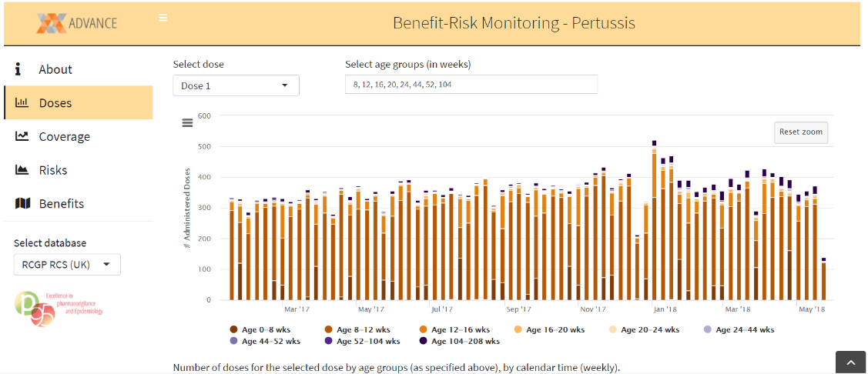

Figure . Dashboard for doses in ADVANCE

In ECVM, the dashboard will be replicated per risk group, so there will be two different data models

The data models are as follows

**DOSES_BIRTHCOHORTS**

|  |  |  |  |
| --- | --- | --- | --- |
| **Name** | **Description** | **Format/Vocabulary** | **Comments** |
| datasource |  | ARS  BIFAP  CPRD  PHARMO |  |
| week | Monday of the week | YYYYMMDD  eg  20210104 |  |
| vx_manufacturer |  | Pfizer  Moderna  AstraZeneca  J&J  …  all_manufacturers: any manufacturer |  |
| dose |  | 1 = dose 1  2 = dose 2  COMP = complete dose  UKN = unknown dose  any_dose = any dose | complete dose will be 1 for vaccines with 1 dose, and 2 for vaccines with 2 doses |
| birth_cohort | Classification of birth year | <1940  1940-1949  1950-1959  1960-1969  1970-1979  1980-1989  1990+  all_birth cohorts: any age |  |
| N | number of doses administered in this week for this vaccine manufacturer in this birth cohort | int |  |

**DOSES_RISKFACTORS**

|  |  |  |  |
| --- | --- | --- | --- |
| **Name** | **Description** | **Format/Vocabulary** | **Comments** |
| datasource |  | ARS  BIFAP  CPRD  PHARMO |  |
| week | Monday of the week | YYYYMMDD  eg  20210104 |  |
| vx_manufacturer |  | Pfizer  Moderna  AstraZeneca  J&J  …  all_manufacturers: any manufacturer |  |
| dose |  | 1 = dose 1  2 = dose 2  COMP = complete dose  UKN = unknown dose  any_dose = any dose | complete dose will be 1 for vaccines with 1 dose, and 2 for vaccines with 2 doses |
| riskfactor |  | "COVCANCER": cancer  "COVCOPD": Chronic obstructive pulmonary disease  "COVHIV": HIV  "COVCKD": chronic kidney disease  "COVDIAB": diabetes  "COVOBES": severe obesity  "COVSICKLE": Sickle disease  “IMMUNOSUPPR”: users of immunosuppressants  all_risk_factors: any risk factor |  |
| N | number of doses administered in this week for this vaccine manufacturer in the population with this risk factor | int |  |

# 2. Dashboard for coverage

The original ADVANCE dashboard is shown in Figure 2

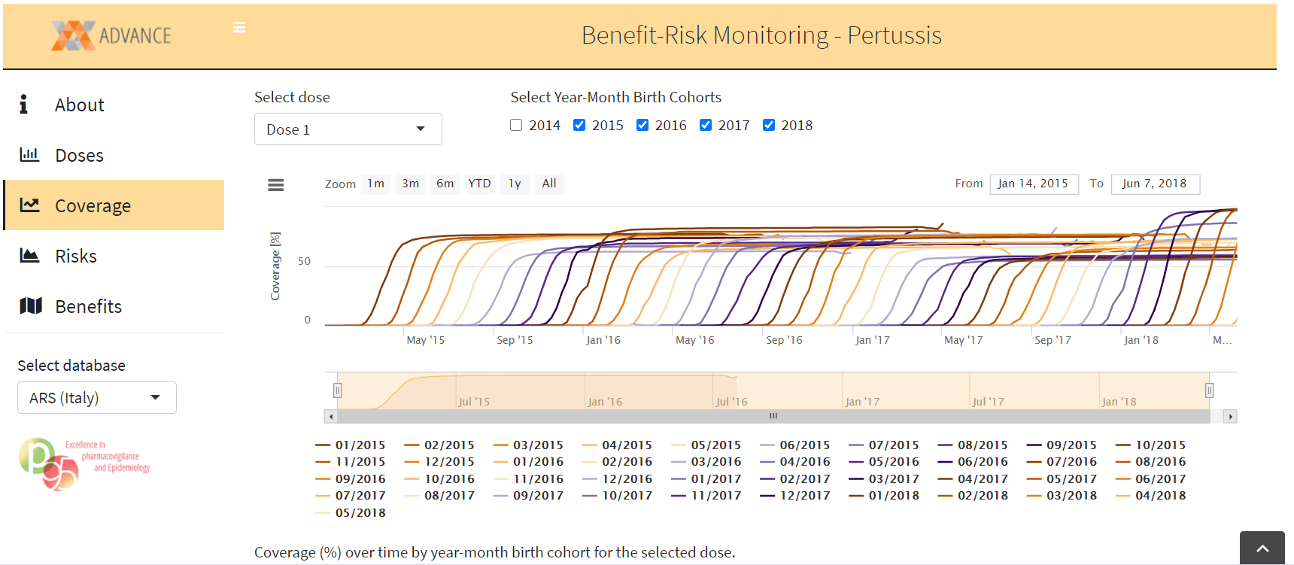

Figure . Dashboard for coverage in ADVANCE

Age bands will be larger in ECVM, and there will be a second version per risk factors, so two data models

**COVERAGE_BIRTHCOHORTS**

|  |  |  |  |
| --- | --- | --- | --- |
| **Name** | **Description** | **Format/Vocabulary** | **Comments** |
| datasource |  | ARS  BIFAP  CPRD  PHARMO |  |
| week | Monday of the week | YYYYMMDD  eg  20210104 |  |
| vx_manufacturer |  | Pfizer  Moderna  AstraZeneca  J&J  …  all_manufacturers: any manufacturer |  |
| dose |  | 1 = dose 1  2 = dose 2  COMP = complete dose  UKN = unknown dose  any_dose = any dose | complete dose will be 1 for vaccines with 1 dose, and 2 for vaccines with 2 doses |
| birth_cohort | Classification of birth year | <1940  1940-1949  1950-1959  1960-1969  1970-1979  1980-1989  1990+  all_birth_cohorts: any age |  |
| percentage | percentage of persons with a record of that dose before or during this week, computed as specified in the protocol | int in [0,100] |  |

**COVERAGE_RISKFACTORS**

|  |  |  |  |
| --- | --- | --- | --- |
| **Name** | **Description** | **Format/Vocabulary** | **Comments** |
| datasource |  | ARS  BIFAP  CPRD  PHARMO |  |
| week | Monday of the week | YYYYMMDD  eg  20210104 |  |
| vx_manufacturer |  | Pfizer  Moderna  AstraZeneca  J&J  …  all_manufacturers: any manufacturer |  |
| dose |  | 1 = dose 1  2 = dose 2  COMP = complete dose  UKN = unknown dose  any_dose = any dose | complete dose will be 1 for vaccines with 1 dose, and 2 for vaccines with 2 doses |
| riskfactor |  | "COVCANCER": cancer  "COVCOPD": Chronic obstructive pulmonary disease  "COVHIV": HIV  "COVCKD": chronic kidney disease  "COVDIAB": diabetes  "COVOBES": severe obesity  "COVSICKLE": Sickle disease  “IMMUNOSUPPR”: users of immunosuppressants  all_risk_factors: any risk factor |  |
| percentage | percentage of persons with a record of that dose before or during this week, computed as specified in the protocol | int in [0,100] |  |

# 3. Dashboard for risk

The original ADVANCE dashboard is shown in Figure 3

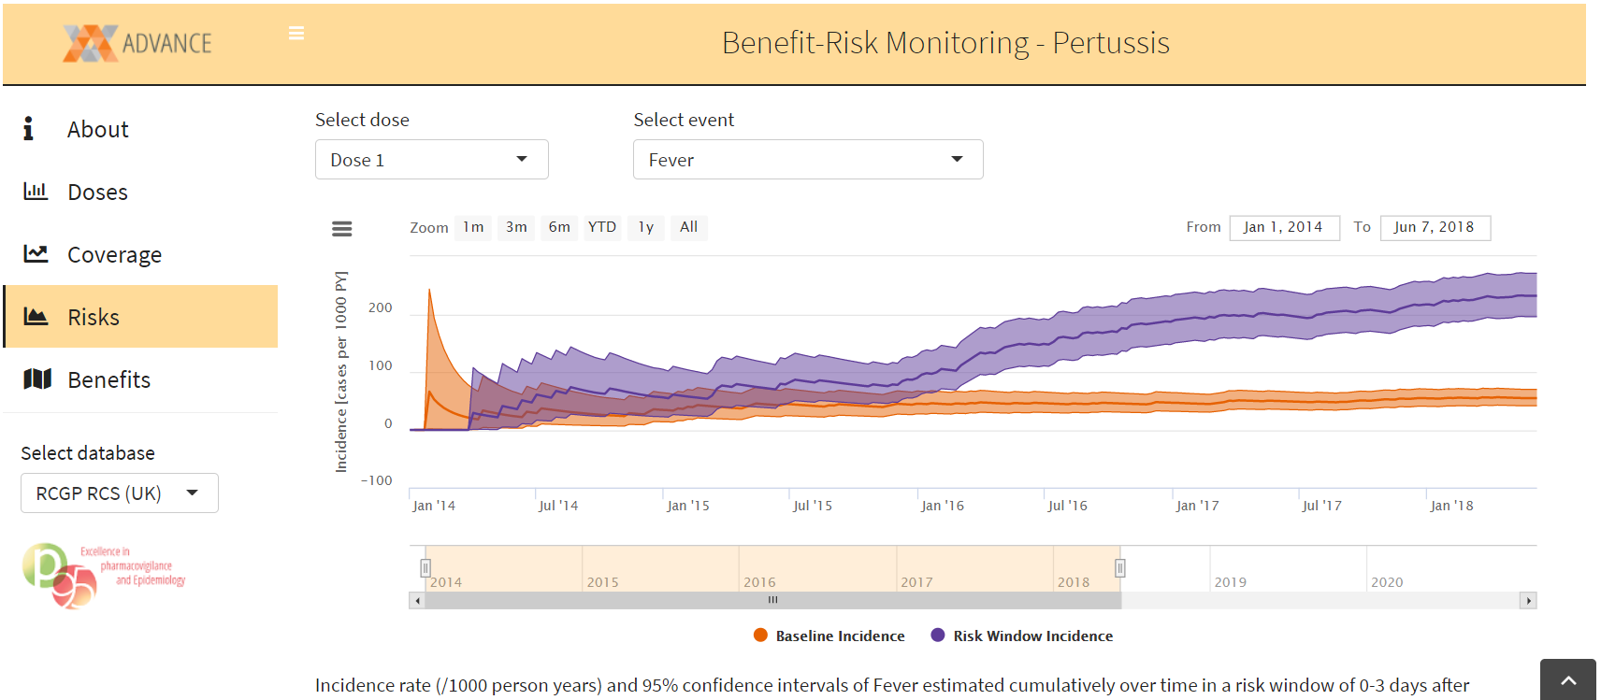

Figure 3. Dashboard for risk in ADVANCE

In ECVM there will four dashboards, two with x time since vaccination, and two with x calendar time. In both cases there will be one curve per age group/at risk + all together + baseline; lines should not be presented all together, but with a possibility to select 2 or more curves to compare. In summary 4 data models

RISK_BIRTHCOHORTS_CALENDARTIME

RISK_RISKFACTORS_CALENDARTIME

RISK_BIRTHCOHORTS_TIMESINCEVACCINATION

RISK_RISKFACTORS_TIMESINCEVACCINATION

**RISK_BIRTHCOHORTS_CALENDARTIME**

|  |  |  |  |
| --- | --- | --- | --- |
| **Name** | **Description** | **Format/Vocabulary** | **Comments** |
| datasource |  | ARS  BIFAP  CPRD  PHARMO |  |
| week | Monday of the week | YYYYMMDD  eg  20210104 | Persons who have a second dose have their person time discarded from the count associated to the first dose |
| vx_manufacturer |  | Pfizer  Moderna  AstraZeneca  J&J  …  none: value for unvaccinated (i.e. dose = no_dose) |  |
| dose |  | 1 = dose 1  2 = dose 2  COMP = complete dose  UKN = unknown dose  any_dose = any dose  no_dose = unvaccinated | complete dose will be 1 for vaccines with 1 dose, and 2 for vaccines with 2 doses  unvaccinated are persons with no past record of any vaccination |
| birth_cohort | Classification of birth year | <1940  1940-1949  1950-1959  1960-1969  1970-1979  1980-1989  1990+  all_birth_cohorts: any age |  |
| AESI |  | CAD = Coronary Artery Disease  GBS = Guillain Barre Syndrome  ADEM = ADEM  NARCOLEPSY = Narcolepsy  ACUASEARTHRITIS = Acute_Aseptic_Arthritis  DM = Diabetes mellitus  IDIOTHROM = Idiopathic thrombocytopenia  MICROANGIO = Microangiopathy  HF = Heart Failure  STRCARD = Stress Cardiomyopathy  ARR = Arrhythmia  MYOCARD = Myocarditis, Pericarditis  COAGDIS = Coagulation disorders  SOCV = Single Organ Cutaneous Vasc  ALI = Acute Liver Injury  AKI = Acute Kidney Injury  GENCONV = Generalized convulsion  MENINGOENC = Meningoencephalitis  ARD = Acute Respiratory Distress  ERYTH = Erythema multiforme  CHILBLAIN = Chilblain like lesions  ANOSMIA = Anosmia, ageusia  ANAPHYL = Anaphylaxis  MISCC = MIS-C  TRANSMYELITIS = transverse myelitis  SUDDENDEAT = Sudden Death | Algorithms for AESI may be multiple, this may affect vocabulary of this variable |
| IR | incidence rate of this AESI in this week in person time already exposed to this dose of this vaccine in the population with this risk factor | float |  |
| lb | lower 95% confidence interval bound for the IR |  |  |
| ub | upper 95% confidence interval bound for the IR |  |  |

**RISK_RISKFACTORS_CALENDARTIME**

|  |  |  |  |
| --- | --- | --- | --- |
| **Name** | **Description** | **Format/Vocabulary** | **Comments** |
| datasource |  | ARS  BIFAP  CPRD  PHARMO |  |
| week | Monday of the week | YYYYMMDD  eg  20210104 | Persons who have a second dose have their person time discarded from the count associated to the first dose |
| vx_manufacturer |  | Pfizer  Moderna  AstraZeneca  J&J  …  none: value for unvaccinated (i.e. dose = no_dose) |  |
| dose |  | 1 = dose 1  2 = dose 2  COMP = complete dose  UKN = unknown dose  any_dose = any dose  no_dose = unvaccinated | complete dose will be 1 for vaccines with 1 dose, and 2 for vaccines with 2 doses  unvaccinated are persons with no past record of any vaccination |
| riskfactor |  | "COVCANCER": cancer  "COVCOPD": Chronic obstructive pulmonary disease  "COVHIV": HIV  "COVCKD": chronic kidney disease  "COVDIAB": diabetes  "COVOBES": severe obesity  "COVSICKLE": Sickle disease  “IMMUNOSUPPR”: users of immunosuppressants  all_risk_factors: any risk factor |  |
| AESI |  | CAD = Coronary Artery Disease  GBS = Guillain Barre Syndrome  ADEM = ADEM  NARCOLEPSY = Narcolepsy  ACUASEARTHRITIS = Acute_Aseptic_Arthritis  DM = Diabetes mellitus  IDIOTHROM = Idiopathic thrombocytopenia  MICROANGIO = Microangiopathy  HF = Heart Failure  STRCARD = Stress Cardiomyopathy  ARR = Arrhythmia  MYOCARD = Myocarditis, Pericarditis  COAGDIS = Coagulation disorders  SOCV = Single Organ Cutaneous Vasc  ALI = Acute Liver Injury  AKI = Acute Kidney Injury  GENCONV = Generalized convulsion  MENINGOENC = Meningoencephalitis  ARD = Acute Respiratory Distress  ERYTH = Erythema multiforme  CHILBLAIN = Chilblain like lesions  ANOSMIA = Anosmia, ageusia  ANAPHYL = Anaphylaxis  MISCC = MIS-C  TRANSMYELITIS = transverse myelitis  SUDDENDEAT = Sudden Death | Algorithms for AESI may be multiple, this may affect vocabulary of this variable |
| IR | incidence rate of this AESI in this week in person time already exposed to this dose of this vaccine in this birth cohort | float |  |
| lb | lower 95% confidence interval bound for the IR |  |  |
| ub | upper 95% confidence interval bound for the IR |  |  |

**RISK_BIRTHCOHORTS_TIMESINCEVACCINATION**

|  |  |  |  |
| --- | --- | --- | --- |
| **Name** | **Description** | **Format/Vocabulary** | **Comments** |
| datasource |  | ARS  BIFAP  CPRD  PHARMO |  |
| week_since_vaccination | week since vaccination with this dose; for unvaccinated … | integer | Persons who have a second dose have their person time discarded from the count associated to the first dose |
| vx_manufacturer |  | Pfizer  Moderna  AstraZeneca  J&J  …  none: value for unvaccinated (i.e. dose = no_dose) |  |
| dose |  | 1 = dose 1  2 = dose 2  COMP = complete dose  UKN = unknown dose  any_dose = any dose  no_dose = unvaccinated | complete dose will be 1 for vaccines with 1 dose, and 2 for vaccines with 2 doses  unvaccinated are persons with no past record of any vaccination |
| riskfactor |  | "COVCANCER": cancer  "COVCOPD": Chronic obstructive pulmonary disease  "COVHIV": HIV  "COVCKD": chronic kidney disease  "COVDIAB": diabetes  "COVOBES": severe obesity  "COVSICKLE": Sickle disease  “IMMUNOSUPPR”: users of immunosuppressants  all_risk_factors: any risk factor |  |
| AESI |  | CAD = Coronary Artery Disease  GBS = Guillain Barre Syndrome  ADEM = ADEM  NARCOLEPSY = Narcolepsy  ACUASEARTHRITIS = Acute_Aseptic_Arthritis  DM = Diabetes mellitus  IDIOTHROM = Idiopathic thrombocytopenia  MICROANGIO = Microangiopathy  HF = Heart Failure  STRCARD = Stress Cardiomyopathy  ARR = Arrhythmia  MYOCARD = Myocarditis, Pericarditis  COAGDIS = Coagulation disorders  SOCV = Single Organ Cutaneous Vasc  ALI = Acute Liver Injury  AKI = Acute Kidney Injury  GENCONV = Generalized convulsion  MENINGOENC = Meningoencephalitis  ARD = Acute Respiratory Distress  ERYTH = Erythema multiforme  CHILBLAIN = Chilblain like lesions  ANOSMIA = Anosmia, ageusia  ANAPHYL = Anaphylaxis  MISCC = MIS-C  TRANSMYELITIS = transverse myelitis  SUDDENDEAT = Sudden Death |  |
| IR | incidence rate of this AESI in this week in person time already exposed to this dose of this vaccine in this birth cohort | float |  |
| lb | lower 95% confidence interval bound for the IR |  |  |
| ub | upper 95% confidence interval bound for the IR |  |  |

**RISK_RISKFACTORS_TIMESINCEVACCINATION**

|  |  |  |  |
| --- | --- | --- | --- |
| **Name** | **Description** | **Format/Vocabulary** | **Comments** |
| datasource |  | ARS  BIFAP  CPRD  PHARMO |  |
| week_since_vaccination | week since vaccination with this dose; for unvaccinated … | integer | Persons who have a second dose have their person time discarded from the count associated to the first dose |
| vx_manufacturer |  | Pfizer  Moderna  AstraZeneca  J&J  …  none: value for unvaccinated (i.e. dose = no_dose) |  |
| dose |  | 1 = dose 1  2 = dose 2  COMP = complete dose  UKN = unknown dose  any_dose = any dose  no_dose = unvaccinated | complete dose will be 1 for vaccines with 1 dose, and 2 for vaccines with 2 doses  unvaccinated are persons with no past record of any vaccination |
| birth_cohort | Classification of birth year | <1940  1940-1949  1950-1959  1960-1969  1970-1979  1980-1989  1990+  all_birth_cohorts: any age |  |
| AESI |  | CAD = Coronary Artery Disease  GBS = Guillain Barre Syndrome  ADEM = ADEM  NARCOLEPSY = Narcolepsy  ACUASEARTHRITIS = Acute_Aseptic_Arthritis  DM = Diabetes mellitus  IDIOTHROM = Idiopathic thrombocytopenia  MICROANGIO = Microangiopathy  HF = Heart Failure  STRCARD = Stress Cardiomyopathy  ARR = Arrhythmia  MYOCARD = Myocarditis, Pericarditis  COAGDIS = Coagulation disorders  SOCV = Single Organ Cutaneous Vasc  ALI = Acute Liver Injury  AKI = Acute Kidney Injury  GENCONV = Generalized convulsion  MENINGOENC = Meningoencephalitis  ARD = Acute Respiratory Distress  ERYTH = Erythema multiforme  CHILBLAIN = Chilblain like lesions  ANOSMIA = Anosmia, ageusia  ANAPHYL = Anaphylaxis  MISCC = MIS-C  TRANSMYELITIS = transverse myelitis  SUDDENDEAT = Sudden Death | Algorithms for AESI may be multiple, this may affect vocabulary of this variable |
| IR | incidence rate of this AESI in this week in person time already exposed to this dose of this vaccine in the population with this risk factor | float |  |
| lb | lower 95% confidence interval bound for the IR |  |  |
| ub | upper 95% confidence interval bound for the IR |  |  |

# 4. Dashboard for benefit

The original ADVANCE dashboard is shown in Figure 4

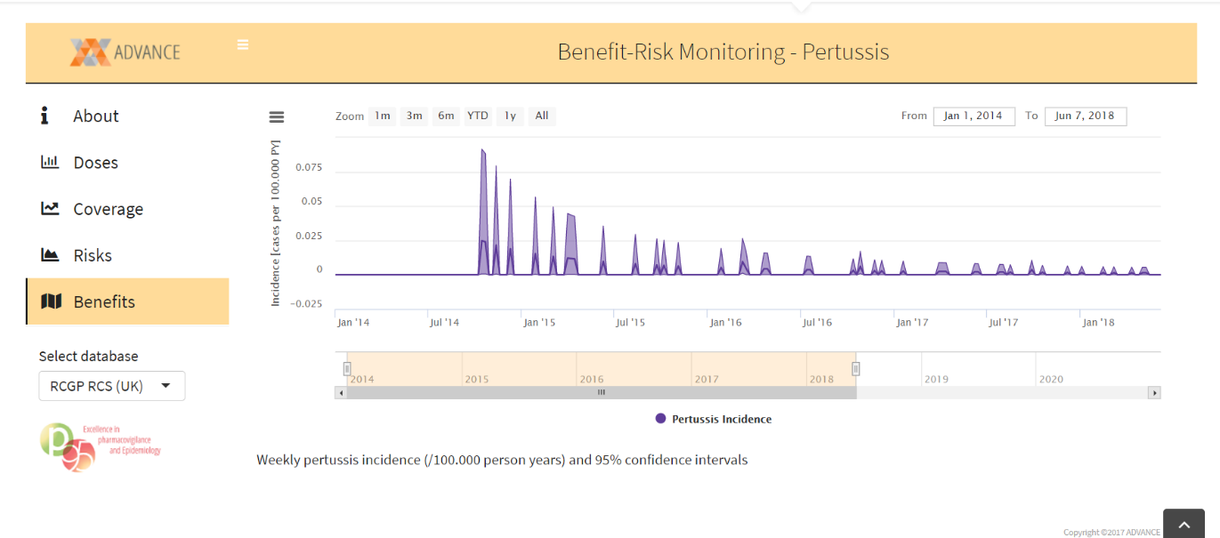

Figure 4. Dashboard for benefit in ADVANCE

In ECVM there will four dashboards, two with x time since vaccination, and two with x calendar time. In both cases there will be one curve per age group/at risk + all together + baseline; lines should not be presented all together, but with a possibility to select 2 or more curves to compare. In summary 4 data models

BENEFIT_BIRTHCOHORTS_CALENDARTIME

BENEFIT_RISKFACTORS_CALENDARTIME

BENEFIT_BIRTHCOHORTS_TIMESINCEVACCINATION

BENEFIT_RISKFACTORS_TIMESINCEVACCINATION

**BENEFIT_BIRTHCOHORTS_CALENDARTIME**

|  |  |  |  |
| --- | --- | --- | --- |
| **Name** | **Description** | **Format/Vocabulary** | **Comments** |
| datasource |  | ARS  BIFAP  CPRD  PHARMO |  |
| week | Monday of the week | YYYYMMDD  eg  20210104 | Persons who have a second dose have their person time discarded from the count associated to the first dose |
| vx_manufacturer |  | Pfizer  Moderna  AstraZeneca  J&J  …  none: value for unvaccinated (i.e. dose = no_dose) |  |
| dose |  | 1 = dose 1  2 = dose 2  COMP = complete dose  UKN = unknown dose  any_dose = any dose  no_dose = unvaccinated | complete dose will be 1 for vaccines with 1 dose, and 2 for vaccines with 2 doses  unvaccinated are persons with no past record of any vaccination |
| birth_cohort | Classification of birth year | <1940  1940-1949  1950-1959  1960-1969  1970-1979  1980-1989  1990+  all_birth_cohorts: any age |  |
| COVID |  | COVID = any recording of COVID-19  COVID_REGISTRY = any recording of COVID  COVID_HOSP = hospitalisation for COVID-19  COVID_DEATH = death due to COVID-19 | Algorithms for COVID may be multiple, this may affect vocabulary of this variable |
| IR | incidence rate of this AESI in this week in person time already exposed to this dose of this vaccine in this birth cohort | float |  |
| lb | lower 95% confidence interval bound for the IR |  |  |
| ub | upper 95% confidence interval bound for the IR |  |  |

**BENEFIT_RISKFACTORS_CALENDARTIME**

|  |  |  |  |
| --- | --- | --- | --- |
| **Name** | **Description** | **Format/Vocabulary** | **Comments** |
| datasource |  | ARS  BIFAP  CPRD  PHARMO |  |
| week | Monday of the week | YYYYMMDD  eg  20210104 | Persons who have a second dose have their person time discarded from the count associated to the first dose |
| vx_manufacturer |  | Pfizer  Moderna  AstraZeneca  J&J  …  none: value for unvaccinated (i.e. dose = no_dose) |  |
| dose |  | 1 = dose 1  2 = dose 2  COMP = complete dose  UKN = unknown dose  any_dose = any dose  no_dose = unvaccinated | complete dose will be 1 for vaccines with 1 dose, and 2 for vaccines with 2 doses  unvaccinated are persons with no past record of any vaccination |
| riskfactor |  | "COVCANCER": cancer  "COVCOPD": Chronic obstructive pulmonary disease  "COVHIV": HIV  "COVCKD": chronic kidney disease  "COVDIAB": diabetes  "COVOBES": severe obesity  "COVSICKLE": Sickle disease  “IMMUNOSUPPR”: users of immunosuppressants  all_risk_factors: any risk factor |  |
| COVID |  | COVID = any recording of COVID-19  COVID_REGISTRY = any recording of COVID  COVID_HOSP = hospitalisation for COVID-19  COVID_DEATH = death due to COVID-19 | Algorithms for COVID may be multiple, this may affect vocabulary of this variable |
| IR | incidence rate of this AESI in this week in person time already exposed to this dose of this vaccine in the population with this risk factor | float |  |
| lb | lower 95% confidence interval bound for the IR |  |  |
| ub | upper 95% confidence interval bound for the IR |  |  |

**BENEFIT_BIRTHCOHORTS_TIMESINCEVACCINATION**

|  |  |  |  |
| --- | --- | --- | --- |
| **Name** | **Description** | **Format/Vocabulary** | **Comments** |
| datasource |  | ARS  BIFAP  CPRD  PHARMO |  |
| week_since_vaccination | week since vaccination with this dose; for unvaccinated … | integer | Persons who have a second dose have their person time discarded from the count associated to the first dose |
| vx_manufacturer |  | Pfizer  Moderna  AstraZeneca  J&J  …  none: value for unvaccinated (i.e. dose = no_dose) |  |
| dose |  | 1 = dose 1  2 = dose 2  COMP = complete dose  UKN = unknown dose  any_dose = any dose  no_dose = unvaccinated | complete dose will be 1 for vaccines with 1 dose, and 2 for vaccines with 2 doses  unvaccinated are persons with no past record of any vaccination |
| riskfactor |  | "COVCANCER": cancer  "COVCOPD": Chronic obstructive pulmonary disease  "COVHIV": HIV  "COVCKD": chronic kidney disease  "COVDIAB": diabetes  "COVOBES": severe obesity  "COVSICKLE": Sickle disease  “IMMUNOSUPPR”: users of immunosuppressants  all_risk_factors: any risk factor |  |
| COVID |  | COVID = any recording of COVID-19  COVID_REGISTRY = any recording of COVID  COVID_HOSP = hospitalisation for COVID-19  COVID_DEATH = death due to COVID-19 | Algorithms for COVID may be multiple, this may affect vocabulary of this variable |
| IR | incidence rate of COVID in this week in person time already exposed to this dose of this vaccine in this birth cohort | float |  |
| lb | lower 95% confidence interval bound for the IR |  |  |
| ub | upper 95% confidence interval bound for the IR |  |  |

**BENEFIT_RISKFACTORS_TIMESINCEVACCINATION**

|  |  |  |  |
| --- | --- | --- | --- |
| **Name** | **Description** | **Format/Vocabulary** | **Comments** |
| datasource |  | ARS  BIFAP  CPRD  PHARMO |  |
| week_since_vaccination | week since vaccination with this dose; for unvaccinated … | integer | Persons who have a second dose have their person time discarded from the count associated to the first dose |
| vx_manufacturer |  | Pfizer  Moderna  AstraZeneca  J&J  …  none: value for unvaccinated (i.e. dose = no_dose) |  |
| dose |  | 1 = dose 1  2 = dose 2  COMP = complete dose  UKN = unknown dose  any_dose = any dose  no_dose = unvaccinated | complete dose will be 1 for vaccines with 1 dose, and 2 for vaccines with 2 doses  unvaccinated are persons with no past record of any vaccination |
| birth_cohort | Classification of birth year | <1940  1940-1949  1950-1959  1960-1969  1970-1979  1980-1989  1990+  all_birth_cohorts: any age |  |
| COVID |  | COVID = any recording of COVID-19  COVID_REGISTRY = any recording of COVID  COVID_HOSP = hospitalisation for COVID-19  COVID_DEATH = death due to COVID-19 | Algorithms for COVID may be multiple, this may affect vocabulary of this variable |
| IR | incidence rate of COVID in this week in person time already exposed to this dose of this vaccine in the population with this risk factor | float |  |
| lb | lower 95% confidence interval bound for the IR |  |  |
| ub | upper 95% confidence interval bound for the IR |  |  |