**Project Report**

# Project Title:

2D Chess with Adaptive AI Opponent

Course: Artificial Intelligence

Instructor: Ms. Ayesha Almas Ansari

# Submitted By:

Arsam Uzair (22K-5006)  
Syed Shaheer Hussaini (22K-5111)  
Muhammad Haris Sheikh (22K-5064)

Submission Date: 09-05-2025

# 1. Introduction

Chess has long been a benchmark for AI development due to its well-defined rules and strategic depth. Traditional 2D chess, however, presents a limited spatial challenge compared to emerging multi-dimensional game variants. This project proposes and implements a 2D chess game incorporating vertical movement and spatial complexity, along with an AI opponent capable of analyzing and adapting to the 2D board using a modified Minimax algorithm with Alpha-Beta pruning.

# 2. Project Objectives

- To design and develop a 2D chess variant with layered gameplay mechanics.  
- To create a competitive AI opponent that can analyze 2D board states and adapt strategies accordingly.  
- To explore the increased computational and strategic complexity introduced by three-dimensional movement.  
- To implement real-time multiplayer support and an engaging user interface using modern frontend tools.

# 3. Game Description

**3.1 Traditional Background:**Chess is played on an 8x8 board with each player maneuvering pieces that have unique movement rules. The goal is to checkmate the opponent's king.  
  
**3.2 Innovations Introduced:**  
- 2D Layered Board: The game extends the classic 8x8 board into three layers (8x8x3), allowing vertical piece transitions.  
- Vertical Movement: New mechanics include pawns promoting on any final-layer cell and bishops/knights operating across 2D space.  
- Stacked Checkmate: A novel win condition wherein the king is simultaneously threatened across all layers.  
- Multiplayer Support: Integration of a real-time online mode with chat features.

# 4. Impact on Gameplay

- Adds strategic depth and spatial complexity.  
- Requires increased AI processing due to larger branching factors.  
- Offers a visually dynamic experience compared to flat chess boards.

# 5. AI Methodology

**5.1 Techniques Used:**- Modified Minimax Algorithm: Designed to evaluate 2D positions and forecast multiple move outcomes.  
- Alpha-Beta Pruning: Enhances efficiency by eliminating suboptimal paths during decision trees.  
- Custom Heuristics: Integrates traditional chess piece values with 2D-specific evaluation metrics.  
  
**5.2 Heuristic Components:**  
- Material Value: Traditional piece scoring with bonuses for vertical control.  
- Positional Advantage: Rewards central and multi-layer dominance.  
- King Safety: Penalizes positions with high vulnerability across planes.  
  
**5.3 Complexity Analysis:**  
- Time Complexity: O(b^d), where b (branching factor) increases by ~30% due to 2D movement, averaging 35 legal moves per turn.  
- Challenges: Includes optimizing performance for real-time play, especially on larger state trees.

# 6. Game Rules and Mechanics

**6.1 Modified Movement Rules:**  
- Pawns: Promote when reaching any opposing side across layers.  
- Bishops: Move diagonally across 2D planes.  
- Knights: Perform L-shaped moves in 2D, including vertical hops.  
  
**6.2 Win Conditions:**  
- Standard checkmate.  
- Stacked Checkmate: A new condition where a king is under threat across all layers simultaneously.

# 7. Implementation Plan

**7.1 Technology Stack:**  
- Frontend: React.js, Three.js (for 2D rendering), Material-UI.  
- Backend: Python Flask, Socket.IO (for real-time multiplayer).  
- AI: NumPy, optional TensorFlow module for future reinforcement learning.  
  
**7.2 Timeline & Milestones:**  
Weeks 1–2: Finalize 2D board structure and UI elements  
Weeks 3–4: Implement 2D movement validation and game state logic  
Weeks 5–6: Develop Minimax-based AI with 2D heuristics  
Week 7: Integrate AI with UI and optimize pruning performance

# 8. Conclusion

This project combines the strategic legacy of chess with modern AI advancements and 2D visualization. The adaptive AI, coupled with innovative mechanics like stacked checkmate and 2D movement, introduces new layers of strategy and engagement. The final product aims to be both a technical demonstration of AI application and a fresh take on one of the oldest games in history.

# 9. Visuals

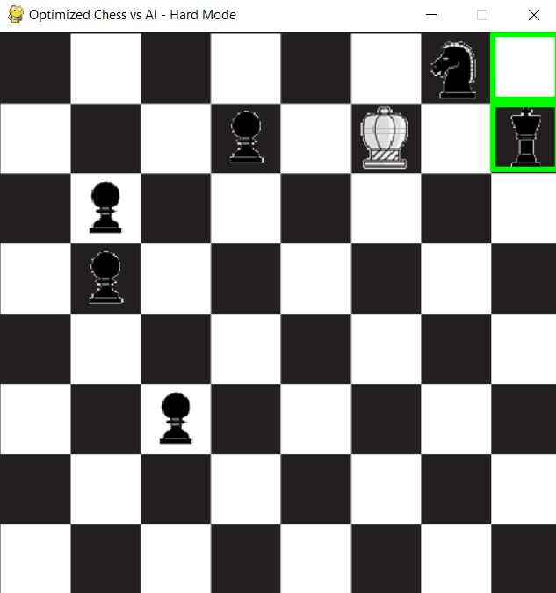

# 10. References

- Russell, S., & Norvig, P. (2020). Artificial Intelligence: A Modern Approach.  
- Chess Programming Wiki – Heuristics and Evaluation.  
- Three.js Documentation.  
- Chess.com – 2D Chess Variants.