 

AEROTHON 23

TEAM

ALTITUDE

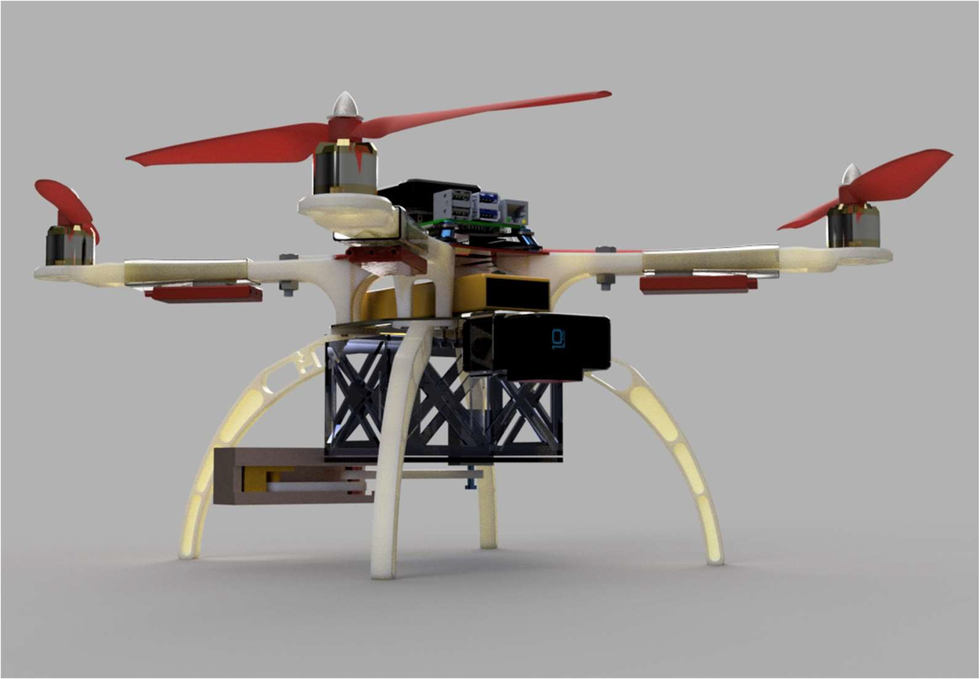

**Team Members**

PRATHVIRAJ CHAVAN SAIKISHORE NAIDU SOHAM KUMTHEKAR SHREYASH AVHAD CHINMAY SANAP VIJAYSINGH RAJPUT

 

**INDEX**

|  |  |  |  |
| --- | --- | --- | --- |
| **SR.NO** | **Title** | | **Page No.** |
| 1. | **Conceptual Design** | |  |
| 2. | **Preliminary Weight Estimation** | |  |
| 3. | **Propulsion system** | |  |
| 3.1 | | *Propulsion System Selection* |  |
| 5. | **Drone Performance** | |  |
| 6. | **Preliminary CAD model** | |  |
|  | **Computational Analysis** | |  |
| 9. | **Material Selection** | |  |
| 10. | **Subsystem Selection** | |  |
|  | 10.1 | *Communication system* |  |
|  | 10.2 | *Control & Navigation System* |  |
| 11. | **Final Design & Calculations** | |  |
| 12. | **Final Specifications and Bill of materials** | |  |
|  | **Methodology of Autonomous Operations** | |  |
|  | **Innovations** | |  |

 

##### Conceptual design:

1. We studied various designs including symmetric, asymmetric, pull-type, push-type, and many fast-moving quadcopters among others. Of these, we found that the basic symmetrical X-type design with pull-type rotors fitted our requirements the best and in feasible conditions.
2. We referred to the internet for drone sizing and came across the standard empirical ratios for frame sizing across rotors as per the size of propellers. As we happen to choose the 10” dual blade props to hover our UAV, the standards say that the frame size across rotors should be 469mm.
3. The ESCs would be mounted on the rotor arms, thus, the size of ESC was the nominal required size for it, plus some clearance; similarly, the ends of the arms would hold the rotors, thus, motor diameter was the nominal size for rotor-arm ends, plus some clearance for ease of fittings. As the rotor arm is webbed from the sides, it aids a good flow of air through it. We then estimated the total area required to mount all other components.
4. The design consists of a Payload mechanism for lifting the load and dropping it at a particular location. Also camera for capturing the images and identifying the target .
5. Basically it’s an X-shaped frame with 4 motors at the end of each arm. The battery is inserted space between two disks. Payload and camera is attached at bottom of lower plate with suitable joints .
6. We have tried to enhance the setup for achieving max performance. We have tried several materials for the frame and changed some mechanisms for increasing stability and quick replacement of damaged parts

##### Preliminary Weight Estimation:

For the drone, we are using the frame of ABS materials with standard dimensions of the baseplate. Also using an BLDC motor attached to arms with ESC and 10” propeller. It consists of payload of a Crank-shaft double flap mechanism for lifting the given load.

|  |  |  |  |  |
| --- | --- | --- | --- | --- |
| **Sr.No** | **Items** | **Weight (Gm)** | **No. of Items** | **Total Weight (Gm)** |
| 1. | Frame (ARM) | 50 | 4 | 200 |
| 2. | Base plate | 45 | 2 | 90 |
| 3. | Motor | 50 | 4 | 200 |
| 4. | Camera | 125 | 1 | 125 |
| 5. | Payload Mechanism | 350 | 1 | 350 |
| 6. | battery | 394 | 1 | 394 |
| 7. | gimble | 200 | 1 | 200 |

 

|  |  |  |  |  |
| --- | --- | --- | --- | --- |
| 8. | Propeller | 25 | 4 | 100 |
| 9. | ESC | 25.5 | 4 | 102 |
| 10. | FC & GPS | 75 | 1 | 75 |
| 11. | Other Electronic  Components | 150 | 1 | 150 |
| Total :(Apprx.) | | | | 1993 |

*Total Drone mass (Apprx.) = 2Kg*

## Propulsion System Selection :

We have designed a quadcopter with dual-blade propellers and its advantages of the quadcopter (4 propellers) are :

1. It is preferred that drones have an even number of rotors to balance the forces applied by each rotor. A quadcopter provides four points that offer variable thrust.
2. The even number of propellers allows to balance of the craft in several ways. Four points offering variable thrust enable the craft to maintain position in the air and a relatively stable hover.
3. It is the most economical way to produce a drone.
4. Controlled maneuverability

D. NO. OF BLADES

1. The main talking points here are thrust and efficiency.
2. Also, 2-blade propellers are a. easy to carry b. durable in case of collisions due to their flexibility
3. They also have a low price.
4. Highly responsive to changes made to the RPM.
5. A 3 blade will create higher amount of thrust and stability, but is heavier and slower in operation along with increased battery consumption.
6. A 2-blade propeller is more likely to rotate out of the way in case the drone goes down, whereas a 3-blade propeller is prone to damage in any kind of crash.
7. However, the double blade propeller provides enough thrust, and its work efficiency is optimum along with its other salient features and advantages, as per the required design

 

. E. SPECIFICATION:

1. Material: Carbon Fibre
2. Size: 10 × 4.5''
3. Weight: 25 g per pair
4. Center bore diameter: 5mm
5. Hole size: 3mm
6. Hole size: 5mm

#### Image of propeller :

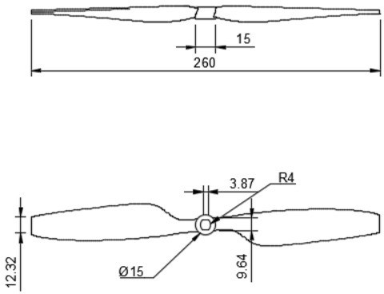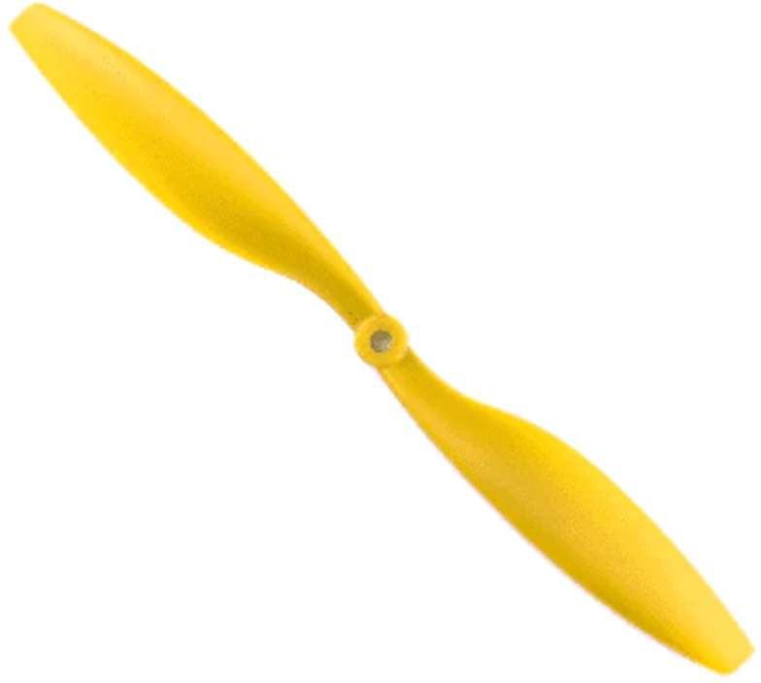

Fig. 1045 Carbon fiber propeller

 

**Drone Performance :**

* 1. THE BENCH TEST:

The This test Is performed to check the motor speed at different current, maximum current drawn by the motor, compatibility of battery and motor and theoretical flight time estimation.

* + 1. Connect one motor to the Esc, Servo motor tester and then to the battery.
    2. Clamp the motor to the restrict its displacement.
    3. Connect the ammeter to the motor.
    4. Record the values (battery consumed by the motor) for the full throttle and for thrust required.
    5. Calculate the change in current, time, RPM, and voltage.
    6. Calculate the total flight time with the current.

2 RESULTS OBTAINED FROM BENCH TEST: - Table 4 -

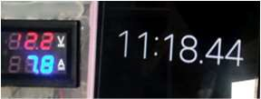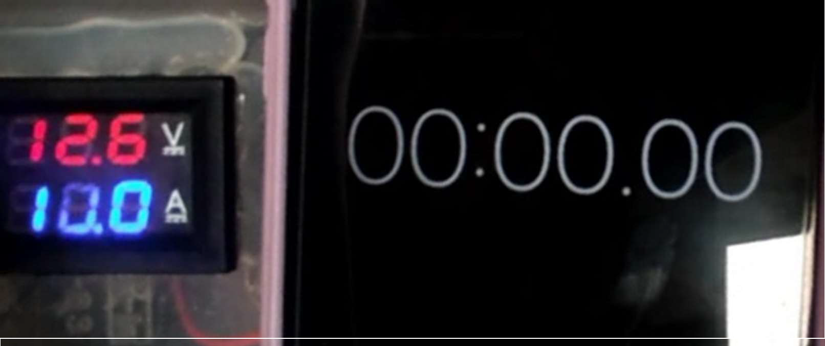

|  |  |
| --- | --- |
| Input Voltage(V) | Current(A) |
| 12.6 | 10 |
| After 11.18min | |
| 12.2 | 7.8 |

1. From this, we can see that the total voltage drop is just 0.4volt.
2. The Maximum RPM (Rotations per minute) achieved in this test is 10,000 rotations per minute.
3. And maximum current drawn from the battery is 20 A when the load is applied even at loading conditions, the temperature rise of the motor is within the permissible limit.
4. During loading, we observed that there is no loss in speed i.e., it runs smooth. We concluded

that the selected motor is best for drone design as its working and efficiency are high.

1. The supreme power of a motor is also something to take into consideration. Exceeding the motor's power restriction would result in the motor heating up and thus harshly lowering its efficiency. For the identical KV value, a motor from one brand may perform better than others.

 

That is why we executed the test on our motor before building a drone around it. Manufacturers’ data can give you knowledge of which motors and propellers will work in your design, but testing is not standardized, so it is impossible to compare parts across manufacturers.

* 1. THE RESASONS FOR SELECTION OF DYS D2826-15 930KV Outrunner Brushless Drone motor:

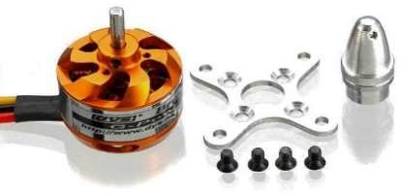

Fig. Motor

* + 1. The net weight of our quadcopter is 2kg. To get optimum thrust from motor we selected this motor which gives 1000g torque when applying 3s LiPo battery.
    2. This motor gives 905 rpm per volt.
    3. We have used 3 cells of LiPo battery.

Each cell gives 3.7volt so net voltage obtained by the 3 pack of cells is11.1 Volt.

* + 1. So each motor gets voltage according to required rpm and thrust requirement.
    2. To get practical information about motor we performed bench test.

 

* 1. **TECHNICAL SPECIFICATION OF BLDC MOTOR**: - Table 5 -

|  |  |
| --- | --- |
| Parameter | Value |
| Brand name | DYS |
| Type | D2826-15 |
| Operating Voltage | 7.2v~11.1v |
| KV rating | 930 RPM/V |
| Max. Watt | 130 W |
| Thrust/ Motor | 960 gm |
| ESC required | 40A |
| Cell Count | 3S(Li-po) |
| Shaft Diamter | 3mm |
| Shaft length | 10 mm |
| Weight | 60gm |

###### Orthographic views of BLDC Motor

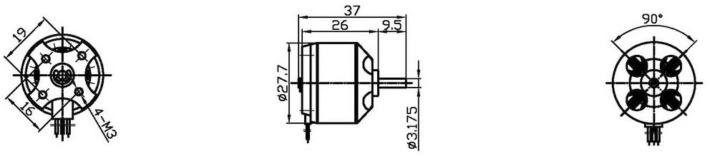

Orthographic views of BLDC Motor

 

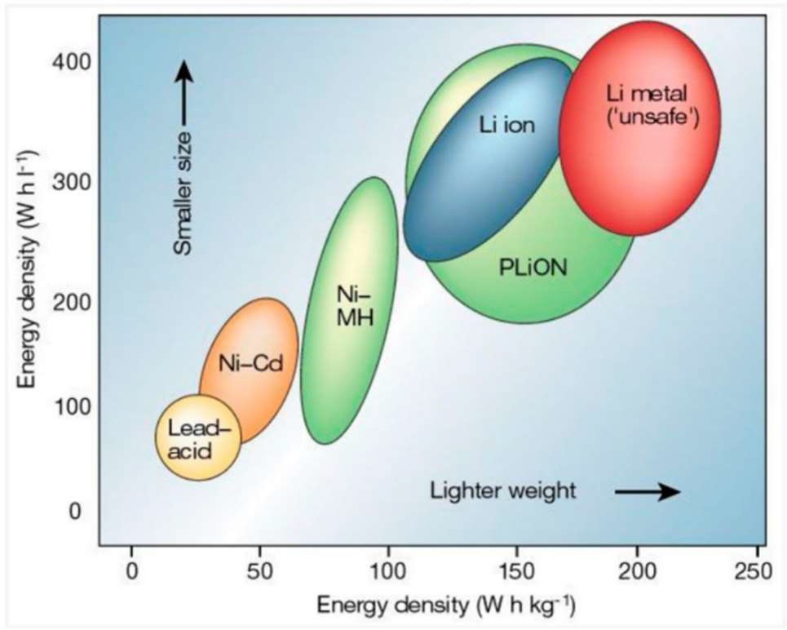**BATTERY** (Part No. 3)

1. Selection Process of our battery:
   1. LI-ion has more specific energy than Li-po but the problem is it’s more volatile, prone to damage when exposed to high temperatures, heavier and loses its charging Capacity, and could burst if the separator is damaged.
   2. On comparing Ni-MH and Li-Po

battery, Ni-MH was found to have low Power to weight ratio and the cell voltage is just 1.2 V.

Comparison graph of various batteries

* 1. Hence, we selected Lithium Polymer Battery.

1. **Calculations**:
   1. Voltage Required for our drone is approximately =11Volts
   2. Average value of voltage given by 1 cell of Li-Po=3.7 V
   3. no. of cells required=11/3 ~ 3 cells. Hence, 3S battery.
   4. Since we are using Li-Po batteries, (it shouldn’t be discharged completely the cycle goes from

3.2 v- 4.2 volts. If the voltage goes below 3.2volts the battery, it shortens battery’s lifetime.

* 1. Effective Capacity= (3.3/4.2) = 0.78
  2. Current drawn by other electronics is much less than the current drawn by the motor, hence, we have neglected those value, but added the buffer required while selection
  3. Calculating the flight time after using motors at max.
  4. Flight time in minutes = ((Battery amp)/(Motor amp)) × Effective Capacity × 60
  5. Max. motor Amp = 11.7 A.
  6. Battery Amp = 5 A
  7. Flight time in minutes = (5/11.7) × 0.78 × 60
  8. Flight time at full throttle = 19.98 minutes,
  9. This value of actual flight time will be more than this since we would not use our motor at

 

maximum capacity.

BATTERY SELECTED: 3S (11.1V), 5000MAH, 50C LI-PO BATTERY

1. Other Specifications of Li-Po:
   1. Weight: 354grams (Minimum weight in Class),
   2. Dimensions: 150 × 45× 20 mm3
   3. Maximum discharge Rate :50C (310A),
   4. Open-Circuit Voltage: 12.45~12.60V（Cell 4.15~4.20V)
   5. Discharge connector: XT 60

**Electronic components Table** (Table 6)

|  |  |  |
| --- | --- | --- |
| **Sr.**  **No.** | **Component** | **Specification** |
| 1 | Pixhawk V2.4.8 flight controller (part no. 6) | * Dimensions:   Flight controller: 82 x 50 x 16 mm   * Weight: 40gm * Processors:  1. 32bitSTM32F427 CortexM4core with FPU 2)32bitSTM32F103 failsafe co-processor.    * Sensors: 2. L3GD20H 16bit gyroscope 3. LSM303D 14bit   accelerometer/magnetometer   1. Invensense MPU6000 3axis accelerometer/ gyroscope |
| 2 | Holybro Pixhawk 4 Neo M8N GPS Module | * 25 x 25 x 4 mm ceramic patch antenna * 32 grams with the case. |

 

|  |  |  |
| --- | --- | --- |
| 3 | Camera : GoPro 8 camera | * Removable rechargeable battery * Max video bit rate: 100 Mbps * Max lens aperture: f/2.8 * Max ISO range: 100-3200 * Wi-Fi and Bluetooth connectivity |
| 4 | Power distribution board and base for flight controller | * Dimensions:180 x 118 x 2mm * Weight:94 gm |
| 5 | Electronic speed controller | ReadytoSky 40A 2-4S ESC for Drone   * BEC output: 5V 3A. * Weight (gm) 34 |

 

|  |  |  |
| --- | --- | --- |
| 6 | FlySky CT6B 2.4GHz 6CH Transmitter with FS- R6B Receiver | * No. of Channels: 6 * Bandwidth: 500 kHz * Operating Voltage: 12V DC (1.5AA x 8 Battery) |
| 7 | Servo Motor | TowerPro MG90S Mini Digital Servo Motor (180° Rotation)   * Weight: 13 gm * Operating voltage: 4.8V~ 6.6V * Dimensions: 12.4 x 22.8 x 32.5 mm3. |

 

**Connections Diagram :**

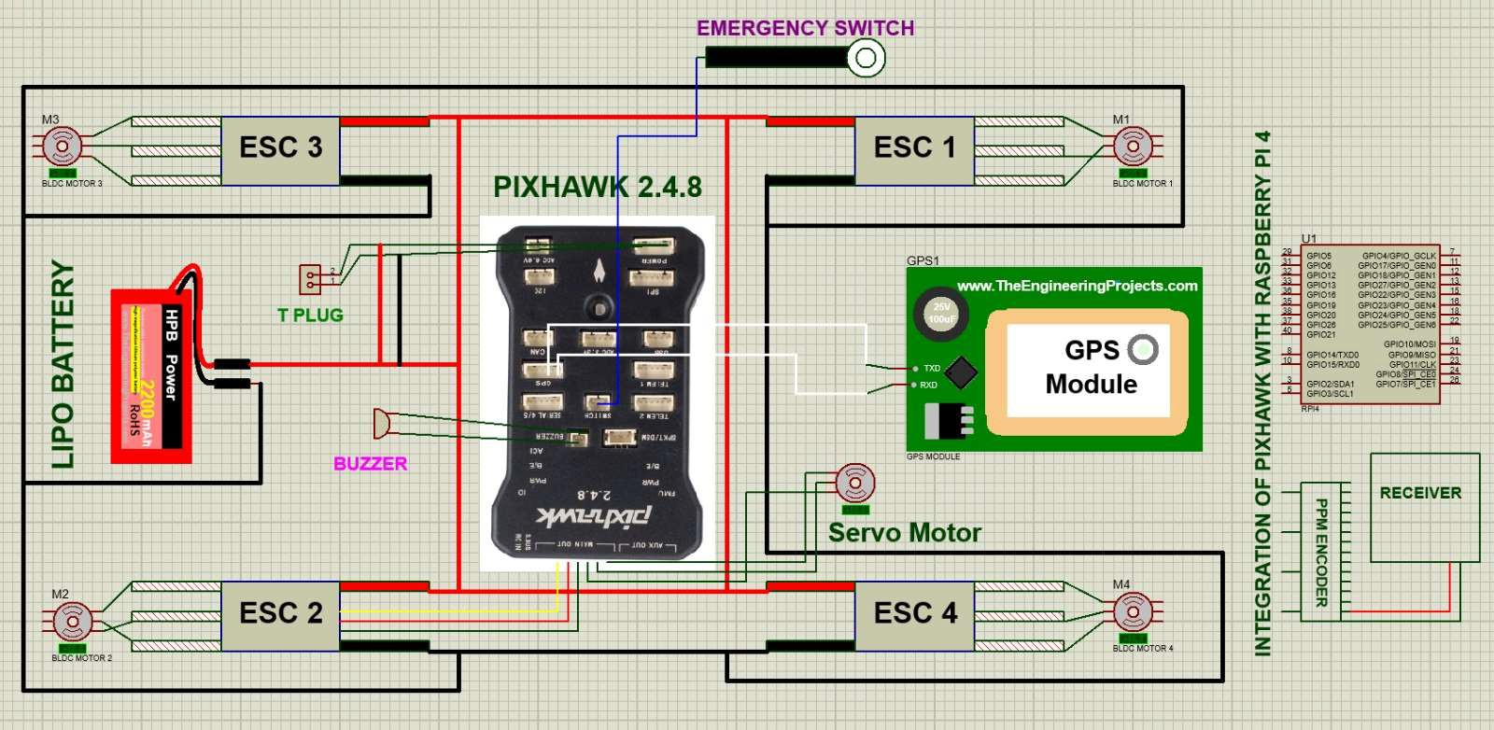

#### Stability Analysis :

Here, a. F1 = Weight of 2 motors = 2 x 60 gm-f = 120gm-f = 1.177 N

1. F2 = Weight of 2 ESCs = 2 x 34 gm-f = 46 gm-f = 0.667N
2. F3 = Weight of Battery = 354 gm-f = 3.472N
3. F4 = Weight of (Flight Control Module + Standard Base Board) = (23 + 51) gm-f = 0.726N
4. Calculating Moment about Axis O-O (↻ +, ↺ -)
   1. From Right Side:

 

* + 1. 𝛴*M* = (𝐹1 × 158) + (𝐹2 × 100) + (𝐹3 × 0) + (𝐹4 × 0)

2. = (1.373 × 158) + (0.4513 × 100) + (5.6898 × 0) + (0.726 × 0) = 262.064 𝑁𝑚𝑚

* 1. From Left Side: 1. 𝛴𝑀 = (−𝐹1 × 158) + (−𝐹2 × 100) + (−𝐹3 × 0) + (−𝐹4 × 0) 2. = (−1.373 × 75) + (−0.4513 × 45) + (−5.6898 × 0) + (−0.726 × 0) = −262.064 𝑁𝑚𝑚

1. 𝛴𝑀 = 262.064 + (−262.064) = 0.0

From the above free-body diagram of the assembly and the calculations, it is clear that

1. There is no unresolved moment in the assembly which may lead to an overturning couple
2. The drone’s CG will lie on the vertical axis which is at the center of the drone.
3. The drone will not be unstable during its flight due to any unbalanced mass

#### CG Calculations :

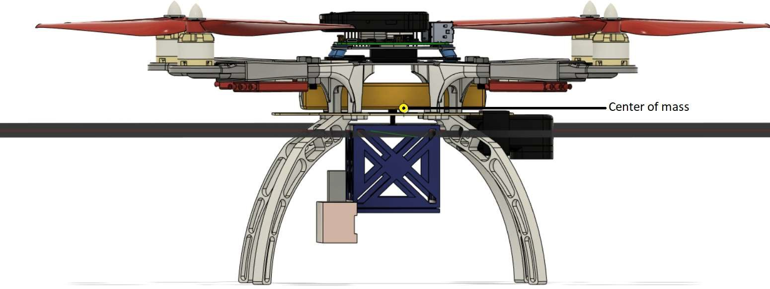

*Centre of mass (software calculated)*

 

### Preliminary Computer-Aided Design Model And Sizing

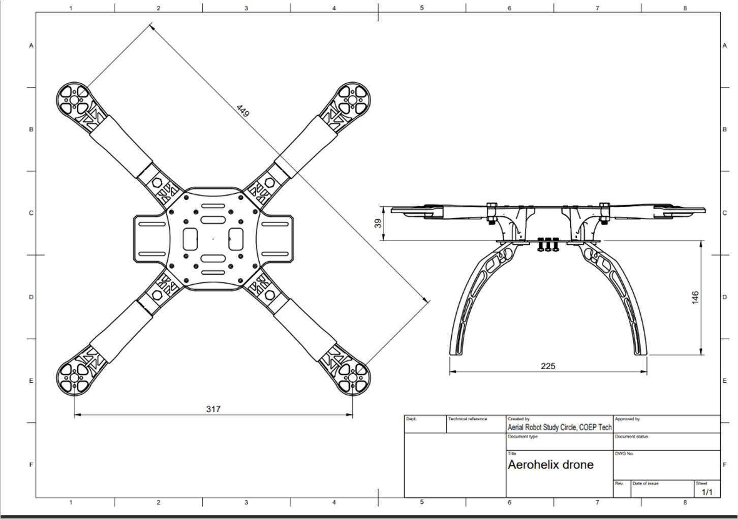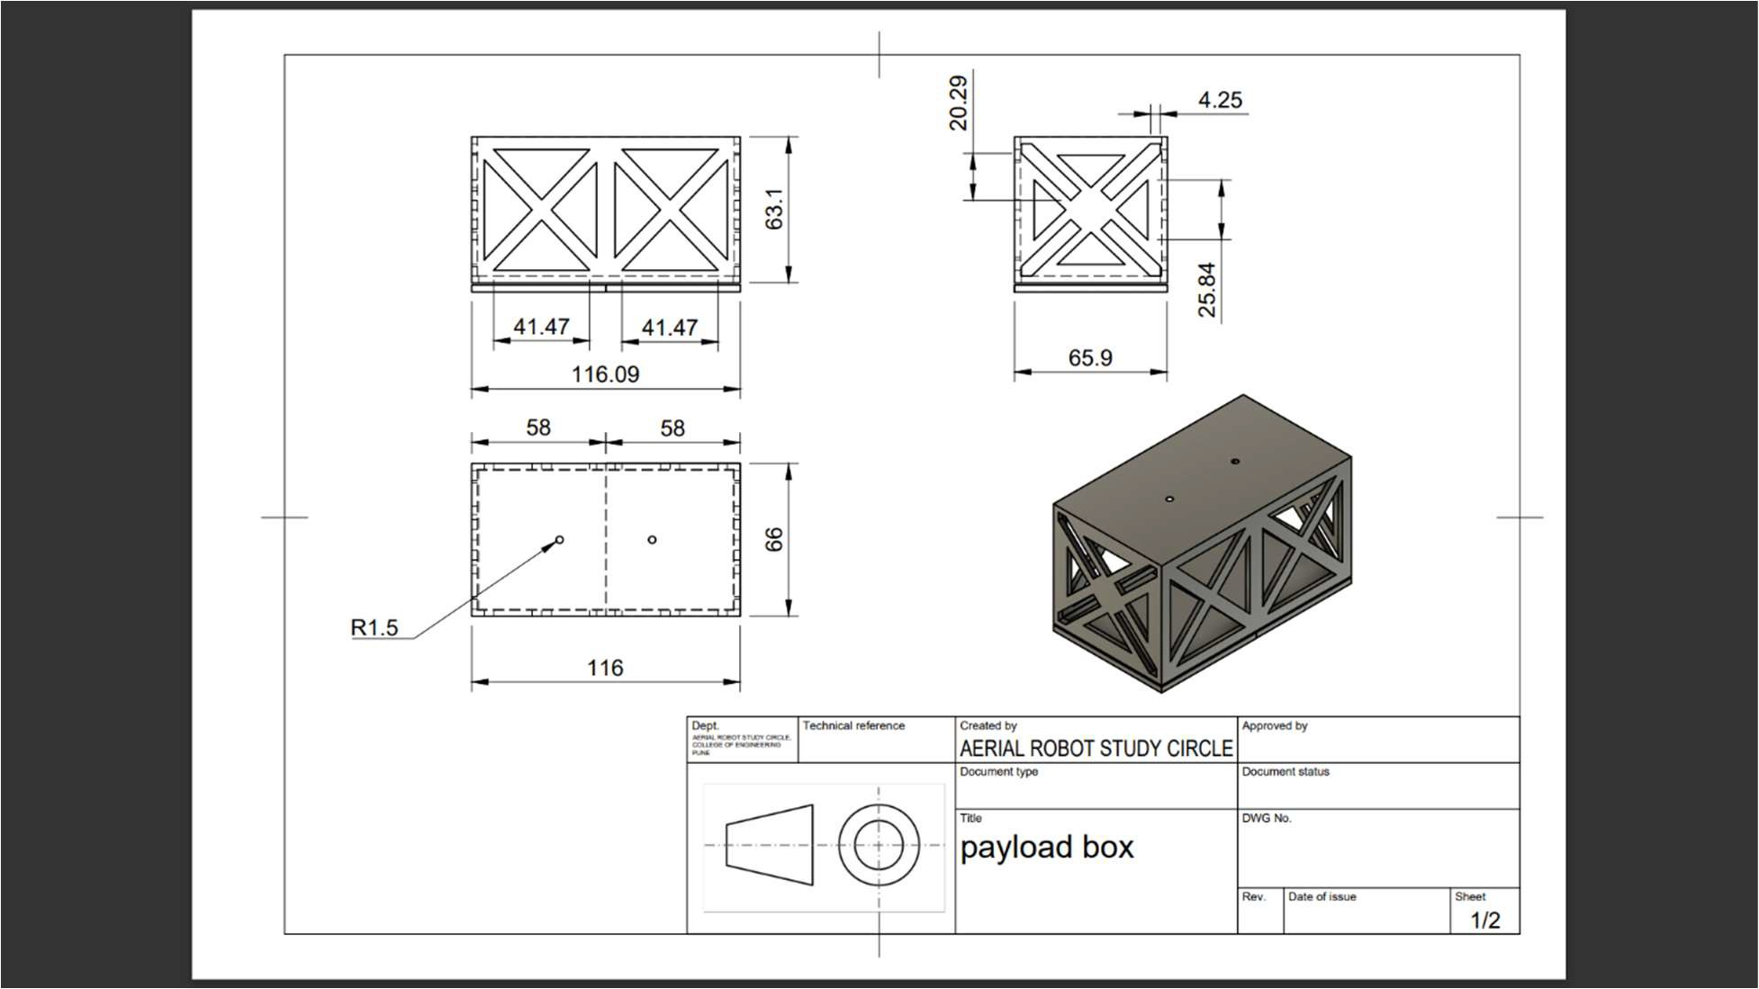

**:..a"l'I"...;.: .. = An5C::**

Where innovations soar high!

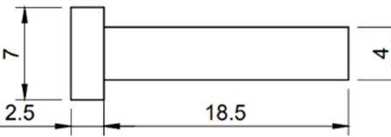R3.5

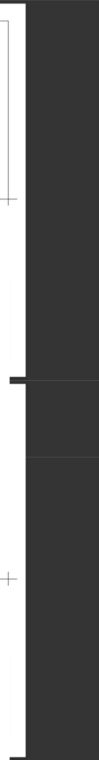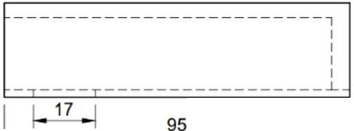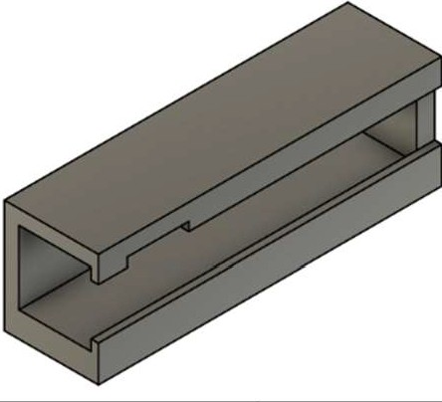

@

I

, *I*

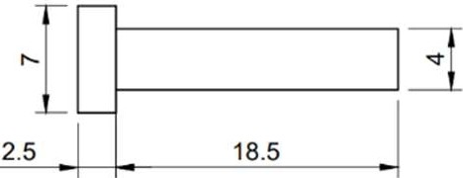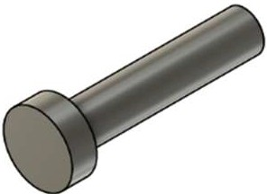

**0..-,by**

AERIAL ROBOT STUDY CIRCLE

**Appowdby**

-(]-@)-

MOTERSHAFT NEW

f=OWG,-,No=cc r.=--i

3/1

*'L* E--------------- I] "

95

II ]•I

26

(0

N

**0-tly' by**

AERIAL ROBOT STUDY CIRCLE

OWGNo

GUIDE FOR PISTON

-(]-@)-

b--- j

1/1

**:..a"l'I"...;.: .. = An5C::**

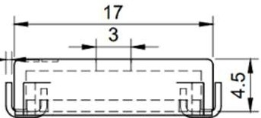Where innovations soar high!

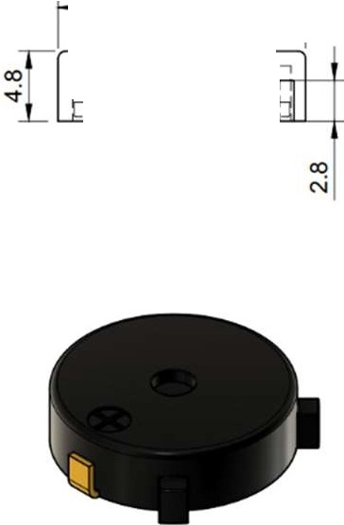

|  |  |  |  |
| --- | --- | --- | --- |
| 17  .5 -+=+--  , ,  I  ---r-,---  ""''  Dia 8.5 | | | |
|  |  | **0..-,by**  AERIAL ROBOT STUDY CIRCLE | **Appowdby** |
| EJ-@)- |  |  |
| **BUZZER** |  |
| 3/1 |

65

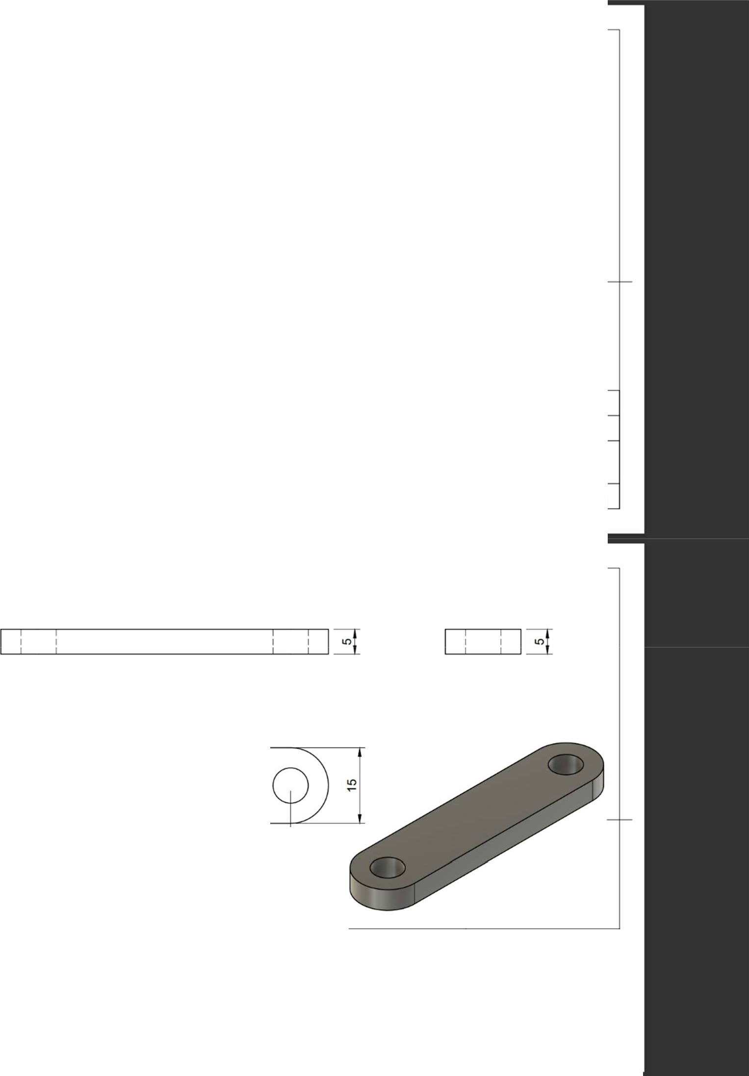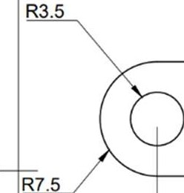

50

I 15 I

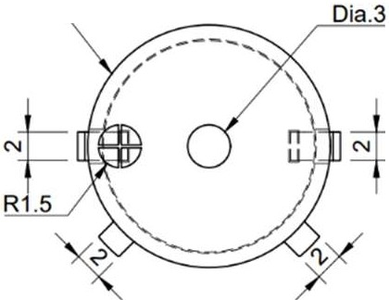

|  |  |  |  |
| --- | --- | --- | --- |
|  |  | **0-tly'**  AERIAL ROBOT STUDY CIRCLE | **by** |
| -[]-@)-, |  |  |
| **CONNECTING ROD** | """'"  b-- ==-- - -j  2/1 |

**:..a"l'I"...;.: .. = An5C::**

Where innovations soar high!

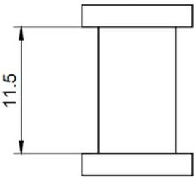"'

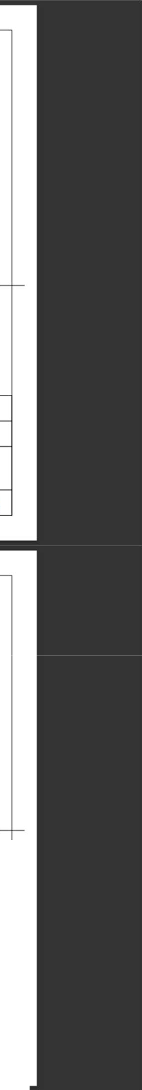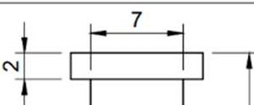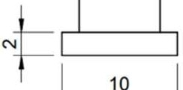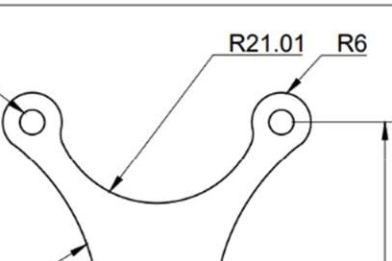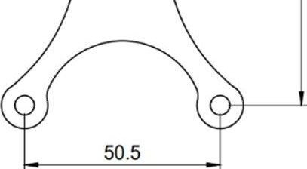

10

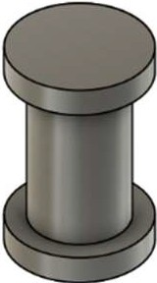R5

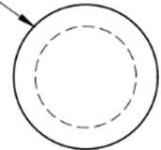

**Appowdby**

**0..-,by**

AERIAL ROBOT STUDY CIRCLE

3/1

CRANK PIN

-8-@-

R2.5

R44.93

<I:

0

co

<I:

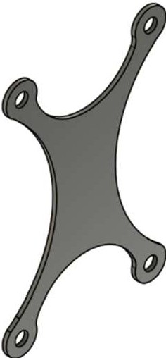"'

N

62.5

**0-tly'**

AERIAL ROBOT STUDY CIRCLE

**by**

DAMPINGBORDBASEb-OWG No=..-..-j

-8-@-

1/1

0 J 0

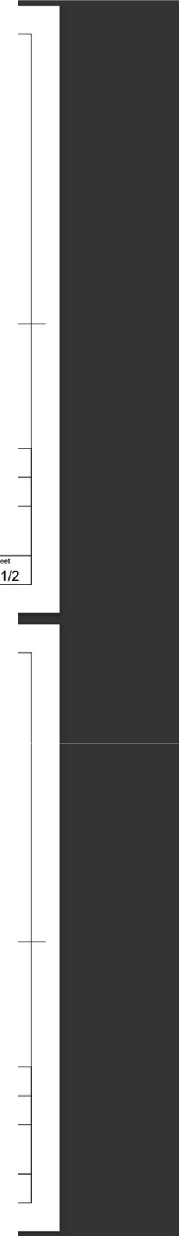

138.8

N N

**:..a"l'I"...;.: .. = An5C::**

Where innovations soar high!

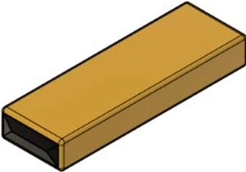138.8

**1**

**I_:**

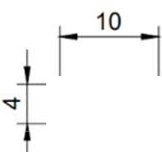-(]-@)-**BATTERY**

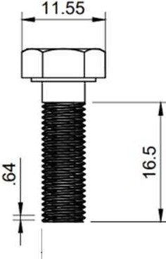

**0..-,by**

AERIAL ROBOT STUDY CIRCLE

**Appowdby**

|  |  |  |  |
| --- | --- | --- | --- |
| I s.89 |  | **r i** | |
|  |  | **0-tly'**  AERIAL ROBOT STUDY CIRCLE | **by** |
| -(]-@)- |  |  |
| **BOLTM6** | ~~....~~  2/1 |

**:..a"l'I"...;.: .. = An5C::**

Where innovations soar high!

•*t=*f---------'-J 56' 1

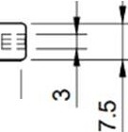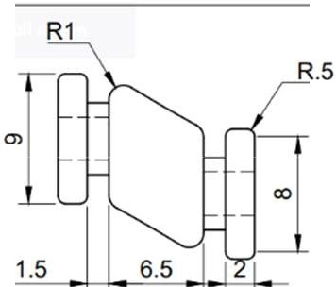

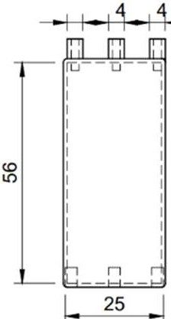4

bOWG,-,No=,,.,.-----r.= i

1/1

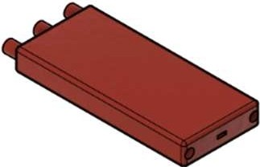

**0..-,by**

AERIAL ROBOT STUDY CIRCLE

**Appowdby**

E]-@-ELECTRONICSSPEEDCONTROL

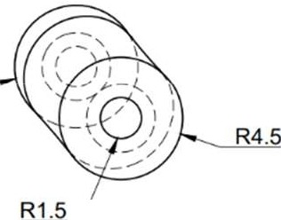8ti ..--

R1

2.22

R.5

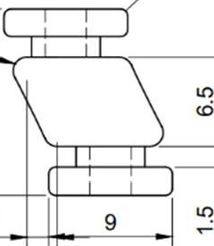

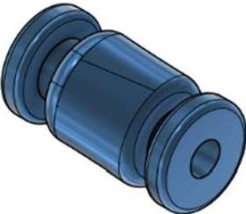

**0-tly'**

AERIAL ROBOT STUDY CIRCLE

**by**

DAMPINGRUBBERbOWG,-,No= .-.. i

-(]-@-

3/1

**:..a"l'I"...;.: .. = An5C::**

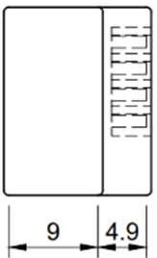Where innovations soar high!

23.2

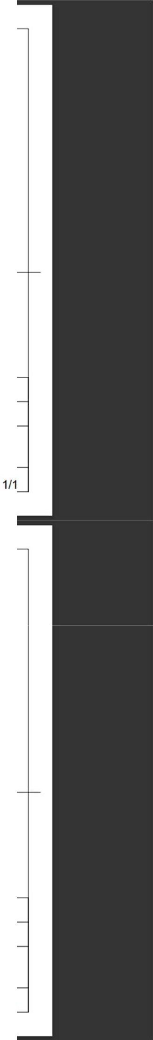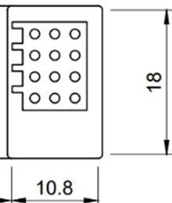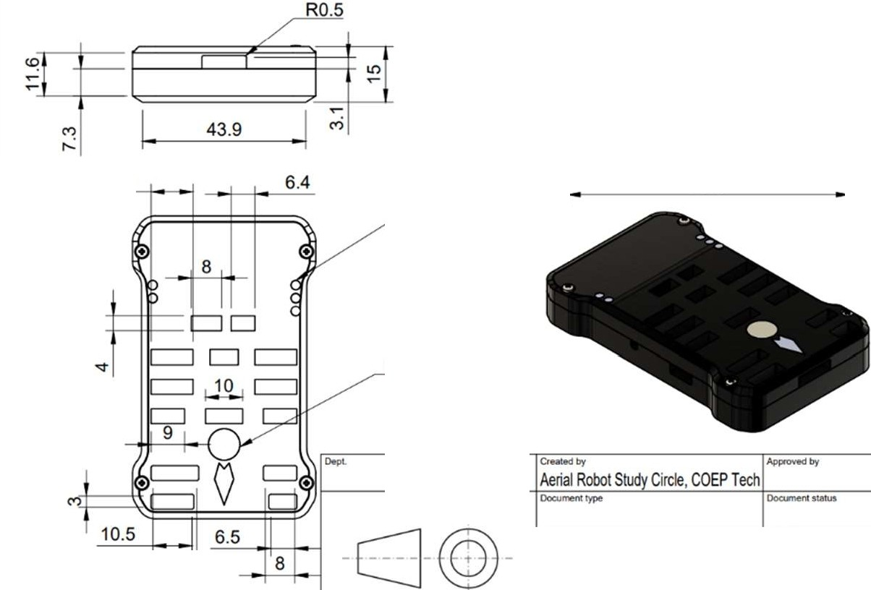

-

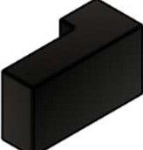

**Appowdby**

**0..-,by**

Aerial RobotSt Circle,COEP Teci1

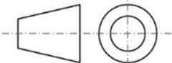

**Reciever**

81.3

]-[

11.25

al I :3--t-------1---'11

###### _ 75.9

5HOLES x 02.5

08.5

###### 7.351

11.8

~~....~~

1/1

**Pixhawk**

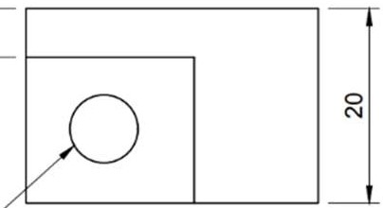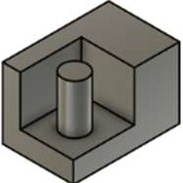

**:..a"l'I"...;.: .. = An5C::**

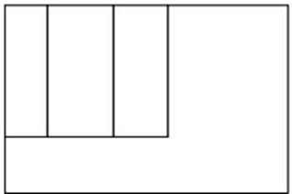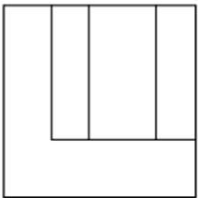Where innovations soar high!

|  |  |  |  |
| --- | --- | --- | --- |
| 17.27 12.73  0  N  "' | | | |
| 07 | - | **0..-,by**  Aerial Robot St Circle, COEP Teci1 | **Appowdby** |
|  |  |  |
| Piston |  |
|  |

182 118

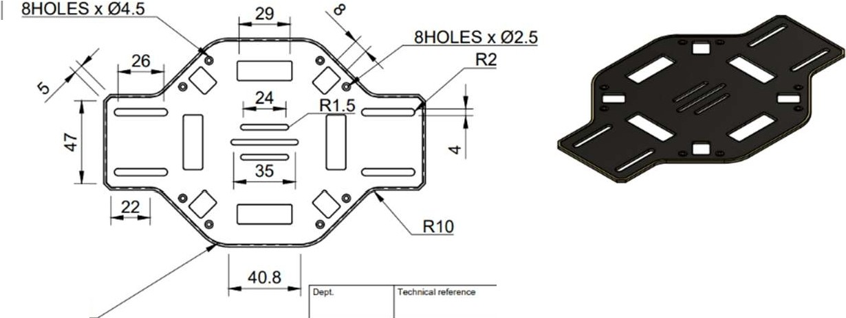

**by**

**0-tly'**

Aerial Robot S Circle, COEPTeci1

R20

....

Lower Hub-PDB

-CJ@)-

1/1

 

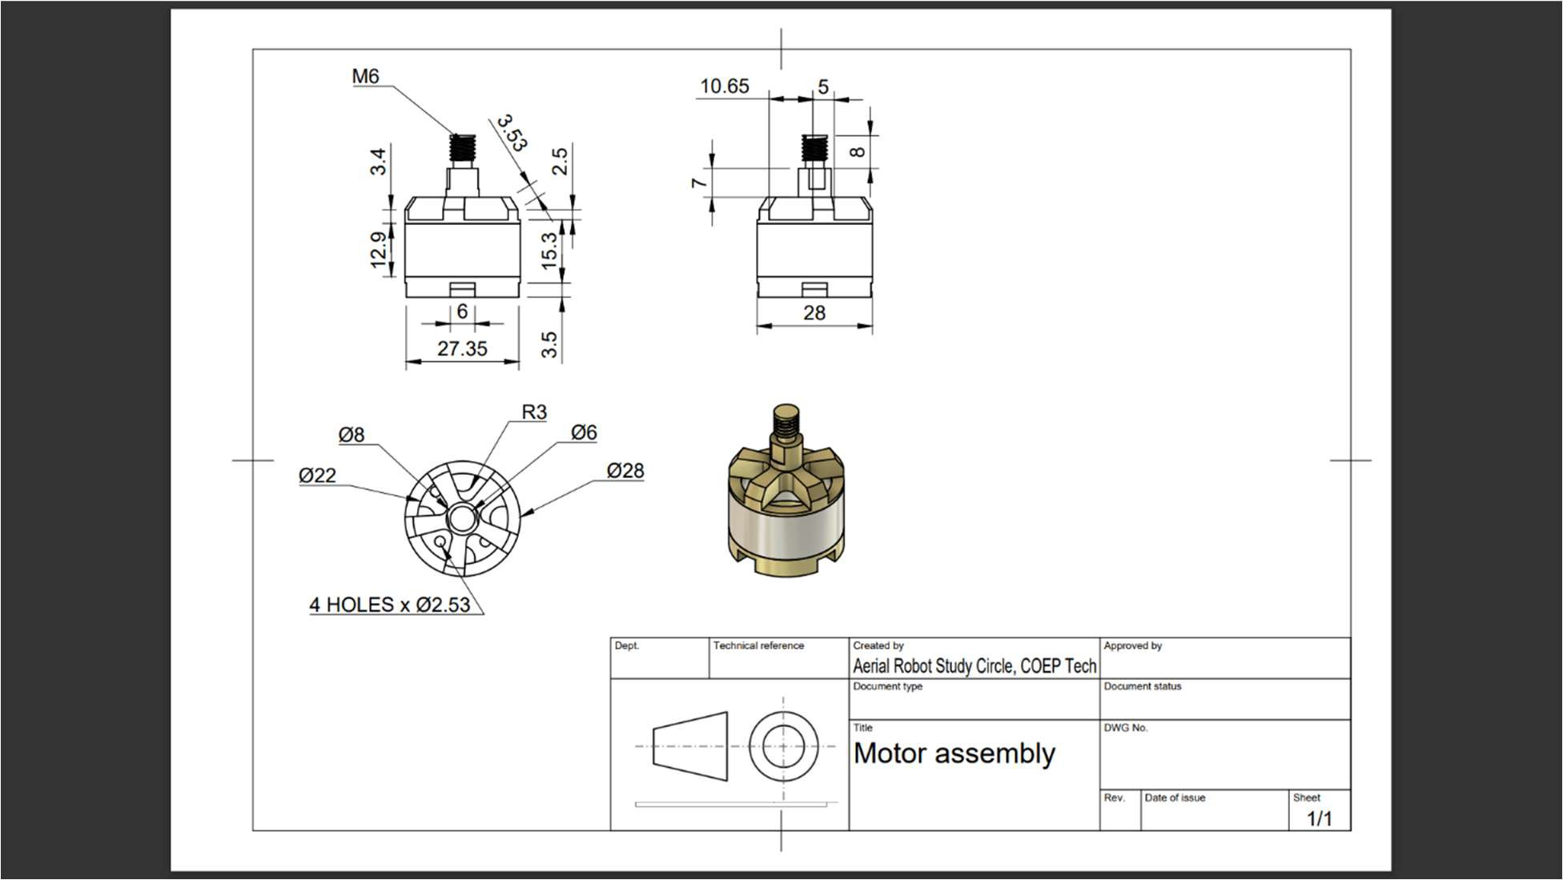

#### Payload Dropping Mechanism :

UAVs are growing at an accelerating rate in the contemporary world and are used in several industries. One of the applications is delivering payload at a precise location, this also being the objective of the competition. The payload lifting mechanism is the most important and ingenious part of the drone.

1. CONSTRUCTION:
   * Box: The mechanism consists of a box which will be used to carry the given payload. This box will have just enough space for the payload and will not allow much movement while inside. The base of the box is cut in center and hinged at ends.

It works like a hinged window.

* + Motor: We will be using a servo motor to control the hinged side of the box. This motor will be fitted on the side wall of the box with its shaft lowered.
  + Crank: The crank will be fitted to the motor shaft. This will span half of the base of box and will transfer the rotation to the connecting rod. They will be joined with the help of crank pin.
  + Connecting rod: This will connect the crank and the piston (with a piston pin). The other half of the base will be covered by the connecting rod. Being driven by the crank, it will give the piston a reciprocating motion.
  + Piston: The piston will be separated from the base and joined to the connecting rod. It shall be driven by the connecting rod and perform a reciprocating motion in the guide.
  + Guide: The guide is a sleeve along the length of the base of the box which will give a path for the piston to move.

 

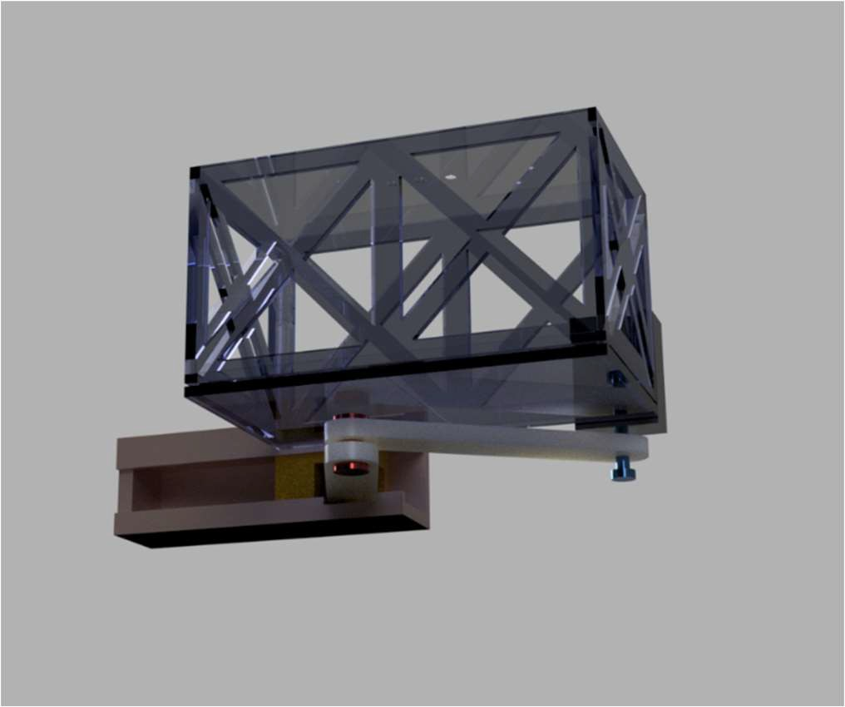

1. WORKING:

We have selected a relatively simple payload dropping mechanism for the autonomous operation. The idea is to employ a servo motor to open a flap and drop the payload, However, by the action of a single flap the payload diverts from its vertical path as it is in contact with the flap (opening surface). As we need to aim for the bullseye and drop the payload as accurately as possible, this diversion is unwanted.

Therefore, we have employed two flaps opening at the center by cutting the base from the center. We have the box attached to the bottom of the drone which has a base made like a window opening from center. This box has been given just the optimum dimensions to fit the payload and not cause any excessive movement during the flight and target detection.

1. The motor fitted at the side will be rotated when the drone reaches the desired location.
2. Thus the crank shall be driven by the action of the motor. They are forming a turning pair, so we will see rotational motion.
3. The crank will then lower, i.e., descend in the direction of the guide.
4. The connecting rod connecting to the crank which is also making a turning pair will cause the connecting rod to descend with the crank.
5. This will cause the piston to move away from the motor, along the guide provided.
6. Once the piston is at a position required for making the crank and the connecting rod completely horizontal, only then both the flaps will open at the same time and drop the payload.
7. SOURCES OF PARTS USED IN THE MECHANISM:
   * Box- Made from polystyrene foam board.
   * Motor- Servo motor from market.
   * Crank- 3D printed.
   * Connecting rod- 3D printed.

 

* + Piston- 3D printed.
  + Guide- 3D printed.
  + Crank pin- 3D printed.
  + Piston pin- 3D printed.

1. FREE BODY DIAGRAM:
2. CALCULATIONS and DIMENSIONS:
   * For Box: Thickness:
   * For motor:

Motor Specifications: TowerPro MG90S Mini Digital Servo Motor (180° Rotation)

Weight: 13 gm

Operating voltage: 4.8V~ 6.6V Dimensions: 12.4 x 22.8 x 32.5 mm3.

* + For Crank:
  + For Crank pin:
  + For Connecting rod:
  + For piston pin:
  + For piston:
  + For Guide:

The box had to be enough to carry the 200gm(0.2kg) of payload we needed to fit in it. The dimensions of the base are 160 x 60 mm.

The area is 9600mm2.

The stress acting on the base= force/ area.

= 0.2 x 9.81/ 9600

= 1.962/9600= 0.000204 N/mm2

=0.000204 Pa.

The ultimate tensile strength of our material is 48MPa= 48 x 106 N/mm2. The acting stress is within the limits of what the material can sustain.

1. JOINING PROCESS:
   * The box is joined to the bottom hub plate of drone using screws of M3 x 16mm.
   * The motor will be joined by super glue to the side wall of the box.
   * The guide with the piston allowed to slide in it, is fixed along length of base by super glue.

 

* + The crank is fitted to the motor shaft by motor pin.
  + The crank is fitted to connecting rod by crank pin.
  + And finally, the connecting rod is fitted to the piston by a piston pin.

I.ADVANTAGES OF THIS MECHANISM:

* The whole payload mechanism can be mounted to the upper drone frame using screws, providing provision at the top reference plate.
* This mechanism employs only one servo motor, minimizing power consumption and improving efficiency.
* The parts of this mechanism are simple to 3D print.
* The material selected is light.
* In short, this mechanism is low-cost, lightweight, and compact.
* The payload drop is easy and efficient as it falls vertical be both flaps opening at the same time.

**add orthographic view of payload here**

 

## Innovation :

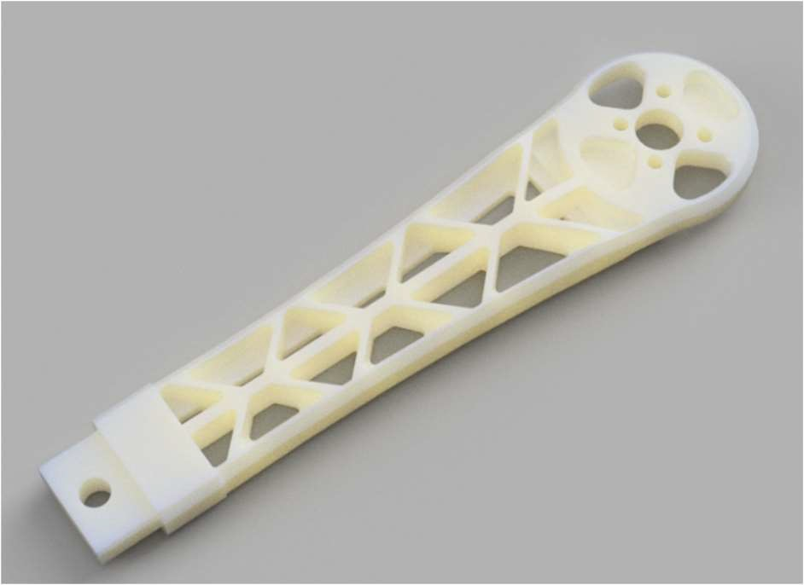In this project, we have tried several new methods and techniques to enhance drone performance. 1.Frame

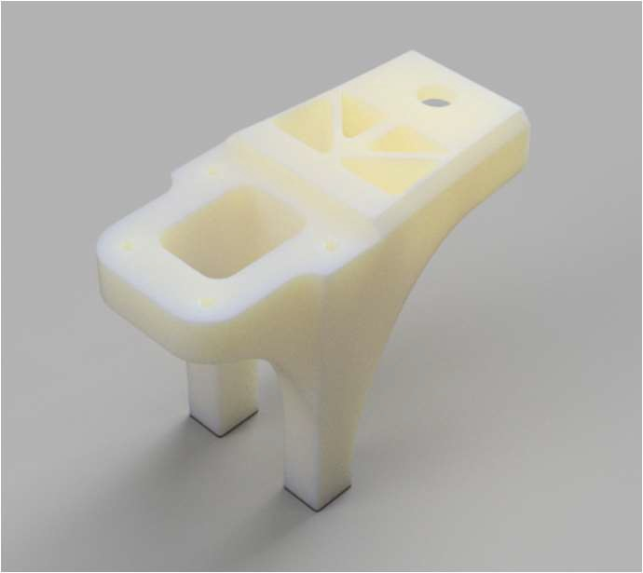

In the drone, the frame arms are one of the most important parts. It gives strength and support to whole system. Normally it is attached with PDB and a support plate which makes it difficult to replace when damaged. With detachable arms, we have improved the use and portability of our drone. In order to be able to remove the rotor arms, the design's structure has been altered. We can make it easier to carry and travel without compromising its strength by disconnecting the electrical speed controller connections and separating the hub and arms.

1. Material

The most easily available process for making the arms is 3D printing which gives us a lightweight frame, but many of the easily available 3D printing material does not provide enough strength. We have tackled this problem by coating the drone body with glass fibre reinforced polymer. GFRP is basically low-cost composite material made from glass fibre in a polymeric matrix. Glass wool reinforced in heat resistant epoxy provides extra features of heat resistance.

We made the material by first mixing the appropriate binder and epoxy resin. We then evenly apply it on the drone with a brush in the required orientation for homogenous application, this is the hand layup process. Then we also used Cobalt powder-gel which acts as a fast reaction catalyst. This also ensures dimensional stability and excellent shock-absorbing capabilities.The glass fibers provide high strength and stiffness to the composite, while the polymer matrix binds the fibers together and protects them from damage.

 

1. Payload :

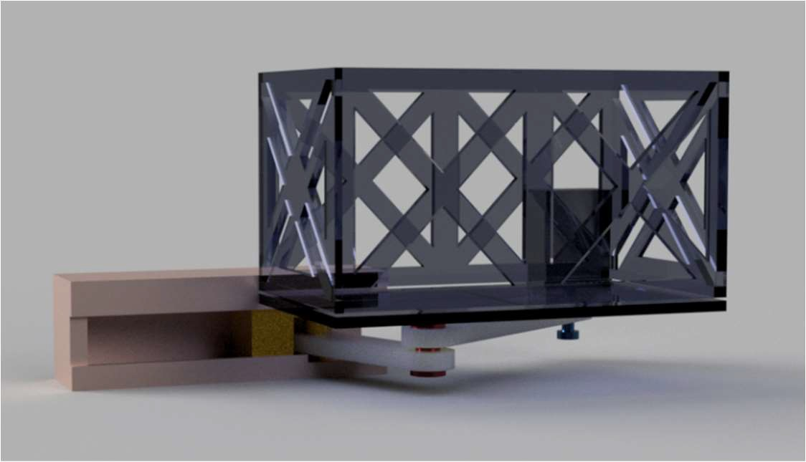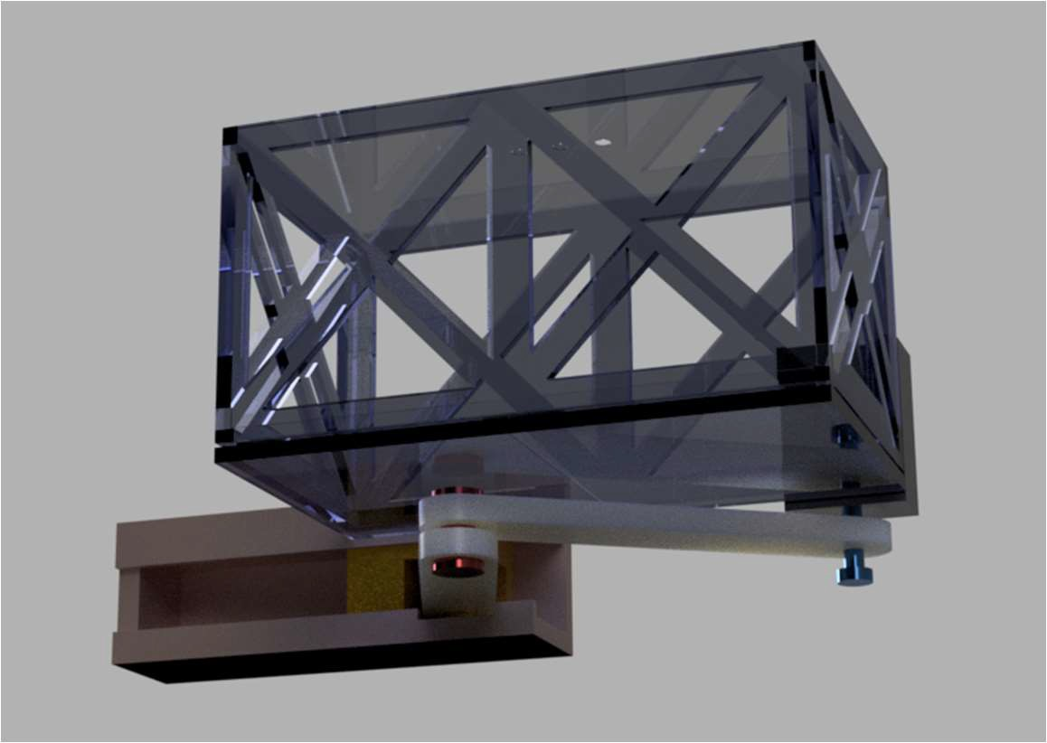

For designing the payload-dropping mechanism we have thought of something simple and effective. Considering the requirement of recognizing the target and dropping the payload at the bullseye, we needed to make sure that the drop was straight. We are going with an opening base controlled via a servo motor. A box of Polystyrene foam core with a hinged base that is held on the open side by the motor. This is simple indeed, however when a single base opens from one side, the payload diverts from the vertical path as it was in contact with the base. So, we needed a base that opens from the central position and both the flaps at the same time. This is where our links come in handy. The links form a turning pair driven by the servo motor and the base will not open until the links are completely off both flaps.

 

# Autonomous Operation :

1. Autonomous Flight -

In pixhawk fc we are achieving autonomous flight by programming the flight controller using Mission Planner software. In mission planner software we set the path to be followed by the drone and after attaching the payload to the drone , we start the mission.

In mission Planner , Firstly we define the starting point (take off point) and set the takeoff height (height at which drone should reach initially after takeoff). The drone will maintain the specified height (30m here) after takeoff.

After reaching the height of 30m , drone will follow the Path to search for the Target.

1. Autonomous Identification of Target (Automation using ML model) -

For the identification of target (bullseye target) we are implementing the Machine Learning model which is able to detect the bullseye Target from the the video captured by the camera attached to the drone.

Here we are using SSD Mobilenet ML model which has already been trained to detect various real time objects. We have fine-tuned the model with the dataset of bullseye Target images to detect the target.

First we collected various images of bullseye target from internet.

Then to avoid the problem of Overfitting we used Data Augmentation for generating more images in dataset (using ‘keras’ and ‘sklearn’ libraries in python).

* + The Problem of Overfitting -

In machine learning, overfitting is a common problem where the model performs well on the training data but poorly on the test data. When a model becomes very complicated and begins to memorise the training set of data rather than understanding the underlying patterns.

Lack of training data is one of the primary reasons of overfitting. The model may memorise the noise or the particular traits of the training data when the training data is very limited or insufficiently diverse. A model which is over complicated or has too many parameters in relation to the amount of training data is another factor in overfitting. A complex model may be very effective over the training data , but it may not generalize well to unseen data.

Overfitting can be tackled by several techniques, such as increasing the amount of training data, reducing the complexity of the model, applying regularization techniques, and using data augmentation. Data augmentation can be used to reduce overfitting by increasing the diversity of the training data and exposing the model to variety of the input data.

* + Data Augmentation - the solution for Overfitting -

 

Data augmentation is very useful technique used in machine learning to increase the amount and variety of training data. It creates new data images from the existing ones. This technique can be particularly useful in situations where the available training data is limited or when the data is imbalanced.

There are various data augmentation techniques, such as rotation, flipping, scaling, shifting, adjusting brightness and adding noise to the data. These techniques can be applied to various types of data, including images, audio, and text.

Data augmentation can help improve the performance of machine learning models by increasing the diversity of the training data and reducing the problem of overfitting. It also helps to improve the generalization of the model by exposing it to different variations of the input data.Here we have used ‘keras’ and ‘sklearn’ libraries for data augmentation

* + Why Keras? –

Keras is a high-level neural networks API that is written in Python and runs on top of TensorFlow, CNTK, or Theano. It was designed to enable fast experimentation with deep neural networks, while being user-friendly and easy to use.

Keras provides a simple and consistent interface for defining and training deep learning models. It supports various types of neural networks, including convolutional neural networks, recurrent neural networks, and combination models.

Keras is widely used in the industry and academia for research and production applications. It allows for easy integration with other Python libraries and frameworks, such as TensorFlow and scikit-learn, and can run on different hardware, including CPUs and GPUs.

* + Why Sklearn? –

Scikit-learn is a popular Python library for machine learning. It provides a wide range of supervised and unsupervised learning algorithms, including classification, regression, clustering, and dimensionality reduction.

Scikit-learn is designed to be simple and easy to use, with a consistent API and clear documentation. It includes tools for data preprocessing, feature selection, and model evaluation, making it a comprehensive package for end-to-end machine learning workflows.

Scikit-learn is widely used in both academia and industry for research, prototyping, and production applications. It also supports integration with other Python libraries and frameworks, such as NumPy, Pandas, and TensorFlow. Additionally, scikit-learn provides useful tools for data visualization and exploratory data analysis.

 

* + **Pseudo Code for Data Augmentation** - #importing keras lib

from keras.preprocessing.image import ImageDataGenerator

# Create an ImageDataGenerator object datagen = ImageDataGenerator(

#various operation on images to generate new images rotation_range=30,

height1_shift_range=0.2,

.

.

.

fill_mode='nearest')

# Load the image data

train_data = datagen.flow_from_directory( 'train',

target_size=(224, 224), batch_size=32, class_mode='binary')

# Train the model using the augmented data model.fit(train_data, epochs=10)

After collecting data we performed Image Annotation on the data images using Labelimg software. Then we divided the dataset into 2 sets as ‘Training Data’ and ‘Test Data’. Training data is be used to train the model and Test data is used to map the accuracy/effectiveness of trained model after training.

* + Image Annotation -

Image annotation is the process of adding metadata or labels to an image which provides additional information about its contents. Image annotation is a crucial task in many fields, including computer vision, machine learning, and natural language processig.

Image annotation can be used to perform a variety of tasks, such as object detection, image segmentation, image classification, and image captioning. Each type of annotation requires different techniques and tools.

Image Annotation will generate .xml file for each image.Those files contain information about annotated images, they contain size of image , location and label of each annotated object in the image.

Now after image annotation we need to Create TFrecords for our images - For that we first need to convert .xml files to .csv

 

* + Pseudo Code for Converting .xml files to .csv -

# To Import the necessary modules

import os, glob, pandas as pd, xml.etree.ElementTree as ET

#defines a function named "xml_to_csv" that takes a single #argument, the path to the directory containing the XML files.

def xml_to_csv(path):

xml_list = []

#uses the glob module to find all files in the specified directory with the #".xml" extension

for xml_file in glob.glob(path + '/*.xml'):

#parse the XML file using ElementTree and extract the root element of #the XML document.

tree = ET.parse(xml_file) root = tree.getroot()

#loops through each "object" element found in the XML file. for member in root.findall('object'):

#extracts the necessary information from each "object" element and #stores it in a tuple named "value"

value = (root.find('filename').text, int(root.find('size')[0].text),...... #appends the "value" tuple to the "xml_list" list.

xml_list.append(value)

#defines a loop to iterate through the two directories "Train" and "Test". for directory in ['Train', 'Test']:

#This line calls the "xml_to_csv" function with the path to the current

#directory and assigns the resulting DataFrame to a variable named #"xml_df". xml_df = xml_to_csv(os.path.join(os.getcwd(),

'Bullseye_Detector/{}'.format(directory)))

#saves the "xml_df" DataFrame as a CSV file with the name #"Train_labels.csv" or "Test_labels.csv" in the "data" directory.

xml_df.to_csv('data/{}_labels.csv'.format(directory), index=None) print('Successfully converted xml to csv.')

* + TFrecords -

TFrecords is a file format used in TensorFlow, an open-source machine learning library developed by Google. TFrecords is a binary file format that is designed to efficiently store large

 

amounts of data in a structured manner. TFrecords are used to store data in a format that can be easily fed into TensorFlow models during training.

Benefits of TFrecords -

1. Faster Data Access: Since the TFrecord file format is optimized for use with TensorFlow, it allows for faster data access during

training.

1. Portability: Since TFrecords are a standard file format in TensorFlow, they can be used across different programming languages and platforms.
2. Easy to Manage: TFrecords are easy to manage as they can be stored on disk or in the cloud, and they are self-contained and can be easily distributed.

To create tfrecords i.e. before running our script we need to have object_detection api installed in the system

* + Object Detection API -

Object Detection API is a popular open-source framework developed by Google researchers that allows developers to easily build, train, and deploy object detection models. The API is built on top of TensorFlow, an open-source machine learning library developed by Google, and it provides pre-trained models and tools for training custom models.

Applications of Object Detection API -

* 1. Autonomous driving: Object Detection API can be used to detect and track various day to day objects, such as pedestrians, vehicles, electronic devices and traffic signs, in real-time to enable safe autonomous driving.
  2. Surveillance systems: It can be used to detect and track objects, such as people and vehicles, in surveillance videos to enhance security.
  3. Medical imaging: Object Detection API can also be used to detect and locate abnormalities, such as tumors and lesions, in medical images to aid diagnosis and treatment.
  + Commands Used to install Object Detection API -

Cloning repository -

1. git clone https://github.com/tensorflow/models.git

Tensorflow uses protocol buffers for defining its data structures and network protocols. Protobuf compiler package contains piler for protocol buffers which are used to compile .proto files and convert them into python scripts.

1. sudo apt-get install protobuf-compiler python-pil python-lxml
2. sudo pip install jupyter
3. sudo pip install matplotlib

 

Now In models/research dir -

1. protoc object_detection/protos/*.proto –python_out=.

Now In models dir -

1. export PYTHONPATH=$PYTHONPATH:`pwd`:`pwd`/slim Now to allow python to import modules/packages from ‘slim’ dir
2. sudo python3 setup.py install

When we installed object detection api in system we run the script named generate_tf_records.py We run this script twice for Train and Test data. This script will generate .record files for both Test and Train data.

After running script we set up cofiguration files by using ssd_mobilenet_v1 and by making some changes in no. of classes and batch size , setting path to files in our system etc.

After that we need to create Label Map for our model which creates .pbtxt file for the model

* + Label Map -

Label maps are a very critical component of object detection and image classification systems. They are essentially text files that contain the label names and IDs associated with each object in a dataset. Label maps are used to annotate and identify objects in images, which is necessary for training and deploying object detection and classification models.

The format of label maps is typically a text file with two columns: one for the label name and one for the ID. The label name is a human-readable string that describes the object, while the ID is an integer that uniquely identifies the object.

item {

id: 1

name: 'bullseye'

}

So the file containing above code will be saved with .pbtxt extension

* + .pbtxt file -

1. A .pbtxt file is a text-based serialization format used to describe a TensorFlow graph definition in a human-readable form. It is often used as an alternative to the binary .pb file format, which is a serialized form of the same graph definition.
2. The .pbtxt file contains a series of text messages that define the nodes and edges of a TensorFlow computation graph. Each message represents a single node or edge in the graph, and includes information such as the node name, input and output tensors, and the type of operation performed by the node.
3. One advantage of using .pbtxt files is that they can be easily edited and inspected using a text editor or other command-line tools. This can be useful for debugging and testing purposes, as well as for creating custom graph definitions.

 

Finally we started to Train The Model by running train.py script.

While training the model we focused on the loss to get below 1 (took approximately 3-4 hours for entire training )

1. Autonomous payload Drop -

For Autonomous payload Drop we need to Deploy our Model into pixhawk flight controller For deployment of model we have made use of RaspberryPi

* + Why raspberrypi? -

Raspberry Pi is a popular single-board computer that is often used in projects that require a low-cost, low-power device with high processing capabilities.

Some Advantages of Using RaspberryPI -

1. High Processing Capabilities: Despite its low cost, Raspberry Pi has powerful processing capabilities that can handle a wide range of tasks, including image processing, machine learning, and other complex applications.
2. Low Power Consumption: Raspberry Pi consumes very little power, making it an ideal choice for battery-powered projects and other applications that require energy-efficient computing.
3. Low Cost: Raspberry Pi is an affordable computing device that is widely available and offers a lot of processing power for its price.
4. Small Size: Raspberry Pi is small in size and can easily fit in compact spaces, making it ideal for use in embedded systems and other projects that require a small form factor.
5. Open Source: Raspberry Pi is based on open-source software, which means that users can modify and customize the software to suit their needs.
6. Easy to Use: Raspberry Pi is easy to set up and use, even for beginners, thanks to its user-friendly operating system and a large community of developers who provide support and resources.
   * Communication between Pixhawk and Raspberry Pi
7. The protocol used for communication between Pixhawk and Raspberry Pi is the MAVLink protocol. MAVLink is a messaging protocol that is designed specifically for communication between unmanned vehicles and their ground

 

control stations. It is an open-source protocol and is widely used in the drone industry.

1. MAVLink uses a packetized communication protocol to send and receive data between devices. Each packet includes a header, message ID, message length, message payload, and a checksum. The header includes information such as the system ID, component ID, and message sequence number. The message ID indicates the type of message being sent, such as a request for data or a command to perform a certain action. The message length indicates the length of the message payload in bytes, and the checksum is used to ensure data integrity.
2. One of the key advantages of MAVLink is its flexibility and extensibility. The protocol supports a wide range of devices and can be easily adapted to support new devices and applications. MAVLink also provides a rich set of APIs and tools for developers, making it easy to integrate with other software and hardware components.

##### Hardware connections –

1. Make sure that arrow on the pixhawk is facing towards usb ports on Raspberry Pi
2. Mount the flight controller on top of rpi using 11 mm spacers
3. Insert the 6 pin df-13 connector into the telemetry 2 port on the pixhawk and connect 4 out of 6 free ends to the rPi as follows –
   * red – Vcc on rPi
   * black – Ground on rPi
   * blue (rx from pixhawk) – tx on rPi
   * white(tx from pixhawk) – rx on rPi

After setting up the hardware we need to setup **rPi SD** card. For that we need to flash an image into that card to have an operating system.

Download **RaspberryPi OS** Lite version and after extracting all files we will have the image that we required.

 

Now to flash that image into SD card we used software named Etcher. After flashing image open the file **wpa_supplicant.conf** file from the extracted files and put the wifi name and password in that file.

Download the **ssh client** from putty.org which will allow us to remotely login into rPi. Now insert the SD card into the rPi which has our image.

Login into putty client using [pi@raspberrypi.local](mailto:pi@raspberrypi.local) as hostname. For further login use **login as: pi**

and password: raspberry

After successful login run following commands in putty client to install necessary packages – sudo apt-get update

sudo apt-get upgrade

sudo apt-get install python-pip #pip allows to install python packages sudo apt-get install python-dev

sudo pip install future

sudo apt-get install screen python-wxgtk4.0 python-lxml sudo pip install future pyserial

#**mavproxy** – control drone through command line of rPi #**dronekit** – command drone through python scripting sudo pip install dronekit mavproxy

Now we need to set up RaspberryPi to allow the communication via UART. We did that using comand **sudo raspi-config.**

The bluetooth device on rPi by default uses the UART and that should be disconnected as we are going to use UART. This is done by adding **dtoverlay=disable-bt** command inside **config.txt**

After completing this do **sudo reboot**.

For initiating communication run following commands

**mavproxy.py --master=/dev/ttyAMA0** #to connect with pixhawk

Now we are all set to srart writing our python script to control the drone.

 

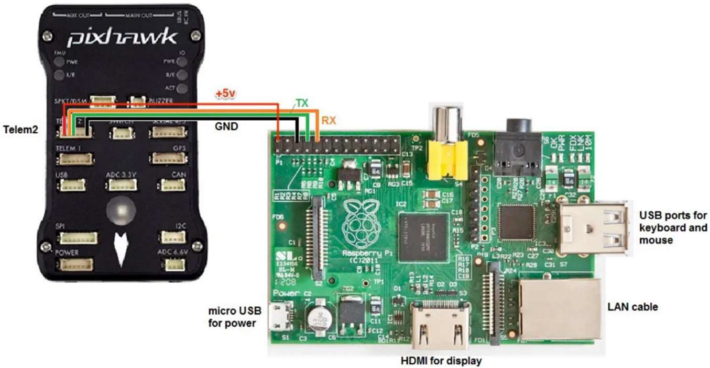

Below is the pseudo-code we have written to establish communication between pixhawk and raspberry pi -

* Pseudo Code -

// Initialize communication between Pixhawk and Raspberry Pi initialize_communication(pixhawk, raspberry_pi);

// Load the bullseye target detection model on Raspberry Pi model = load_model("bullseye_detection_model");

// Continuously monitor Pixhawk for drone location data while (true) {

location_data = get_location_data(pixhawk);

// Use the bullseye detection model to determine if the drone is over the target if (is_over_target(model, location_data)) {

// Deploy payload on the target deploy_payload(pixhawk);

}

}

By Implementing above steps we have successfully developed a drone which is able to idetify the bullseye target autonomously and drop the payload on target with great accuracy.

In conclusion, the integration of machine learning model in task automation has proven to be a highly effective solution for optimizing processes and increasing efficiency.

 

## Material Selection:

##### Acrylonitrile Butadiene Styrene (ABS)

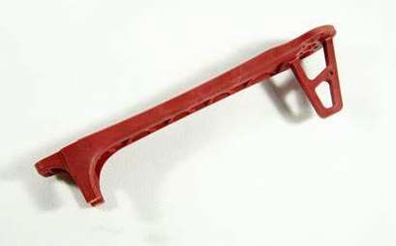

1. **Properties**

|  |  |
| --- | --- |
| Density | 1.04 g/cc |
| Thermal Conductivity | 0.18 W/(mK) |
| Modulus of elasticity | 1.825 Gpa |
| Tensile strength | 20 MPa |
| Coefficient of Thermal expansion | 84.2 µm/m-°C |
| Melting Point | 234 °C |
| Specific Heat | 1.99 J/g-°C |

1. Purpose :- to build the frame structure
2. Location :- Body frame arms
3. Manufacturing Process :- 3D printing
4. Why it is selected (Advantages)
   * ABS is relatively light, which is significant for drones because bulkier frames might compromise flying quality and battery life.
   * Tough and robust ABS helps safeguard the drone's internal parts in the case of a collision or harsh landing.
   * Simple to work with: ABS is a great material for bespoke drone frames or other modifications since it's simple to mould and shape.
   * Cost-effective: When compared to other materials like carbon fiber, ABS is a more inexpensive material, making it a more economical choice for drone frames.

 

* + ABS is a good option for drone frames overall because of its combination of light weight, toughness, use, and affordability. Although they can be more expensive, materials like carbon fiber may provide even higher strength and rigidity.

#### Glass Wool

1. **Properties**

|  |  |
| --- | --- |
| Density | 2.5 g/cc |
| Thermal Conductivity | 0.03 W/mK |
| Modulus of elasticity |  |
| Tensile strength | 0.02 MPa |
| Coefficient of Thermal expansion | 0.03 W m/K |
| Melting Point | 1227 °C |
| Specific Heat | 840 J/g K |

1. Purpose:- for thermal insulation and to increase damping capacity
2. Location- Surface Coating of frame
3. 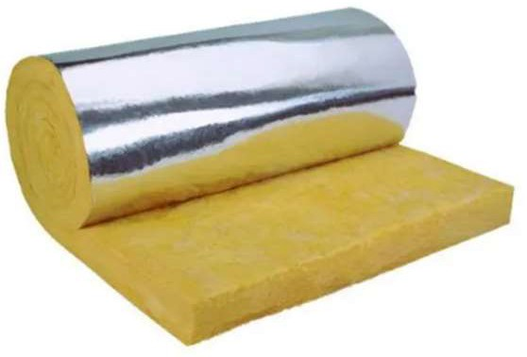Manufacturing- (Bought as final product)Hand-lay up process
4. Advantages-
   * Compared to other materials for frame body, this mixture of composite helps us provide excellent heat resistance, Enhancement in strength, good damping capacity and shock absorption.
   * The random orientation and distribution of glass wool distributes the load uniformly.
   * Studying to microscopic scale, these glass fibers detards the movement of crack nucleation and crack growth phenomena, which concludes in providing good strength to weight ratio.
   * If a single phase- single constituent element is used, the crack propagation becomes easier to crack throughout and the surface energy on the tip of the crack is compiled hence considering these factors the glasswool as reinforcement was used.

 

#### Epoxy Binder

1. Properties

|  |  |
| --- | --- |
| Density | 1.2 g/cc |
| Thermal Conductivity | 0.25 W/(m K) |
| Modulus of elasticity |  |
| Tensile strength | 3.81 GPa |
| Coefficient of Thermal expansion | 60–80 ppm/K |
| Melting Point | 50°C. |
| Specific Heat | 0.300 J/g-°C |

1. Purpose:- Matrix Material for Glass Wool
2. Location- Surface coating
3. Manufacturing- Manual Hand-layup process by brush(Purchased as product)
   * Epoxy binder as slurry is used for formation of matrix material.
   * This slurry is mixed with catalyst if required for promoting the drying phenomena
4. Advantage-
   * Excellent matrix adhesiveness with reinforcement.
   * Good Hardness to strength
   * Excellent Damping capacity
   * Low density compared to other materials.
   * As it is readily available , these binders are used on large scale as matrix material for glass reinforcements.

### Cyanoacrylates

1. Properties

 

|  |  |
| --- | --- |
| Density | 1.06 g/cc |
| Thermal Conductivity | 0.32 W/mK |
| Modulus of elasticity | **1.25 GPa** |
| Tensile strength | **23.1 MPa** |
| Coefficient of Thermal expansion | **90 x 10-6 mm/mm/°C**. |
| Melting Point | -22°C |
| Specific Heat |  |

1. 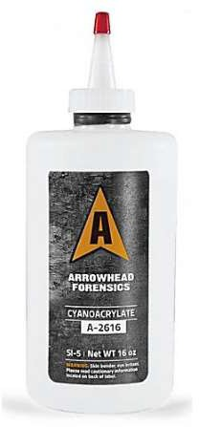Purpose:- Material joining media
2. Location- Surface of Frame body(Interface of ABS and Composite)
3. Advantage-
   * Cyanoacrylate is one of the most quick setting thermoset plastic adhesive, hence provides greater extend towards adhesiveness.
   * Provides excellent bonding in both asperities and surface of the materials to be joint.
   * Curing time required for this is between 4 to 40 seconds depending upon the volume and surface area of the material.
   * This glue can react at normal room temperatures without providing any of the external heat for completion of curing.

### Gfrp ( Glass Fibre Reinforced polymer)

1. Properties

|  |  |
| --- | --- |
| Density | 2 g/cc |
| Thermal Conductivity | 0.05 W/km |
| Modulus of elasticity | 70,000 N/mm². |
| Tensile strength | 3500 N/mm² |

 

|  |  |
| --- | --- |
| Coefficient of Thermal expansion | 5.4 x 10-6 cm/cm/°C. |
| Melting Point | softens at 2,000 °C |
| Specific Heat | 0.34J/◦C |

1. Purpose- to increase the strength, toughness and hardness of the frame by applying it as a coating on the surface.And in order to create the casings for all the electrical components
2. Location :- over drone body and casing
3. Manufacturing process:- Hand layup process
4. 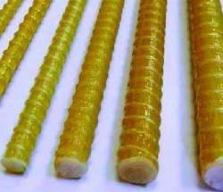Advantage
   * GFRP as Glass fiber reinforced polymer is widely used for making low density but high strength materials which can be implemented for making a protective shock absorbent layer over frame of drone.
   * Glass fiber used as reinforcement of the matrix has its special unique properties like excellent shock absorbing capacity because of its fiber orientation.
   * Being a lightweight material, it sustains at elevated temperatures and has good dimensional stability.
   * Foam core board
5. Properties

|  |  |
| --- | --- |
| Density | 0.4 g/cc |
| Thermal Conductivity | 0.034 W/km |
| Modulus of elasticity | 150 MPa |
| Tensile strength | 10 MPa |
| Coefficient of Thermal expansion | 0.030 W/mK |
| Melting Point | 180 °C    1300 J/KgK |
| Specific Heat |

1. Purpose:- for holding the payload
2. Location:- Below drone
3. Manufacturing Process:- Procured
4. Advantage:- Low density, high rigidity and easily available

 

# Subsystem Selection :

##### Communication System:

Drones are the best way to carry out any small-scale aerial jobs, we see them everywhere, be it photography domain, food delivery, defense, agriculture and you name it! Due to its versatility, it can be put to work as its size is optimal for carrying out the work it has been assigned with. It is potentially the future of aerial business as it will also help in minimizing human efforts in hazardous circumstances.

These Drones are controlled by ‘Transmitters’. A Drone Radio Transmitter is a wireless electronic device that makes use of radio signals to transmit instructions using a set radio frequency over to the receiver, which is connected to the

drone being controlled from a distance.

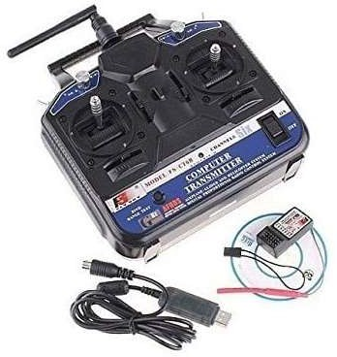Control Modes: The transmitter offers four control modes that allow the user to choose the control stick configuration that suits them best. The control modes are: mode 1 (throttle right), mode 2 (throttle left), mode 3 (throttle right but with the control sticks switched), and mode 4 (throttle left but with the control sticks switched).

Transmitter performance: The FS-CT6B transmitter operates at 2.4 GHz, which is less prone to interference than lower frequency radio systems. The transmitter has an output power of less than 100 mW, which means that it can be used legally without a license in most countries.

LCD Display: The transmitter has a clear and easy-to-read LCD display that displays important information such as battery voltage, signal strength, trim settings and channel status.

Channels: The FS-CT6B transmitter offers 6 control channels that can be used to control various functions on the RC plane, such as throttle, elevator, ailerons, rudder and auxiliary functions.

 

Receiver Compatibility: The transmitter is compatible with a wide range of receivers, including the FS-R6B receiver. The receiver can be easily connected to the transmitter using a simple bonding process.

Battery life: The transmitter can be powered by 8xAA batteries or a rechargeable battery (not included). The transmitter also has a built-in charging port that can be used to charge the rechargeable battery.

Range: The transmitter has a range of up to 1000 meters, making it suitable for a wide range of RC applications.

Modes: The transmitter offers a variety of modes, including trainer mode, throttle and servo reverse.

Ergonomics: The transmitter is ergonomically designed, with a comfortable grip and intuitive button placement. This makes it easier to use for a longer period of time.

Overall, the FS-CT6B transmitter is a versatile and reliable radio control system that offers a range of features and functions. Its easy-to-use interface, compatibility with a variety of receivers, and long-range applications.

SPECIFICATIONS OF THE SELECTED DRONE RADIO TRANSMITTER

* Channels: 6 CH
* Control Distance: Up to 1000 meters in the air
* Super active and passive anti-jamming capabilities.
* Very low power consumption.
* High receiving sensitivity.
* 8 model memory, digital control.
* We can program by PC with the included software.
* 4 Types (Airplane, Heli90, Heli120, Heli140).
* Use a linear spread of fine paragraph by an excess antenna.
* It covers the entire bandwidth of the antenna bandwidth range.
* High quality and stability.
  1. Operating Voltage: 12 V
  2. Weight: 511 gm
  3. Dimension: 189x97x295 mm

 

##### Navigation System :

The M8N GPS is a high-precision Global Navigation Satellite System (GNSS) receiver module that is widely used in various applications such as drones, autonomous vehicles and navigation systems. Here is a detailed description of the M8N GPS module:

**GNSS system**: The M8N GPS module is compatible with the Global Navigation System (GPS) and the Russian Global Navigation Satellite System (GLONASS). This means it can receive signals from both GPS and GLONASS satellites to provide more accurate and reliable location information.

**Chipset**: The M8N GPS module uses the u-blox M8N chipset, which is a high-performance GNSS receiver that provides accurate location information even in challenging environments such as urban canyons and forested areas.

**Positioning Accuracy**: The M8N GPS module has a positioning accuracy of up to 2.5 meters, making it ideal for applications that require highly accurate position data.

**Refresh rate**: The M8N GPS module has a fast refresh rate of up to 10 Hz, which means it can provide up to 10 updates of position, speed and

time data per second.

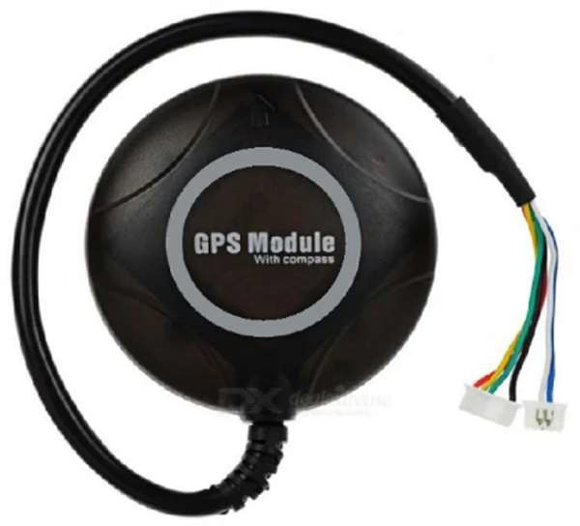**Antenna**: The M8N GPS module comes with a built-in ceramic patch antenna that provides good signal reception and eliminates the need for an external antenna.

**Interfaces**: The M8N GPS module has a number of interfaces, including UART, I2C and USB. This makes it easy to interface with a variety of devices such as microcontrollers, single board computers and other devices.

**Power consumption**: The M8N GPS module has a

low power consumption of only 45mA, making it ideal for battery-powered applications.

**Operating Temperature Range:** The M8N GPS module has an operating temperature range of

-40°C to 85°C, making it suitable for use in a wide range of environments and applications.

 

**Size**: The M8N GPS module has a compact size of 25mm x 25mm x 4mm, which makes it easy to integrate into various devices.

**Detailed Weight Breakdown:**

|  |  |  |  |  |
| --- | --- | --- | --- | --- |
| **Sr.No** | **Items** | **Mass (Gm)** | **No. of Items** | **Total Mass (Gm)** |
| Drone Frame | | | | |
|  | Arms | 50 | 4 | 200 |
|  | Base plate | 50 | 2 | 100 |
|  | legs | 15 | 4 | 60 |
|  | Propeller | 25 | 4 | 100 |
| Electronics Components | | | | |
|  | Motor | 50 | 4 | 280 |
|  | Flight controller | 38 | 1 | 38 |
|  | GPS | 26 | 1 | 26 |
|  | Camera | 125 | 1 | 125 |
|  | battery | 397 | 1 | 397 |
|  | ESC | 25.5 | 4 | 102 |
| Payload Mechanism | | | | |
|  | Frame | 300 | 1 | 300 |
|  | Servo motor | 12 | 1 | 12 |
|  | Slider-Crank mechanism | 50 | 1 | 50 |
|  |  |  |  |  |
| additional mass ( screws, wires, ect) | | | | 150 |
| Total :(Apprx.) | | | | 1940 |

## Drone Performance Recalculation :

##### Thrust to Weight ratio:

1. Total weight = 2kg approx.
2. Thrust-to-weight ratio = 2:1

 

1. No. of motors = 4
2. Required thrust per motor = (2× 2) /4 + 20% = 1.2kg = 11772 N

##### Power Required for the mission :

Power consumed by Motors :

The selected motor has a maximum current draw of 11.7A .The battery is providing volta age of 11.1 V. Therefore, the maximum power that the motor can consume is:

Power = Voltage x Current Power = 11.1V x 11.7 A Power = 130 W Max Power consumed by 4 Motors = 4 X 130 = 520 W

The Pixhawk 2.4.8 is a flight controller board that requires a 5V power supply with a maximum current draw of 2.5A. Therefore, the maximum power consumption of the Pixhawk 2.4.8 would be:

Power = Voltage x Current Power = 5V x 2.5A Power = 12.5W

Power consumed by raspberry pi ranges from 3.5-4 W and of camera is 2 W Along with this, assumed some losses of 5 W

Total maximum power required (Apprx.) = 520+12.5+2+5W = 539.5 W

##### Endurance calculation :

Maximum **(A)** draw : 49

Draw based on sel. flying load (% ) : 16.2 Flying time in minutes : 19 min

Flying time in minutes 80% rule ² : 15 min Maximum power consumption **(W)** ⁴ : 540 W

 

##### Optimized Final Design

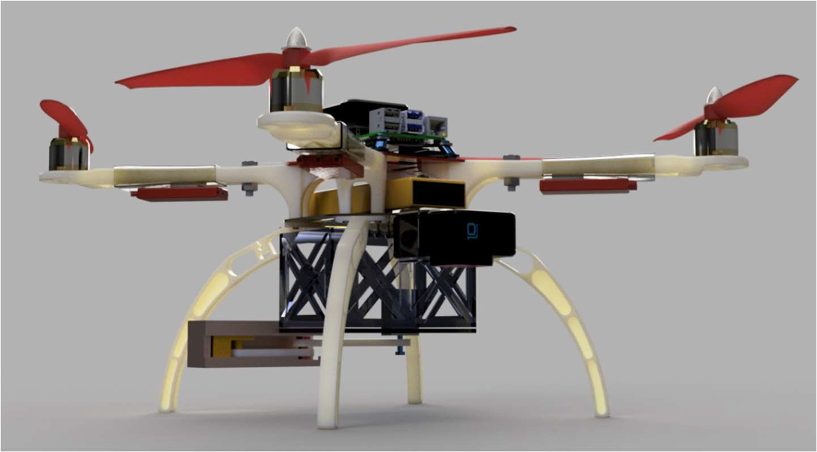

BILL OF MATERIALS OF THE UAV (UNMANNED AERIAL VEHICLE): - (Table 7)

|  |  |  |  |
| --- | --- | --- | --- |
| PART NO. | PART NAME | MATERIAL/SPECS | QUANTITY |
| 1 | Frame | ABS + GFRP | 1 |
| 2 | Motor | GT2215 BLDC | 4 |
| 3 | Battery | Li-Po | 1 |
| 4 | GPS | Pixhawk 4 Neo M8N GPS | 1 |
| 6 | Flight Control Module | Pixhawk V2.4.8 | 1 |
| 7 | Standard Base Board | F450 Quadcopter Frame PCB Board | 1 |
| 8 | Esc |  | 4 |
| 10 | Propellor CCW | Carbon Fibre | 2 |
| 11 | Propellor CW | Carbon Fibre | 2 |
| 12 | Payload Dropping Mechanism | Polystyrene Foam Board | 1 |



**r)ijl"...; i..- = An5C::**

Where innovations soar high!