CASE STUDY ANALYSIS REPORT
Software Engineering — Problem Statement 15
Smart Classroom Attendance, Engagement, and Performance Analytics System
Prepared as part of Software Engineering Course Assessment
Date: July 2026

1. Understanding the Problem Statement

1.1 Problem Explanation
Educational institutions continue to rely heavily on manual, paper-based or semi-digital methods for taking attendance and assessing student performance. These conventional processes consume significant instructional time, are prone to human error and proxy attendance, and — most critically — offer little to no insight into how engaged students actually are during a class session. As a result, instructors frequently discover that a student is struggling only after mid-semester examinations, by which point meaningful intervention becomes difficult.
The proposed Smart Classroom Attendance, Engagement, and Performance Analytics System addresses this gap by combining AI-based facial recognition or RFID technology for automated attendance capture with continuous engagement monitoring and predictive analytics. The system is designed to give instructors and administrators real-time, data-driven visibility into classroom participation and academic trajectory, enabling early, personalized intervention for at-risk students.

1.2 Objectives of the Proposed System
- Automate student attendance recording using AI-based facial recognition or RFID technology.
- Continuously analyze classroom engagement through participation and behavioral signals.
- Monitor academic performance across assessments in real time.
- Apply predictive AI models to identify academically at-risk students early.
- Generate intuitive learning analytics dashboards for teachers and administrators.
- Support personalized learning strategies tailored to individual student needs.
- Reduce the administrative workload associated with manual attendance and record-keeping.
- Improve overall teaching effectiveness through actionable, data-backed insights.

1.3 Scope of the Problem
The scope of this system covers classroom-level and institution-wide attendance automation, engagement analytics, and performance tracking for schools, colleges, and universities. It includes hardware integration (cameras/RFID readers), a cloud-based analytics backend, predictive modeling for at-risk identification, and dashboards for teachers, administrators, students, and parents. The scope excludes proctoring of remote online examinations and does not extend to full-scale learning-content delivery (i.e., it complements, rather than replaces, an institution's existing Learning Management System).

2. Key Stakeholders and Challenges

2.1 Stakeholder Roles and Responsibilities
Stakeholder | Role / Responsibility | Key Challenges Faced
Students | Attend classes; engage in learning activities; view personal analytics. | Privacy concerns over facial recognition; lack of visibility into own progress.
Teachers / Faculty | Conduct classes; monitor engagement; act on predictive alerts. | Limited time to track each student individually; delayed insight into struggling students.
Academic Administrators | Oversee institution-wide attendance and performance policy; generate reports. | Manual compilation of attendance/performance data; inconsistent record-keeping.
IT / System Administrators | Deploy, maintain, and secure the platform and hardware. | Ensuring system uptime, data security, and integration with legacy systems.
Parents / Guardians | Monitor child's attendance and academic progress. | Little or delayed communication from institution regarding performance issues.
Academic Counsellors | Provide personalized interventions for at-risk students. | Late identification of at-risk students reduces intervention effectiveness.

2.2 Major Challenges Summary
Across stakeholders, three challenges recur consistently: (1) the absence of real-time, automated data collection forces reliance on error-prone manual processes; (2) engagement and participation are rarely measured at all, leaving teachers with an incomplete picture of classroom dynamics; and (3) academic risk is typically identified reactively — after poor grades appear — rather than proactively through continuous monitoring. The proposed system is designed specifically to resolve these three challenges.

3. Analysis of the Current Approach

3.1 Existing Process
Most institutions currently use one of the following: (a) manual roll-call attendance recorded in register books or basic spreadsheets, (b) isolated biometric or barcode attendance machines that only capture entry/exit data without further analysis, or (c) periodic, manually compiled performance reports generated only after formal examinations. Engagement, in almost all cases, is not measured at all — it is left entirely to a teacher's subjective impression.

3.2 Strengths and Limitations
Aspect | Strengths of Current System | Limitations
Attendance | Simple to understand; low technology dependency. | Time-consuming; vulnerable to proxy attendance and manual entry errors.
Performance Tracking | Familiar exam-based evaluation process. | Only periodic; no continuous or early insight into student trajectory.
Engagement Monitoring | None required — low overhead. | Entirely absent; no objective measurement of classroom participation.
Reporting | Reports are institution-approved and audit-friendly. | Manually compiled; slow, error-prone, and rarely real-time.
Intervention | Counsellors available on request. | Reactive rather than proactive; at-risk students often identified too late.

3.3 Gaps to be Addressed
- No automated, tamper-resistant attendance mechanism.
- No continuous or quantifiable engagement measurement.
- No predictive mechanism to flag at-risk students before performance visibly declines.
- No unified dashboard consolidating attendance, engagement, and performance data.
- Heavy administrative burden on faculty for manual record compilation.
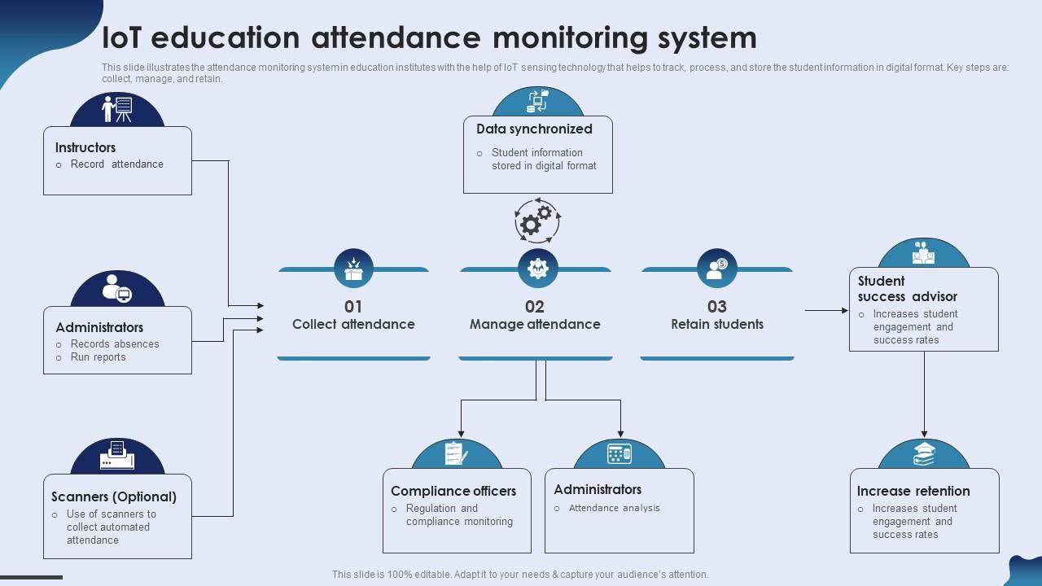

Figure 2: Illustrative learning-analytics dashboard showing engagement scores and student risk distribution.

4. Proposed Software Solution

4.1 Solution Overview
The proposed system is a cloud-based Smart Classroom Analytics Platform composed of an AI-driven data-capture layer, a cloud analytics engine, and role-based dashboards. Facial recognition cameras or RFID readers installed in classrooms automatically log attendance the moment a student enters. The same camera feed (or supplementary sensors) is used to derive engagement signals — such as attentiveness and participation frequency — while academic performance data is synchronized from assessments and the institution's LMS. A predictive model continuously scores each student's risk level, triggering early alerts for instructors and counsellors.
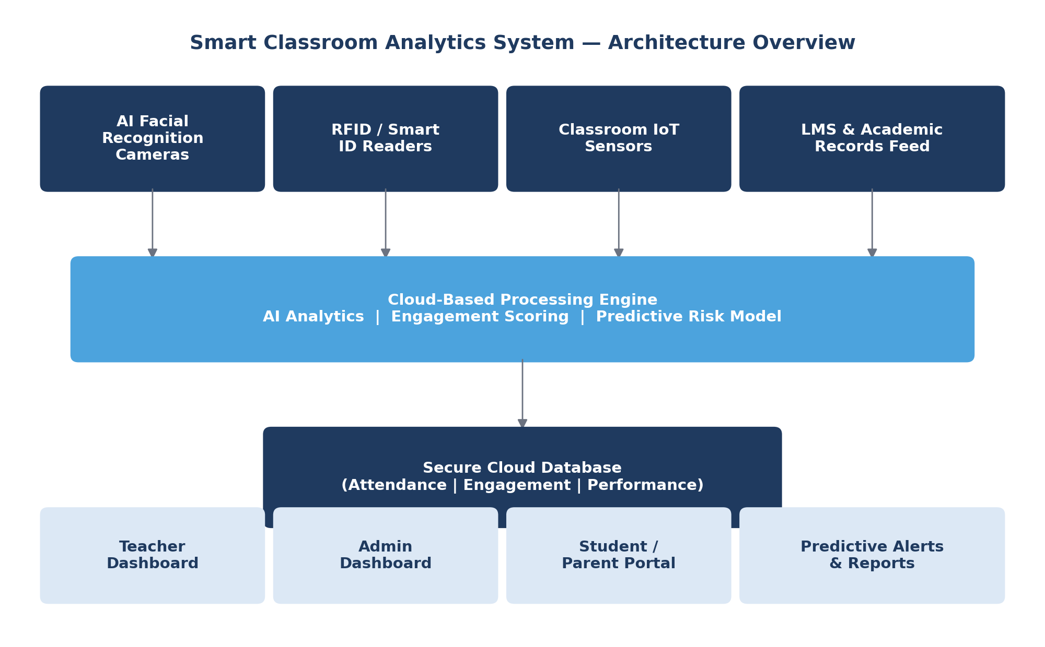
Figure 1: High-level system architecture of the Smart Classroom Analytics Platform.

4.2 Major Functional Modules
Module | Description
Attendance Capture Module | Captures attendance via facial recognition / RFID and logs it to the central database in real time.
Engagement Analytics Module | Derives participation and attentiveness scores from classroom sensor/camera data.
Performance Monitoring Module | Aggregates assessment scores and academic records from the LMS and gradebooks.
Predictive Risk Engine | Applies machine learning models to flag students showing early signs of academic risk.
Dashboard & Reporting Module | Presents role-specific visual analytics to teachers, administrators, students, and parents.
Notification & Intervention Module | Sends automated alerts to teachers/counsellors and suggests personalized intervention plans.
User & Access Management Module | Manages authentication, roles, and permissions across all user categories.
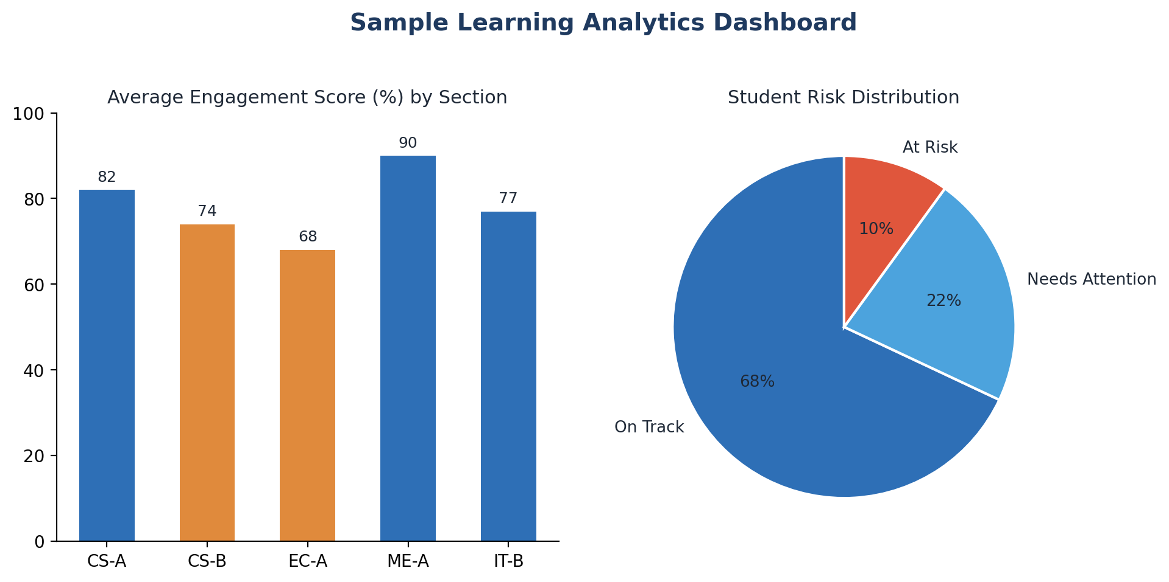

.

4.3 Functional and Non-Functional Requirements

4.3.1 Functional Requirements
- The system shall automatically record attendance using facial recognition or RFID with a minimum accuracy of 98%.
- The system shall compute and update engagement scores for each class session.
- The system shall synchronize academic performance data from the LMS/gradebook in near real time.
- The system shall generate predictive at-risk alerts based on attendance, engagement, and performance trends.
- The system shall provide role-based dashboards for teachers, administrators, students, and parents.
- The system shall allow administrators to generate and export institution-wide reports.

4.3.2 Non-Functional Requirements
- Scalability: the system shall support concurrent monitoring across multiple classrooms and campuses without performance degradation.
- Reliability: the system shall maintain 99.5% uptime during institutional working hours.
- Security & Privacy: biometric data shall be encrypted at rest and in transit, and access shall be role-restricted in compliance with data-protection regulations.
- Usability: dashboards shall be intuitive enough for non-technical staff to use without extensive training.
- Maintainability: the modular architecture shall allow individual modules to be updated independently.
- Performance: attendance recognition shall complete within 2–3 seconds per student on average.

4.4 Application of Software Engineering Principles
Principle | How It Is Incorporated
Modularity | The system is decomposed into independent modules (attendance, engagement, performance, prediction, dashboard) that can be developed, tested, and deployed separately.
Scalability | Cloud-native, microservices-based deployment allows horizontal scaling as more classrooms/campuses are added.
Maintainability | Clear separation of concerns and well-documented APIs allow individual modules to be updated without affecting the whole system.
Reliability | Redundant cloud infrastructure and automated failover ensure consistent data capture and availability.
Usability | Role-specific, visually intuitive dashboards minimize training overhead for teachers and administrators.
Security | End-to-end encryption, role-based access control, and compliance with data-protection standards safeguard sensitive biometric and academic data.
5. Justification of the Chosen Methodology

5.1 Selected Methodology: Agile (Scrum Framework)
The Agile methodology, implemented through the Scrum framework, is recommended for developing the Smart Classroom Analytics System. Given the system's multiple independent modules (attendance capture, engagement analytics, predictive modeling, dashboards) and the likelihood of evolving requirements — such as new engagement metrics or additional integrations with third-party LMS platforms — Agile's iterative, incremental approach is well suited to this project.
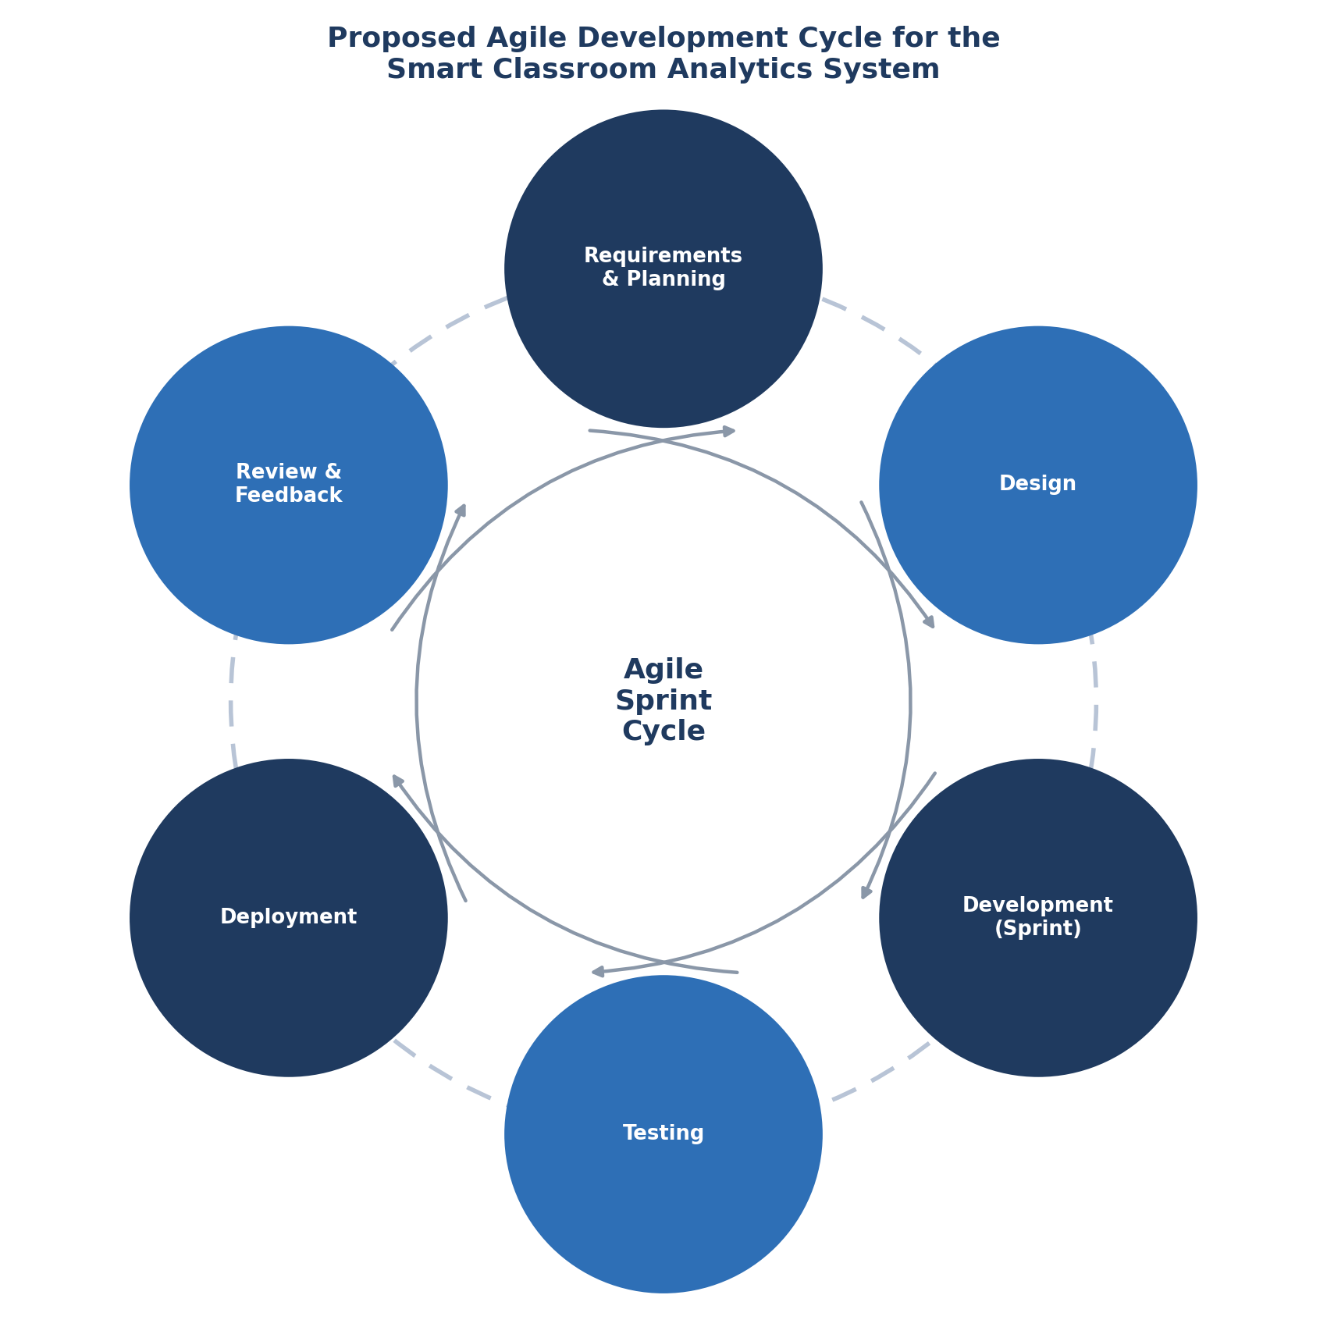

5.2 Why Agile/Scrum Is Suitable
- Incremental delivery allows each functional module (e.g., attendance, then engagement analytics, then prediction) to be built, tested, and released in independent sprints.
- Frequent stakeholder feedback from teachers and administrators ensures the dashboards and alerts remain genuinely usable in real classroom conditions.
- Iterative refinement of the predictive risk model is essential, since machine learning components typically improve through repeated tuning against real classroom data.
- Sprint reviews allow early detection of integration issues between hardware (cameras/RFID) and the cloud backend, reducing late-stage risk.
- Agile's flexibility accommodates institution-specific customization requests without derailing the overall project timeline.

5.3 Comparison with Alternative Models
Model | Suitability for This Project
Waterfall | Not ideal — rigid, sequential phases make it difficult to refine the predictive model or incorporate stakeholder feedback mid-development.
Spiral | Viable given the risk-sensitive nature of biometric data, but adds process overhead not justified for a project of this scale.
Agile / Scrum (Selected) | Best fit — supports modular, iterative delivery, continuous stakeholder feedback, and progressive refinement of AI components.
DevOps | Complementary rather than alternative — recommended for continuous deployment once Agile development stabilizes each module.
In practice, the recommended approach combines Agile/Scrum for iterative development with DevOps practices (continuous integration and deployment) for reliably rolling out updates across multiple institutional deployments, ensuring both adaptability during development and operational stability afterward.

6. Expected Outcomes and Limitations

6.1 Expected Benefits
Benefit | Description
Accurate Attendance Management | Eliminates proxy attendance and manual errors through automated AI/RFID capture.
Improved Student Engagement | Continuous engagement measurement gives teachers actionable, real-time feedback.
Early At-Risk Identification | Predictive analytics flags struggling students weeks earlier than traditional methods.
Better Learning Outcomes | Timely, personalized interventions improve academic performance over time.
Reduced Administrative Effort | Automation frees faculty and staff from manual record-keeping tasks.
Data-Driven Decisions | Dashboards support evidence-based teaching and institutional policy decisions.
Increased Institutional Efficiency | Centralized analytics streamline reporting across departments and campuses.

6.2 Potential Risks and Implementation Challenges
- Data privacy concerns: biometric facial-recognition data requires strict regulatory compliance and clear consent mechanisms.
- Initial hardware investment: cameras, RFID readers, and network infrastructure require upfront capital expenditure.
- Model accuracy: predictive risk models require sufficiently large and representative historical data to be reliable.
- Change management: faculty and students must be trained and onboarded to trust and effectively use the new system.
- Integration complexity: synchronizing with existing legacy LMS or ERP systems may require custom connectors.

6.3 Limitations
The system's predictive accuracy is inherently dependent on data quality and historical volume; institutions with limited digitized records may see reduced prediction reliability during the initial rollout period. Additionally, facial recognition performance can be affected by lighting conditions, camera placement, and classroom size, which may necessitate a hybrid RFID fallback in some deployments.

6.4 Future Enhancements
- Integration of natural-language sentiment analysis on classroom discussion transcripts for deeper engagement insight.
- Mobile app extensions for parents to receive real-time performance and attendance notifications.
- Adaptive learning-content recommendations personalized to each student's identified risk profile.
- Expansion of predictive models with explainable-AI (XAI) techniques to increase transparency for educators.

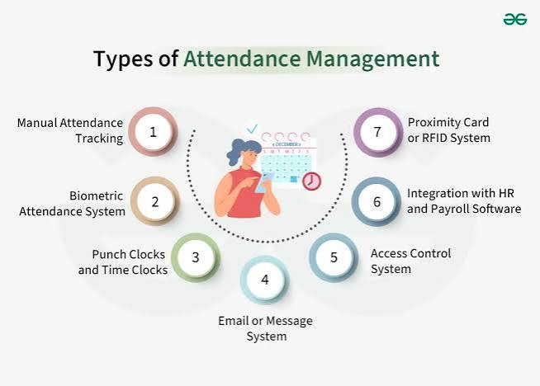

7. Conclusion
The Smart Classroom Attendance, Engagement, and Performance Analytics System addresses a well-defined and pressing gap in current educational administration: the absence of real-time, holistic visibility into student attendance, participation, and academic trajectory. By applying core software engineering principles — modularity, scalability, reliability, usability, and security — within an Agile/Scrum development methodology, the proposed solution is technically feasible, stakeholder-aligned, and positioned to meaningfully improve both administrative efficiency and student learning outcomes.

