PROJECT REPORT
Smart Classroom Attendance, Engagement,
and Performance Analytics System
AI-Enabled Facial Recognition & Learning Analytics for Modern Classrooms

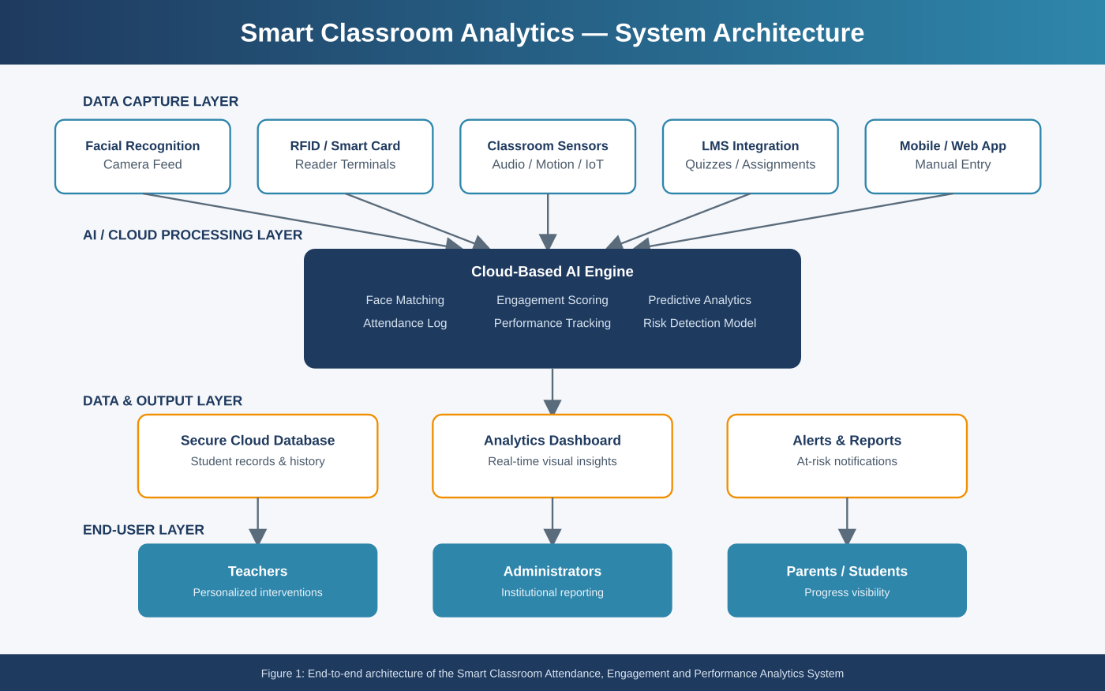

Industry: Education Technology (EdTech)
Domain: AI, Facial Recognition, Learning Analytics, Cloud Computing
July 2026

Table of Contents
1. Executive Summary 3
2. Industry Context 3
3. Problem Statement 4
4. Objectives 4
5. Proposed System Overview 5
6. System Workflow 6
7. Key Features and Modules 6
8. Sample Analytics Dashboard 7
9. Technology Stack 8
10. Expected Outcomes 8
11. Traditional vs. Smart Classroom System 8
12. Implementation Roadmap 9
13. Challenges and Considerations 9
14. Conclusion 9

1. Executive Summary
Educational institutions continue to rely on manual or semi-automated attendance and evaluation processes that consume significant instructional time while providing little insight into how students are actually engaging with learning material. This report presents a Smart Classroom Attendance, Engagement, and Performance Analytics System — a cloud-based platform that uses AI-driven facial recognition or RFID identification to automate attendance, continuously analyzes classroom participation and academic performance, and applies predictive analytics to flag at-risk students early. The system is designed to reduce administrative overhead, give teachers real-time, data-driven visibility into their classrooms, and enable timely, personalized interventions that improve overall learning outcomes.
The sections that follow outline the industry context, problem statement, system objectives, proposed architecture, workflow, feature set, technology stack, expected outcomes, and an implementation roadmap for institutions considering adoption of this platform.

2. Industry Context
The global education sector is undergoing rapid digital transformation. Artificial intelligence, computer vision, IoT-based identification (RFID/NFC), and cloud-based learning management platforms are increasingly deployed to modernize classroom operations. Institutions are moving away from paper registers and spreadsheet-based grade tracking toward integrated digital ecosystems that combine attendance, engagement, and academic performance data into a single analytical view. This shift is driven by the need to reduce administrative workload on teaching staff, improve transparency for parents and administrators, and generate the kind of longitudinal data required to identify learning gaps before they become critical.

3. Problem Statement
Traditional attendance-taking and manual performance evaluation consume valuable instructional time that could otherwise be spent teaching. Roll-call attendance is prone to human error and proxy attendance, while performance evaluation based on periodic tests alone offers a lagging, incomplete picture of student learning. Critically, teachers often lack the tools to identify at-risk students early enough to intervene effectively, and disengagement in the classroom frequently goes unnoticed until it is reflected in exam results. A smart classroom analytics platform addresses these gaps by automating identity capture, continuously analyzing participation signals, and using predictive models to surface risk indicators in real time, enabling educators to design and implement personalized learning interventions.

4. Objectives
The system is designed around eight core objectives that together support a complete attendance-to-intervention analytics cycle:
# | Objective | Description
1 | Automate Attendance | Automatically record student attendance using AI-based facial recognition or RFID, eliminating manual roll-call.
2 | Analyze Engagement | Continuously assess classroom participation, attention, and interaction levels.
3 | Monitor Performance | Track academic performance continuously across assignments, quizzes, and exams rather than only at term end.
4 | Predict At-Risk Students | Apply AI/ML models to flag students showing early signs of academic difficulty.
5 | Generate Analytics Dashboards | Present real-time, visual learning analytics for teachers and administrators.
6 | Support Personalized Learning | Enable tailored intervention and learning strategies based on individual student data.
7 | Reduce Administrative Workload | Free up instructional time currently spent on manual attendance and record-keeping.
8 | Improve Teaching Effectiveness | Give educators actionable insight to adapt instruction and improve outcomes.

5. Proposed System Overview
The platform is organized into four functional layers: a data-capture layer (cameras, RFID readers, IoT sensors, LMS integration, and mobile apps), a cloud-based AI processing layer (face matching, engagement scoring, performance tracking, and predictive analytics), a data and output layer (secure database, dashboards, and automated alerts), and an end-user layer serving teachers, administrators, and parents or students. This layered design allows new capture devices or analytics models to be added without disrupting existing workflows.

Figure 1: End-to-end system architecture

6. System Workflow
Data flows through the system in five stages: attendance capture, engagement analysis, continuous performance monitoring, AI-based prediction and risk scoring, and finally personalized intervention by the teacher. A continuous feedback loop feeds outcomes of each intervention back into the model, improving prediction accuracy over successive terms.
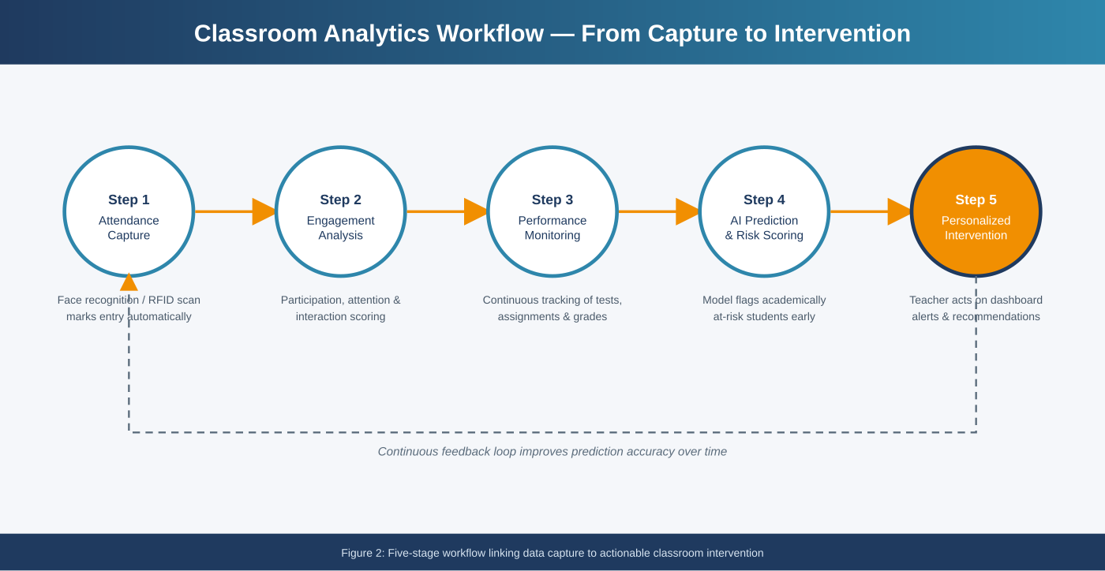
Figure 2: Five-stage analytics workflow

7. Key Features and Modules
Module | Key Capabilities
Attendance Automation | Facial recognition / RFID-based check-in, duplicate and proxy detection, automated absence notifications.
Engagement Analytics | Participation tracking, attention scoring, classroom interaction and question-response analysis.
Performance Monitoring | Continuous grade tracking across assignments, quizzes, and exams with trend visualization.
Predictive Risk Engine | Machine learning models that flag at-risk students using attendance, engagement, and performance signals.
Analytics Dashboard | Real-time visual dashboards for teachers and administrators with drill-down by student, class, or subject.
Intervention Planner | Recommended personalized learning strategies and interventions for flagged students.
Reporting & Alerts | Automated report generation and instant alerts to teachers, administrators, and parents.

8. Sample Analytics Dashboard
The dashboard consolidates attendance, engagement, and performance metrics into a single real-time view. Teachers can see class-wide KPIs at a glance, drill into subject-level engagement trends, and review a prioritized list of at-risk students along with system-recommended actions.
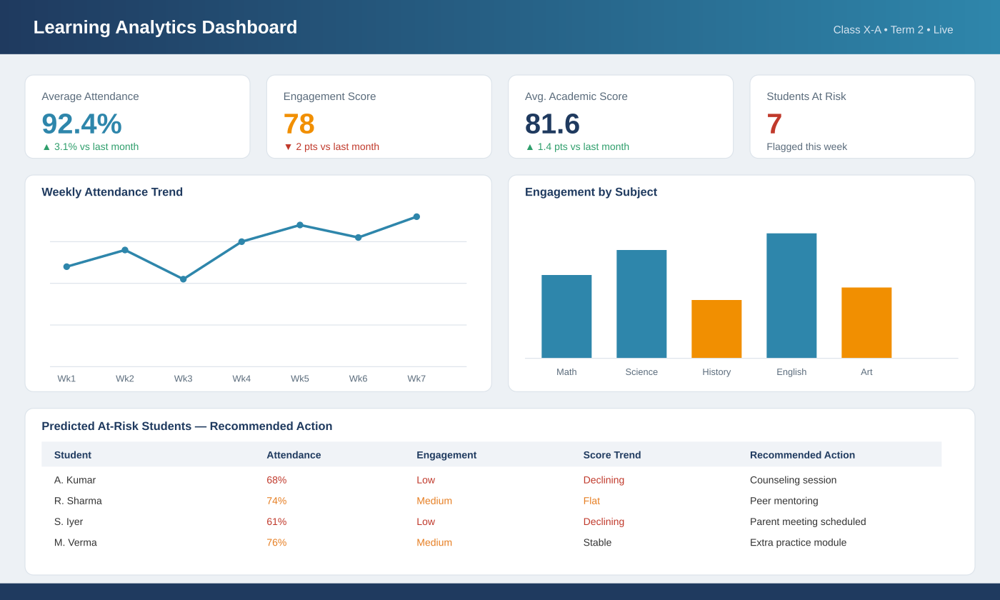
Figure 3: Sample learning analytics dashboard view

9. Technology Stack
Layer | Recommended Technologies
Attendance Capture | AI facial recognition (CNN-based models), RFID/NFC readers, IoT sensors
Backend & AI/ML | Python, TensorFlow / PyTorch, cloud ML services, REST APIs
Data Storage | Cloud databases (SQL/NoSQL), encrypted student data warehouse
Frontend / Dashboard | Web and mobile dashboards (React / Flutter), data visualization libraries
Integration | LMS integration, school ERP/SIS integration, notification services (SMS/email/app)
Security & Compliance | Role-based access control, data encryption, compliance with data privacy regulations

10. Expected Outcomes
# | Expected Outcome
1 | Accurate, automated attendance management with minimal manual effort
2 | Improved student engagement through real-time monitoring
3 | Early identification of academically at-risk students
4 | Better overall learning outcomes through timely intervention
5 | Reduced manual administrative effort for teaching staff
6 | Data-driven teaching decisions supported by continuous analytics
7 | Enhanced, continuous academic performance monitoring
8 | Increased institutional efficiency and transparency

11. Traditional vs. Smart Classroom System
Parameter | Traditional System | Smart Classroom Analytics System
Attendance | Manual roll-call, time-consuming, error-prone | Automated via facial recognition / RFID, instant and accurate
Engagement Tracking | Not measured or informally observed | Continuously measured and quantified
Performance Evaluation | Periodic, exam-based, lagging indicator | Continuous, real-time tracking across activities
Risk Identification | Reactive, often after poor results | Proactive, AI-based early prediction
Reporting | Manual compilation, delayed | Automated, real-time dashboards
Administrative Load | High — significant teacher time spent | Low — automated data capture and reporting

12. Implementation Roadmap
Phase | Duration | Key Activities
Phase 1: Requirements & Design | 4-6 weeks | Stakeholder consultation, infrastructure assessment, system architecture design
Phase 2: Pilot Deployment | 6-8 weeks | Install capture devices in select classrooms, configure AI models, initial data collection
Phase 3: Dashboard & Analytics Rollout | 4-6 weeks | Deploy dashboards, train predictive models on pilot data, teacher training
Phase 4: Institution-wide Rollout | 8-10 weeks | Scale to all classrooms, integrate with existing LMS/ERP systems
Phase 5: Monitoring & Optimization | Ongoing | Continuous model refinement, feedback collection, feature enhancement

13. Challenges and Considerations
- Data privacy and consent: facial recognition and student performance data require strict compliance with data protection regulations and institutional policy.
- Accuracy in varied conditions: lighting, camera angle, and occlusion (masks, hats) can affect facial recognition accuracy; RFID provides a reliable fallback.
- Change management: teachers and administrators need training and time to adapt workflows around the new system.
- Infrastructure requirements: reliable network connectivity and camera/RFID hardware are prerequisites for consistent performance.
- Bias and fairness in AI models: predictive risk models must be regularly audited to avoid biased or inequitable flagging of students.

14. Conclusion
The Smart Classroom Attendance, Engagement, and Performance Analytics System addresses long-standing inefficiencies in manual attendance and evaluation processes while giving educators the analytical tools needed to identify and support at-risk students early. By automating routine administrative tasks and surfacing continuous, data-driven insight, the platform allows teachers to redirect their time and attention toward personalized instruction — ultimately improving engagement, academic performance, and institutional efficiency.

