EXPERIMENT 1
BUS TICKET BOOKING SYSTEM – FIGMA PROTOTYPE

1. AIM
To design and develop a simple interactive prototype of a Bus Ticket Booking System using Figma, demonstrating the user interface and navigation flow from login to bus search, bus selection, and seat selection.

2. OBJECTIVES
- To understand basic UI prototyping using Figma.
- To design mobile screens for a bus ticket booking application.
- To create a simple and user-friendly booking interface.
- To connect the screens using Figma prototype interactions.
- To demonstrate the complete user navigation flow.

3. TOOLS REQUIRED
- Figma
- Computer/Laptop
- Web Browser

4. PROCEDURE
1. Open Figma and create a new design file.
2. Create a mobile frame using a suitable iPhone/mobile device frame.
3. Design the Login screen with BusGo title, email, password, Login, and Create Account elements.
4. Create the Bus Search screen with From, To, Date, and Search Bus fields.
5. Create the Available Buses screen showing bus names, bus types, timings, prices, and Select buttons.
6. Create the Seat Selection screen with driver position and available seats.
7. Open the Prototype tab in Figma.
8. Connect the Login button to the Bus Search screen.
9. Connect Search Bus to Available Buses.
10. Connect Select to Seat Selection.
11. Set the interactions to On Click → Navigate to.
12. Click Present/Play and test the complete prototype.
Figure 1: Bus Ticket Booking System Figma Prototype
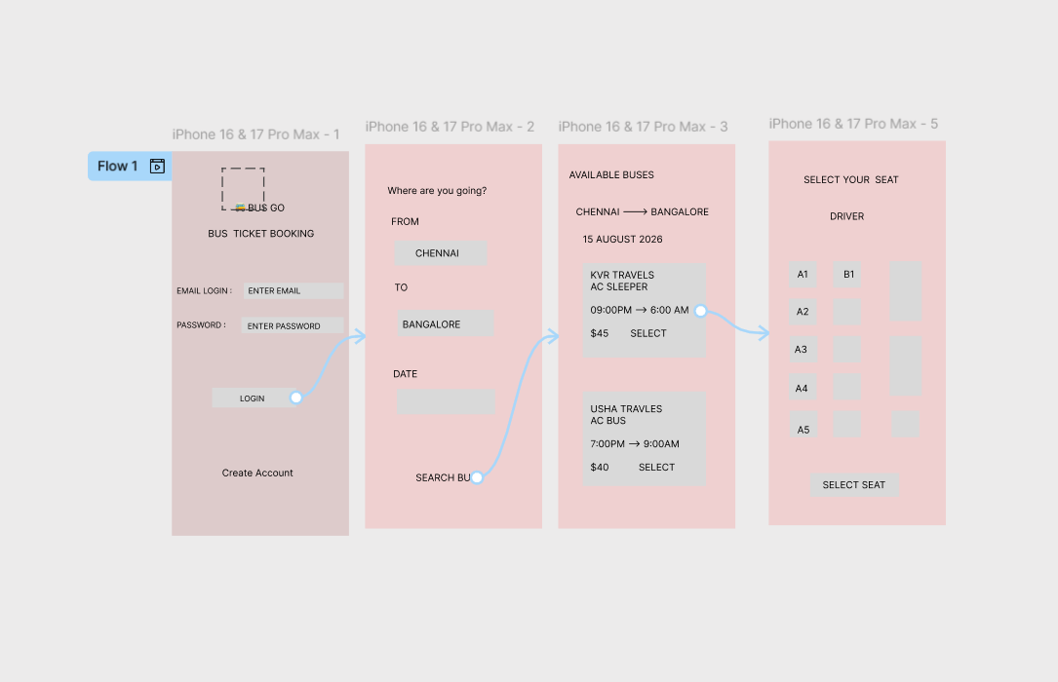

5. RESULT
A simple interactive Bus Ticket Booking System prototype was successfully created using Figma. The prototype demonstrates login, bus search, available bus selection, and seat selection screens with navigation between them.

6. CONCLUSION
The Figma prototype provides a visual representation of the Bus Ticket Booking System before actual development. It helps users and developers understand the application flow and interface.

EXPERIMENT 2
E-COMMERCE MOBILE APP – FIGMA PROTOTYPE
1. AIM
To create an interactive prototype of an E-Commerce mobile application using Figma and present alternative user interface designs to stakeholders in order to collect feedback, resolve conflicting UI preferences, and obtain design approval.
2. OBJECTIVES
To understand mobile UI design and prototyping using Figma.
To create a simple E-Commerce mobile application interface.
To design alternative Home screen layouts for different stakeholder preferences.
To demonstrate the product browsing and shopping flow.
To collect stakeholder feedback and select the preferred UI design.
3. TOOLS REQUIRED
Figma
Computer/Laptop
Web Browser
4. PROCEDURE
1. Open Figma and create a new design file.
2. Create a mobile frame using a suitable iPhone/mobile device frame.
3. Design the Login screen with email, password, Login, Forgot Password, and Sign Up options.
4. Create Home Design A with search products, categories, and featured products.
5. Create Home Design B with a Big Sale banner, Shop Now button, and Trending Products.
6. Use Design A and Design B as alternative UI proposals for stakeholders.
7. Present both designs to stakeholders and ask which layout is easier and more attractive.
8. Collect feedback about search placement, categories, product display, promotions, and navigation.
9. Select or combine the preferred elements based on stakeholder feedback.
10. Open the Prototype tab and connect the screens.
11. Set interactions to On Click → Navigate to.
12. Click Present/Play to demonstrate the prototype.
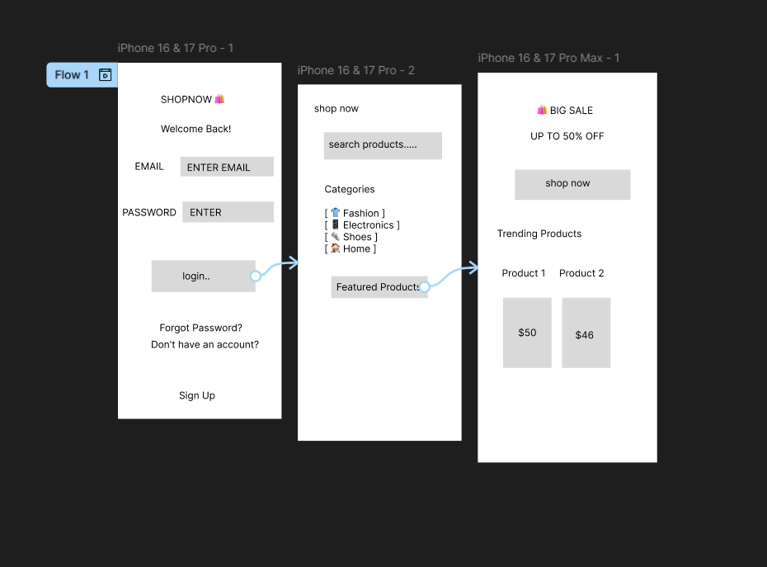

Figure 1: E-Commerce Mobile App Alternative UI Prototypes

5. STAKEHOLDER FEEDBACK
UI Element | Design A | Design B
Main focus | Search and categories | Promotions and sale
Product section | Featured products | Trending products
Home layout | Search-focused | Promotion-focused
Decision | Collect feedback | Collect feedback
6. RESULT
Two alternative E-Commerce mobile UI designs were successfully created in Figma. The prototype can be presented to stakeholders to compare the designs, collect feedback, resolve conflicting opinions, and approve the final interface.
7. CONCLUSION
Figma prototyping helps stakeholders visualize an E-Commerce application before development. Providing alternative designs makes it easier to discuss different opinions and select a final user interface based on stakeholder feedback.

