EOS EXAMINATION WEB DEVELOPMENT 2022

ARSHAD MK

Reg no:1P21CS004

1. 1. Write a JavaScript code that **will allow the ball to move between two fixed positions on the x-axis and y-axis on the page.**

Output:

https://arshadmsc.github.io/EOS_programme1/

2.Write a JavaScript code to **determine stops between 2 locations. Then add an animated marker on the map to highlight the bus routes.**

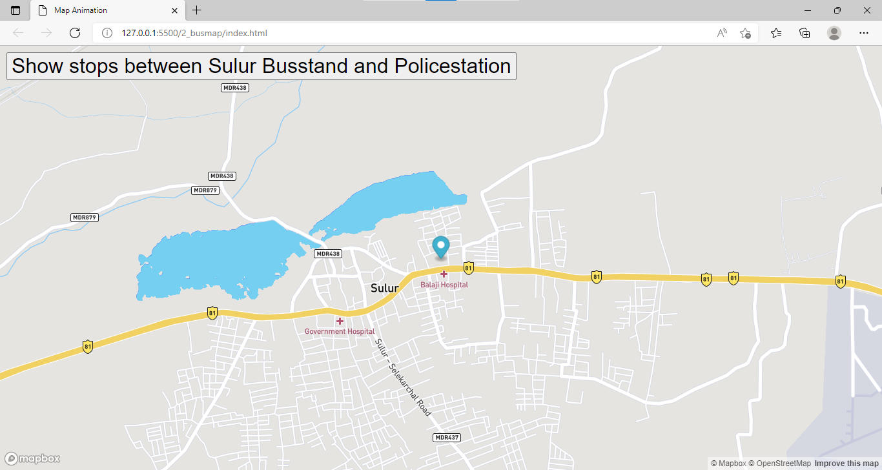

Output:

https://arshadmsc.github.io/EOS-Examination/

ARSHAD.MK