**ABSTRACT**

Search engine optimization (SEO) is the practice of getting targeted traffic to a website from a search engine’s organic rankings. Since organic search is one of the ways through which people discover content online, higher rankings can translate to higher organic traffic to a website.

SEO is often about making small modifications to parts of your website. When viewed individually, these changes might seem like incremental improvements, but when combined with other optimizations, they could have a noticeable impact on your site's user experience and performance in organic search results.

SEO includes both technical and content practices aimed to align with the best search engine algorithm needs. Common tasks associated with SEO include creating high-quality content, optimizing content around specific keywords, and building backlinks.

In other words:

SEO is all about improving a site’s rankings in the organic (non-paid) section of the search results

The project titled SEO friendly website aims at bringing these changes to an e-commerce website, With the intention to make the website more SEO friendly and thus rank higher in SERPs

###### TABLE OF CONTENTS

|  |  |  |
| --- | --- | --- |
| **Sr.no** | **Section** | **Page no** |
| **1.** | Introduction | 1 |
| **2.** | Problem Statement | 2 |
| **3.** | Technical Details | 3 |
| **4.** | Key Features | 4 |
| **5.** | Project Advantages | 5 |
| **6.** | Bonus Feature | 6 |
| **7.** | Result | 7-8 |
| **8.** | Conclusion | 9 |

1. **Introduction**
   1. **SEO friendly website**
      1. **Definition**

A SEO friendly website is an ordinary website (mostly E- commerce) but with highly optimized code such that it is highly optimized in accordance with searching Algorithms of Search Engines which leads to a higher ranking.

* + 1. **SEO Structure**

The best SEO friendly structure is hierarchical, which moves from general pages, with optimized URLs, to more specific ones. Hierarchical navigation is tree-like in nature. The home page is at the top, underneath which are category pages that can be further broken into different sub-categories.

* 1. **Advantages**
     1. **Increased organic traffic**

As the browser or search engine rank your search higher. It increases consumer outreach to your website thus increasing the organic traffic buildup

* + 1. **Increase in sales**

As the consumer outreach increases, sales increase accordingly

* + 1. **Better User Experience**

Introduction of SEO friendly practices not only makes it

browser friendly but also user friendly.

1. **Problem Statement**

About 10,000+ new E-commerce websites are created every year in India alone. Yet all of them fade away in dust. Whenever we try to search for something to buy on google, all we see is Flipkart and Amazon, at most we will see Myntra. so, what happened to all these sites? Where are they when we have to buy something? Big bulls like Flipkart and Amazon have dominated the Indian e-commerce search. So, what is wrong with other E-commerce sites?

1. **Technical Details**
   1. The project uses
      1. HTML (version: HTML 5),
      2. CSS (version: CSS 3) and minor
      3. JAVASCRIPT (version: ES13)
   2. The project uses GOOGLE CHROME (version:116.0.5845.188) as the default browser and reference browser
   3. The code editor used during the creation of the project is VS Code (version: 1.78)
   4. The project also uses Google fonts (Poppins)
   5. and swiper.com official site (swiper effect)
2. **Key Features**

To tackle this problem, we need:

4.1 Foremost, An E-commerce website

4.2 Unique ids which separate each individual element

4.3 The appropriate usage of keywords to emphasize the element

4.4 The usage of appropriate meta tags

4.5 To make the website mobile friendly as well

* 1. Use of proper head , title and meta description tags
  2. Use of keyword-rich anchor text in your links

1. **Project Advantages**
   1. The website created will henceforth rank much higher on google searches compared to its non-SEO counterparts.
   2. Consumer outreach to the website will increase
   3. Increase in website productivity
   4. Increases Brand awareness
   5. Optimizes your website for mobile users
   6. Boosts Credibility
   7. Doesn’t cost you anything
   8. Gives competitive advantage
   9. Helps reach a wider audience
   10. Improves website usability
2. **Bonus Features**
   1. the website contains blogs about groceries
   2. Furthermore, we have installed a sliding effect in our product and our reviews section which slides after approx. 7.5s
   3. We have added our own icon next to the title



1. **Result**

The resulting website looks something like this:

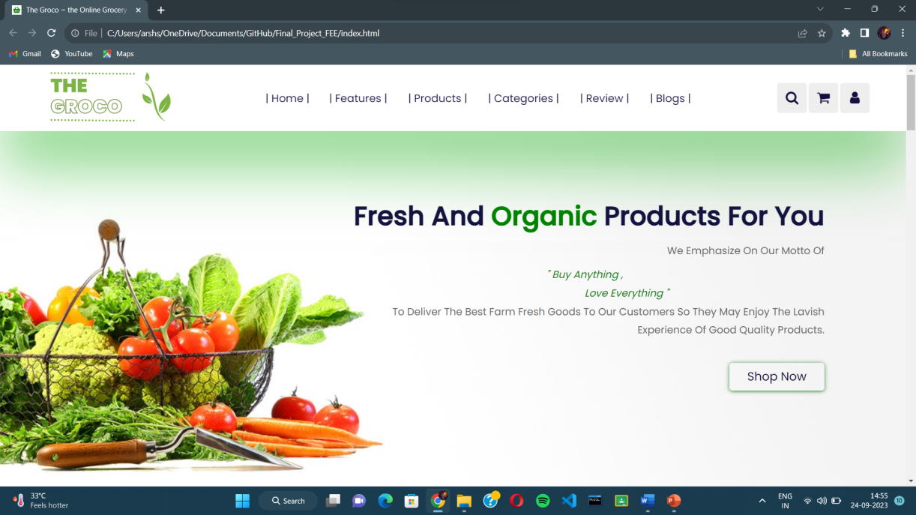

the website uses a backend html consisting of multiple meta tags, keywords, ids, alt attributes, etc. to make the site SEO friendly.

**6.1 Title**

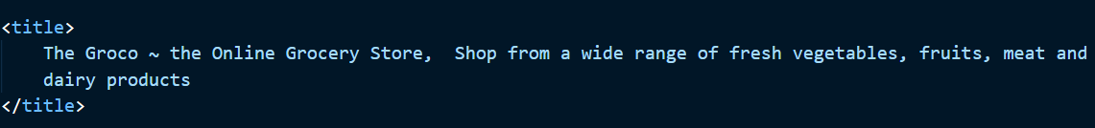



Title should consist of keywords and be descriptive

**6.2 Meta Tags**

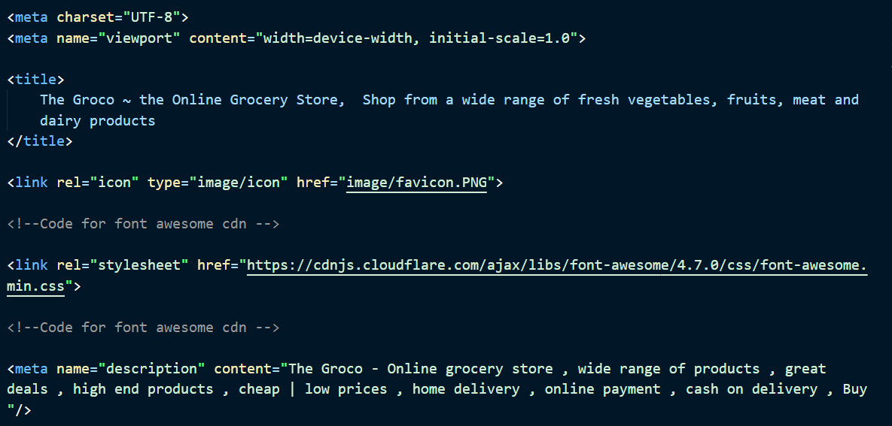

Meta tags help in SEO algorithms and also to make the site more mobile friendly.

**6.3 Class, Alt and Id attributes**

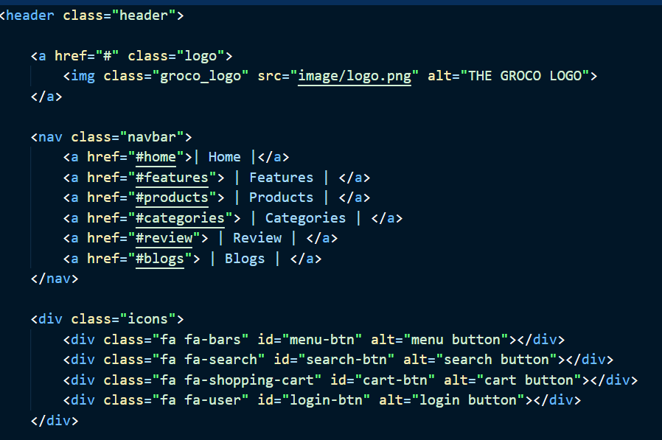

class, alt and id attributes are very helpful both in making use of CSS and JavaScript, and also to make the site more user friendly and adds keywords to individual elements to increase the keyword count.

**6.4 Media Queries**

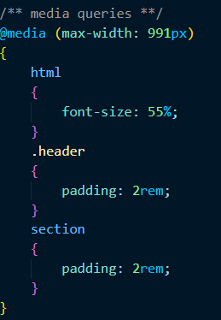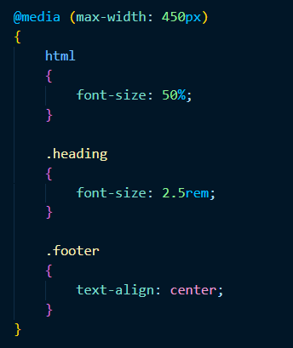

**Media queries** were used to make the website more mobile friendly and responsive. They help to make the website look good on mobile.

**6.5 Mobile View**

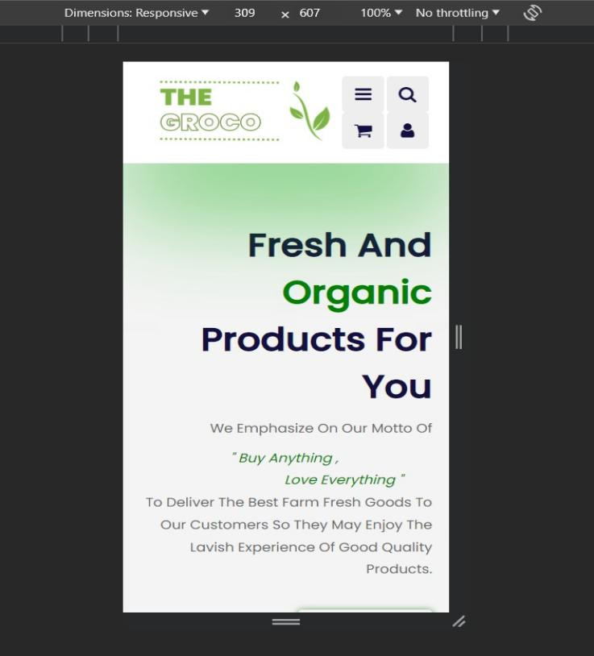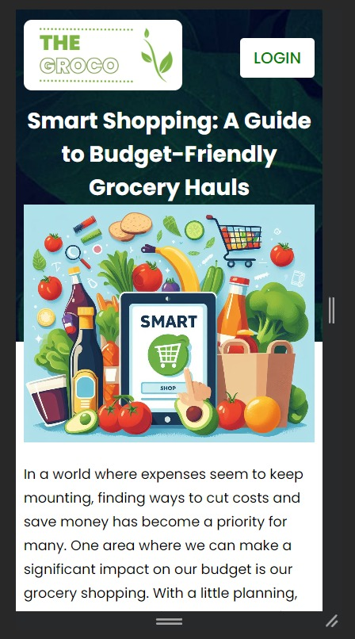

The pages have been designed to be **responsive**,

i.e, they look great on a computer

and mobile devices alike !

**6.6 Use Of Javascript**

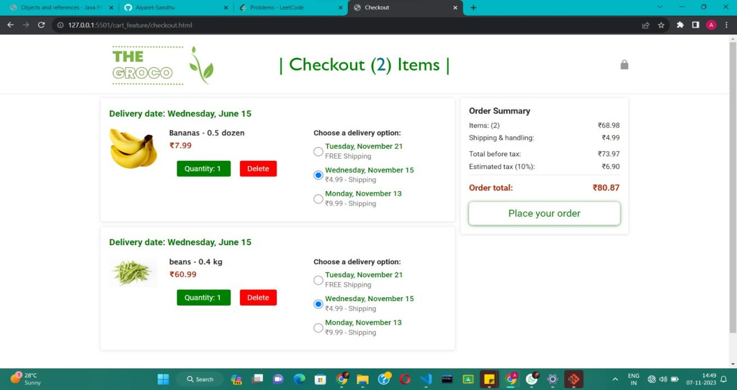

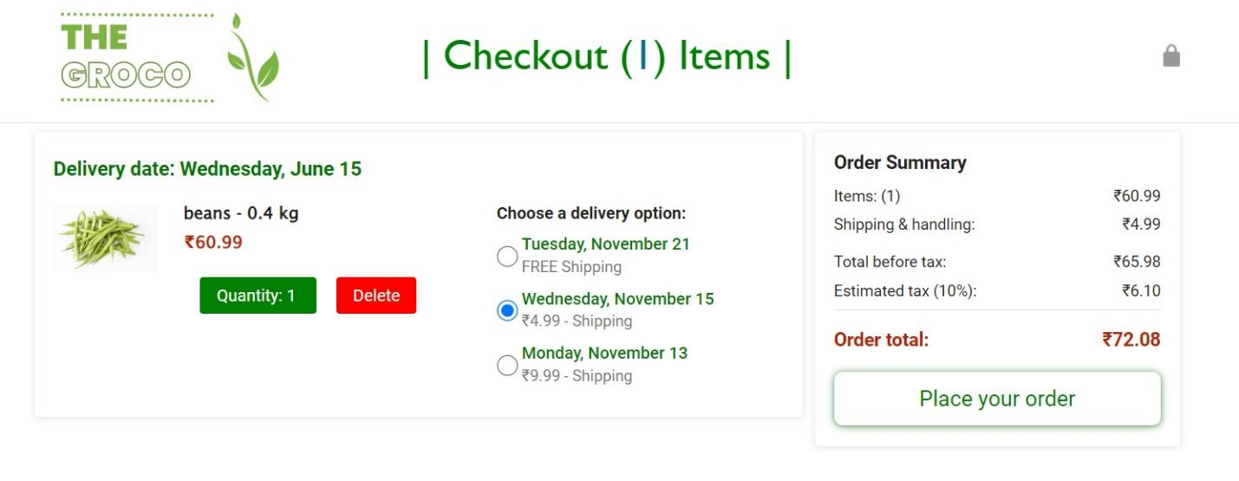

Javascript has been used to automate and enhance the working of the webpages like checkout, add to cart and sign in page.

**6.7.1 GitHub**

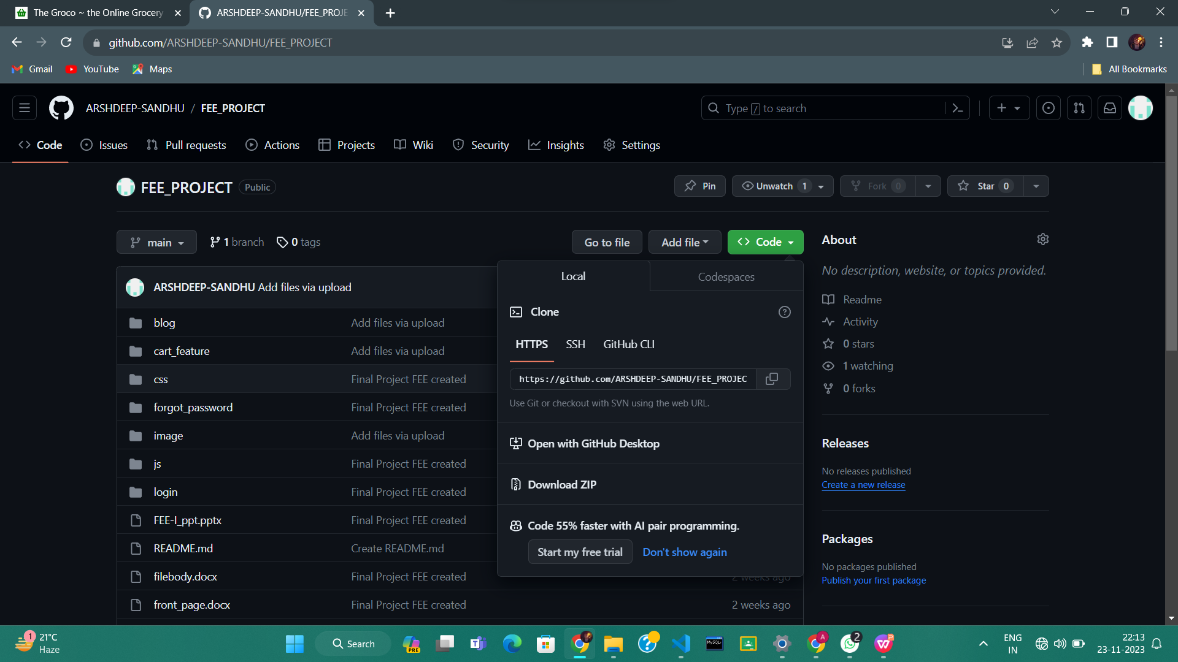

GitHub repository for the FEE Project, showing the code for the online grocery store Groco.

**6.7.2 GitHub Proof**

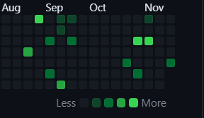

Calendar heatmap showing activity from August to November, with most activity occurring in October.

**6.8 Map of store**

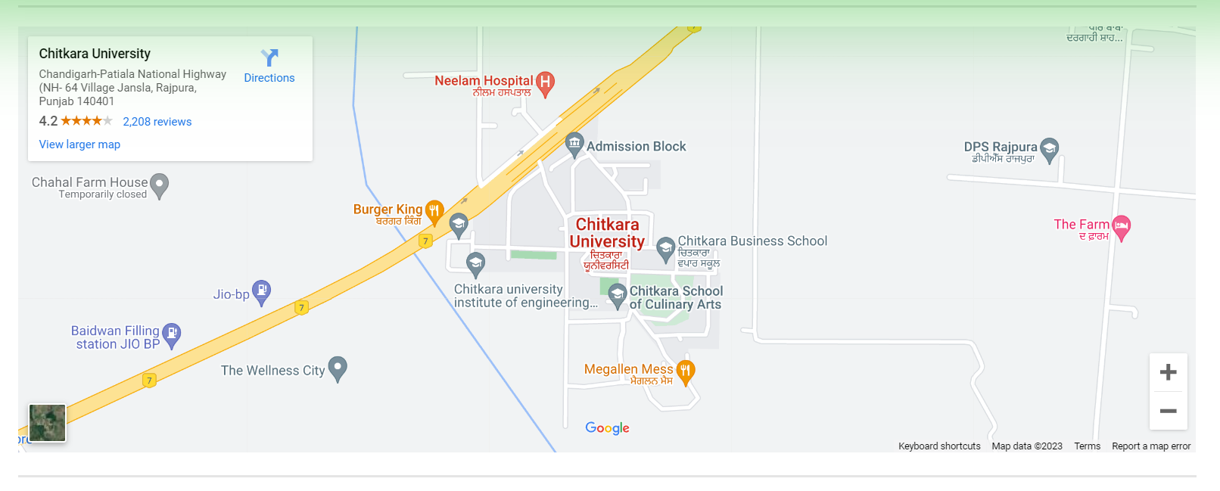

A Google Maps screenshot of the Chitkara University campus in Jansla, Punjab, India, centered on the university's Admissions Block.

6.9 Login Page

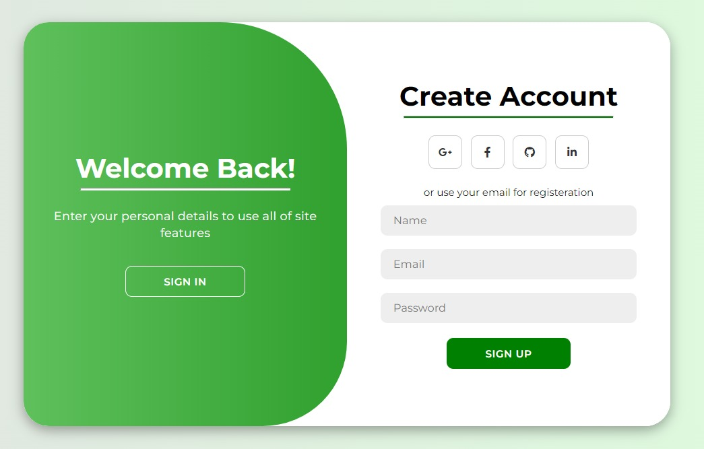

A green and white sign up form with fields for name, email, and password, and a "SIGN UP" button.

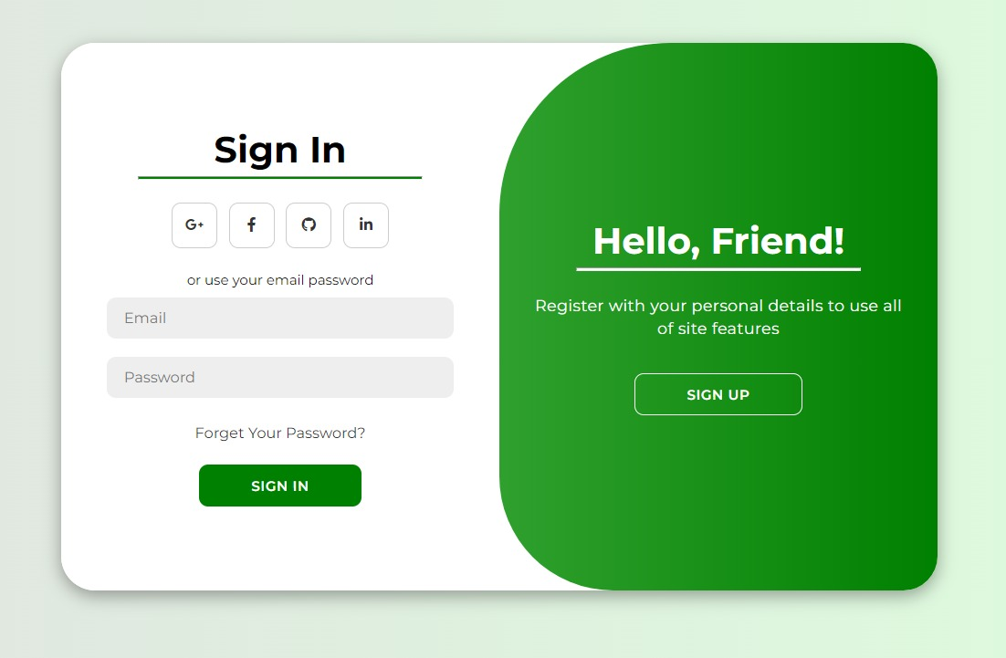

A green and white sign-in page with fields for email and password, a "SIGN IN" button, and links to register for a new account and reset a forgotten password.

6.10.1 Buying Option

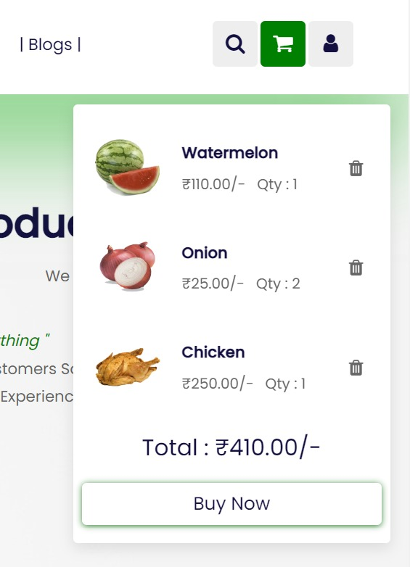

A screenshot of a Power BI forum post asking how to get images to show up in Power BI visuals.

6.10.2 More Products

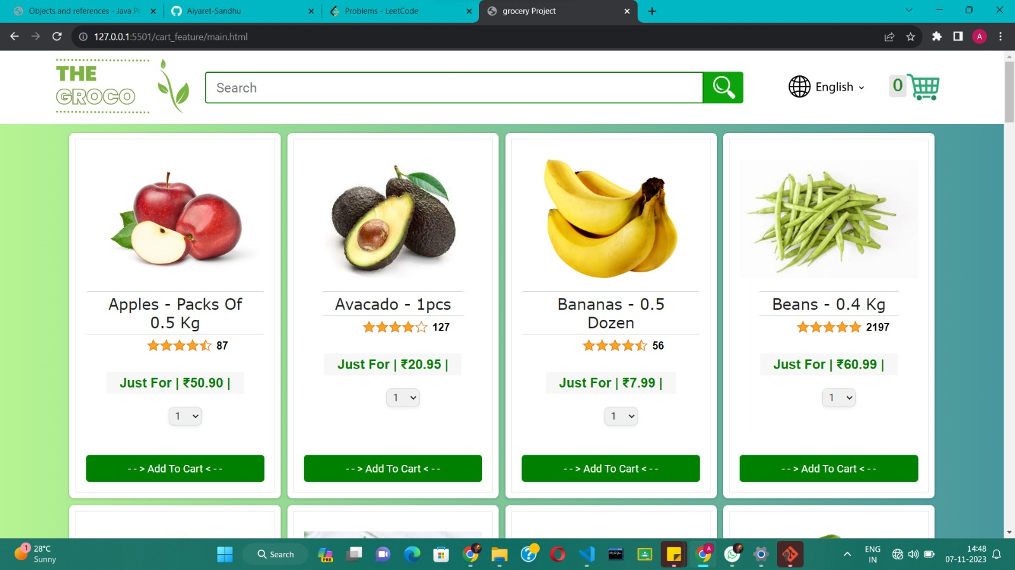

A screenshot of the GROCO website showing fresh fruits and vegetables for sale, including apples, avocados, bananas, and beans, with prices listed.

6.11 Blog page



The button to go on Blog page in Groco webpage

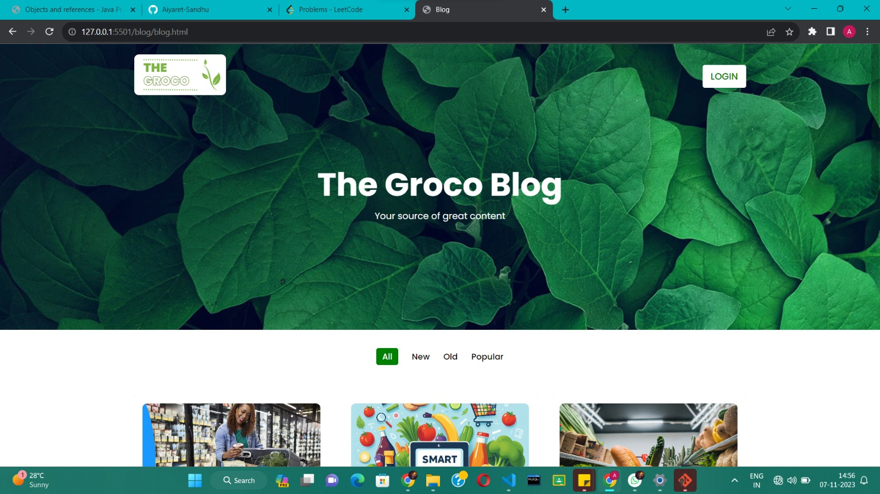

A screenshot of the Groco blog website, a source of information on grocery shopping and healthy eating.

6.12 Description in blogs

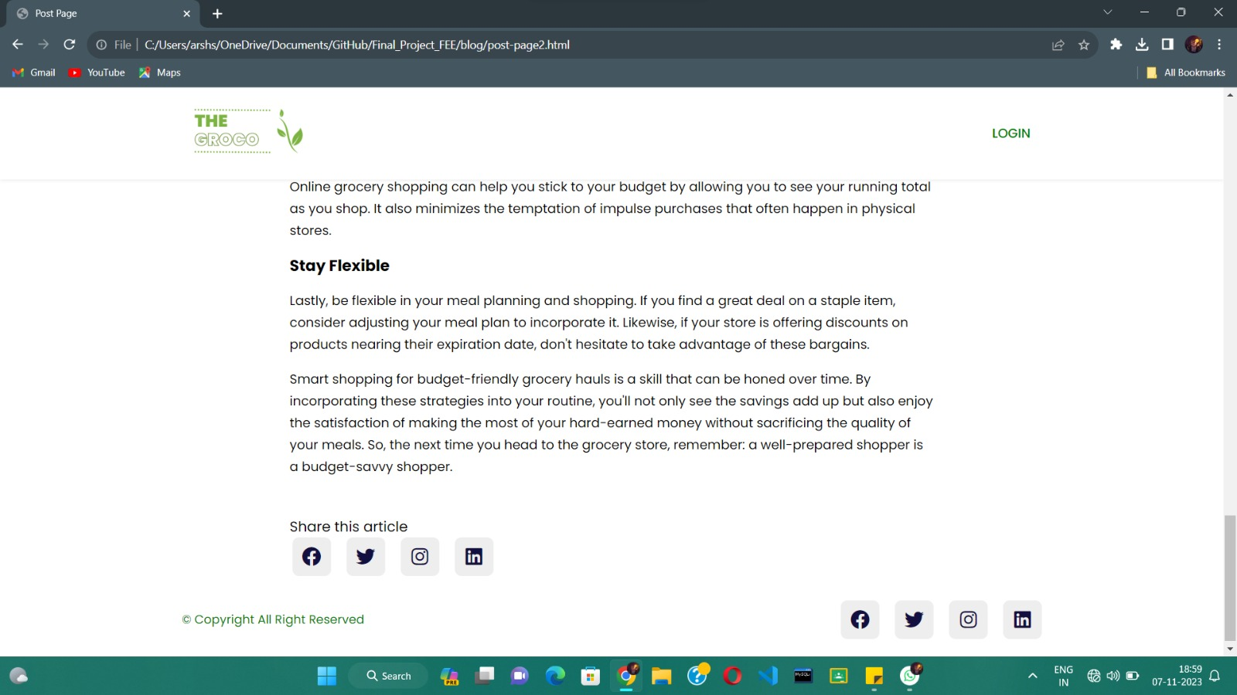

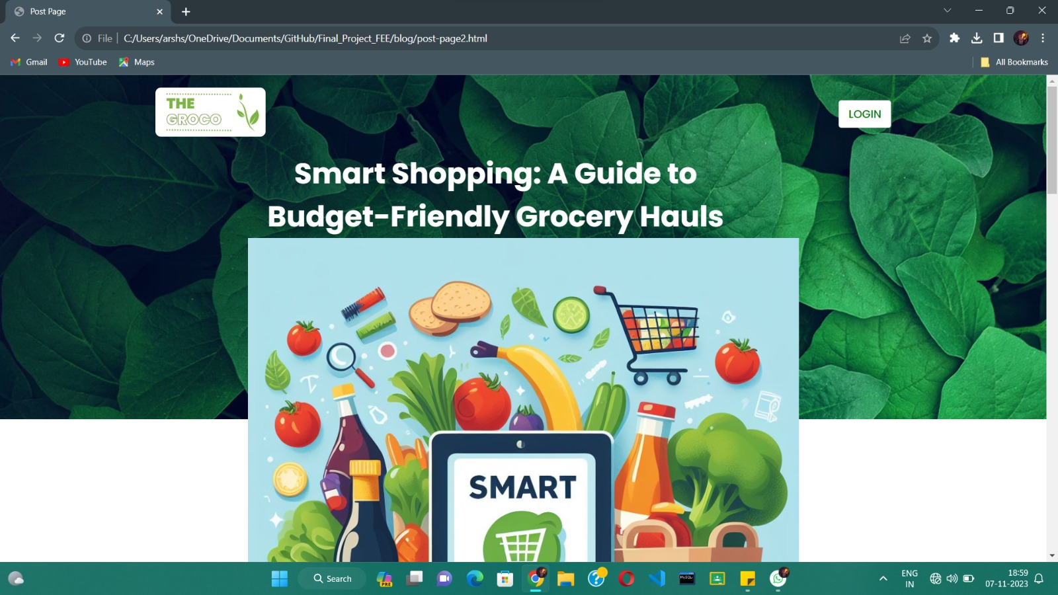

A screenshot of the Groco blog post "Smart Shopping for Budget-Friendly Grocery Hauls", with a photo of a grocery cart filled with fresh fruits and vegetables.

1. **Conclusion**

This Project has been an eyeopener to all the respective members about the world of front-end engineering, e-commerce, and teamwork.

The insight illuminated about the struggle experienced by small e-commerce websites and the importance of a fully devoted workforce. The future of E-commerce is promising, and SEO friendly websites shall rule this new era of technology and non-SEO websites will soon fade away in the pages of history. The SEO scope is not only limited to e-commerce, it is universal but it stands on us how we utilize it.

**LIST OF REFERENCES**

* [**https://fonts.google.com/**](https://fonts.google.com/)
* [**https://supersimple.dev/**](https://supersimple.dev/)
* [**https://swiperjs.com/**](https://swiperjs.com/)
* [**https://www.canva.com/create/logos/**](https://www.canva.com/create/logos/)
* [**https://www.fontawesome.com/**](https://www.fontawesome.com/)