Antutive website: founder content on the About page
What the About page at antutive.com/about currently says and shows about the founder, taken from the page source and the built production HTML on 12 September 2026.

1. Where it appears
The founder appears once on the website, in the “The People” section near the bottom of the About page (https://antutive.com/about). The section sits after the company journey graphic and before the closing “See what we’re building” call to action. The founder is also declared in the site-wide Organization structured data (see section 5).

2. Section copy, exactly as rendered
Eyebrow label | The People
Heading | The people behind Antutive
Intro paragraph | Antutive is a small founding team in Gothenburg that built Famant out of its own households’ coordination pain, and runs it today.

3. Founder card
Below the intro is a white card with the photograph on the left and the profile on the right (stacked vertically on phones). The card content is:
Small label | Founder
Name | Vinayak Panchaman
Title | Founder & CEO
LinkedIn link | Link text “LinkedIn”, opening https://www.linkedin.com/in/vinayak-panchaman/ in a new tab. Accessible name: “Vinayak Panchaman on LinkedIn (opens in a new tab)”.
Quotation | “Good technology feels like someone actually thought about your day. That’s what we’re trying to build here, products that earn their place in people’s lives.”
Note on the quotation. In the page source this statement is marked as a DRAFT founder statement, “website copy pending Vinayak Panchaman’s approval before it may be treated as an attributed quote”. It is nevertheless rendered publicly today, attributed to the founder by position on the card. If it is not approved wording, it should be replaced or removed.
There is no biography, career history, education, previous companies or contact detail for the founder on the page. Only the name, title, photograph, LinkedIn link and the quotation above are published.

4. The photograph
File | public/brand/vinayak-panchaman.jpg (served at https://antutive.com/brand/vinayak-panchaman.jpg)
Source size | 1600 × 1433 pixels, landscape JPEG, 150 KB
Alt text | Vinayak Panchaman, Founder & CEO of Antutive
How it is displayed | In a portrait frame with a 4:5 aspect ratio, 15 rem (240 px) wide on desktop, rounded corners and a soft shadow. The image is set to cover the frame and is positioned at 36% from the left, so the visible area is roughly the middle-left 1146 × 1433 pixels of the source (about 163 px cropped from the left edge and 291 px from the right).
What is visible | A seated portrait: the founder in a black polo shirt and rimless glasses, smiling, with an open laptop on his lap, a plant to the left and a coffee mug in the foreground printed with a “data[delimited]” mark. Light, neutral indoor background. In the source file the laptop lid also carries a red Microsoft MCT sticker; in the cropped view on the page only its left edge remains visible at the right-hand side.
Observation. The mug and the laptop sticker show third-party branding that is not Antutive’s. This is cosmetic, but a reviewer looking closely will notice it. A retouched or alternative portrait would remove the distraction.

Figure 1. The source file as stored in the repository (1600 × 1433).

Figure 2. The same file cropped as the About page displays it (4:5 frame, positioned 36% from the left).
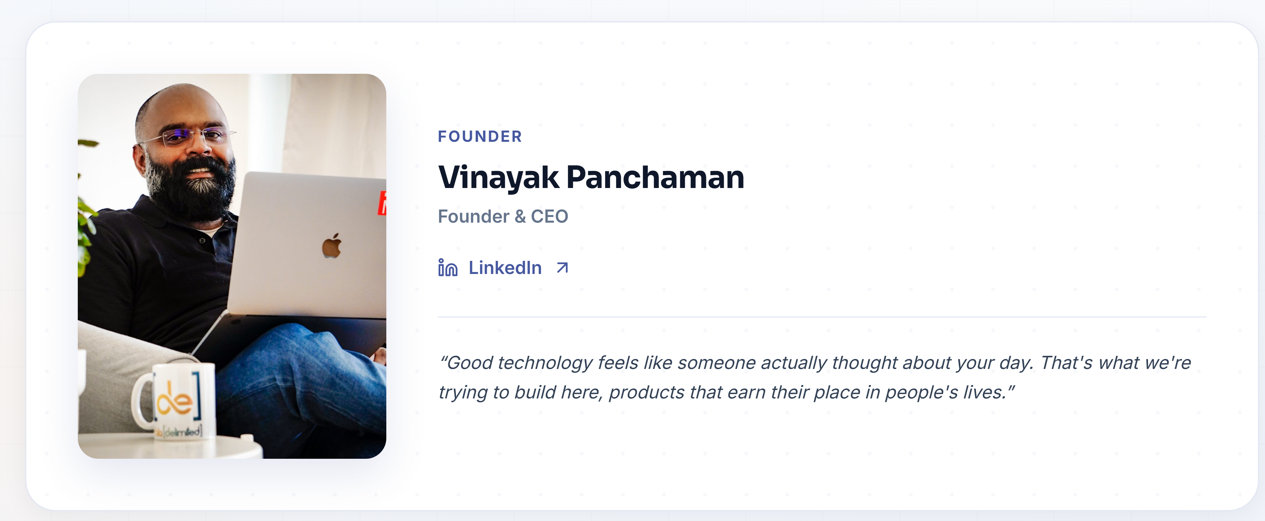
Figure 3. The founder card as rendered on the About page at desktop width (1280 px).
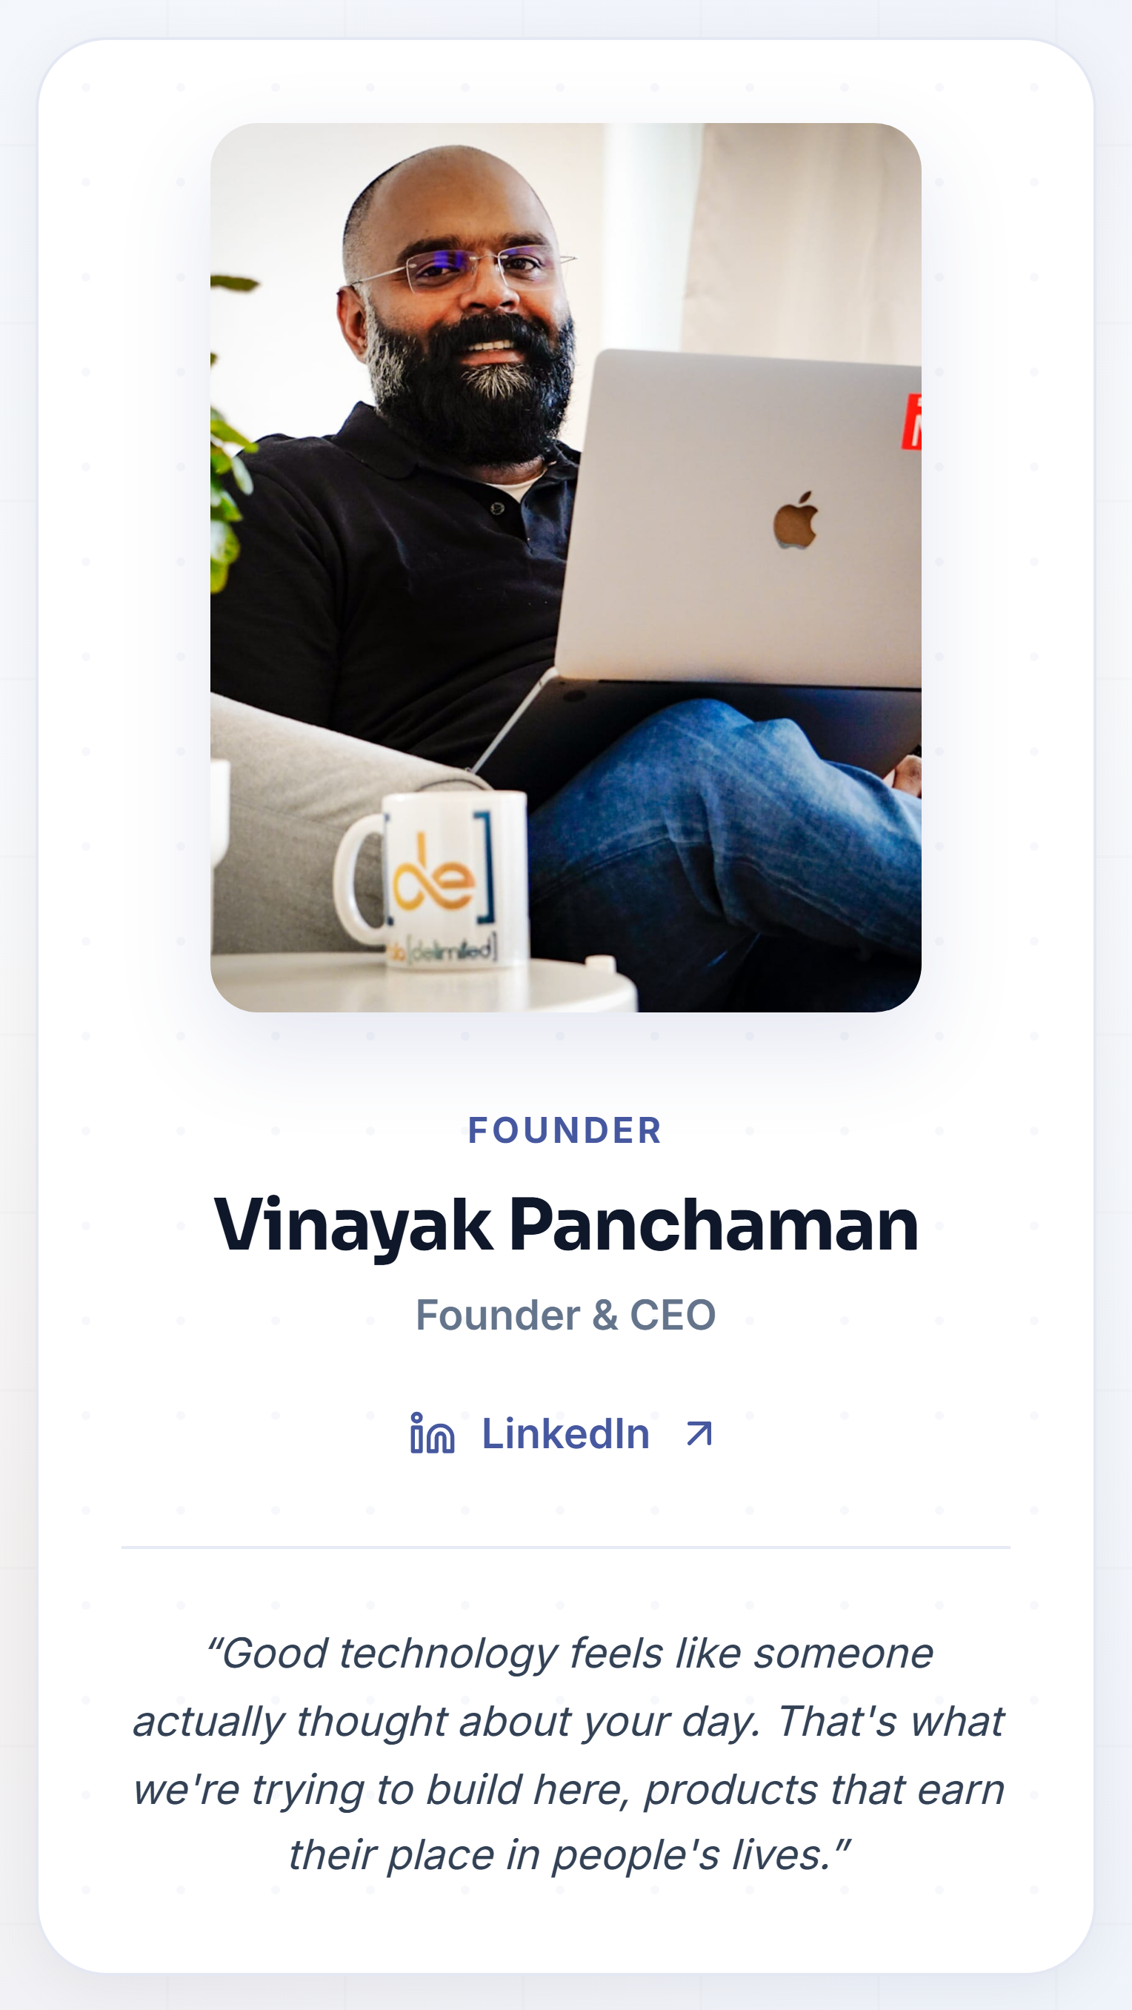
Figure 4. The same card at phone width (390 px), where the photo stacks above the profile.

5. Structured data (every page)
The site-wide Organization JSON-LD in the HTML head declares the founder as a Person on every page, which is how search engines and crawlers read the relationship:
@type | Person
name | Vinayak Panchaman
jobTitle | Founder & CEO
sameAs | https://www.linkedin.com/in/vinayak-panchaman/
The name, title and LinkedIn URL in the structured data match the About page card exactly.

6. Where the content lives in the code
Page component | src/app/pages/About.tsx (constants FOUNDER_PHOTO, FOUNDER_LINKEDIN, FOUNDER_QUOTE near the top; the card markup in the “The People” section)
Photo | public/brand/vinayak-panchaman.jpg
Structured data | index.html (Organization JSON-LD, founder node)
Placeholder behaviour | If FOUNDER_PHOTO is set to null the card shows a dashed placeholder box reading “Founder image / Vinayak Panchaman” instead of the photo. The photo is currently set, so the placeholder is not rendered.

7. Quick checklist for review
• Name and title correct: Vinayak Panchaman, Founder & CEO.
• LinkedIn URL correct and public: https://www.linkedin.com/in/vinayak-panchaman/ (resolves; the public headline currently shows IKEA rather than Antutive).
• Quotation: approve as an attributed quote, edit, or remove (currently marked draft in source).
• Photograph: keep as is, or replace with a portrait without third-party branding.
• Optional: add a one- or two-sentence biography if the company wants more founder context on the page. Nothing of that kind exists today.

