
NATIONAL UNIVERSITY OF COMPUTER AND EMERGING SCIENCES

Project ML

NAME: ARSLAN JAVED(22I-0613)

SECTION: AI (A)

SUBMITTED TO: Sir Ahmed Raza

Advanced Flight Departure Delay Analysis
Course: AI-3002: Machine Learning
Semester: BS-AI: Fall-2024
Due Date: 9th Dec 2024

1. Introduction
- Problem Statement:
Flight departure delays disrupt aviation efficiency, impacting passengers, airline operations, and broader logistics. This project aims to identify patterns affecting delays and develop predictive models for accurate delay estimation.
- Objective:
  - Perform exploratory data analysis to identify trends and key factors.
  - Build binary and multi-class classification models to categorize delays.
  - Develop regression models to predict exact delay durations.
  - Generate predictions for unseen test data and submit results to Kaggle competitions.

2. Dataset Description
- Data Sources:
  - Train Data: Includes historical flight records with delays.
  - Test Data: Contains flight information without delay values.
  - Weather Data: Provides environmental conditions such as temperature and wind speed.
- Features Overview:
Key features include flight number, scheduled time, departure/arrival IATA codes, weather metrics, and calculated delay.

3. Methodology
3.1. Data Preprocessing and Feature Engineering
- Data Integration:
  - Merged weather data with flight data using time and location as keys.
- Data Cleaning:
  - Handled missing values using imputation techniques.
  - Formatted time fields into standard datetime format.
- Feature Engineering:
  - Derived new features: hour of the day, day of the week, month of the year.
  - Calculated departure delays (Actual - Scheduled).
3.2. Exploratory Data Analysis (EDA)
- Delay Distributions: Histogram of delayed durations.
- Temporal Analysis: Visualizations of delays across different times (hour, day, month).
- Correlation Analysis: Examined relationships between delays and weather features using scatter plots and heatmaps.

4. Predictive Modeling
4.1. Classification Models
- Binary Classification:
  - Objective: Classify flights as on-time or delayed.
  - Model Used: Logistic Regression / Random Forest.
  - Metrics: Accuracy, Precision, Recall, F1-Score, Confusion Matrix.
- Multi-Class Classification:
  - Objective: Categorize flights into delay ranges (No Delay, Short, Moderate, Long).
  - Model Used: Decision Tree / Gradient Boosting.
  - Metrics: Class-wise Precision-Recall, Confusion Matrix, F1-Score.
4.2. Regression Model
- Objective: Predict exact delay durations in minutes.
- Model Used: Linear Regression.
- Evaluation Metrics: Mean Absolute Error (MAE), Root Mean Square Error (RMSE).

5. Results and Discussion
- Model Comparisons:
  - Tabular comparison of models with evaluation metrics.
- Insights from EDA:
  - Key patterns and correlations identified during the analysis phase.
- Impact of Weather:
  - Discuss specific weather attributes strongly correlated with delays.

6. Visualizations
Include the following:
- Histograms for delay distributions.
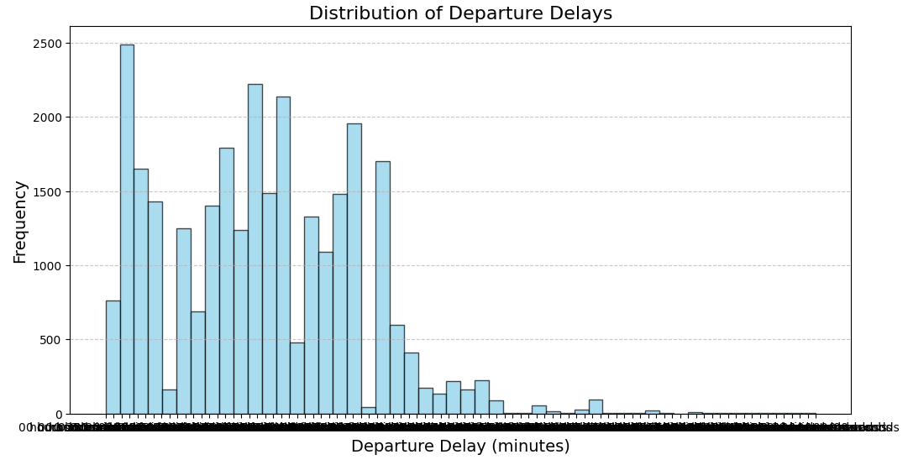
- Line charts showing temporal trends (hourly, daily, monthly delays).
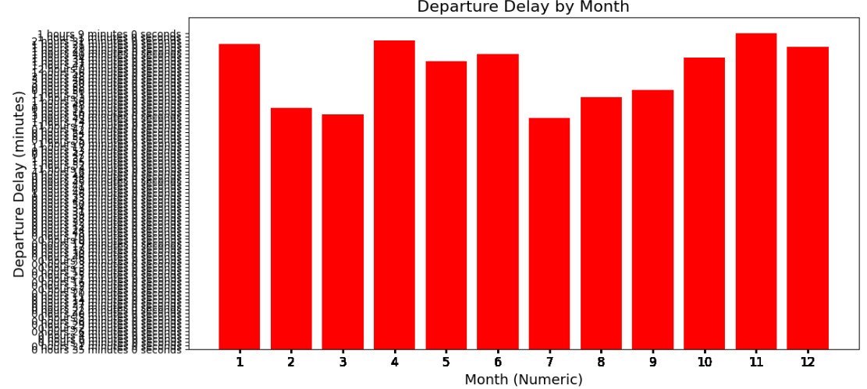
- Heatmaps for correlations between weather and delay attributes.
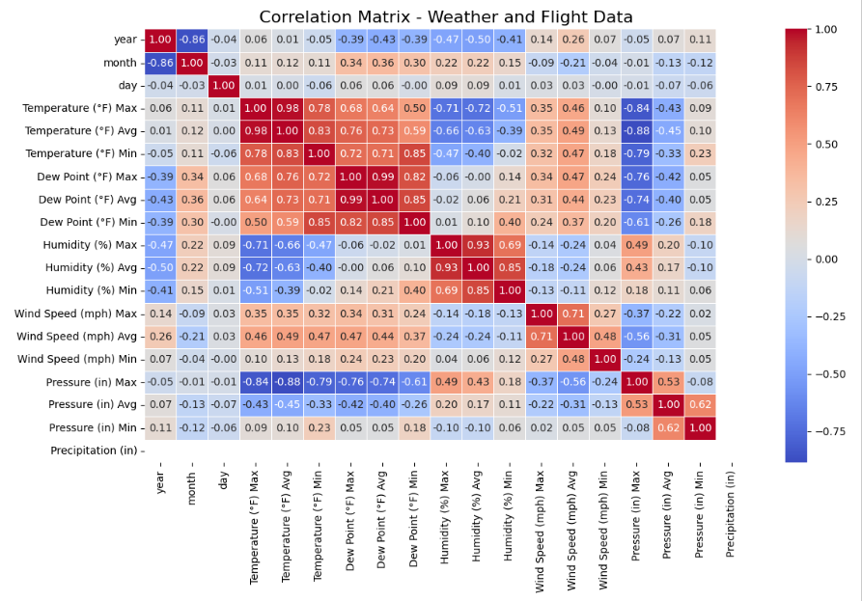
- Confusion matrices for classification models.

7. Conclusion
- Summarize key findings.
- Highlight the most effective model for each task.
- Discuss limitations and areas for future work.

8. Models
Models are Saved and then make predictions, then submit them on Kaggle.
Competition for Binary test file:
https://www.kaggle.com/t/167561bcf3484f0fb0b69e791e3751bf
Competition for Multi test file
https://www.kaggle.com/t/840c5a9252f04361985d04cc65ce84b8
Competition for Regression test file:
https://www.kaggle.com/t/36f8c00f74da47c1a2a39613be8c96bb

