Low Level Design (view BOOKING DETAIL)

Project Code | Team 1
Project Name | Airline Reservation System(online booking)

Prepared/Modified by | Role | Date of Preparation
Shwetha HD,Gamidi Srilekha,Manasa Bhargavan | Software Analyst | 26/12/2017
Reviewed by | Role | Date of Review
Sourabh Jain | Software Analyst | 27/12/2017
Approved by | Role | Date of Approval
Rahul Vikash | Training Manager
Circulation List | deeksha.sinha@capgemini.com,  sri-lekha.gamidi@capgemini.com, manasa.manasa@capgemini.com, manisha.kumari@capgemini.com,  shwetha.h-d@capgemini.com, sourabh.b.jain@capgemini.com, sai.suggisetti@capgemini.com | Version Number of the template:1.0
Version Number | 1.4

Table of Contents

1. Description Of The Unit 3
2. References 4
3. Dependencies / Assumptions 5
4. Class Diagrams 6
5. Sequence Diagrams 7
6. Activity Diagrams 7
7. Design Components 8
7.1 List Of UI Components 8
7.2 List Of Design Classes 8
8. Re-Usable Routines/Components 9
9. Messages 10
10. Configuration Files 11
11. Crud Matrix Table 12
12. Data Mapping Matrix 13
13. Action Flow Matrix 14
14. Stored Procedures 15
15. Program Specification / Pseudo Code 16
REVISION HISTORY OF THE WORK PRODUCT 17

Description Of The Unit

The Display Booking Detail is basically used by the customer of the system, to view the booking details.
On clicking the Search Ticket button of any valid booking id from the user on viewTicket page, the customer will be navigated to the view booking detail which shows the description of a particular booking detail where he/she can view complete description of booking.
The viewTicket page shows the detailed description of the booking. If they select a cancel booking option, they can cancel the booking. By selecting update booking they can update the particular booking information.

References

Reference | Description
Repository reference | https://IGTEBLRSVNTNG.igatecorp.com/svn/oct3_Team1
Class Diagram | /Project Documents/Design Documents/HLD/Class Diagrams
URS | /Project Documents/Requirements/Case Study/Ecommerce-grp1 and grp3.doc
UTP | /Project Documents/Test Plan/UTP/Test Cases/ViewBookingDetail/UTP_ViewBookingDetail.xls
DB Design | /Project Documents/Design Documents/HLD/DB Design/E-Commerce_GROUP_DBDESIGN.xls

Dependencies / Assumptions

Assumptions:
Valid details of the booking information stored in the database.

Class Diagrams

Class Diagram

4.1 CLASS STRUCTURE

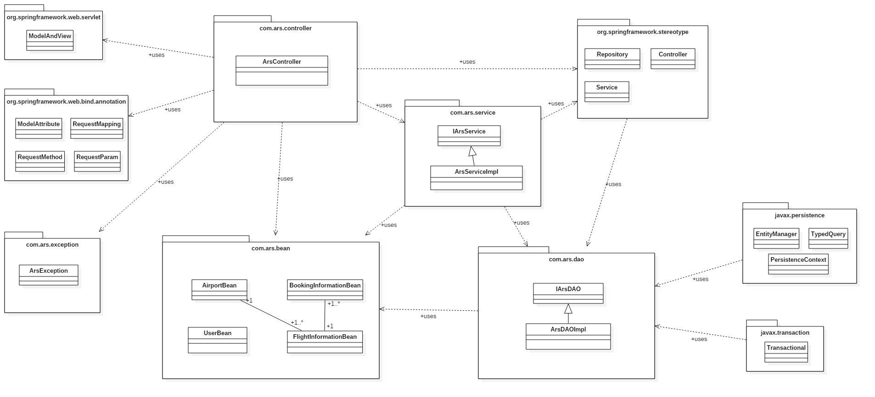

4.2 BEAN CLASS

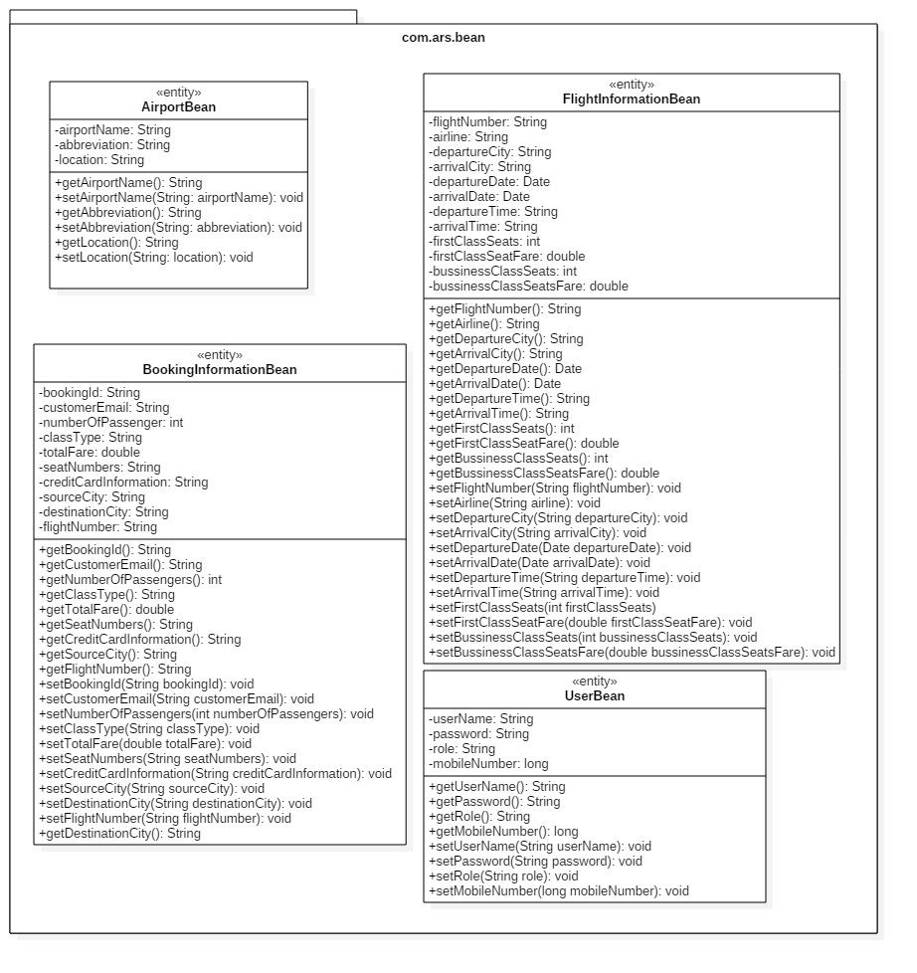

4.3 SERVICE CLASS

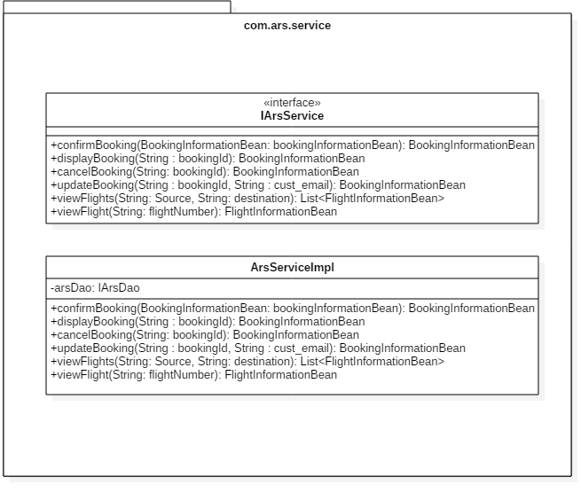

4.4 DAO CLASS

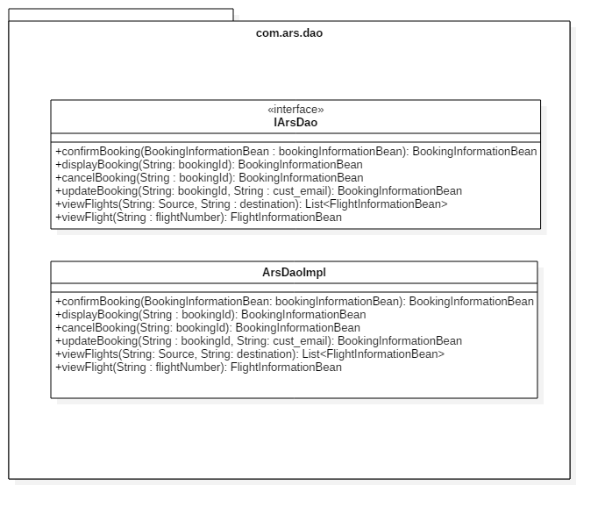

4.5 CONTROLLER CLASS

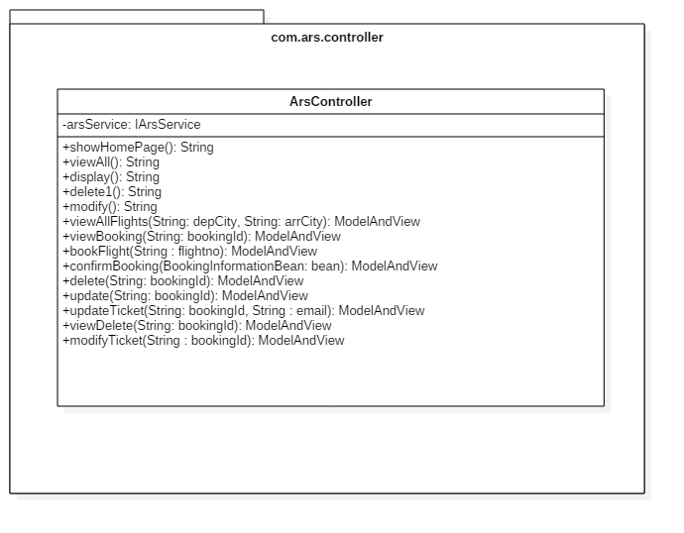

Sequence Diagrams

Sequence Diagram

DISPLAY BOOKING

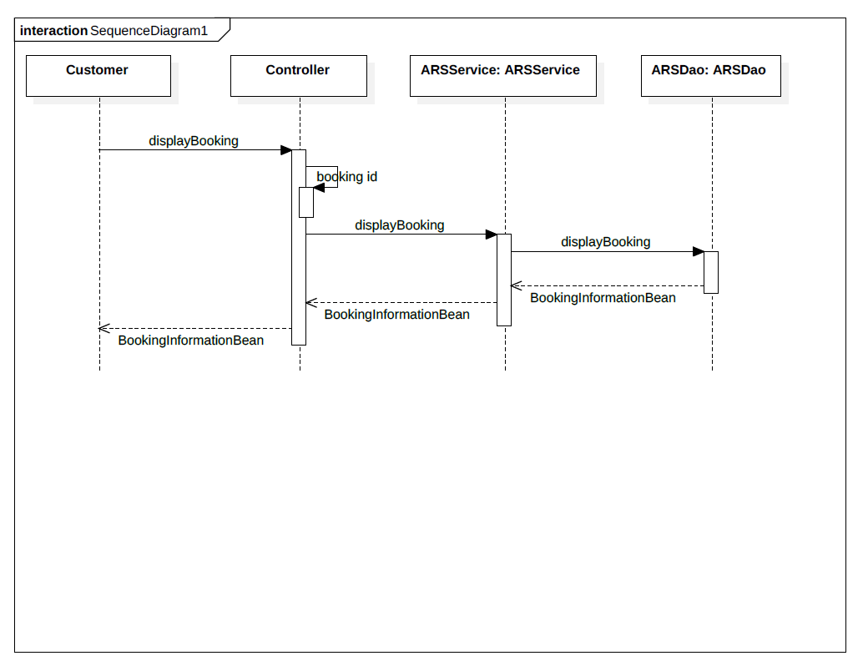

  - CANCEL BOOKING

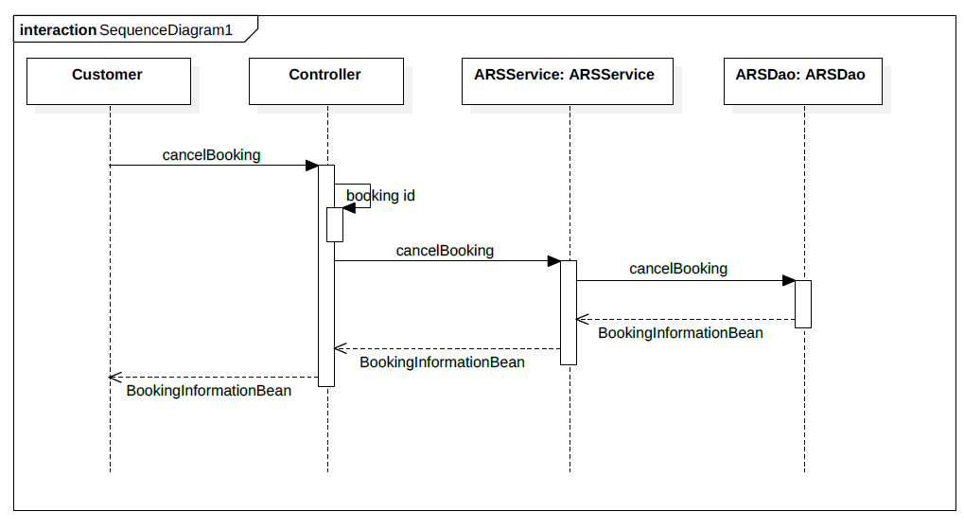

5.3 UPDATE BOOKING

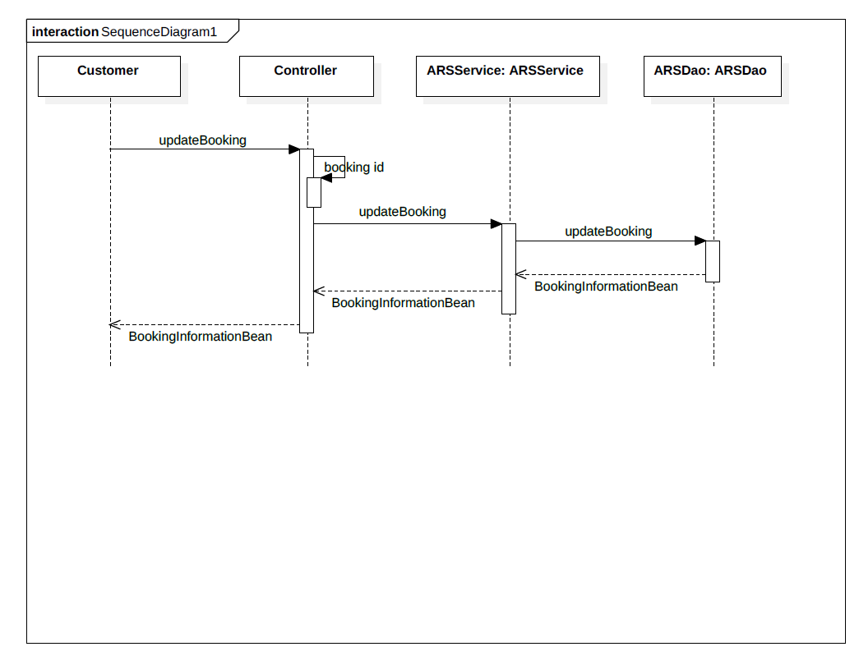

activity diagrams

Activity Diagram

6.1 SEARCH TICKET

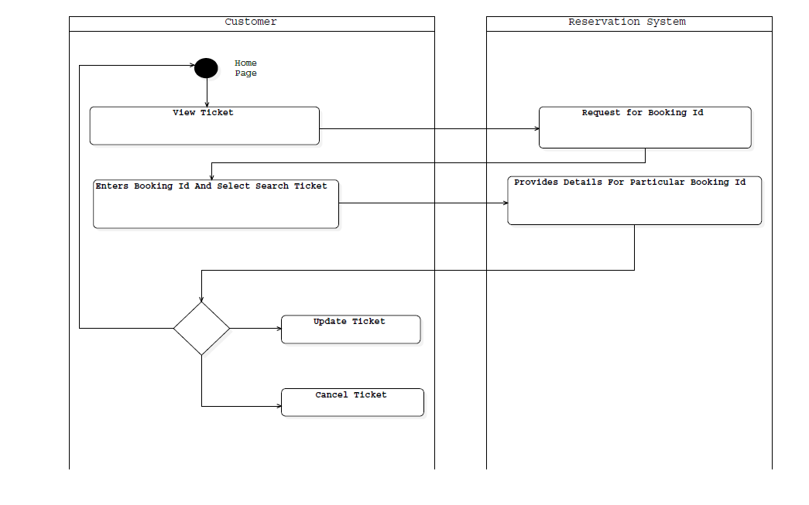

6.2 UPDATE TICKET
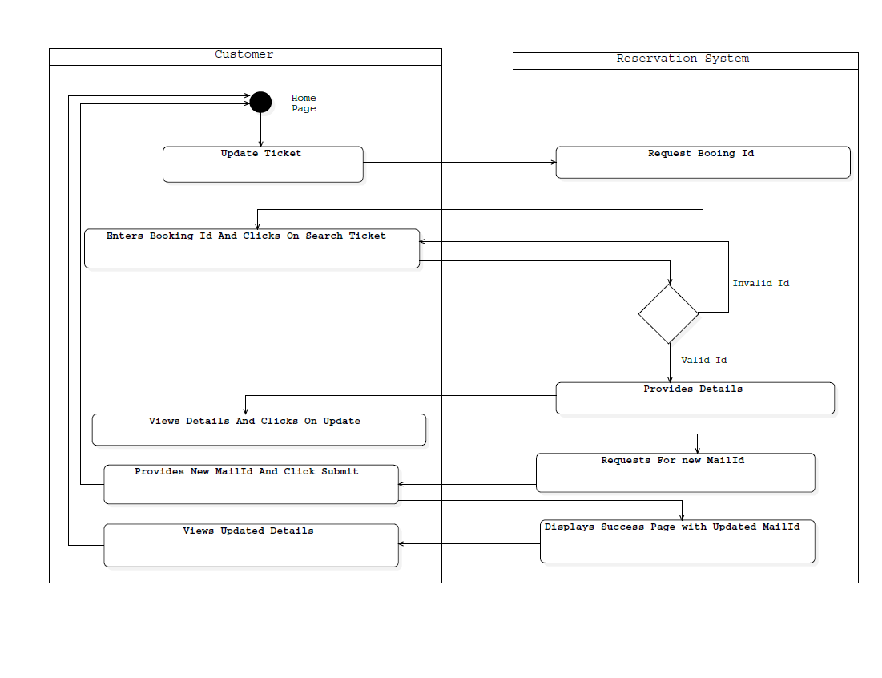

  - CANCEL TICKET

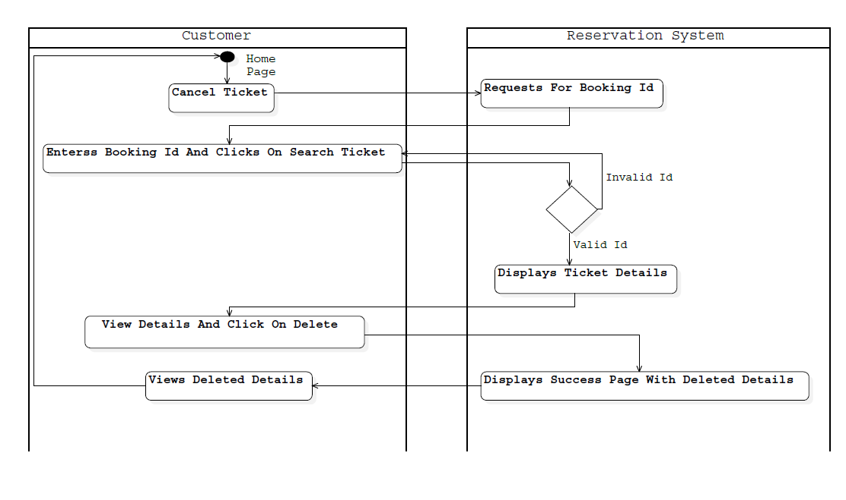

Design Components

List Of UI Components

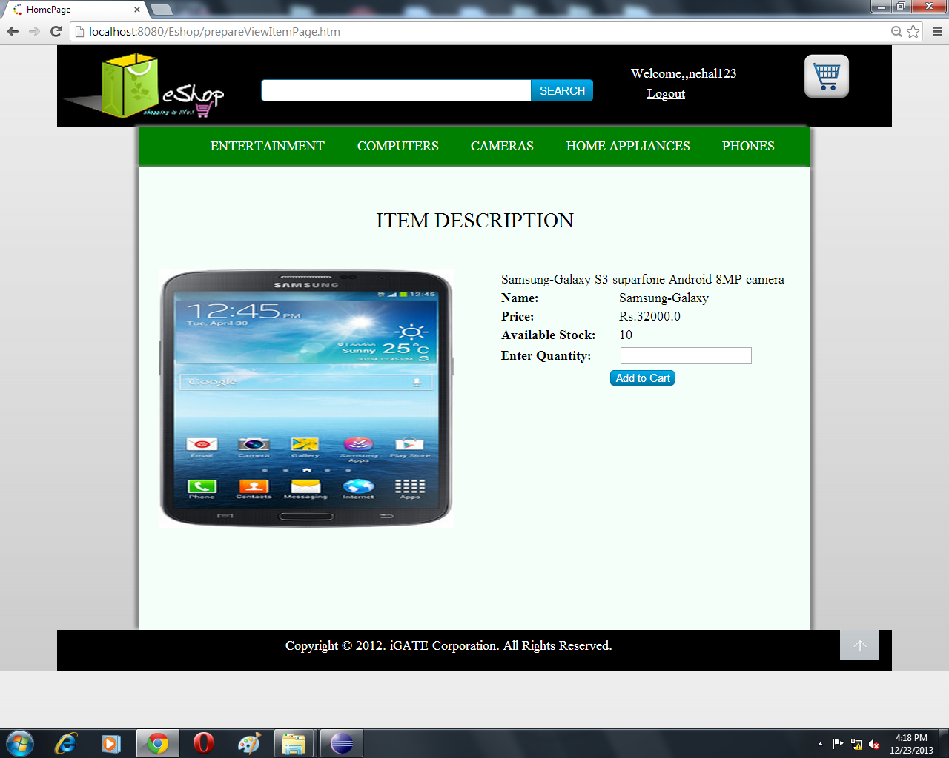

List Of Design Classes
Sr. No. | LLD Name | Class Name | Method Name | Method Description
1 | Display Booking | Booking information bean | Appropriate getters and setters methods | Getters retrieve the property values and setters set the property values
2 | Display Booking | Ars Controller | public ModelAndView viewBooking(@RequestParam("bookingId")String bookingId ):ModelAndView | Get the appropriate booking details from the viewTicket Page and set the data into booking information bean and add these data to the model.  Validate the information entered by customer for the booking with the available flight.  Show appropriate message.
3 | Display Booking | ArsServiceImpl | displayBooking(String bookingId) | Calls displayBooking  (String) of ArsDaoImpl class and returns the Booking details to controller.
4 | Display Booking | ArsDaoImpl | displayBooking(String bookingId) | Retrieves the booking details from database and returns the booking Object to ArsServiceImpl

Re-Usable Routines/Components

Re-Usable Routines/Components

- CSS files
- Javascript files
- DataAccessException class
- Database properties files

Messages

#. | Type | Message Text
M1 | Error | Enter a valid booking Id.
M2 | Error | No Ticket Found
M3 | Error | Please Enter a Number
M4 | Error | Value must be greater than or equal to 1
M5 | Error | Value must be less than 99999

Configuration Files

File Name | Path | Description
Web.xml | /WebContent/Web-INF | To configure the bean properties.
Dispatcher-servlet.xml | /WebContent/Web-INF | To configure the request mapping and view resolver.
jpaContext.xml | /WebContent/Web-INF | To provide information about the current JPA setup.

Crud Matrix Table

# | Table Name | Create | Read | Update | Delete
1 | Bookinginformation | N | Y | Y | Y

Data Mapping Matrix

Sr. No. | Screen Label | Field Source | Field Type | Data Type | Max Length | Data Flow | Mandatory
1 | View | NA | Button | NA | NA | UI | NA
2 | bookingId | . Booking_Id | HiddenFiled | Varchar2 | 10 | UI→D  D→UI | Yes

Legend
D → UI (Database to User Interface)
UI → D (User Interface to Database)
UI (User Interface Only)

Action Flow Matrix

Sr. No. | Action | Description | Process
1 | On click Search Ticket Button | Shows the detailed description of the booking to customer. | The customer is navigated to View Ticket Page.
2 | On Click Update Button | It shows booking information and asks to enter the new emailId. | The customer is navigated to success Page.
3 | On Click Delete Button | It shows the deleted booking information | The customer is navigated to success Page.

Stored Procedures

# | Stored Procedure Name  (with Description) | Input/Out Parameters | Type | Size
1. | N/A | N/A | N/A | N/A

Program Specification / Pseudo Code

14.1 <ACTION: Search Ticket_CLICK>
Pseudo Code:
- Client Side Scripting:
None

- Server Side Scripting:
BEGIN
Call public ModelAndView viewBooking(@RequestParam("bookingId")String bookingId ):ModelAndView in ArsController Class
Store bookingId into a variable
Call displayBooking(bookingId) of ArsServiceImpl Class
Call displayBooking(bookingId) of ArsDaoImpl Class
Navigate to ViewTicket page.
END

REVISION HISTORY OF THE WORK PRODUCT

# | Date | Version # | Section Changed | Details of changes made | Approved By
1 | 22/12/2017 | 1.0 | LLD prepared | N/A | Rahul Vikash
2 | 24/12/2017 | 1.1 | List of design classes  Action Matrix | Name of controller is modified to “ArsController”.  Action Matrix was added | Rahul Vikash
3 | 25/12/2017 | 1.2 | Reusable components,  References,  Data Mapping Matrix. | Reusable Components added.  File name with relative path is added in the references section.  The name of text boxes(screen label is changed). | Rahul Vikash
4 | 26/12/2017 | 1.3 | List of design classes,  Pseudo code | The names of the methods in list of design classes and pseudo code were changed as per the class diagrams. | Rahul Vikash
5 | 27/12/2017 | 1.4 | Configuration files,UI Components | Paths of the configuration files is updated and UI components(Screen Shots) added. | Rahul Vikash

