CO322: Data Structure and Algorithms

Lab1: Simple sorting algorithms

Name: Rodrigo A.R.S.P.

E. Number: E/11/343

Date: 02-02-2015

**Discussion:** In terms of the theoretical analysis all the above algorithms are O(n2 ). Does the numbers you measure agree? Suppose for a one data set you run an algorithm; say the bubble sort; twice will you see the same time? If not why? What if you take the average by repeating the experiment?

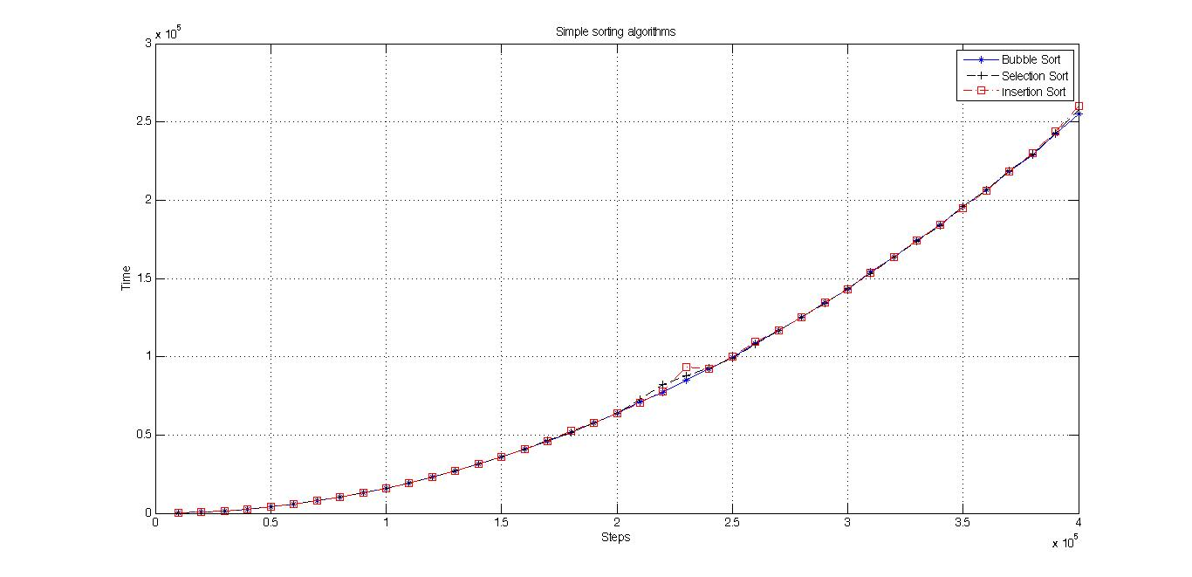According to the theoretical analysis all the above algorithms are O(n2). But the outputs of the program does not show it like that.

Figure 1: Simple sorting algorithms with time

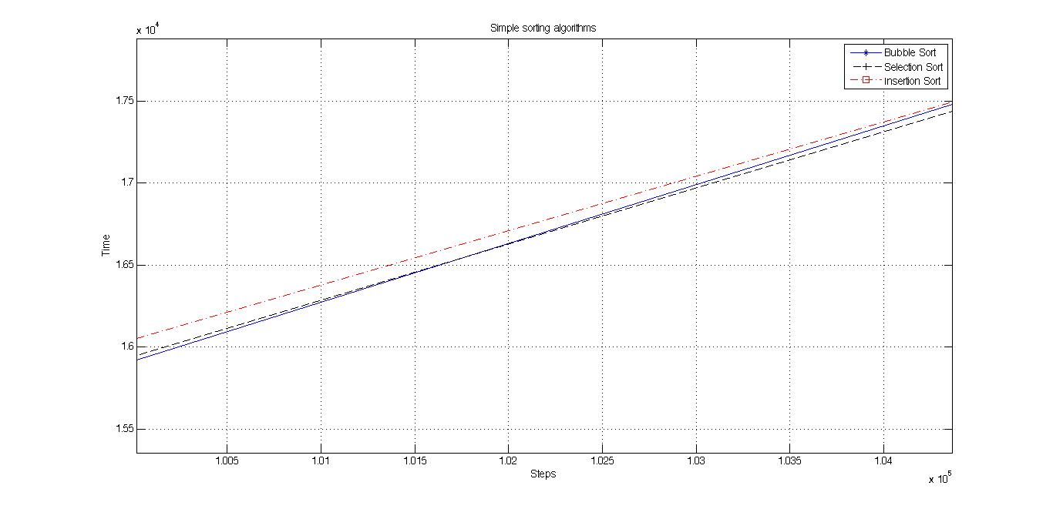

Figure 2: Simple sorting algorithms with time zoomed

These figures shows that the time complexity is not the same.

The reason is that for the theoretical analysis we only consider about the number of comparisons and the number of swaps. But actually all the assignments, comparisons, function calls are counting for the time complexity.

The results are below

Iteration with array size: 10000

time taken to bubble sort: 173

time taken to selection sort: 161

time taken to insertion sort: 150

Iteration with array size: 20000

time taken to bubble sort: 624

time taken to selection sort: 617

time taken to insertion sort: 621

Iteration with array size: 30000

time taken to bubble sort: 1413

time taken to selection sort: 1420

time taken to insertion sort: 1409

Iteration with array size: 40000

time taken to bubble sort: 2524

time taken to selection sort: 2564

time taken to insertion sort: 2527

Iteration with array size: 50000

time taken to bubble sort: 3971

time taken to selection sort: 3973

time taken to insertion sort: 3966

Iteration with array size: 60000

time taken to bubble sort: 5708

time taken to selection sort: 5717

time taken to insertion sort: 5697

Iteration with array size: 70000

time taken to bubble sort: 7814

time taken to selection sort: 7808

time taken to insertion sort: 7822

Iteration with array size: 80000

time taken to bubble sort: 10176

time taken to selection sort: 10175

time taken to insertion sort: 10175

Iteration with array size: 90000

time taken to bubble sort: 12995

time taken to selection sort: 12987

time taken to insertion sort: 12959

Iteration with array size: 100000

time taken to bubble sort: 15916

time taken to selection sort: 15943

time taken to insertion sort: 16046

Iteration with array size: 110000

time taken to bubble sort: 19505

time taken to selection sort: 19366

time taken to insertion sort: 19367

Iteration with array size: 120000

time taken to bubble sort: 23081

time taken to selection sort: 23006

time taken to insertion sort: 23078

Iteration with array size: 130000

time taken to bubble sort: 27050

time taken to selection sort: 26956

time taken to insertion sort: 27111

Iteration with array size: 140000

time taken to bubble sort: 31350

time taken to selection sort: 31366

time taken to insertion sort: 31374

Iteration with array size: 150000

time taken to bubble sort: 35942

time taken to selection sort: 36028

time taken to insertion sort: 36023

Iteration with array size: 160000

time taken to bubble sort: 40960

time taken to selection sort: 41057

time taken to insertion sort: 40887

Iteration with array size: 170000

time taken to bubble sort: 46282

time taken to selection sort: 46387

time taken to insertion sort: 46230

Iteration with array size: 180000

time taken to bubble sort: 51777

time taken to selection sort: 51767

time taken to insertion sort: 52545

Iteration with array size: 190000

time taken to bubble sort: 57599

time taken to selection sort: 57885

time taken to insertion sort: 57780

Iteration with array size: 200000

time taken to bubble sort: 64051

time taken to selection sort: 63879

time taken to insertion sort: 63872

Iteration with array size: 210000

time taken to bubble sort: 70862

time taken to selection sort: 72899

time taken to insertion sort: 70547

Iteration with array size: 220000

time taken to bubble sort: 77481

time taken to selection sort: 82134

time taken to insertion sort: 77990

Iteration with array size: 230000

time taken to bubble sort: 85006

time taken to selection sort: 87629

time taken to insertion sort: 93520

Iteration with array size: 240000

time taken to bubble sort: 92388

time taken to selection sort: 92864

time taken to insertion sort: 92191

Iteration with array size: 250000

time taken to bubble sort: 99707

time taken to selection sort: 99073

time taken to insertion sort: 100143

Iteration with array size: 260000

time taken to bubble sort: 108474

time taken to selection sort: 107844

time taken to insertion sort: 109328

Iteration with array size: 270000

time taken to bubble sort: 116733

time taken to selection sort: 117017

time taken to insertion sort: 116769

Iteration with array size: 280000

time taken to bubble sort: 125004

time taken to selection sort: 125229

time taken to insertion sort: 125247

Iteration with array size: 290000

time taken to bubble sort: 134714

time taken to selection sort: 134315

time taken to insertion sort: 134395

Iteration with array size: 300000

time taken to bubble sort: 143183

time taken to selection sort: 143366

time taken to insertion sort: 143303

Iteration with array size: 310000

time taken to bubble sort: 153994

time taken to selection sort: 153058

time taken to insertion sort: 153578

Iteration with array size: 320000

time taken to bubble sort: 163721

time taken to selection sort: 163467

time taken to insertion sort: 163637

Iteration with array size: 330000

time taken to bubble sort: 174074

time taken to selection sort: 173761

time taken to insertion sort: 174006

Iteration with array size: 340000

time taken to bubble sort: 184289

time taken to selection sort: 183994

time taken to insertion sort: 184125

Iteration with array size: 350000

time taken to bubble sort: 196246

time taken to selection sort: 196252

time taken to insertion sort: 195091

Iteration with array size: 360000

time taken to bubble sort: 206405

time taken to selection sort: 206614

time taken to insertion sort: 205951

Iteration with array size: 370000

time taken to bubble sort: 218225

time taken to selection sort: 218983

time taken to insertion sort: 218033

Iteration with array size: 380000

time taken to bubble sort: 228909

time taken to selection sort: 229642

time taken to insertion sort: 229820

Iteration with array size: 390000

time taken to bubble sort: 242489

time taken to selection sort: 242570

time taken to insertion sort: 243803

Iteration with array size: 400000

time taken to bubble sort: 255258

time taken to selection sort: 258016

time taken to insertion sort: 259908

Iteration with array size: 80000

time taken to bubble sort: 10176

time taken to selection sort: 10175

time taken to insertion sort: 10175

Iteration with array size: 90000

time taken to bubble sort: 12995

time taken to selection sort: 12987

time taken to insertion sort: 12959

Iteration with array size: 100000

time taken to bubble sort: 15916

time taken to selection sort: 15943

time taken to insertion sort: 16046

Iteration with array size: 110000

time taken to bubble sort: 19505

time taken to selection sort: 19366

time taken to insertion sort: 19367

Iteration with array size: 120000

time taken to bubble sort: 23081

time taken to selection sort: 23006

time taken to insertion sort: 23078

Iteration with array size: 130000

time taken to bubble sort: 27050

time taken to selection sort: 26956

time taken to insertion sort: 27111

Iteration with array size: 140000

time taken to bubble sort: 31350

time taken to selection sort: 31366

time taken to insertion sort: 31374

Iteration with array size: 150000

time taken to bubble sort: 35942

time taken to selection sort: 36028

time taken to insertion sort: 36023

Iteration with array size: 160000

time taken to bubble sort: 40960

time taken to selection sort: 41057

time taken to insertion sort: 40887

Iteration with array size: 170000

time taken to bubble sort: 46282

time taken to selection sort: 46387

time taken to insertion sort: 46230

Iteration with array size: 180000

time taken to bubble sort: 51777

time taken to selection sort: 51767

time taken to insertion sort: 52545

Iteration with array size: 190000

time taken to bubble sort: 57599

time taken to selection sort: 57885

time taken to insertion sort: 57780

Iteration with array size: 200000

time taken to bubble sort: 64051

time taken to selection sort: 63879

time taken to insertion sort: 63872

Iteration with array size: 210000

time taken to bubble sort: 70862

time taken to selection sort: 72899

time taken to insertion sort: 70547

Iteration with array size: 220000

time taken to bubble sort: 77481

time taken to selection sort: 82134

time taken to insertion sort: 77990

Iteration with array size: 230000

time taken to bubble sort: 85006

time taken to selection sort: 87629

time taken to insertion sort: 93520

Iteration with array size: 240000

time taken to bubble sort: 92388

time taken to selection sort: 92864

time taken to insertion sort: 92191

Iteration with array size: 250000

time taken to bubble sort: 99707

time taken to selection sort: 99073

time taken to insertion sort: 100143

Iteration with array size: 260000

time taken to bubble sort: 108474

time taken to selection sort: 107844

time taken to insertion sort: 109328

Iteration with array size: 270000

time taken to bubble sort: 116733

time taken to selection sort: 117017

time taken to insertion sort: 116769

Iteration with array size: 280000

time taken to bubble sort: 125004

time taken to selection sort: 125229

time taken to insertion sort: 125247

Iteration with array size: 290000

time taken to bubble sort: 134714

time taken to selection sort: 134315

time taken to insertion sort: 134395

Iteration with array size: 300000

time taken to bubble sort: 143183

time taken to selection sort: 143366

time taken to insertion sort: 143303

Iteration with array size: 310000

time taken to bubble sort: 153994

time taken to selection sort: 153058

time taken to insertion sort: 153578

Iteration with array size: 320000

time taken to bubble sort: 163721

time taken to selection sort: 163467

time taken to insertion sort: 163637

Iteration with array size: 330000

time taken to bubble sort: 174074

time taken to selection sort: 173761

time taken to insertion sort: 174006

Iteration with array size: 340000

time taken to bubble sort: 184289

time taken to selection sort: 183994

time taken to insertion sort: 184125

Iteration with array size: 350000

time taken to bubble sort: 196246

time taken to selection sort: 196252

time taken to insertion sort: 195091

Iteration with array size: 360000

time taken to bubble sort: 206405

time taken to selection sort: 206614

time taken to insertion sort: 205951

Iteration with array size: 370000

time taken to bubble sort: 218225

time taken to selection sort: 218983

time taken to insertion sort: 218033

Iteration with array size: 380000

time taken to bubble sort: 228909

time taken to selection sort: 229642

time taken to insertion sort: 229820

Iteration with array size: 390000

time taken to bubble sort: 242489

time taken to selection sort: 242570

time taken to insertion sort: 243803

Iteration with array size: 400000

time taken to bubble sort: 255258

time taken to selection sort: 258016

time taken to insertion sort: 259908

Iteration with array size: 30000

time taken to bubble sort: 1413

time taken to selection sort: 1420

time taken to insertion sort: 1409

Iteration with array size: 40000

time taken to bubble sort: 2524

time taken to selection sort: 2564

time taken to insertion sort: 2527

Iteration with array size: 50000

time taken to bubble sort: 3971

time taken to selection sort: 3973

time taken to insertion sort: 3966

Iteration with array size: 60000

time taken to bubble sort: 5708

time taken to selection sort: 5717

time taken to insertion sort: 5697

Iteration with array size: 70000

time taken to bubble sort: 7814

time taken to selection sort: 7808

time taken to insertion sort: 7822

Iteration with array size: 80000

time taken to bubble sort: 10176

time taken to selection sort: 10175

time taken to insertion sort: 10175

Iteration with array size: 90000

time taken to bubble sort: 12995

time taken to selection sort: 12987

time taken to insertion sort: 12959

Iteration with array size: 100000

time taken to bubble sort: 15916

time taken to selection sort: 15943

time taken to insertion sort: 16046

Iteration with array size: 110000

time taken to bubble sort: 19505

time taken to selection sort: 19366

time taken to insertion sort: 19367

Iteration with array size: 120000

time taken to bubble sort: 23081

time taken to selection sort: 23006

time taken to insertion sort: 23078

Iteration with array size: 130000

time taken to bubble sort: 27050

time taken to selection sort: 26956

time taken to insertion sort: 27111

Iteration with array size: 140000

time taken to bubble sort: 31350

time taken to selection sort: 31366

time taken to insertion sort: 31374

Iteration with array size: 150000

time taken to bubble sort: 35942

time taken to selection sort: 36028

time taken to insertion sort: 36023

Iteration with array size: 160000

time taken to bubble sort: 40960

time taken to selection sort: 41057

time taken to insertion sort: 40887

Iteration with array size: 170000

time taken to bubble sort: 46282

time taken to selection sort: 46387

time taken to insertion sort: 46230

Iteration with array size: 180000

time taken to bubble sort: 51777

time taken to selection sort: 51767

time taken to insertion sort: 52545

Iteration with array size: 190000

time taken to bubble sort: 57599

time taken to selection sort: 57885

time taken to insertion sort: 57780

Iteration with array size: 200000

time taken to bubble sort: 64051

time taken to selection sort: 63879

time taken to insertion sort: 63872

Iteration with array size: 210000

time taken to bubble sort: 70862

time taken to selection sort: 72899

time taken to insertion sort: 70547

Iteration with array size: 220000

time taken to bubble sort: 77481

time taken to selection sort: 82134

time taken to insertion sort: 77990

Iteration with array size: 230000

time taken to bubble sort: 85006

time taken to selection sort: 87629

time taken to insertion sort: 93520

Iteration with array size: 240000

time taken to bubble sort: 92388

time taken to selection sort: 92864

time taken to insertion sort: 92191

Iteration with array size: 250000

time taken to bubble sort: 99707

time taken to selection sort: 99073

time taken to insertion sort: 100143

Iteration with array size: 260000

time taken to bubble sort: 108474

time taken to selection sort: 107844

time taken to insertion sort: 109328

Iteration with array size: 270000

time taken to bubble sort: 116733

time taken to selection sort: 117017

time taken to insertion sort: 116769

Iteration with array size: 280000

time taken to bubble sort: 125004

time taken to selection sort: 125229

time taken to insertion sort: 125247

Iteration with array size: 290000

time taken to bubble sort: 134714

time taken to selection sort: 134315

time taken to insertion sort: 134395

Iteration with array size: 300000

time taken to bubble sort: 143183

time taken to selection sort: 143366

time taken to insertion sort: 143303

Iteration with array size: 310000

time taken to bubble sort: 153994

time taken to selection sort: 153058

time taken to insertion sort: 153578

Iteration with array size: 320000

time taken to bubble sort: 163721

time taken to selection sort: 163467

time taken to insertion sort: 163637

Iteration with array size: 330000

time taken to bubble sort: 174074

time taken to selection sort: 173761

time taken to insertion sort: 174006

Iteration with array size: 340000

time taken to bubble sort: 184289

time taken to selection sort: 183994

time taken to insertion sort: 184125

Iteration with array size: 350000

time taken to bubble sort: 196246

time taken to selection sort: 196252

time taken to insertion sort: 195091

Iteration with array size: 360000

time taken to bubble sort: 206405

time taken to selection sort: 206614

time taken to insertion sort: 205951

Iteration with array size: 370000

time taken to bubble sort: 218225

time taken to selection sort: 218983

time taken to insertion sort: 218033

Iteration with array size: 380000

time taken to bubble sort: 228909

time taken to selection sort: 229642

time taken to insertion sort: 229820

Iteration with array size: 390000

time taken to bubble sort: 242489

time taken to selection sort: 242570

time taken to insertion sort: 243803

Iteration with array size: 400000

time taken to bubble sort: 255258

time taken to selection sort: 258016

time taken to insertion sort: 259908

Iteration with array size: 130000

time taken to bubble sort: 27050

time taken to selection sort: 26956

time taken to insertion sort: 27111

Iteration with array size: 140000

time taken to bubble sort: 31350

time taken to selection sort: 31366

time taken to insertion sort: 31374

Iteration with array size: 150000

time taken to bubble sort: 35942

time taken to selection sort: 36028

time taken to insertion sort: 36023

Iteration with array size: 160000

time taken to bubble sort: 40960

time taken to selection sort: 41057

time taken to insertion sort: 40887

Iteration with array size: 170000

time taken to bubble sort: 46282

time taken to selection sort: 46387

time taken to insertion sort: 46230

Iteration with array size: 180000

time taken to bubble sort: 51777

time taken to selection sort: 51767

time taken to insertion sort: 52545

Iteration with array size: 190000

time taken to bubble sort: 57599

time taken to selection sort: 57885

time taken to insertion sort: 57780

Iteration with array size: 200000

time taken to bubble sort: 64051

time taken to selection sort: 63879

time taken to insertion sort: 63872

Iteration with array size: 210000

time taken to bubble sort: 70862

time taken to selection sort: 72899

time taken to insertion sort: 70547

Iteration with array size: 220000

time taken to bubble sort: 77481

time taken to selection sort: 82134

time taken to insertion sort: 77990

Iteration with array size: 230000

time taken to bubble sort: 85006

time taken to selection sort: 87629

time taken to insertion sort: 93520

Iteration with array size: 240000

time taken to bubble sort: 92388

time taken to selection sort: 92864

time taken to insertion sort: 92191

Iteration with array size: 250000

time taken to bubble sort: 99707

time taken to selection sort: 99073

time taken to insertion sort: 100143

Iteration with array size: 260000

time taken to bubble sort: 108474

time taken to selection sort: 107844

time taken to insertion sort: 109328

Iteration with array size: 270000

time taken to bubble sort: 116733

time taken to selection sort: 117017

time taken to insertion sort: 116769

Iteration with array size: 280000

time taken to bubble sort: 125004

time taken to selection sort: 125229

time taken to insertion sort: 125247

Iteration with array size: 290000

time taken to bubble sort: 134714

time taken to selection sort: 134315

time taken to insertion sort: 134395

Iteration with array size: 300000

time taken to bubble sort: 143183

time taken to selection sort: 143366

time taken to insertion sort: 143303

Iteration with array size: 310000

time taken to bubble sort: 153994

time taken to selection sort: 153058

time taken to insertion sort: 153578

Iteration with array size: 320000

time taken to bubble sort: 163721

time taken to selection sort: 163467

time taken to insertion sort: 163637

Iteration with array size: 330000

time taken to bubble sort: 174074

time taken to selection sort: 173761

time taken to insertion sort: 174006

Iteration with array size: 340000

time taken to bubble sort: 184289

time taken to selection sort: 183994

time taken to insertion sort: 184125

Iteration with array size: 350000

time taken to bubble sort: 196246

time taken to selection sort: 196252

time taken to insertion sort: 195091

Iteration with array size: 360000

time taken to bubble sort: 206405

time taken to selection sort: 206614

time taken to insertion sort: 205951

Iteration with array size: 370000

time taken to bubble sort: 218225

time taken to selection sort: 218983

time taken to insertion sort: 218033

Iteration with array size: 380000

time taken to bubble sort: 228909

time taken to selection sort: 229642

time taken to insertion sort: 229820

Iteration with array size: 390000

time taken to bubble sort: 242489

time taken to selection sort: 242570

time taken to insertion sort: 243803

Iteration with array size: 400000

time taken to bubble sort: 255258

time taken to selection sort: 258016

time taken to insertion sort: 259908

Iteration with array size: 180000

time taken to bubble sort: 51777

time taken to selection sort: 51767

time taken to insertion sort: 52545

Iteration with array size: 190000

time taken to bubble sort: 57599

time taken to selection sort: 57885

time taken to insertion sort: 57780

Iteration with array size: 200000

time taken to bubble sort: 64051

time taken to selection sort: 63879

time taken to insertion sort: 63872

Iteration with array size: 210000

time taken to bubble sort: 70862

time taken to selection sort: 72899

time taken to insertion sort: 70547

Iteration with array size: 220000

time taken to bubble sort: 77481

time taken to selection sort: 82134

time taken to insertion sort: 77990

Iteration with array size: 230000

time taken to bubble sort: 85006

time taken to selection sort: 87629

time taken to insertion sort: 93520

Iteration with array size: 240000

time taken to bubble sort: 92388

time taken to selection sort: 92864

time taken to insertion sort: 92191

Iteration with array size: 250000

time taken to bubble sort: 99707

time taken to selection sort: 99073

time taken to insertion sort: 100143

Iteration with array size: 260000

time taken to bubble sort: 108474

time taken to selection sort: 107844

time taken to insertion sort: 109328

Iteration with array size: 270000

time taken to bubble sort: 116733

time taken to selection sort: 117017

time taken to insertion sort: 116769

Iteration with array size: 280000

time taken to bubble sort: 125004

time taken to selection sort: 125229

time taken to insertion sort: 125247

Iteration with array size: 290000

time taken to bubble sort: 134714

time taken to selection sort: 134315

time taken to insertion sort: 134395

Iteration with array size: 300000

time taken to bubble sort: 143183

time taken to selection sort: 143366

time taken to insertion sort: 143303

Iteration with array size: 310000

time taken to bubble sort: 153994

time taken to selection sort: 153058

time taken to insertion sort: 153578

Iteration with array size: 320000

time taken to bubble sort: 163721

time taken to selection sort: 163467

time taken to insertion sort: 163637

Iteration with array size: 330000

time taken to bubble sort: 174074

time taken to selection sort: 173761

time taken to insertion sort: 174006

Iteration with array size: 340000

time taken to bubble sort: 184289

time taken to selection sort: 183994

time taken to insertion sort: 184125

Iteration with array size: 350000

time taken to bubble sort: 196246

time taken to selection sort: 196252

time taken to insertion sort: 195091

Iteration with array size: 360000

time taken to bubble sort: 206405

time taken to selection sort: 206614

time taken to insertion sort: 205951

Iteration with array size: 370000

time taken to bubble sort: 218225

time taken to selection sort: 218983

time taken to insertion sort: 218033

Iteration with array size: 380000

time taken to bubble sort: 228909

time taken to selection sort: 229642

time taken to insertion sort: 229820

Iteration with array size: 390000

time taken to bubble sort: 242489

time taken to selection sort: 242570

time taken to insertion sort: 243803

Iteration with array size: 400000

time taken to bubble sort: 255258

time taken to selection sort: 258016

time taken to insertion sort: 259908

Iteration with array size: 230000

time taken to bubble sort: 85006

time taken to selection sort: 87629

time taken to insertion sort: 93520

Iteration with array size: 240000

time taken to bubble sort: 92388

time taken to selection sort: 92864

time taken to insertion sort: 92191

Iteration with array size: 250000

time taken to bubble sort: 99707

time taken to selection sort: 99073

time taken to insertion sort: 100143

Iteration with array size: 260000

time taken to bubble sort: 108474

time taken to selection sort: 107844

time taken to insertion sort: 109328

Iteration with array size: 270000

time taken to bubble sort: 116733

time taken to selection sort: 117017

time taken to insertion sort: 116769

Iteration with array size: 280000

time taken to bubble sort: 125004

time taken to selection sort: 125229

time taken to insertion sort: 125247

Iteration with array size: 290000

time taken to bubble sort: 134714

time taken to selection sort: 134315

time taken to insertion sort: 134395

Iteration with array size: 300000

time taken to bubble sort: 143183

time taken to selection sort: 143366

time taken to insertion sort: 143303

Iteration with array size: 310000

time taken to bubble sort: 153994

time taken to selection sort: 153058

time taken to insertion sort: 153578

Iteration with array size: 320000

time taken to bubble sort: 163721

time taken to selection sort: 163467

time taken to insertion sort: 163637

Iteration with array size: 330000

time taken to bubble sort: 174074

time taken to selection sort: 173761

time taken to insertion sort: 174006

Iteration with array size: 340000

time taken to bubble sort: 184289

time taken to selection sort: 183994

time taken to insertion sort: 184125

Iteration with array size: 350000

time taken to bubble sort: 196246

time taken to selection sort: 196252

time taken to insertion sort: 195091

Iteration with array size: 360000

time taken to bubble sort: 206405

time taken to selection sort: 206614

time taken to insertion sort: 205951

Iteration with array size: 370000

time taken to bubble sort: 218225

time taken to selection sort: 218983

time taken to insertion sort: 218033

Iteration with array size: 380000

time taken to bubble sort: 228909

time taken to selection sort: 229642

time taken to insertion sort: 229820

Iteration with array size: 390000

time taken to bubble sort: 242489

time taken to selection sort: 242570

time taken to insertion sort: 243803

Iteration with array size: 400000

time taken to bubble sort: 255258

time taken to selection sort: 258016

time taken to insertion sort: 259908

Iteration with array size: 280000

time taken to bubble sort: 125004

time taken to selection sort: 125229

time taken to insertion sort: 125247

Iteration with array size: 290000

time taken to bubble sort: 134714

time taken to selection sort: 134315

time taken to insertion sort: 134395

Iteration with array size: 300000

time taken to bubble sort: 143183

time taken to selection sort: 143366

time taken to insertion sort: 143303

Iteration with array size: 310000

time taken to bubble sort: 153994

time taken to selection sort: 153058

time taken to insertion sort: 153578

Iteration with array size: 320000

time taken to bubble sort: 163721

time taken to selection sort: 163467

time taken to insertion sort: 163637

Iteration with array size: 330000

time taken to bubble sort: 174074

time taken to selection sort: 173761

time taken to insertion sort: 174006

Iteration with array size: 340000

time taken to bubble sort: 184289

time taken to selection sort: 183994

time taken to insertion sort: 184125

Iteration with array size: 350000

time taken to bubble sort: 196246

time taken to selection sort: 196252

time taken to insertion sort: 195091

Iteration with array size: 360000

time taken to bubble sort: 206405

time taken to selection sort: 206614

time taken to insertion sort: 205951

Iteration with array size: 370000

time taken to bubble sort: 218225

time taken to selection sort: 218983

time taken to insertion sort: 218033

Iteration with array size: 380000

time taken to bubble sort: 228909

time taken to selection sort: 229642

time taken to insertion sort: 229820

Iteration with array size: 390000

time taken to bubble sort: 242489

time taken to selection sort: 242570

time taken to insertion sort: 243803

Iteration with array size: 400000

time taken to bubble sort: 255258

time taken to selection sort: 258016

time taken to insertion sort: 259908

Iteration with array size: 330000

time taken to bubble sort: 174074

time taken to selection sort: 173761

time taken to insertion sort: 174006

Iteration with array size: 340000

time taken to bubble sort: 184289

time taken to selection sort: 183994

time taken to insertion sort: 184125

Iteration with array size: 350000

time taken to bubble sort: 196246

time taken to selection sort: 196252

time taken to insertion sort: 195091

Iteration with array size: 360000

time taken to bubble sort: 206405

time taken to selection sort: 206614

time taken to insertion sort: 205951

Iteration with array size: 370000

time taken to bubble sort: 218225

time taken to selection sort: 218983

time taken to insertion sort: 218033

Iteration with array size: 380000

time taken to bubble sort: 228909

time taken to selection sort: 229642

time taken to insertion sort: 229820

Iteration with array size: 390000

time taken to bubble sort: 242489

time taken to selection sort: 242570

time taken to insertion sort: 243803

Iteration with array size: 400000

time taken to bubble sort: 255258

time taken to selection sort: 258016

time taken to insertion sort: 259908

Iteration with array size: 380000

time taken to bubble sort: 228909

time taken to selection sort: 229642

time taken to insertion sort: 229820

Iteration with array size: 390000

time taken to bubble sort: 242489

time taken to selection sort: 242570

time taken to insertion sort: 243803

Iteration with array size: 400000

time taken to bubble sort: 255258

time taken to selection sort: 258016

time taken to insertion sort: 259908

If we run the same function twice it will not show the same time, because the array will not be the same and different arrays will take different times because of the change of comparisons and swaps.