CO322: Data Structure and Algorithms

Lab2: Odd man out!

Rodrigo A.R.S.P

E/11/343

10-02-2015

In this program, there are 2 methods used. One to sort the array list and another to find the odd man.

The two methods:

* Merge sort
* oddMan

Merge Sort

Merge sort algorithm is known as an algorithm with the time complexity of O(NlogN).

oddMan

Algorithm of this method is removing pairs which having least distance until the array list size becomes one.

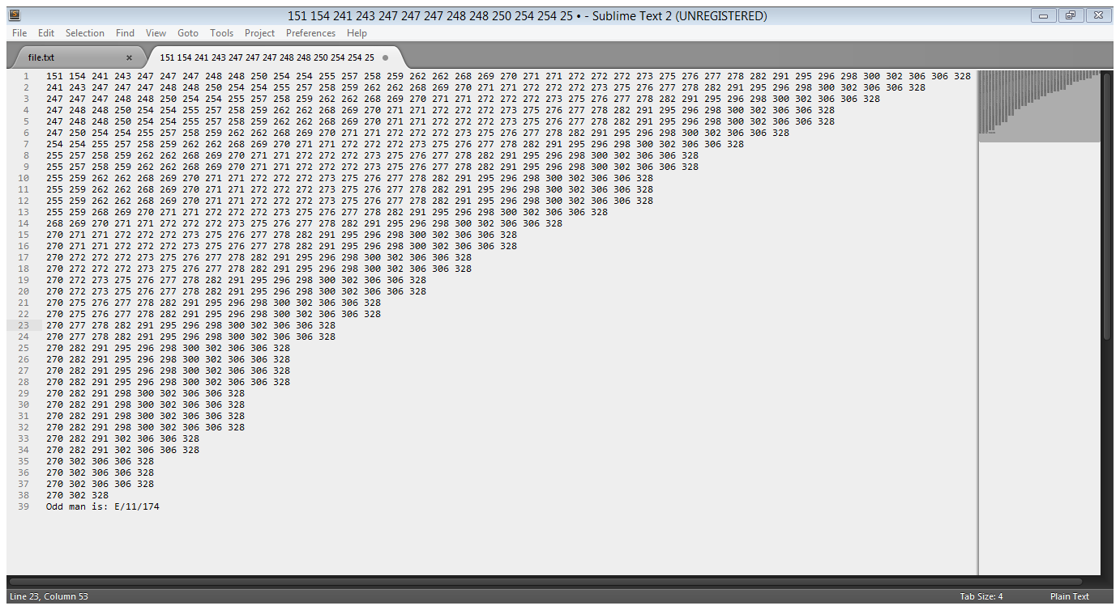

This get the distance values of a value with other two values around it.

As example get the 3 values as;

a b c

prew_dist = b - a

next_dist = c – b

If prew_dist is larger than next_dist this comparison continues until it reaches the end of the array or this logic become false. Then pair them up from the end.

Else, that means these distances are equal or next_dist is larger than prew_dist, then it simply pair the values.

When the size reaches one it prints the remaining values E number.

This method is consists of only one loop so it runs maximum of N times. (N means the number of members in the list)

So the time complexity of the method is O(N).