**Abstract**

Water pollution is one of the biggest fears for the green globalization. In order to ensure the safe supply of the drinking water the quality needs to be monitored in real time.

In this project “Python Based Water Monitoring System” we design and develop a low-cost system for real time monitoring of the water quality using IOT, (internet of things). The system consists of several sensors used to measuring physical and chemical parameters of the water. The parameters such as temperature, PH, turbidity, flow sensor of the water can be measured. The measured values from the sensors can be processed by the core controller. The measured values from the sensors can be processed by the core controller. The Raspberry Pi model can be used as a core controller. Finally, the sensor data can be viewed on internet using WI-FI system.

**Keywords** - Temperature Sensors, pH Sensor, Turbidity Sensor, Raspberry PI4 Uno, Raspberry Pi.

**Introduction**

In today's world, water is an essential resource without which we cannot survive; thus, water can be considered a critical resource in the lives of people who benefit from its use while also being harmed by its misuse and unpredictability. (Flooding, droughts, salinity, acidity, and degraded quality) Water pollution is one of them. Greatest concerns about green globalization To ensure a safe supply of drinking water.

**The project's significance**

The project is based on resolving water pollution issues by identifying the underlying issues present in water quality by analyzing the intrinsic issues that cause the quality of water from different sources to degrade and cause water-borne diseases. This project was inspired primarily by the number of diseases present in most Indian localities, which cause significant harm to the populace, particularly in rural areas and areas where water is not readily available or easily checked. This project is extremely relevant in today's world where money is time. As a result, the system enables us to easily monitor the quality of water in real time.

**Purpose**

Water quality has been shown to be distributed over most areas (both rural and and cities) have deteriorated over time because of the sources from which they supply their water. Depicted, dirty, defective on the part of responsible civil society maintenance of water quality. It could also be due to improper maintenance A machine that performs activities necessary to purify or improve water quality distributed to households. It has been observed that this strongly influences the water count. Infected disease in the city. This project is working to achieve a reasonable assessment of some water quality. Of the most basic parameters, **i.e**. temperature is monitored and climate Changes do not affect water. PH is monitored to keep it as high as possible. Optimal range, suitable for human consumption and prevents the spread of disease microbes. Water flow is monitored to ensure there are no interruptions or leaks to maintain a certain flow rate which also prevents the growth of fungi and small plants transport network. Finally, as the turbidity of the water is monitored, we can measure the number of contaminants in the water and arrange this if necessary If the water quality is not within acceptable limits, any action necessary to change the water quality offer. A great advantage of this system is the ability to monitor product quality in real time. Water (that is, its immediate quality is monitored), immediately granting us the ability Determine if the water is actually drinkable. the system gives us that Possibility to instantly identify water attributes or parameters and check if they are present No additional measures should be taken to purify or improve water quality water monitoring system New Horizon College of Engineering 2018-2019 3 sent to us. This will help you make clear purchasing decisions Save money and time with or without additional equipment.

**Scope of the project**

This project is run considering that all sensor readings from the sensors are reasonable. Out of Stock These values **​​**contain the parameters of the water sample to be tested. temperature, pH, turbidity**,** flow rate**,** etc.

**Problem definition**

Today, the number of diseases caused by microorganisms in water in Pakistan it’s increasing at an alarming rate and presents a significant problem that hinders growth. Increasing population and its impact on the effective functioning of entire cities is one of the greatest. This is because most bodies of water are polluted and there is no good way to tell if they are polluted. The water sent to us is either treated properly or no effective measures are taken About water quality management of water sources.

* **Problem explanation**

As seen in most lakes in our cities, water quality has deteriorated significantly. Bubbles from impurities released into the lake. water is Be sure to treat it to make it suitable for consumption and daily use. Besides, we should have a means of measuring quality in terms of easily accessible parameters Understand and monitor quality in real time. Now that many people gather People who care about water especially in summer, the government has started to identify this Water may not have been treated before use and solutions are needed to identify the reasons behind the increasing pollution of water sources in this city. one of Some of the most important reasons are that supply groups are unlimited. water in the neighborhood. In most cases water is also supplied by private providers Severe water shortage impacts local water quality As a result, we receive many complaints. Although not visible in the early stages, Only everyone with a weakened immune system, such as the elderly and newborns Infants are affected. If you allow it to grow, it will definitely lead to a massive epidemic ratio. Therefore, a suitable method for determining water quality is required.

**Objective of the study**

This project focuses on the above problem by introducing dynamic IOT Python. Based water monitoring system using Raspberry Pi to determine water level and volume Detects contamination, pH fluctuations and the presence of bacteria. water waste and you can also find water purity

**PH TUBE SENSOR**

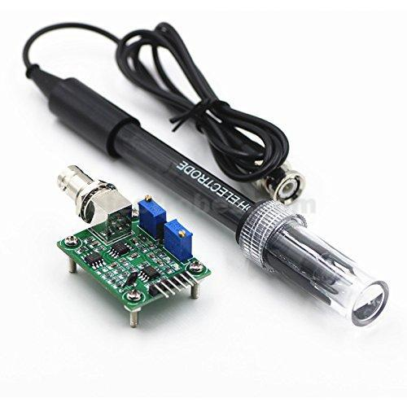

**Introduction:**

Need to measure water quality and other parameters but haven't got any low cost pH meter? Find it difficult to use with Raspberry PI4? Here comes an analog pH meter, specially designed for Raspberry PI4 controllers and has built-in simple, convenient and practical connection and features. It has an LED which works as the Power Indicator, a BNC connector and PH2.0 sensor interface. To use it, just connect the pH sensor with BNC connector, and plug the PH2.0 interface into the analog input port of any Raspberry PI4 controller. If pre-programmed, you will get the pH value easily. Comes in compact plastic box with foams for better mobile storage. Attention In order to ensure the accuracy of the pH probe, you need to use the standard solution to calibrate it regularly. Generally, the period is about half a year. If you measure the dirty aqueous solution, you need to increase the frequency of calibration.

**Specifications:**

* Applications
* Water quality testing
* Aquaculture
* Specification
* Module Power : 5.00V
* Module Size : 43mm×32mm
* Measuring Range:0-14PH
* Measuring Temperature :0-60 ℃
* Accuracy : ± 0.1pH (25 ℃)
* Response Time : ≤ 1min
* pH Sensor with BNC Connector
* PH2.0 Interface ( 3 foot patch )
* Gain Adjustment Potentiometer
* Power Indicator LED
* Cable Length from sensor to BNC connector:660mm

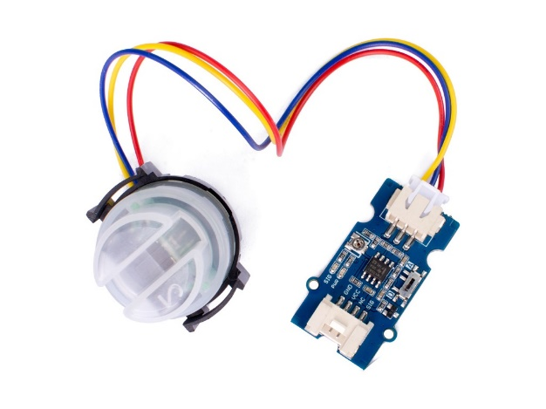**TURBIDITY SENSOR**

**Introduction**

The turbidity sensor detects water quality by measuring the levels of turbidity, or the opaqueness. It uses light to detect suspended particles in water by measuring the light transmittance and scattering rate, which changes with the amount of total suspended solids (TSS) in water. As the TTS increases, the liquid turbidity level increases. Turbidity sensors are used to measure water quality in rivers and streams, wastewater and effluent measurements, control instrumentation for settling ponds, sediment transport research and laboratory measurements. This liquid sensor provides analog and digital signal output modes. The threshold is adjustable when in digital signal mode. You can select the mode according to your MCU.

**Specifications**

* Response Time : <500ms
* Insulation Resistance: 100M (Min)
* Output Method:
* Analog output: 0-4.5V
* Digital Output: High/Low level signal (you can adjust the threshold value by adjusting the potentiometer)
* Operating Temperature: 5℃~90℃
* Storage Temperature: -10℃~90℃
* Weight: 30g
* Adapter Dimensions: 38mm*28mm*10mm/1.5inches *1.1inches*0.4inches

**WATER FLOW SENSOR**

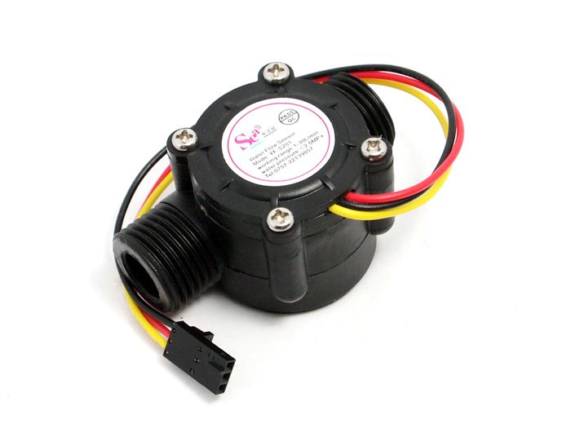

**Introduction**

This Gravity: liquid flow sensor is designed based on the electromagnetic principle. It adopts O-ring rubber seal and uses silicone sealant at the outlet end to strength water-resistance. With high anti-interference and anti-impact, the sensor offers reliable performance and long service life. Also, it is designed with G3/4 thread connectors for easy installation.

The sensor can be used with microcontrollers like Raspberry PI4 UNO to measure the flow of liquids with high concentration and low viscosity like water, diesel, engine oil, milk, paint, detergent, honey, etc. (no impurity in liquid)

**Specifications**

* Gravity interface, easy to wire
* Wide voltage of 3.5~24V
* Measure the flow of the high-concentration but low-viscosity liquid
* RoHS compliant
* Specification
* Operating Voltage: DC3.5~24V
* Operating Current: ≤10mA (DC5V)
* Output Mode: NPN pulse signal
* Pipe Diameter: G3/4
* Thread I.D.: 16mm/0.63"
* Thread O.D.: 26mm/1.02"
* Thread Length: 18.7mm/0.74"
* Water Pressure Resistance: ≤1.2MPA
* Insulation Resistance: >100MΩ
* Flow Range: 30-3000L/H
* Error: ±1% (20-3000L/H)
* High Level of Output Pulse: >DC4.7V (input voltage DC5V)
* Low Level of Output Pulse: <DC0.5V (input voltage DC5V)
* Duty Cycle of Output Pulse: 50%±10%
* Flow & Pulse Correlation: 1L=75 pulses
* Operating Temperature: ≤80°C
* Operating Humidity: 35%~90%RH (no frosting)
* Storage Temperature: -25°~+80°C
* Storage Humidity: 25%~95%RH
* Dimensions: 92×47×39mm/3.62×1.85×1.54"