# **Tech Wiz IOT**

**Group Members:**

M. Arsalan

Wajahat Ali

Samuel Anan

Raja Tahir

Thomas

Arnold

# **Abstract:**

Agriculture is facing a number of complicated challenges that are impeding productivity, sustainability, and economic viability. Among the pressing challenges are the effects of climate change, water scarcity, soil degradation, pests and illnesses, market access hurdles, workforce shortages, and rural-urban migration. This abstract presents a comprehensive way to addressing these issues. Implementing climate-resilient farming practices, optimizing water management strategies, promoting soil conservation and restoration methods, adopting integrated pest management techniques, improving market access and infrastructure, providing farmers with education and skill development, leveraging technology adoption, initiating rural development initiatives, reforming land tenure systems, stabilizing market prices, and prioritizing the environment are among the suggested solutions. The successful deployment of these ideas necessitates government collaboration.

# **Problem statement:**

Agriculture faces a range of issues, which vary depending on place and context, but some common ones include:

**Climate change** can interrupt crop cycles and reduce yields by causing erratic weather patterns, severe temperatures, droughts, and floods.

**Water Scarcity**: Water scarcity affects irrigation and crop growth in many locations.

**Soil Degradation**: Excessive land usage, erosion, and poor farming techniques can all contribute to soil depletion and diminished fertility.

**Insects, diseases**, and weeds can harm crops and lower yields, resulting in considerable economic losses.

# **Proposed Solution:**

Among the proposed answers to agricultural challenges are:

Climate-Resilient Farming Practices: Promoting the use of climate-smart farmsing techniques that are more adaptable to shifting weather patterns and harsh conditions.

Water management entails using efficient irrigation methods, practicing water conservation, and investing in water storage and delivery infrastructure.

Soil conservation and restoration entails promoting sustainable land management strategies such as cover cropping, crop rotation, and agroforestry in order to minimize soil deterioration and increase fertility.

Integrated Pest Management (IPM) is the use of a combination of biological, chemical, and cultural approaches to manage pests and diseases while having the least possible impact on the environment.

# **Design/Architecture:**

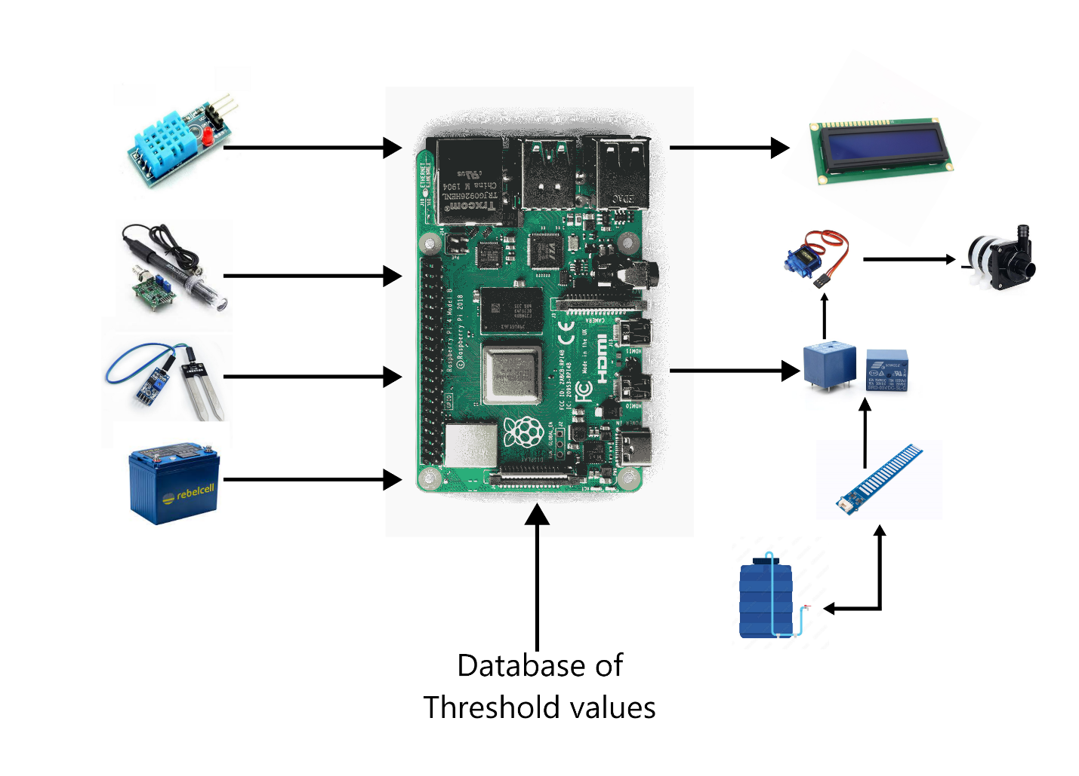

# **Components/Model:**

**Relay 10A**



**Description:**

A relay is an electrical device that uses a tiny control signal to switch a bigger electrical load. It is frequently used to operate circuits with low-power signals, such as a switch controlling a high-power light or motor.

**DHT11 Sensor**



**Description:**

The DHT11 sensor is a basic digital temperature and humidity sensor commonly used in various applications, including home automation, weather stations, and environmental monitoring. It's designed to provide accurate measurements of temperature and humidity levels in its immediate surroundings.

# **Issues/Solution:**

Here are some agricultural concerns and possible solutions:

Impacts of Climate Change

To offset the effects of shifting weather patterns, implement climate-resilient farming practices such as drought-tolerant crops, enhanced irrigation, and agroforestry.

Water scarcity is a problem.

Solution: To optimize water use, employ efficient irrigation technologies such as drip irrigation and rainwater harvesting, and invest in water storage and distribution infrastructure.

Problem: Soil Degradation

Solution: To increase soil health and minimize erosion, promote sustainable land management strategies such as cover cropping, crop rotation, and reduced tillage.

Pests and diseases are a problem.

To reduce insect damage, implement integrated pest management tactics that incorporate biological controls, natural predators, and targeted chemical use.

# **Conclusion:**

Finally, the agriculture industry faces a slew of issues that necessitate comprehensive and adaptive solutions. Farmers and agricultural systems face a variety of challenges, including climate change, water constraint, soil degradation, pest outbreaks, market access hurdles, and labor shortages. Addressing these difficulties requires a coordinated effort from governments, non-governmental organizations (NGOs), research institutions, and the corporate sector.