**Abstract:**

Agriculture is facing a number of complicated challenges that are impeding productivity, sustainability, and economic viability. Among the pressing challenges are the effects of climate change, water scarcity, soil degradation, pests and illnesses, market access hurdles, workforce shortages, and rural-urban migration. This abstract presents a comprehensive way to addressing these issues. Implementing climate-resilient farming practices, optimizing water management strategies, promoting soil conservation and restoration methods, adopting integrated pest management techniques, improving market access and infrastructure, providing farmers with education and skill development, leveraging technology adoption, initiating rural development initiatives, reforming land tenure systems, stabilizing market prices, and prioritizing the environment are among the suggested solutions. The successful deployment of these ideas necessitates government collaboration.

**Problem statement:**

Agriculture faces a range of issues, which vary depending on place and context, but some common ones include:

**Climate change** can interrupt crop cycles and reduce yields by causing erratic weather patterns, severe temperatures, droughts, and floods.

**Water Scarcity**: Water scarcity affects irrigation and crop growth in many locations.

**Soil Degradation**: Excessive land usage, erosion, and poor farming techniques can all contribute to soil depletion and diminished fertility.

**Insects, diseases**, and weeds can harm crops and lower yields, resulting in considerable economic losses.

**Proposed Solution:S**

Among the proposed answers to agricultural challenges are:

Climate-Resilient Farming Practices: Promoting the use of climate-smart farmsing techniques that are more adaptable to shifting weather patterns and harsh conditions.

Water management entails using efficient irrigation methods, practicing water conservation, and investing in water storage and delivery infrastructure.

Soil conservation and restoration entails promoting sustainable land management strategies such as cover cropping, crop rotation, and agroforestry in order to minimize soil deterioration and increase fertility.

Integrated Pest Management (IPM) is the use of a combination of biological, chemical, and cultural approaches to manage pests and diseases while having the least possible impact on the environment.

**Design/Architecture:**

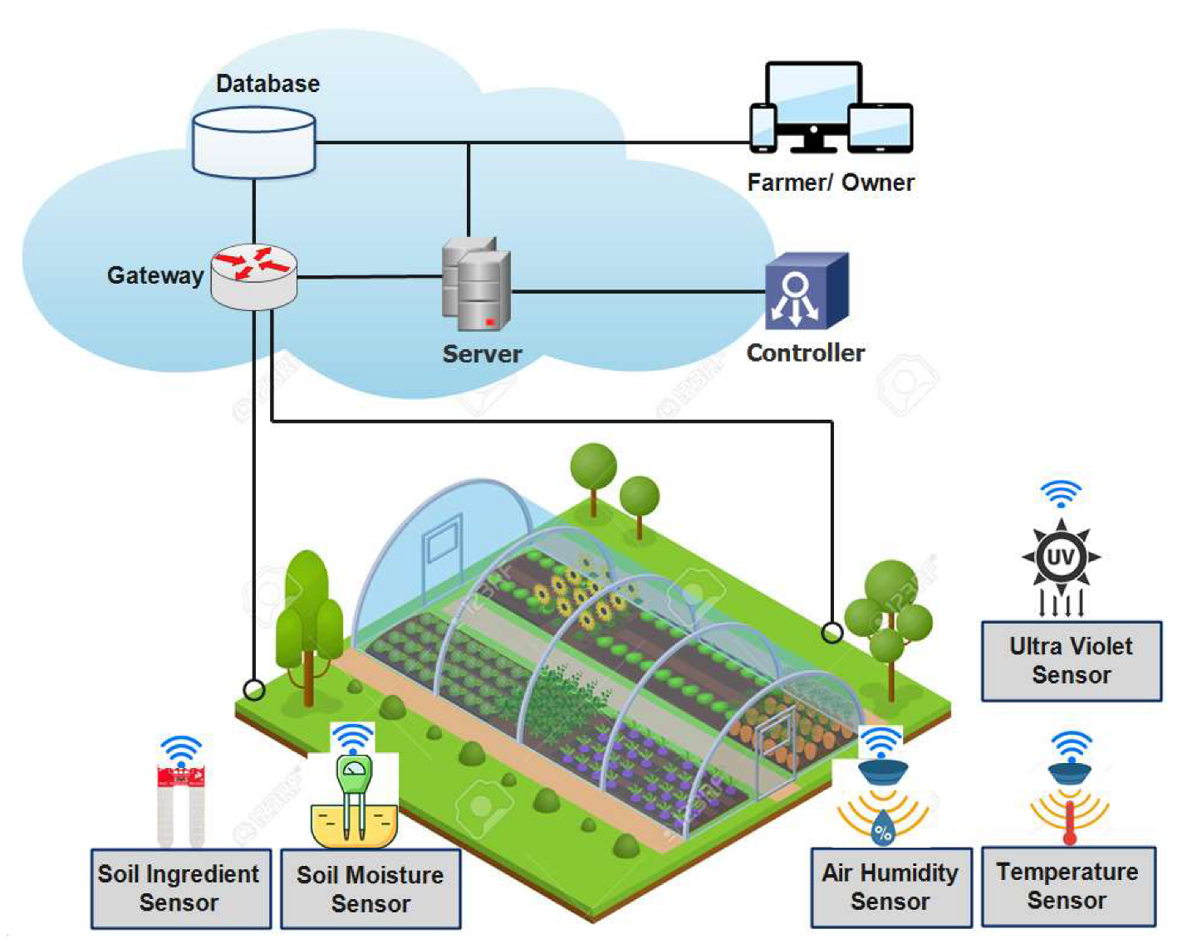

**Components/Model:**

**Relay 10A**



**Description:**

A relay is an electrical device that uses a tiny control signal to switch a bigger electrical load. It is frequently used to operate circuits with low-power signals, such as a switch controlling a high-power light or motor.

**Optimized Land Use**: The same plot of land is used for different crops within a single growing season, maximizing the field's yield.

Relay planting increases the harvest time, resulting in a more continuous supply of fresh produce.

**Weed Suppression**: Weeds that grew between rows of the first crop can be suppressed by the second crop.

**Soil Health**: Different crops have different root systems and nutritional needs. By varying root interactions and nutrient usage, relay crops can improve soil health.

**Risk Management**: If one crop is harmed by weather or pests, the other may thrive, lowering the overall risk of crop loss.

**Diversification of Income**: Planting a variety of crops with various market demands can offer farmers with a diversified income stream

**Issues/Solution:**

Here are some agricultural concerns and possible solutions:

Impacts of Climate Change

To offset the effects of shifting weather patterns, implement climate-resilient farming practices such as drought-tolerant crops, enhanced irrigation, and agroforestry.

Water scarcity is a problem.

Solution: To optimize water use, employ efficient irrigation technologies such as drip irrigation and rainwater harvesting, and invest in water storage and distribution infrastructure.

Problem: Soil Degradation

Solution: To increase soil health and minimize erosion, promote sustainable land management strategies such as cover cropping, crop rotation, and reduced tillage.

Pests and diseases are a problem.

To reduce insect damage, implement integrated pest management tactics that incorporate biological controls, natural predators, and targeted chemical use.

**Conclusion:**

Finally, the agriculture industry faces a slew of issues that necessitate comprehensive and adaptive solutions. Farmers and agricultural systems face a variety of challenges, including climate change, water constraint, soil degradation, pest outbreaks, market access hurdles, and labor shortages. Addressing these difficulties requires a coordinated effort from governments, non-governmental organizations (NGOs), research institutions, and the corporate sector.