1. **What is quantum computing and how does it differ from classical computing?**

Quantum computing is the area of study focused on developing computer technology based on the principles of quantum theory.

Quantum computing follows quantum physics, with enormous processing power through ability to be in multiple states and to perform tasks using all possible permutations simultaneously, whereas the classical computing follows classical Physics and principles of related theories.

1. **What are qubits and how do they differ from classical bits?**

Qubits are the fundamentals units of quantum information/data, analogous to classical bits in classical computing. However, unlike classical bits, which can be in one of two states (0 or 1), qubits can exist in multiple states simultaneously due to the principles of quantum superposition and entanglement. This property allows quantum computers to perform certain calculations much more efficiently than classical computers.

1. **What are quantum gates and how do they differ from classical gates?**

Quantum gates are the basic building blocks of quantum circuits, similar to classical logic gates in classical computing. They are mathematical operations that act on qubits to perform quantum computations. Quantum gates manipulate the quantum states of qubits, allowing for operations such as superposition, entanglement, and interference.

Quantum gates operate on qubits. However, quantum gates can manipulate qubits in ways that are fundamentally different from classical gates due to the principles of quantum mechanics. Some common types of quantum gates are Hadamard Gate (for superposition), Pauli-X gate (similar to classical NOT gate).

1. **What are quantum algorithms and how do they differ from classical algorithms?**

Quantum algorithms are algorithms specifically designed to run on quantum computers, leveraging the principles of quantum computations. They differ from classical algorithms, which run on classical computers and operate according to the laws of classical phyics.

There are some basic key differences between quantum and classical algorithms:

1. Basic units of information: Classical computers use bits as the fundamental unit of information, with each bit representing either a 0 or a 1. Quantum computers, on the other hand, use quantum bits or qubits, which can represent both 0 and 1 simultaneously due to the principles of superposition.
2. Operations: Classical algorithms perform operations sequentially, one after the other. Quantum algorithms can perform operations on multiple qubits simultaneously, thanks to the principles of superposition and entanglement, allowing for parallel processing.
3. Gate operations: Quantum algorithms use quantum gates to manipulate qubits, analogous to classical logic gates but operating on qubits according to quantum principles.
4. Superposition and entanglement: Quantum algorithms can exploit superposition and entanglement, which are unique quantum phenomena. Superposition allows qubits to represent multiple states simultaneously, while entanglement allows the state of one qubit to be correlated with the state of another, even when physically separated.
5. Quantum parallelism: Quantum algorithms can explore multiple solutions to a problem simultaneously through quantum parallelism. This capability can lead to significant speedups over classical algorithms for certain tasks, such as integer factorization (e.g., Shor's algorithm) and database search (e.g., Grover's algorithm).
6. Measurement: In quantum computing, measurement collapses the superposition of qubits into definite classical states. This process is essential for extracting useful information from quantum computations.
7. **What are some potential applications of quantum computing?**

Potentially, applications for quantum computing are

* + Cryptography
  + Quantum Teleportation
  + Climate Modeling and Weather Forecasting
  + Problems optimizations
  + Drug Discovery

**Coding option:**

|  |
| --- |
| Implement a quantum circuit in Python using the Qiskit library to simulate the creation and measurement of a Bell state. The circuit should take two qubits as input and produce an entangled pair that is maximally correlated.­­ |

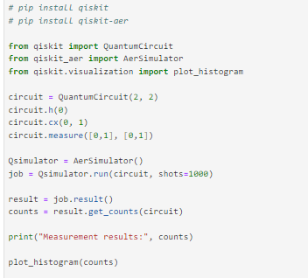

Output:

