# Challenge

The cultural heritage sector is experiencing a digital revolution driven by the growing adoption of non-invasive, non-destructive imaging and analytical approaches generating multi-dimensional data from entire artworks (e.g., hyperspectral imaging, macro X-ray fluorescence scanning, and novel forms of imaging X-ray radiography).

X-radiographs (X-ray images) are a particularly valuable tool during the examination and restoration of paintings because these can help establish the condition of a painting (e.g., whether there are losses and damages that may not be apparent at the surface, perhaps because of obscuring varnish, overpainted layers, structural issues, or cracks in the paint) and the status of different paint passages (e.g., help to identify retouchings or fills).

However, interpreting X-ray images can be problematic because – due to the penetration ability of x-rays – these can contain features appearing on the front, back, or even within the painting.

A classic example relates to the well-known polyptych panel painting *The Adoration of the Mystic Lamb* (the *Ghent Altarpiece*), completed before 1432 by the brothers Hubert and Jan van Eyck (see *Figs. 1 and 2*), where X-ray images of outer wing panels contain features of the paintings appearing both on the front and back of the panel (see *Fig. 3*).

*The challenge relates to the separation of the mixed X-ray images from the double-sided panels into separate X-ray images of corresponding (imagined) “one-sided” paintings.*

# Approach

Our team has developed a suite of entirely new self-supervised deep learning based approaches to tackle this X-ray image separation problem [1,2]. Our approach leverages readily available visible (RGB) images of the paintings on each side of the panel in order to decompose the mixed X-ray image onto its constituent (imagined) X-ray images (see *Fig. 4*).

Results obtained for details from the *Adam* and *Eve* panels of the Ghent Altarpiece demonstrate the efficacy of our proposed approaches [1,2] in relation to previous ones [3,4]. See *Figs. 5 and 6*.

# Other Use-Cases

Our team anticipates our proposed self-supervised deep learning based approaches can be adapted to tackle other related image separation challenges. These include the decomposition of a variety of mixed image modalities that contain various features present within a painting such as underdrawing and other *pentimenti*, or concealed designs.

# Research Team

University College London

Wei Pu, Miguel Rodrigues, Zahra Sabetsarvestani

Duke University

Ingrid Daubechies, Barak Sober

National Gallery, London

Nathan Daly, Catherine Higgitt

# Representative Publications

1. Z. Sabetsarvestani, B. Sober, C. Higgitt, I. Daubechies, and M. R. D. Rodrigues. Artificial intelligence for art investigation: Meeting the challenge of separating x-ray images of the Ghent Altarpiece. Science Advances, 2019.
2. W. Pu, B. Sober, N. Daly, C. Higgitt, I. Daubechies, M. R. D. Rodrigues. A connected auto-encoders based approach for image separation with side information: with applications to art investigation. IEEE International Conference on Acoustics, Speech and Signal Processing, 2020. [3] Z. Sabetsarvestani, F. Renna, F. Kiraly and M. R. D. Rodrigues. Source Separation with Side Information Based on Gaussian Mixture Models With Application in Art Investigation**.** IEEE Transactions on Signal Processing, 2020.

[4] N. Deligiannis, J. F. C. Mota, B. Cornelis, M. R. D. Rodrigues, and I. Daubechies. Multi-Modal Dictionary Learning for Image Separation With Application In Art Investigation. IEEE Transactions on Image Processing, 2016. **Representative Media Coverage**

The Telegraph

[Hidden](https://www.telegraph.co.uk/science/2019/08/30/hidden-works-goya-van-gogh-van-eyck-could-discovered-using-artifical/) [works](https://www.telegraph.co.uk/science/2019/08/30/hidden-works-goya-van-gogh-van-eyck-could-discovered-using-artifical/) [of](https://www.telegraph.co.uk/science/2019/08/30/hidden-works-goya-van-gogh-van-eyck-could-discovered-using-artifical/) [Goya,](https://www.telegraph.co.uk/science/2019/08/30/hidden-works-goya-van-gogh-van-eyck-could-discovered-using-artifical/) [Van](https://www.telegraph.co.uk/science/2019/08/30/hidden-works-goya-van-gogh-van-eyck-could-discovered-using-artifical/) [Gogh](https://www.telegraph.co.uk/science/2019/08/30/hidden-works-goya-van-gogh-van-eyck-could-discovered-using-artifical/) [and](https://www.telegraph.co.uk/science/2019/08/30/hidden-works-goya-van-gogh-van-eyck-could-discovered-using-artifical/) [Van](https://www.telegraph.co.uk/science/2019/08/30/hidden-works-goya-van-gogh-van-eyck-could-discovered-using-artifical/) [Eyck](https://www.telegraph.co.uk/science/2019/08/30/hidden-works-goya-van-gogh-van-eyck-could-discovered-using-artifical/) [could](https://www.telegraph.co.uk/science/2019/08/30/hidden-works-goya-van-gogh-van-eyck-could-discovered-using-artifical/) [be](https://www.telegraph.co.uk/science/2019/08/30/hidden-works-goya-van-gogh-van-eyck-could-discovered-using-artifical/) [discovered](https://www.telegraph.co.uk/science/2019/08/30/hidden-works-goya-van-gogh-van-eyck-could-discovered-using-artifical/) [using](https://www.telegraph.co.uk/science/2019/08/30/hidden-works-goya-van-gogh-van-eyck-could-discovered-using-artifical/) [artifical](https://www.telegraph.co.uk/science/2019/08/30/hidden-works-goya-van-gogh-van-eyck-could-discovered-using-artifical/) [intelligence](https://www.telegraph.co.uk/science/2019/08/30/hidden-works-goya-van-gogh-van-eyck-could-discovered-using-artifical/) Forbes

[Forget](https://www.forbes.com/sites/simonchandler/2019/09/06/forget-the-future-ai-will-take-us-back-to-the-past/#1cc67ddd2d13) [The](https://www.forbes.com/sites/simonchandler/2019/09/06/forget-the-future-ai-will-take-us-back-to-the-past/#1cc67ddd2d13) [Future,](https://www.forbes.com/sites/simonchandler/2019/09/06/forget-the-future-ai-will-take-us-back-to-the-past/#1cc67ddd2d13) [AI](https://www.forbes.com/sites/simonchandler/2019/09/06/forget-the-future-ai-will-take-us-back-to-the-past/#1cc67ddd2d13) [Will](https://www.forbes.com/sites/simonchandler/2019/09/06/forget-the-future-ai-will-take-us-back-to-the-past/#1cc67ddd2d13) [Take](https://www.forbes.com/sites/simonchandler/2019/09/06/forget-the-future-ai-will-take-us-back-to-the-past/#1cc67ddd2d13) [Us](https://www.forbes.com/sites/simonchandler/2019/09/06/forget-the-future-ai-will-take-us-back-to-the-past/#1cc67ddd2d13) [Back](https://www.forbes.com/sites/simonchandler/2019/09/06/forget-the-future-ai-will-take-us-back-to-the-past/#1cc67ddd2d13) [To](https://www.forbes.com/sites/simonchandler/2019/09/06/forget-the-future-ai-will-take-us-back-to-the-past/#1cc67ddd2d13) [The](https://www.forbes.com/sites/simonchandler/2019/09/06/forget-the-future-ai-will-take-us-back-to-the-past/#1cc67ddd2d13) [Past](https://www.forbes.com/sites/simonchandler/2019/09/06/forget-the-future-ai-will-take-us-back-to-the-past/#1cc67ddd2d13)

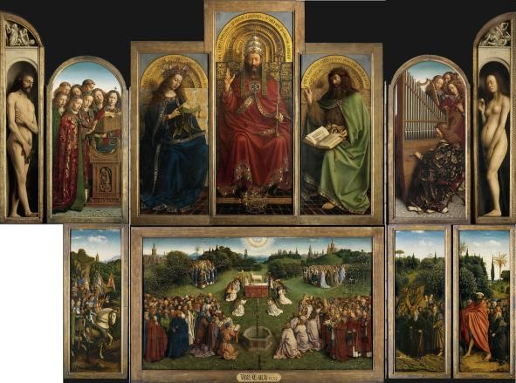

Fig. 1. The *Ghent Altarpiece* open. The bottom left panel of the open left wing has been missing since its theft in 1934. Images in this figure, used with permission of copyright holder, Saint-Bavo’s Cathedral, [www.lukasweb.be](http://www.lukasweb.be/) – Art in Flanders; photo Hugo Maertens.

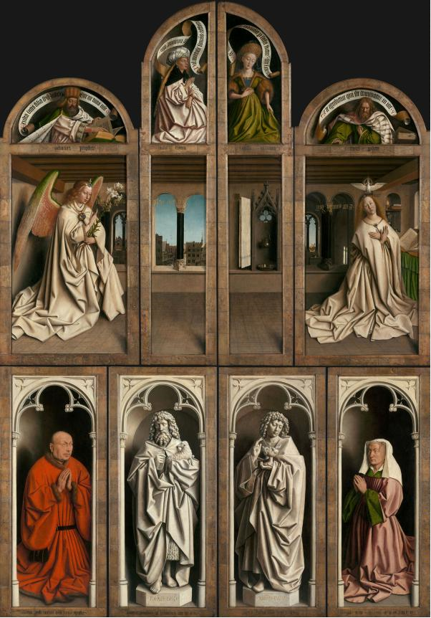

Fig. 2. The *Ghent Altarpiece* closed. Images in this figure, used with permission of copyright holder, Saint-Bavo’s Cathedral, [www.lukasweb.be](http://www.lukasweb.be/) – Art in Flanders; photo Dominique Provost.

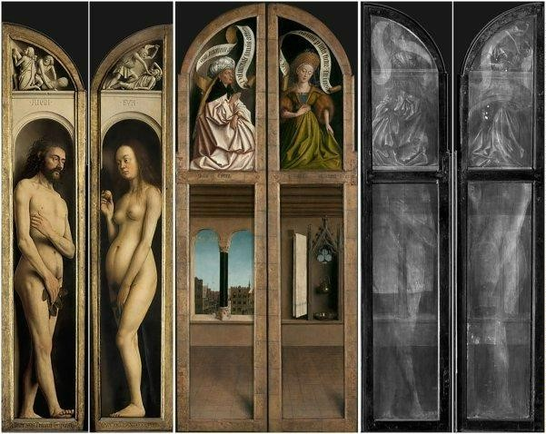

Fig. 3. Two double-sided panels from the . Images in this figure, used with permission of copyright holder, Saint-Bavo’s Cathedral, [www.lukasweb.be](http://www.lukasweb.be/) – Art in Flanders; photo Dominique Provost.

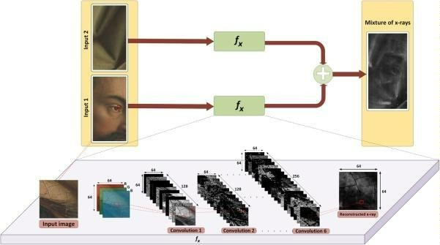

Fig. 4. A diagram of our proposed self-supervised neural network based X-ray image separation approach.

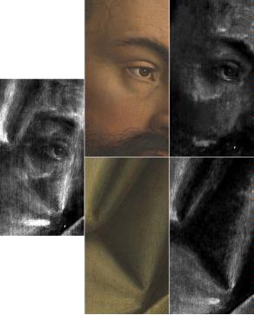Fig. 5. X-ray separation performed by the new neural networks based algorithm (left – mixed X-ray; center – visible images of each side; right – the reconstructed X-ray images). Images in this figure, used with permission of copyright holder, Saint-Bavo’s Cathedral, [www.lukasweb.be](http://www.lukasweb.be/) – Art in Flanders; photos: Hugo Maertens (interior view; *Adam*), Dominique Provost (exterior view), KIK-IRPA (X-ray).

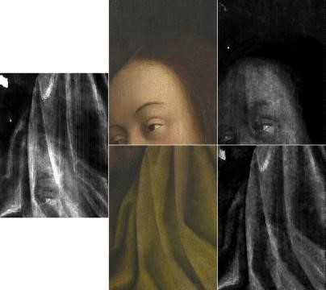

Fig. 6. X-ray separation performed by the new neural networks based algorithm (left – mixed X-ray; center – visible images of each side; right – the reconstructed X-ray images). Images in this figure, used with permission of copyright holder, Saint-Bavo’s Cathedral, [www.lukasweb.be](http://www.lukasweb.be/) – Art in Flanders; photos: Hugo Maertens (interior view; *Eve*), Dominique Provost (exterior view), KIK-IRPA (X-ray).