# Can We Trust Consumer Ratings? Exploring the Truth Behind GameStop Reviews

**Executive Summary**

This project delves into consumer reviews within the gaming industry, leveraging a dataset of product reviews from a prominent retail platform. The primary objective was to discern patterns in consumer behavior and evaluate the validity of review ratings as reliable indicators of product recommendations.

Through comprehensive data preprocessing, including text normalization and TF-IDF vectorization, and employing a range of clustering and machine learning techniques like KMeans, DBSCAN, and ensemble models, the study unveiled nuanced insights into the dynamics of consumer ratings and recommendations.

The analysis revealed that high ratings do not consistently align with positive recommendations, highlighting a discrepancy that challenges traditional assumptions about consumer feedback in retail settings. These findings provide actionable insights for retailers to refine their marketing strategies and product positioning.

**Introduction**

The rise of online retail has amplified the importance of consumer reviews in influencing purchasing decisions. In the gaming industry, where new products are constantly introduced and consumer expectations are high, understanding these reviews can provide crucial insights for retailers and developers. This project utilizes a dataset of product reviews from GameStop, a leading figure in the retail gaming sector. The dataset comprises various attributes of reviews, including user ratings, recommendations, and textual feedback from consumers.

The motivation for this project stems from the need to explore beyond mere numerical ratings, delving into the subtleties of what truly influences a consumer to recommend a product. This involves not only analyzing the text of the reviews to gauge sentiment but also correlating these sentiments with the given ratings to identify patterns that may not be immediately apparent from ratings alone.

**Methodologies**

The analysis began with the initial data import from a comprehensive CSV file containing thousands of reviews. Data cleaning was pivotal, involving the removal of duplicates and handling missing values to ensure the integrity of the analyses. Text data from reviews underwent extensive preprocessing to convert unstructured text into a structured form. This included:

* Tokenization: Splitting text into meaningful units such as words.
* Removal of stopwords: Eliminating common words that add no significant value to text analysis.
* Lemmatization: Reducing words to their base or root form.

Following preprocessing, the text data was vectorized using the Term Frequency-Inverse Document Frequency (TF-IDF) technique, which helps in emphasizing words that are more relevant to the context of the reviews. To analyze the structured data, a combination of statistical techniques and machine learning models was utilized:

* Clustering Analysis: KMeans and DBSCAN were used to identify inherent groupings within the data that signify different patterns in consumer reviews.
* Dimensionality Reduction: Principal Component Analysis (PCA) was conducted to reduce the number of variables and focus on the most informative aspects that influence review outcomes.
* Predictive Modeling: Several machine learning models, including Support Vector Machines (SVM), Random Forest, and Gradient Boosting Machines (XGBoost), were applied to predict the likelihood of product recommendations based on review texts and ratings. Each model was carefully tuned using GridSearchCV to find the optimal parameters for best performance.

**Model Evaluation**

Model performance was assessed using various metrics such as accuracy, precision, recall, and the F1 score. The SHAP (SHapley Additive exPlanations) framework was also introduced to interpret the models, providing insights into which features most significantly impact the predictive outcomes.

**Results and Discussion**

The analysis revealed several intriguing insights into consumer behavior and review patterns:

* Review Rating Discrepancies: It was observed that high star ratings do not necessarily correlate with recommendations. This discrepancy highlights the complexity of consumer satisfaction and suggests that numerical ratings alone may not fully capture consumer sentiment.
* Brand Popularity and Consumer Loyalty: Certain brands consistently received higher ratings and recommendations, indicating strong brand loyalty among consumers. This finding underscores the importance of brand reputation in the gaming industry.
* Clustering Patterns: The clustering analysis helped identify distinct groups of reviewers based on their review patterns and preferences, offering a nuanced understanding of the target customer base.

**Discussion**

The results from the predictive models provided robust tools for predicting consumer recommendations based on review texts. The use of SHAP values in interpreting these models shed light on the influence of specific words and phrases in reviews, enhancing our understanding of what drives consumer recommendations.

Overall, the findings challenge the traditional reliance on numerical ratings as sole indicators of product quality and consumer satisfaction. Instead, they advocate for a more holistic approach to analyzing consumer reviews, incorporating both numerical data and textual analysis to gain a fuller understanding of consumer behavior.

**Visualizations**

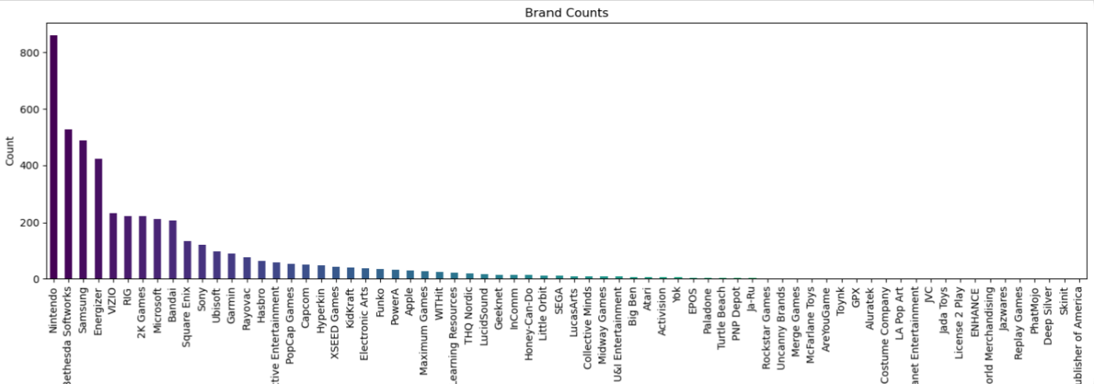

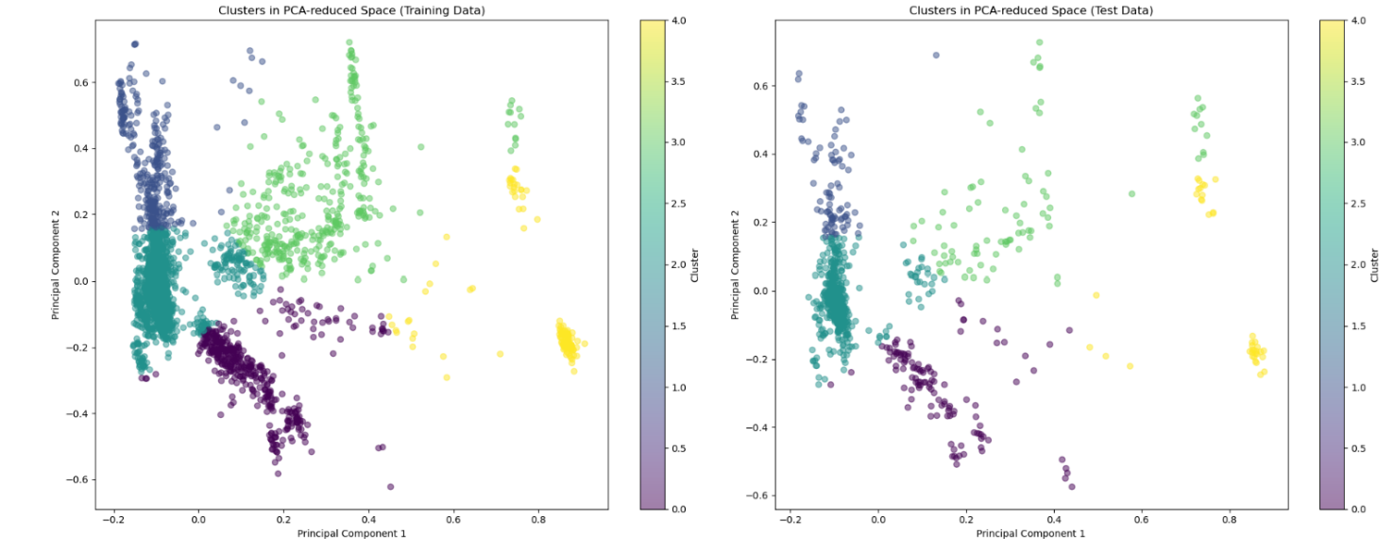

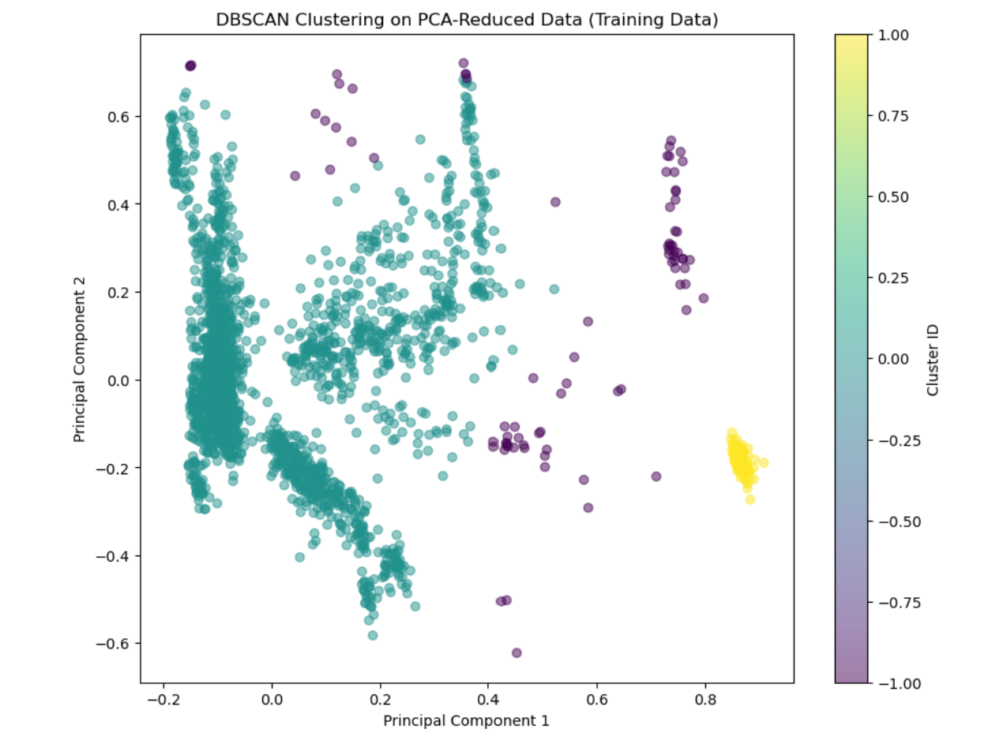

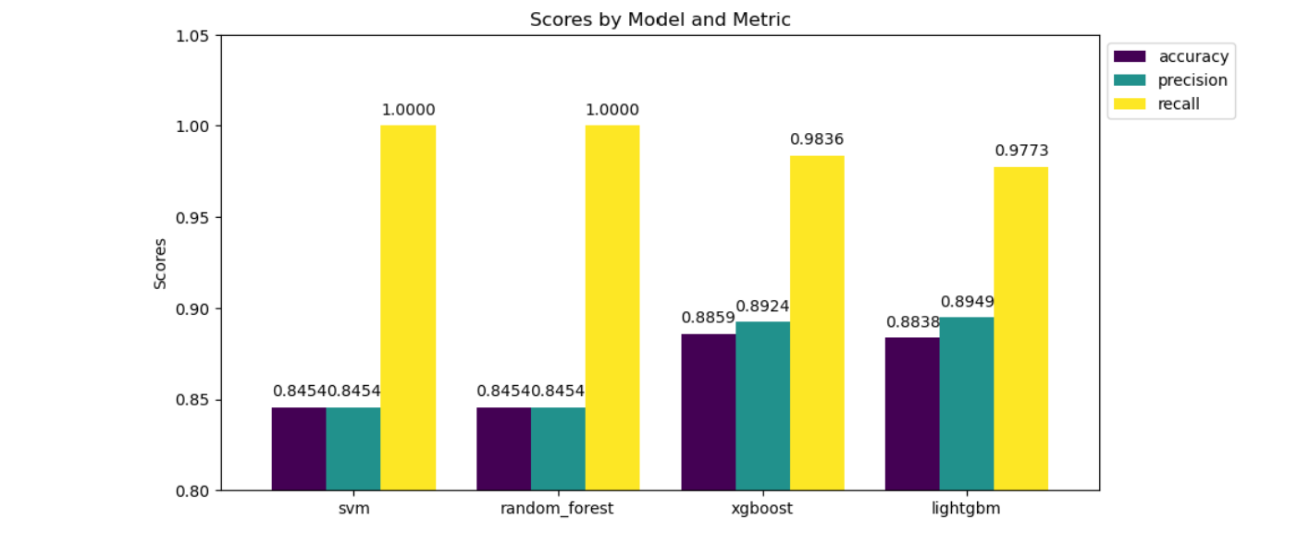

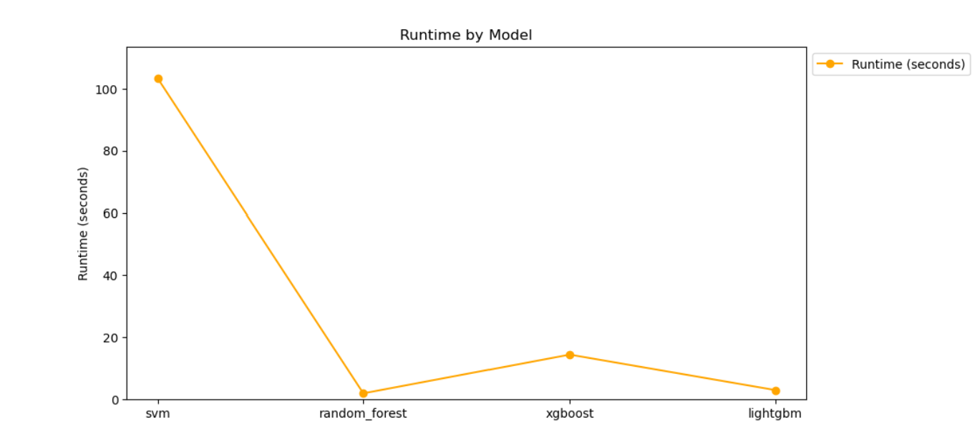

**Conclusion**

This project has successfully demonstrated the potential of advanced data analytics in uncovering deep insights from consumer reviews in the gaming industry. Through meticulous preprocessing, TF-IDF vectorization, clustering, and various predictive modeling techniques, we were able to reveal significant discrepancies between star ratings and actual product recommendations, as well as identify strong indicators of brand loyalty.

The conclusions drawn from this analysis challenge traditional assumptions about consumer reviews and highlight the necessity for retailers to adopt more sophisticated analytical approaches. By integrating both quantitative and qualitative data analyses, retailers can gain a more comprehensive understanding of consumer sentiments and preferences.

**Future Work**

To build upon the findings of this project, several avenues for future research are suggested:

* Temporal Analysis of Reviews: Analyzing how reviews change over time with respect to product life cycles could offer valuable insights into trends in consumer satisfaction and product durability.
* Expansion of Data Sources: Incorporating review data from additional platforms could help validate the findings across different segments of the market and enhance the generalizability of the models.
* Integration with Sales Data: Combining review data with actual sales data to correlate the impact of consumer reviews on sales performance. This would provide actionable insights for optimizing inventory and marketing strategies based on consumer feedback.
* Advanced Machine Learning Techniques: Employing more complex machine learning algorithms, such as Neural Networks, Named Entity Recognition (NER), or Topic Modeling could provide more nuanced insights into the content of the reviews, allowing for better categorization and understanding of key themes and topics.