SIMATS ENGINEERING

ASSESSMENT TOOL 1: Constraint-Based Problem Solving

COURSE NAME: Cloud Computing and
Big Data Analytics

COURSE CODE: CSA15

COURSE OUTCOME COVERED
CO5: Design big data processing systems using the Hadoop ecosystem including HDFS, MapReduce, and YARN.
(BL5)
Assessment Tool Weightage: 40%
Dave&#39;s Taxonomy: Articulation (Level 4)
Question Count: 5

Total Marks: 50

Code of Conduct
I ___ARTHI REDDY(192565054)_ (Name / Reg No) certify that this submission is my original work and that I have adhered
to the guidelines specified for this assessment.
I understand that any violation of academic integrity rules will result in disciplinary action.
Signature of the student: ____________________

Assessment Tasks
Constraint-Based Problem Solving
1. Design an HDFS-based storage solution for a media platform under the constraints that data availability must
remain above 99.9%, replication factor cannot exceed 3, and storage growth must stay cost efficient. Justify
your design.
2. A MapReduce workflow must process log data within a 20-minute batch window using limited cluster nodes.
Propose a job design under these constraints and explain task distribution.
3. A YARN-managed cluster supports ETL, reporting, and machine learning jobs. Design a scheduler policy
under the constraints of fairness, priority for ETL, and recovery from node failure.
4. An enterprise needs to ingest data from SAN, NAS, and operational databases into a big data platform while
maintaining backup reliability and minimal duplication. Propose a constrained architecture and justify each
component.
5. Design an end-to-end Hadoop ecosystem solution under the constraints of secure data movement, high
availability, and integration with Apache NiFi or ETL pipelines. Explain how your design satisfies all
constraints.
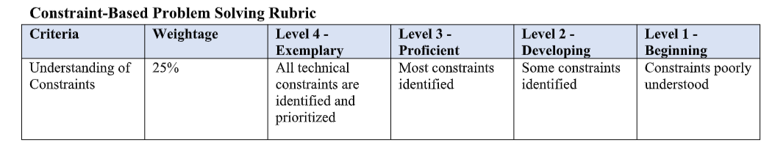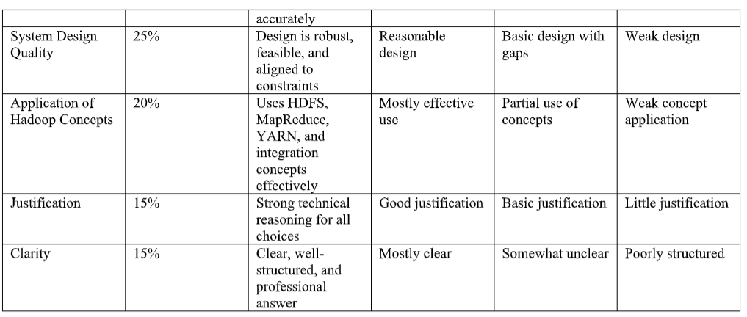

1. HDFS-Based Storage Solution for Media Platform
Design
- Store videos, images, audio, and metadata in HDFS.
- Use a Replication Factor of 3, which is the maximum allowed.
- Distribute replicas across different DataNodes and racks using rack awareness.
- Use NameNode High Availability (HA) with Active and Standby NameNodes.
- Use erasure coding for older, less frequently accessed media to reduce storage cost.
Justification
- 99.9%+ availability: Three replicas and NameNode HA provide fault tolerance.
- Replication ≤ 3: The design uses exactly 3 replicas.
- Cost efficient: Frequently accessed data uses replication, while cold data can use erasure coding.
- Scalability: New DataNodes can be added as media storage grows.
Conclusion
HDFS with 3-way replication, rack awareness, NameNode HA, and erasure coding provides high availability, fault tolerance, and cost-effective storage.

2. MapReduce Design for 20-Minute Log Processing
Design
- Store incoming log files in HDFS.
- Divide logs into suitable input blocks so multiple tasks can process them in parallel.
- Use Mapper tasks to extract important information such as IP address, timestamp, error code, and URL.
- Use Combiner to perform local aggregation and reduce network traffic.
- Use Reducer tasks to calculate final statistics such as error counts and traffic volume.
Task Distribution
- Assign multiple Mapper tasks across the available cluster nodes.
- Keep data processing close to the DataNodes using data locality.
- Use a limited but sufficient number of Reducers to avoid excessive resource usage.
- Configure task memory and CPU resources according to the available nodes.
- Monitor slow tasks and use speculative execution when required.
Justification
- Parallel Mappers reduce processing time.
- Combiners reduce shuffle data.
- Data locality reduces network overhead.
- Proper task distribution helps complete the batch within the 20-minute window.
Conclusion
A parallel MapReduce design using data locality, combiners, and optimized task distribution can process logs efficiently within the required time.

3. YARN Scheduler Policy for ETL, Reporting and ML
Scheduler Design
Use the Capacity Scheduler with separate queues:
Queue | Priority | Purpose
ETL | High | Critical data processing
Reporting | Medium | Business reports
ML | Low/Medium | Machine learning jobs
Policy
- Give ETL jobs the highest priority.
- Reserve a minimum resource capacity for reporting and ML so they are not completely blocked.
- Apply fair resource sharing within each queue.
- Set maximum resource limits to prevent one job from consuming the entire cluster.
- Enable preemption when high-priority ETL jobs require resources.
Node Failure Recovery
- YARN ResourceManager detects failed nodes.
- Failed tasks are automatically restarted on healthy nodes.
- Application state is maintained through checkpoints/recovery mechanisms.
- Replicated HDFS data allows jobs to continue even when a DataNode fails.
Conclusion
A Capacity Scheduler with priority queues, fair sharing, resource limits, and automatic task recovery satisfies fairness, ETL priority, and failure recovery.

4. Enterprise Data Ingestion from SAN, NAS and Databases
Proposed Architecture
SAN / NAS / Operational Databases
↓
Apache NiFi / ETL Layer
↓
Data Validation & Deduplication
↓
HDFS / Data Lake
↓
Backup & Replication
↓
Analytics / Reporting / ML
Components and Justification
1. Apache NiFi
- Collects data from SAN, NAS, and databases.
- Provides data routing and flow management.
- Supports secure and reliable data transfer.
2. ETL Layer
- Extracts data from operational databases.
- Transforms data into a common format.
- Removes invalid and duplicate records.
3. HDFS
- Provides scalable distributed storage.
- Stores large volumes of enterprise data.
4. Deduplication
- Uses unique IDs, checksums, or record matching.
- Prevents storing identical data multiple times.
- Reduces storage requirements.
5. Backup
- Maintain replicated copies of important data.
- Use separate backup storage for disaster recovery.
- Schedule regular incremental backups.
Conclusion
The architecture provides secure ingestion, minimal duplication, reliable backup, and scalable storage while integrating different enterprise data sources.

5. End-to-End Hadoop Ecosystem Solution
Architecture
Data Sources
↓
Apache NiFi / ETL
↓
Secure Data Transfer
↓
HDFS
↓
YARN
↓
MapReduce / Spark / Hive
↓
Analytics & Machine Learning
1. Secure Data Movement
- Use Kerberos authentication for Hadoop services.
- Use TLS/SSL encryption for data transmission.
- Apply access control using Apache Ranger or similar security mechanisms.
- Encrypt sensitive data where required.
2. High Availability
- Configure NameNode HA using Active and Standby NameNodes.
- Use 3-way HDFS replication for important data.
- Deploy redundant ResourceManager services.
- Use rack-aware replica placement to handle rack failures.
3. Apache NiFi / ETL Integration
- NiFi collects data from databases, files, APIs, and other sources.
- ETL pipelines clean and transform incoming data.
- NiFi provides monitoring, routing, and back-pressure.
- Processed data is written into HDFS for further analytics.
4. Processing Layer
- YARN manages cluster resources.
- MapReduce/Spark performs distributed processing.
- Hive provides SQL-based analytics.
- Machine learning workloads can run using suitable distributed frameworks.
5. Constraint Satisfaction
Constraint | Solution
Secure data movement | Kerberos + TLS/SSL
High availability | NameNode HA + replication
Data processing | YARN + MapReduce/Spark
Data ingestion | Apache NiFi + ETL
Large-scale storage | HDFS
Fault tolerance | Replication + automatic recovery
Conclusion
The proposed Hadoop ecosystem provides a secure, highly available, scalable, and integrated big-data platform. It combines NiFi/ETL for ingestion, HDFS for storage, YARN for resource management, and MapReduce/Spark/Hive for processing and analytics.

