ASSIGNMENT – 1

CODE:

float a;

float vout;

float vout1;

int LED = 13;

int gasSensor;

int piezo = 2;

void setup()

{

pinMode(A0, INPUT);

pinMode(A1, INPUT);

pinMode(LED, OUTPUT);

pinMode(piezo, OUTPUT);

Serial.begin(9600);

}

void loop()

{

vout = analogRead(A1);

vout1 = (vout/1023)\*5000;

a = (vout1-500)/10;

gasSensor = analogRead(A0);

if (a>=80)

{

digitalWrite(LED,HIGH);

}

else

{

digitalWrite(LED,LOW);

}

if (gasSensor>=100)

{

digitalWrite(piezo,HIGH);

}

else

{

digitalWrite(piezo,LOW);

}

Serial.print("in DegreeC = ");

Serial.print(" ");

Serial.print(a);

Serial.print("\t");

Serial.print("GasSensor = ");

Serial.print(" ");

Serial.print(gasSensor);

Serial.println();

delay(1000);

}

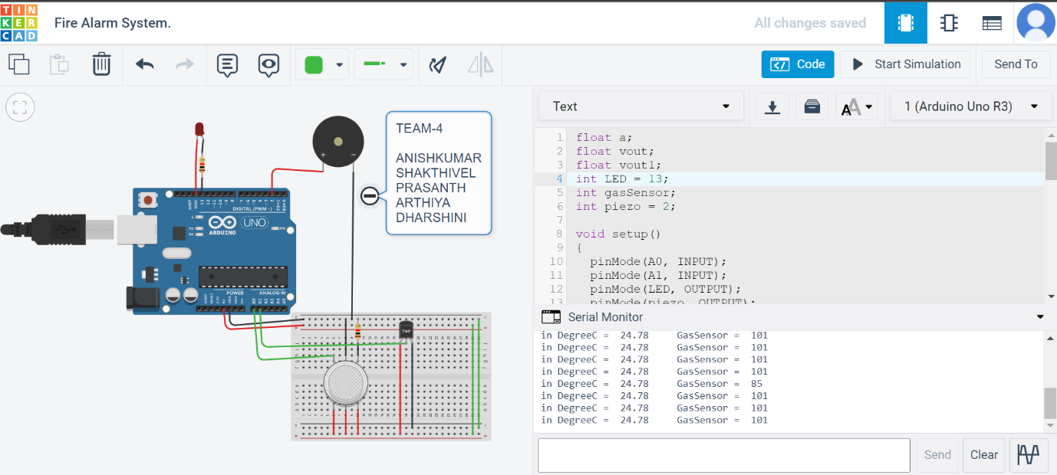

LINK :

<https://www.tinkercad.com/things/iFU0OFXAjqV>