ARTI 502
Deep Learning: 2nd Assignment

Training-Testing CNN with CIFAR Dataset using PyTorch
Year 2026 Term 1

Group #1
Group Members:
# | Member Name | Member Academic ID
1 | Ali Walled Al-Hashim |  | 2230004042
2 | Hadi Muneer Al-Abu Allairat |  | 2230005761
3 | Hadi Osama Al-Shalabi |  | 2230009003
4 | Omar Mohammed Hejazi |  | 2230009001
5 | Raed Shafiq Almozel |  | 2230001793

Overview
In this assignment, we will have you train some convolutional neural networks and will use a small dataset (CIFAR).

Objective
To implement two core building blocks to deep learning:
- Convolution layers
- Maxpooling layers.

Tasks (with PyTorch)

Task 1: Getting the CIFAR Dataset
Instructions:
- Download the dataset first. Since PyTorch hosts the CIFAR dataset, you can load it using their helper function later.
- You need to change DATA_PATH to an empty directory to download the dataset to.

Deliverable:
Screenshot showing the dataset loaded successfully.
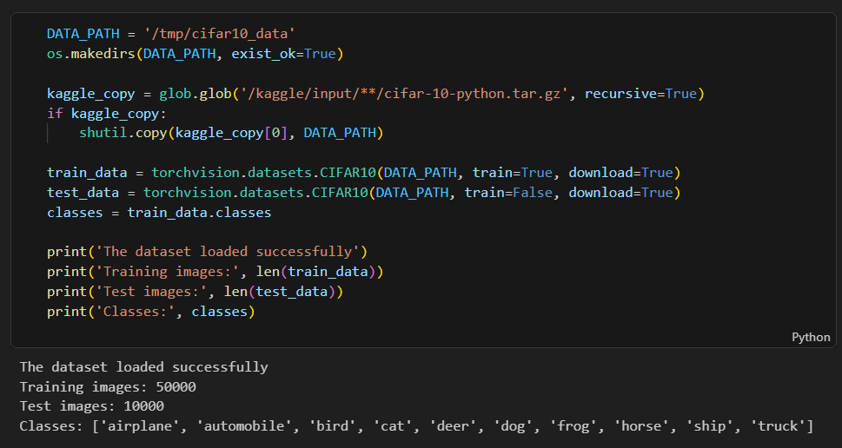

Task 2: Defining the Network
Instructions:
- Just like with MNIST in the first assignment you need to define your network architecture. This time you will be using convolutional layers and maxpooling to extract features from our images before you feed those features into your final classifier.

- Check out the documentation for nn.Conv2d

- So, the first parameter is the number of channels in the input. Second is the number of filters we'll use (AKA number of channels in the output). Third is kernel size. Next is stride and padding which are optional and have default values.

- Create your training and test functions

Deliverable:
- Provide screenshots of your code to define your network
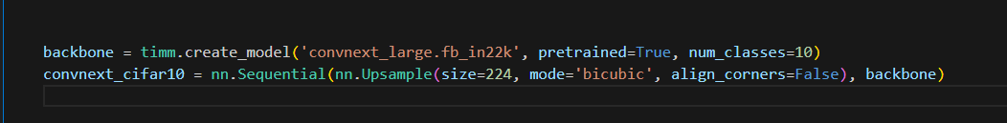
*Pre-trained model

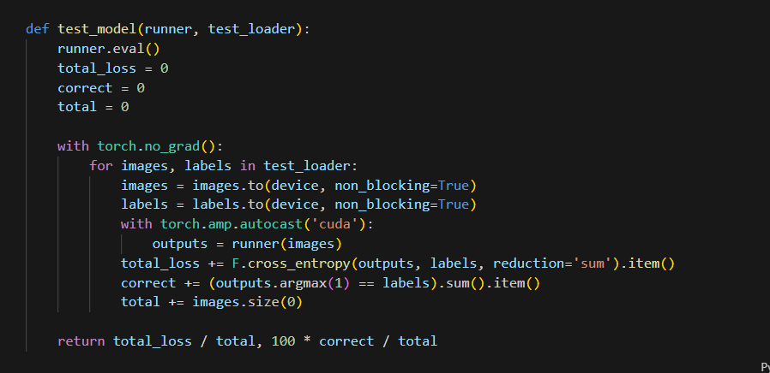
- Show screenshots of your training and test functions.
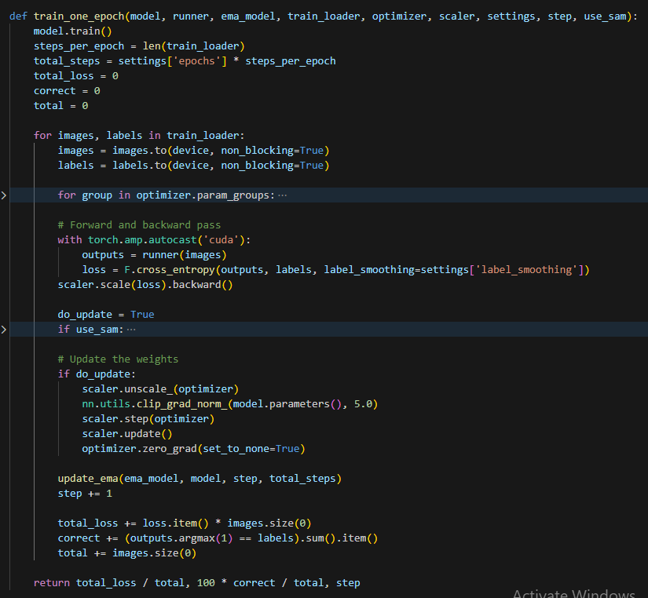

Task 3: Loading Data
Instructions:
- It's worthwhile to check out how the Dataloader loads the images into tensors. You can print out the size of the loaded data in the images tensors. Also, you can use matplotlib to see the visualization of the images data
Deliverable:
- Provide screenshots how to find:
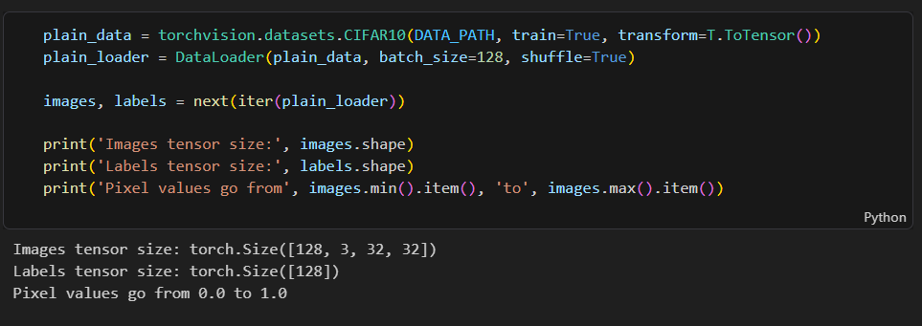
  - Images tensor size

  - Data images visualization using matplotlib
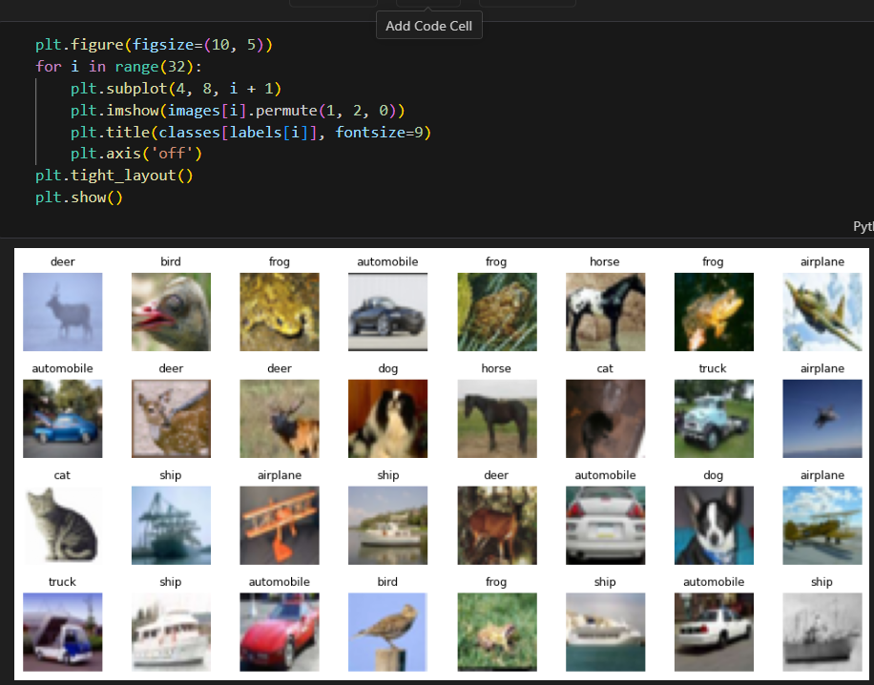

Task 4: Dataset Augmentation
Instructions:
- In this assignment, you may find that data augmentation helps you a lot (or possibly hurts your performance).
- Play around with various data augmentations we will suggest some:
  - ToPILImage - useful for many built-in transforms which expect PIL images.
  - RandomHorizontalFlip
  - RandomResizedCrop
  - ColorJitter
  - RandomRotation
  - Normalize
  - Adding various types of noise
  - ToTensor - PyTorch expects the output from the dataset to be a tensor in CxHxW format.
Note: You should be careful about which of these you apply to the test data. You usually don't want to apply noise to the test data, but you do want to normalize it the same way for example.

Deliverables:
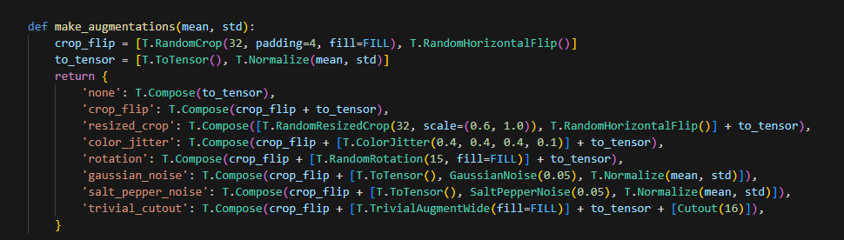
- Apply your code with various Dataset Augmentation as mentioned above.

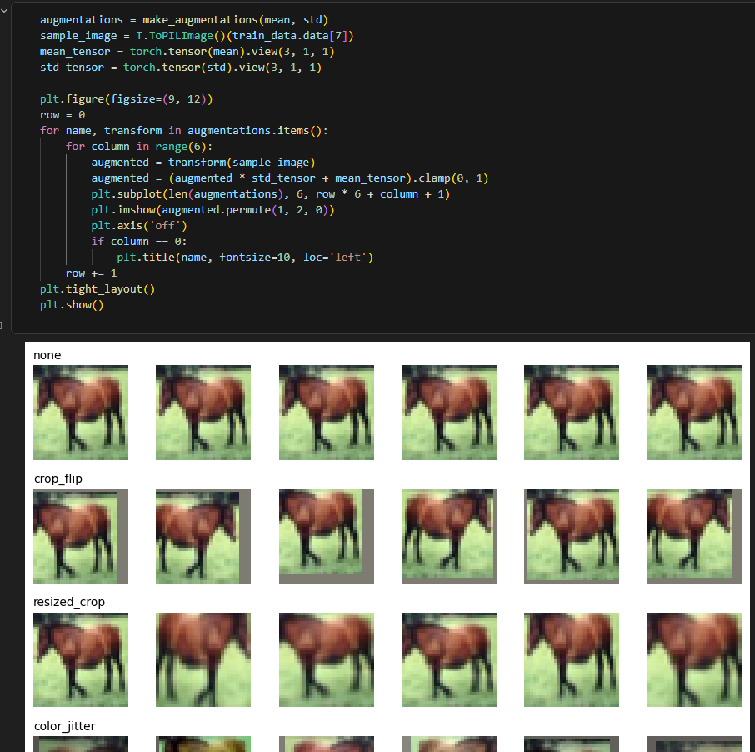

Task 5: Training Function and Tuning hyperparameters
Instructions:
- Generally, it is useful to see how your training is going. Often people print their loss to make sure it goes down and their accuracy to make sure it goes up. But pictures are better than words. So, for this part, you should record and plot the training loss, test loss, and test accuracy (and whatever else you want).
- Try different network architectures and experiment with hyperparameters.

Deliverables:
- Screenshot of your python source code that contains your training function with above requirements
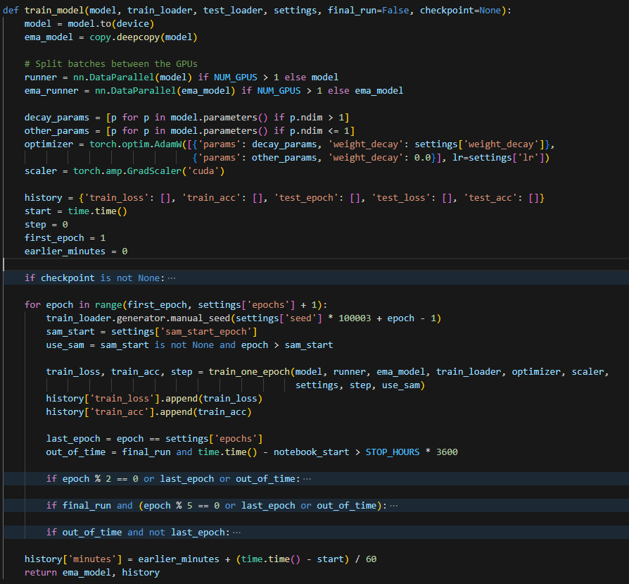
- What design that you tried worked the best? This includes things like network design, learning rate, batch size, number of epochs, and other optimization parameters, data augmentation etc.
  - Network design, we tried:
    - Training from scratch: ~97.5% test accuracy.
    - Other pre-trained models:
      - tf_efficientnetv2_m,
      - convnext_base,
      - convnext_tiny,
      - convnext_large (best performance)

  - learning rates:
    - 3e-5,
    - 1e-4 (best performance),
    - 3e-4

  - weight_decay: 0.01 (best performance), 0.05

  - Batch size fixed at 128 how many images the VRAM can hold at once.

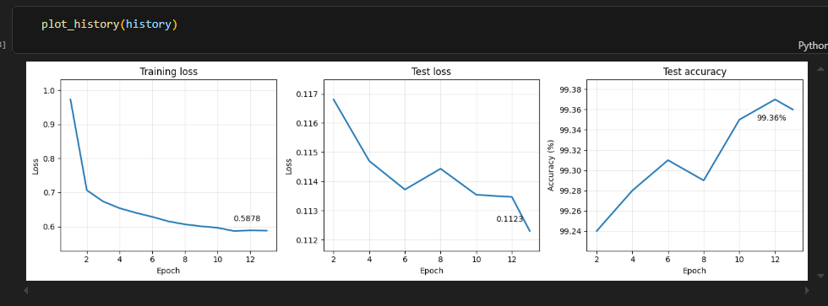
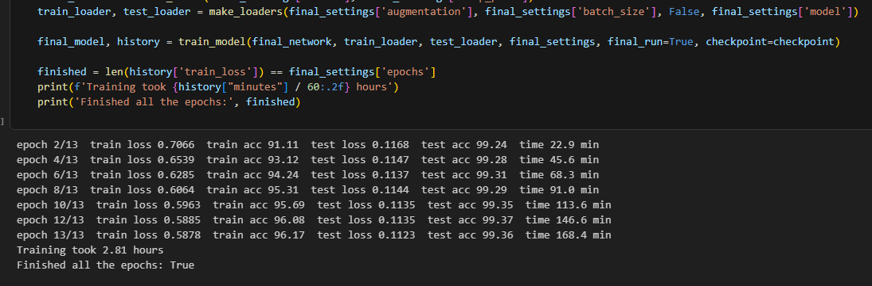
- What was the final train loss? Test loss? Test Accuracy? Provide the plots for train loss, test loss, and test accuracy.

Task 6: Save your source code
Instructions:
- Save your python source code

Deliverable:
- Submit your GitHub link of your source code along with this document, which includes all screenshots via Blackboard.
-
- End of Assignment -

Grading Rubric
Criterion | Excellent | Good | Developing | Poor | Marks
Task 1:  Getting the  CIFAR Dataset | Dataset loaded correctly with  clear screenshot showing successful execution | Loaded  correctly but screenshot is unclear | Dataset loaded with issues or incomplete evidence | Not loaded / missing screenshot | 0.5
Task 2:  Defining the  Network | All clear  screenshots | Minor mistakes or missing small details | Several missing description or unclear screenshots | Not answered /  incorrect / missing evidence | 2
Task 3:  Loading  Data | All clear screenshots | Minor mistakes or missing small  details | Several missing descriptions or unclear  screenshots | Not loaded / missing screenshot | 0.5
Task 4:  Dataset  Augmentation | All datasets augmentation implemented | Major datasets augmentation implemented | Minor datasets augmentation implemented | Not done | 2
Task 5:  Training  Function and Tuning parameters | Tuning parameters and model architecture created, screenshot included, and results description explained accurately | Tuning  Parameters and model  architecture correct but results description is weak | Tuning  Parameters and model  architecture correct but incorrect results description | Not done | 2
Task 6: Save your source code | Source code save successfully | Source code save successfully done but minor missing item | Source code save incomplete or file format incorrect | Not submitted / missing | 0.5
 |  | Total |  |  | 7.5

