AI-Driven Engineering Learning Platform
Technical Implementation Plan
System Overview
The AI-Driven Engineering Learning Platform is a local-first AI tutoring system designed
to support engineering education while also providing learning analytics for instructors.
Student Support:
• Concept explanations
• Engineering problem solving
• Programming debugging
• Design ideation
Instructor Analytics:
• Cognitive depth monitoring (Bloom levels)
• Topic difficulty detection
• Engagement trends
• At-risk student identification
The platform functions as both a student learning assistant and an instructional analytics system.
Core System Architecture
Core Components
- Student Chat Interface
- Backend API Server
- Dialogue Agent (Tutoring AI)
- Identification Agent (Analytics AI)
- Vector Knowledge Database (RAG)
- Learning Record Store (xAPI)
- Instructor Analytics Dashboard
- Local LLM Infrastructure

System Message Flow:

Student Client
↓
Backend API Server
↓
Dialogue Agent (LLM + RAG)
↓
Identification Agent (Analytics)
↓
xAPI Event Generator
↓
Learning Record Store (LRS)
↓
Instructor Analytics Dashboard

This architecture allows the system to provide tutoring while simultaneously generating structured learning analytics from every interaction.

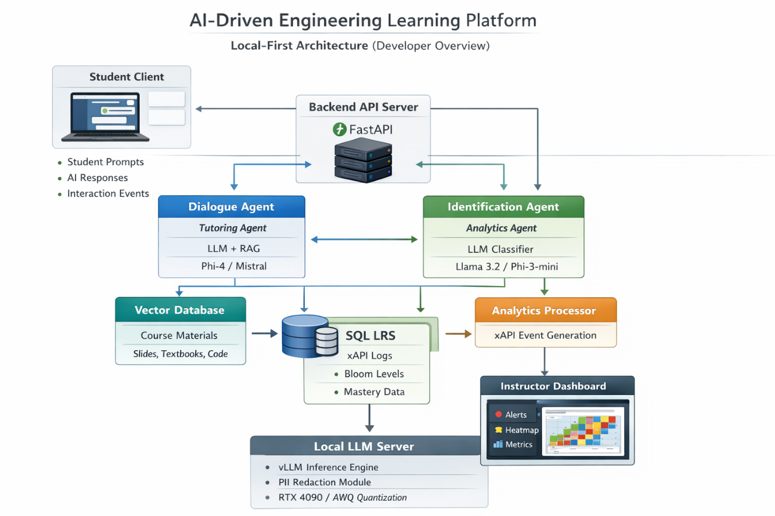
4. System Components

  - Student Client
The student client provides a chat-based interface through which students interact with the tutoring system.
Responsibilities
- Send student prompts to the backend
- Display AI-generated responses
- Maintain conversation history
- Manage student session authentication

  - Backend API Server
The backend server acts as the central orchestration layer of the platform.
Responsibilities
- Receive chat requests from students
- Manage conversation sessions
- Route prompts to AI agents
- Trigger analytics classification
- Generate xAPI interaction events
- Serve analytics data to the instructor dashboard
Example API Endpoints
Chat Interaction
POST /chat
GET /chat/history
POST /chat/session
Analytics Processing
POST /classify
POST /xapi-event
Instructor Analytics
GET /analytics-summary
GET /student-engagement
GET /topic-difficulty
Central orchestration layer.

  - Dialogue Agent (Tutoring AI)
The Dialogue Agent handles all tutoring interactions with students.
Capabilities
- Conceptual explanations
- Engineering problem solving
- Programming assistance
- Design reasoning and brainstorming
Tutoring Strategy
The system follows a graduated disclosure approach:
- Ask probing questions
- Provide conceptual hints
- Offer guided problem-solving steps
- Provide a full explanation when necessary
This approach promotes deeper student reasoning and learning.
Tutoring Pipeline
- Receive student prompt
- Retrieve relevant course material from the knowledge base
- Construct an augmented prompt
- Generate response using the LLM
- Return response to the student interface

  - Identification Agent (Analytics AI)
The Identification Agent analyzes each student interaction and produces structured metadata for learning analytics.
Responsibilities
- Topic classification
- Bloom’s taxonomy level detection
- Interaction intent classification
- Knowledge component tagging
- Difficulty estimation
These analytics allow instructors to understand how students are engaging with course material.

5. Retrieval-Augmented Knowledge Base (RAG)
The tutoring system uses Retrieval-Augmented Generation (RAG) to ground responses in course-specific knowledge.
The knowledge base is stored in a vector database.
Knowledge Sources
The system can ingest:
- Lecture slides
- Textbook excerpts
- Lab manuals
- Programming documentation (e.g., Arduino)
- Engineering code repositories
- Instructor notes
Knowledge Processing Pipeline
- Document ingestion
- Text chunking (typically 500–1000 tokens)
- Embedding generation
- Vector storage in database
Recommended Embedding Models
- bge-large
- nomic-embed
Recommended Vector Databases
- Qdrant
- Chroma

6. Interaction Logging and Learning Analytics
All student interactions are logged using the Experience API (xAPI) standard for learning analytics.
xAPI represents learning activities as structured statements.
xAPI Structure
Actor → Verb → Object → Context
Example:
Student_32 → Asked → PID_Tuning → Control_Systems_Module
Each interaction is stored in a Learning Record Store (LRS).
Recommended Storage
- SQL-based LRS
- PostgreSQL database

7. Learning Analytics Pipeline
Each student interaction generates structured analytics metadata that can be analyzed at the course level.
Example Analytics Record
{
"student_id": "anon_32",
"timestamp": "2026-03-09T13:40:22",
"topic": "PID_Tuning",
"bloom_level": "Analyze",
"intent": "Design",
"difficulty_score": 0.72,
"confidence": 0.89
}
These analytics allow instructors to identify:
- Difficult topics
- Patterns of student misunderstanding
- Cognitive depth of student questions
- Changes in student engagement

8. Instructor Analytics Dashboard
The instructor dashboard provides visual analytics tools that help instructors monitor learning patterns across the class.
The dashboard follows a progressive disclosure design, allowing instructors to view high-level insights before exploring detailed data.
Key Features
Alert Hub
Displays major issues detected by the analytics system.
Examples:
- 80% confusion on PID tuning
- 5 students flagged as at risk

Cognitive Heatmap
Shows topic mastery across Bloom’s taxonomy levels, revealing whether students are primarily asking:
- Conceptual questions
- Application questions
- Analytical questions

Engagement Monitoring
Tracks how frequently students interact with the AI tutor and identifies engagement trends.

Topic Difficulty Ranking
Automatically identifies topics that students struggle with most during the course.

9. Infrastructure and Deployment
The platform is designed as a local-first system to ensure:
- student data privacy
- low latency
- independence from external cloud services
LLM Inference Engine
Recommended inference engine:
vLLM
Advantages:
- high throughput
- efficient GPU memory utilization
- multi-user concurrency

Recommended GPU
RTX 4090 (24GB VRAM)
This hardware is capable of supporting multiple concurrent users in a classroom setting.

Supported LLM Models
Possible models include:
- Phi-4 (14B)
- Mixtral 8×7B
- Llama 3.1 8B
Model selection can be adjusted depending on hardware availability.

Target System Latency
The expected tutoring response time for classroom use is approximately:
1–2 seconds per interaction

10. MVP Development Phases
The system can be developed incrementally through several stages.

Phase 1 — Core Tutoring System
Tasks:
- Deploy local LLM
- Build student chat interface
- Implement RAG knowledge retrieval
Deliverable:
Working AI tutoring system.

Phase 2 — Analytics Agent
Tasks:
- Implement classification model
- Generate structured interaction metadata
- Produce JSON analytics output
Deliverable:
Tutoring system with automatic interaction tagging.

Phase 3 — Analytics Pipeline
Tasks:
- Implement xAPI event generation
- Store events in Learning Record Store
Deliverable:
Fully functioning learning analytics logging pipeline.

Phase 4 — Instructor Dashboard
Tasks:
- Develop alert hub
- Implement cognitive heatmaps
- Build engagement monitoring interface
Deliverable:
Instructor analytics dashboard for monitoring student learning patterns.

