Table of Contents
Test Procedure 2
Assisi V0.2.1 3
07152026 3
Test 1 Run 1 3
07212026 3
Test 1 Run 1 3
07272026 4
Constants 4
2Hz-9201-CMF-0.01 4
5Hz-9201-CMF-0.01 4
10Hz-9201-CMF-0.01 4
5Hz-9201-CMF-1 5
10Hz-9201-CMF-1 5
07292026 5
20Hz-9201-CMF-1 5
20Hz-9201-CMF-0.01 6
20Hz-9201-CMF-0.1 8
20Hz-9201-CMF-0.5 9
10Hz-9201-CMF-0.01 10
10Hz-9201-CMF-1 11
10Hz-9201-CMF-0.1 11
10Hz-9201-CMF-0.5 12
5Hz-9201-CMF-0.1 13
5Hz-9201-CMF-0.5 14
5Hz-9201-CMF-0.01 15
5Hz-9201-CMF-1 16
07302026 17
20Hz-9201-CMF-1 17
20Hz-9201-CMF-0 17
20Hz-9201-CMF-0.1 17
10Hz-9201-CMF-0.1 17
10Hz-9201-CMF-0 17
10Hz-9201-CMF-1 17
5Hz-9201-CMF-0.1 18
5Hz-9201-CMF-0 18
5Hz-9201-CMF-1 18

Test Procedure

Assisi V0.2.1

07152026

Test 1 Run 1
Specimen Type: CMF 0.01% 06/06/2025 Campione 2
Discharge time: ~31 s
Settle time: ~2 min
Dimensions: 5.2 cm cube
Space between meshes: 1.5 cm
Physical notes: eroded edges and faces. Dusty, dry
NI card: NI 9221
PSU: 9V 6A max
Shunt resistor: 1 Mohm
Baseline material resistance: 1.6 Mohm
Post resistance: 3 Mohm
Loaded?: No

07212026

Test 1 Run 1
Specimen Type: CMF 0.01% 06/06/2025 Campione 2
Discharge time: ~31 s
Settle time: ~2 min
Dimensions: 5.2 cm cube
Space between meshes: 1.5 cm
Physical notes: eroded edges and faces. Dusty, dry
NI card: NI 9221
PSU: 9V 6A max
Shunt resistor: 1 Mohm
Baseline material resistance: 1.6 Mohm
Post resistance: 3 Mohm
Loaded?: No

07272026

Constants

2Hz-9201-CMF-0.01
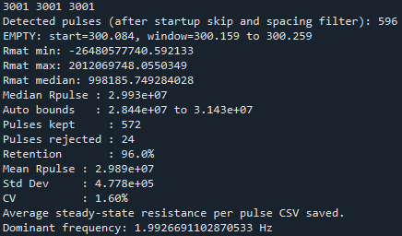

5Hz-9201-CMF-0.01
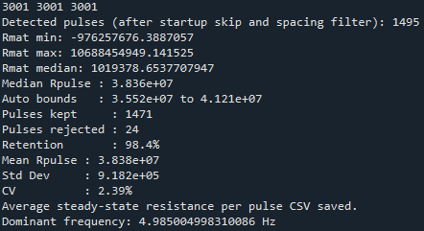

10Hz-9201-CMF-0.01
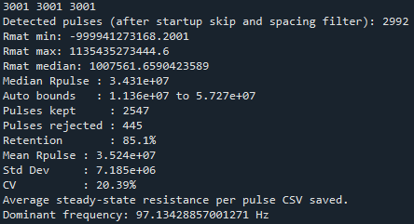

5Hz-9201-CMF-1
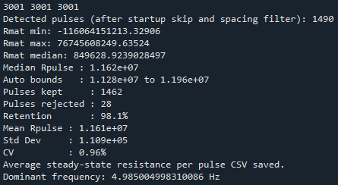

10Hz-9201-CMF-1
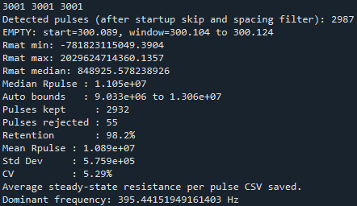

07292026

20Hz-9201-CMF-1
Specimen Type: CMF 1% 12/06/2025 Campione 2
Discharge time: ~1 min
Settle time: ~4 min
Dimensions: 5.2 cm cube
Space between meshes: 1.5 cm
Physical notes: eroded edges and faces. Dusty, dry. This was its first test of the day.
NI card: NI 9201
PSU: 9V 6A max
Shunt resistor: 1 Mohm
Baseline material resistance: 1.3 Mohm
Post resistance: 11 Mohm
Loaded?: No

Pre
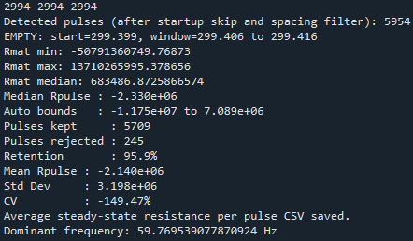

Instron
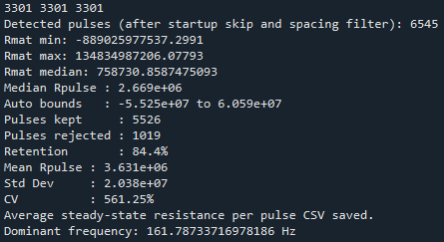constant
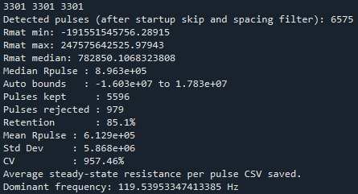triangular

Post
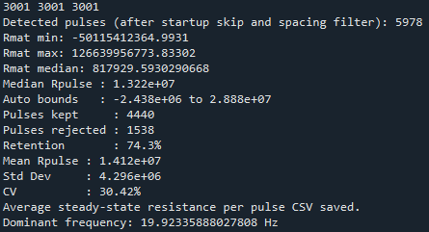

20Hz-9201-CMF-0.01
Specimen Type: CMF 0.01% 12/06/2025 Campione 2
Discharge time: ~1 min
Settle time: ~4 min
Dimensions: 5.2 cm cube
Space between meshes: 1.5 cm
Physical notes: eroded edges and faces. Dusty, dry. This was its first test of the day.
NI card: NI 9201
PSU: 9V 6A max
Shunt resistor: 1 Mohm
Baseline material resistance: 1.4 Mohm
Post resistance: 7 Mohm
Loaded?: No

Pre
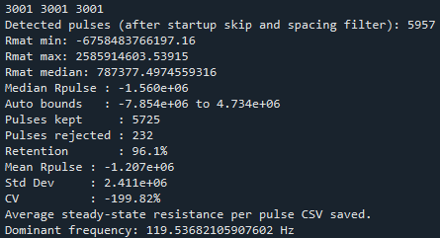

Instron
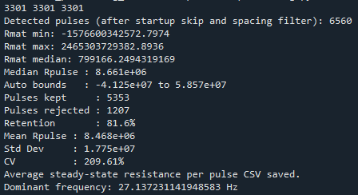constant
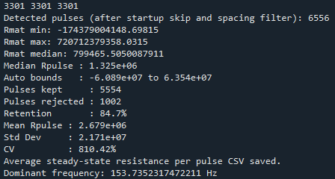triangular

Post
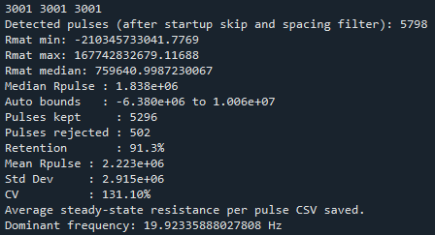

20Hz-9201-CMF-0.1
Specimen Type: CMF 0.1% 12/06/2025 Campione 2
Discharge time: ~1 min
Settle time: ~4 min
Dimensions: 5.2 cm cube
Space between meshes: 1.5 cm
Physical notes: eroded edges and faces. Dusty, dry. This was the first test of the day.
NI card: NI 9201
PSU: 9V 6A max
Shunt resistor: 1 Mohm
Baseline material resistance: 160 ohm
Post resistance: 160 ohm
Loaded?: No

Pre
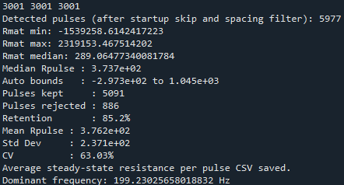

Instron

Post

20Hz-9201-CMF-0.5
Specimen Type: CMF 0.5% 12/06/2025 Campione 2
Discharge time: ~1 min
Settle time: ~4 min
Dimensions: 5.2 cm cube
Space between meshes: 1.5 cm
Physical notes: eroded edges and faces. Dusty, dry. This was the first test of the day.
NI card: NI 9201
PSU: 9V 6A max
Shunt resistor: 1 Mohm
Baseline material resistance: 1.1 kohm
Post resistance: 0.8 kohm
Loaded?: No

Pre
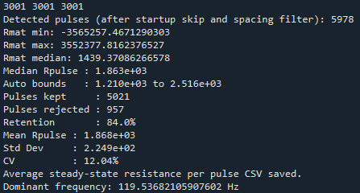

Instron

Post

10Hz-9201-CMF-0.01

Instron
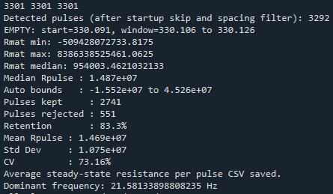

Post
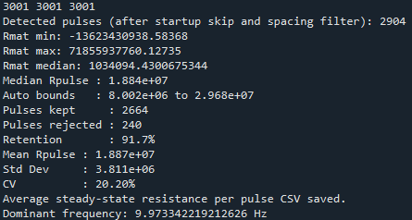

10Hz-9201-CMF-1

Instron
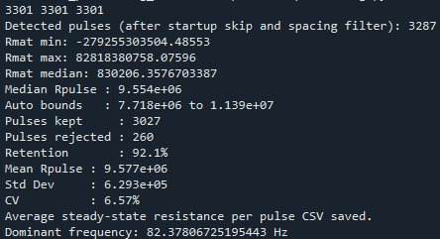

Post
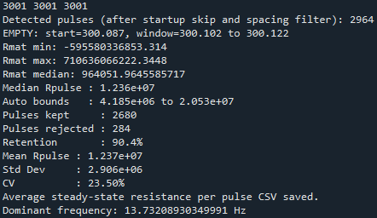

10Hz-9201-CMF-0.1
Specimen Type: CMF 0.1% 12/06/2025 Campione 2
Discharge time: ~1 min
Settle time: ~4 min
Dimensions: 5.2 cm cube
Space between meshes: 1.5 cm
Physical notes: eroded edges and faces. Dusty, dry.
NI card: NI 9201
PSU: 9V 6A max
Shunt resistor: 1 Mohm
Baseline material resistance: 125 ohm
Post resistance: 126 ohm
Loaded?: No

Pre
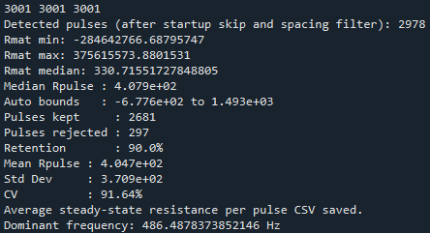

Instron

Post

10Hz-9201-CMF-0.5
Specimen Type: CMF 0.5% 12/06/2025 Campione 2
Discharge time: ~1 min
Settle time: ~4 min
Dimensions: 5.2 cm cube
Space between meshes: 1.5 cm
Physical notes: eroded edges and faces. Dusty, dry.
NI card: NI 9201
PSU: 9V 6A max
Shunt resistor: 1 Mohm
Baseline material resistance: 1 kohm
Post resistance: 1.1 kohm
Loaded?: No

Pre
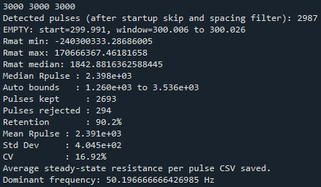

Instron

Post

5Hz-9201-CMF-0.1
Specimen Type: CMF 0.1% 12/06/2025 Campione 2
Discharge time: ~1 min
Settle time: ~4 min
Dimensions: 5.2 cm cube
Space between meshes: 1.5 cm
Physical notes: eroded edges and faces. Dusty, dry.
NI card: NI 9201
PSU: 9V 6A max
Shunt resistor: 1 Mohm
Baseline material resistance: 130 ohm
Post resistance: 136 ohm
Loaded?: No

Pre
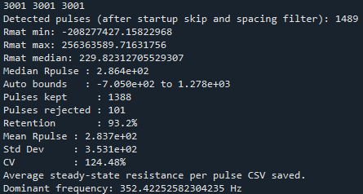

Instron

Post

5Hz-9201-CMF-0.5
Specimen Type: CMF 0.5% 12/06/2025 Campione 2
Discharge time: ~1 min
Settle time: ~4 min
Dimensions: 5.2 cm cube
Space between meshes: 1.5 cm
Physical notes: eroded edges and faces. Dusty, dry.
NI card: NI 9201
PSU: 9V 6A max
Shunt resistor: 1 Mohm
Baseline material resistance: 1.2 kohm
Post resistance: 0.9 kohm
Loaded?: No

Pre
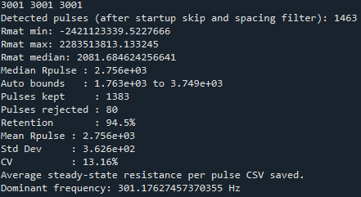

Instron

Post

5Hz-9201-CMF-0.01

Instron
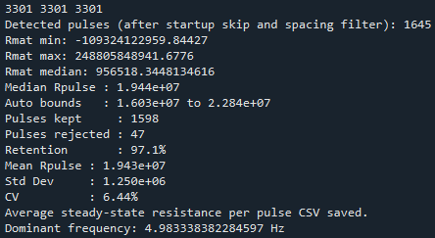0.4kN
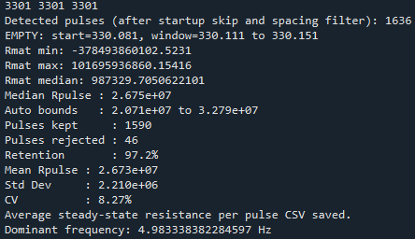0.8kN

Post
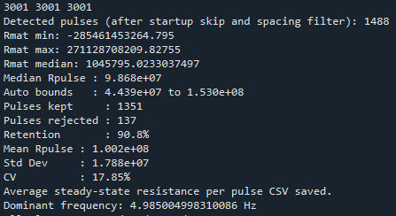

5Hz-9201-CMF-1

Instron
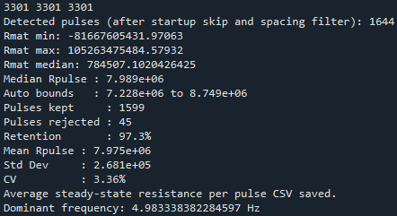0.4kN
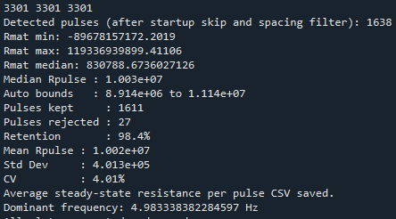0.8kN

Post
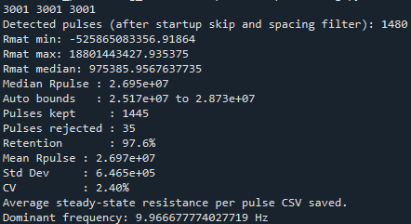

07302026

20Hz-9201-CMF-1

Pre
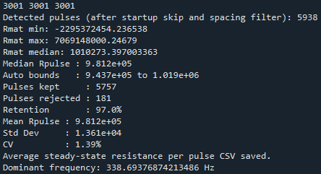330 ohms
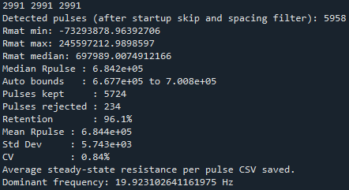550 ohms

Instron

Post

20Hz-9201-CMF-0

Pre
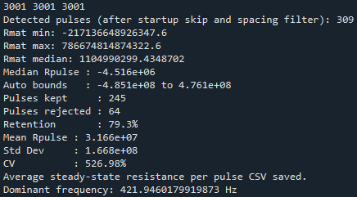

Instron

Post

20Hz-9201-CMF-0.1

Pre
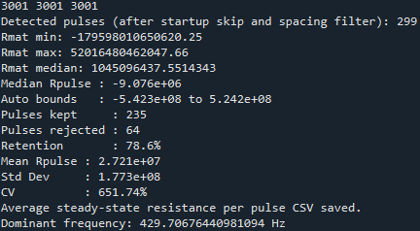

Instron

10Hz-9201-CMF-0.1

Instron

10Hz-9201-CMF-0

Instron

10Hz-9201-CMF-1

Instron

5Hz-9201-CMF-0.1

Instron

5Hz-9201-CMF-0

Instron

5Hz-9201-CMF-1

Instron

