Not getting a signal at the DAQ

NI 9221 is a current target
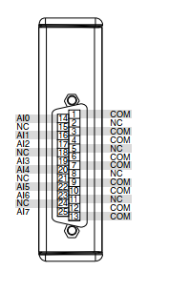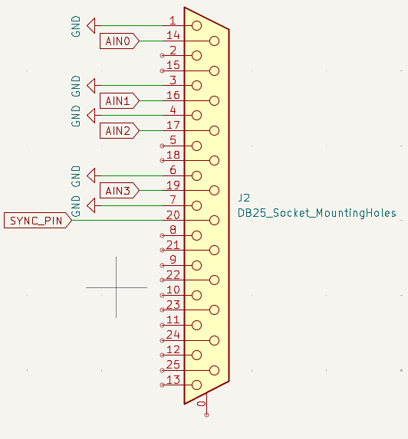

Ok, the first Issue I see is on the CDAQ, I get signal for AI 4, 5, 6, and 7, but here is says channels 0, 1, 2, and 3 are hooked up. I am pretty sure I get real signal off of those.

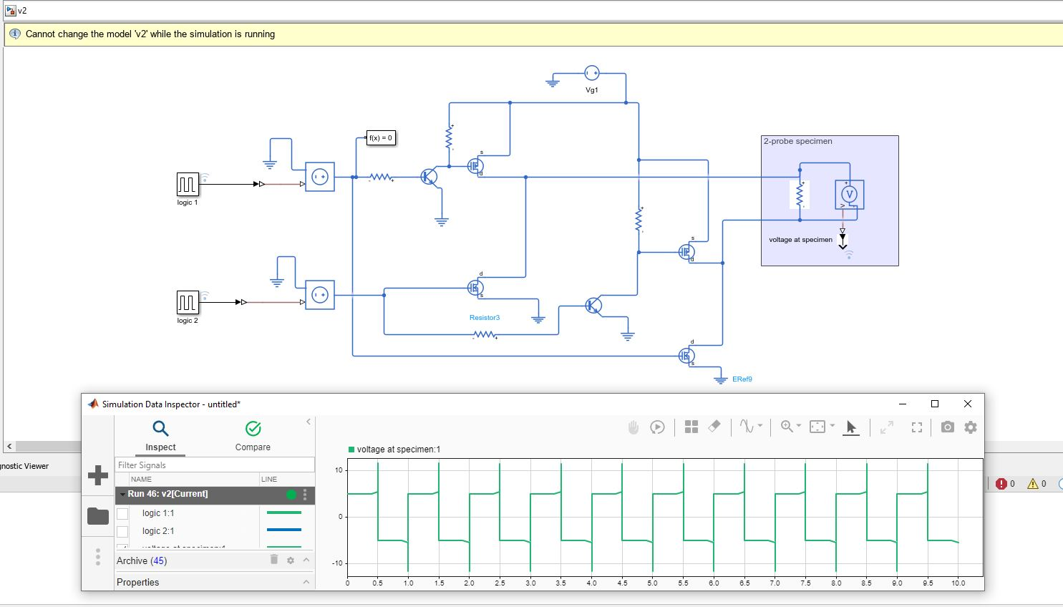
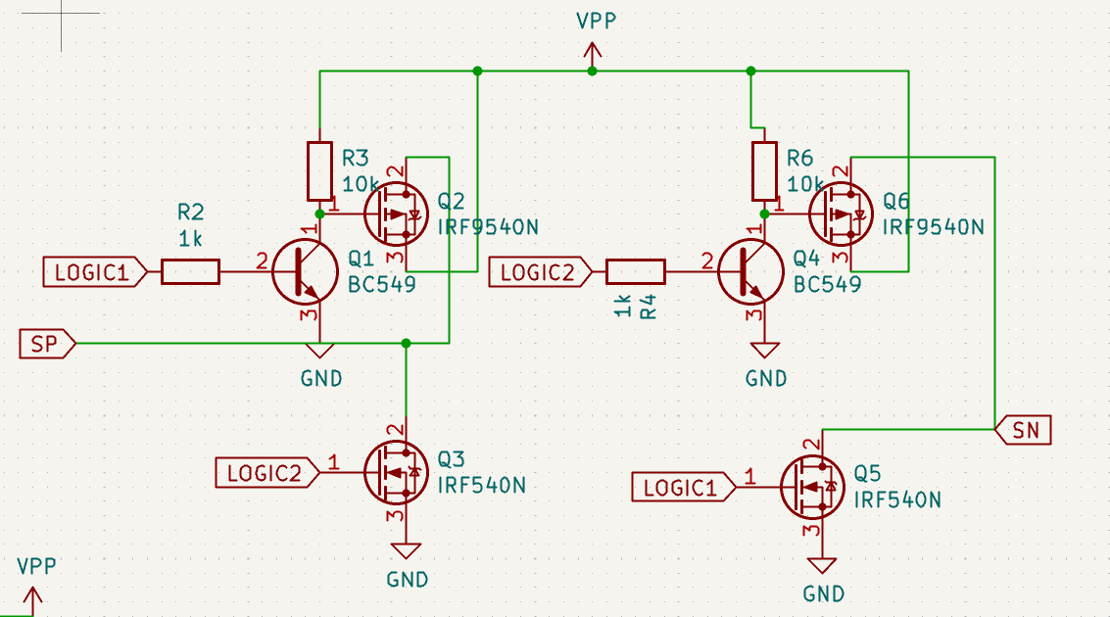

We do need to clean this semantics up. I don’t want to do it now, but in the next version, flip the transistors so wires don’t cross.

