**Design Refinement**

1. Introduction:

This DFX chapter entails this project’s specific design goals, including the design for manufacturability and assembly, cost, safety, the customer requirements, ease of use, durability/reliability, and serviceability. The design refinements which are being processed entail primarily the assembly and ease of use for the mass shaker. The assembly requires precise, accurate measurements along with the dimensions of the screw fasteners and brackets. Ease of use for the system comes down to programming the VFD and the visual data which will be displayed to the user via tachometer sensors for the shaft holding the weight. Manufacturability is vital because the shaker needs to be assembled and produced within a reasonable amount of time. The cost is also an important part of the design because we cannot go over budget, therefore the group has been using many parts readily available in the ARTS lab. Safety is arguably the most vital requirement, due to not only preventing injury to users of this project in the future, but also avoiding possible liability involved. The reliability/durability and serviceability of the bridge shaker go hand in hand. This project is planned to last without needing servicing for several years (3-5), thus robustness with the sourcing of quality parts is key to this project's success within the ARTS lab. The serviceability for the shaker will be dependent on the methods of securing the parts together, and whether the parts sources will be available in the future.

2. Design for Manufacturability and Assembly

To optimize manufacturability, the team considered material selection and connector design. Off-the-shelf parts were chosen in order to ease sourcing, and parts were chosen considering both cost and replaceability. 8020 40 series extruded aluminum in was chosen due to its ease of assembly. The 8020 series includes support brackets, connectors, beams, and fasteners that are compatible with each other to facilitate the manual assembly process by reducing the number of specialized parts and sourcing as many parts from one company as possible. The main trade off here is that 8020 extruded aluminum is more expensive due to its specialized design, and all connectors will have to be 8020 connectors to pair properly with the beams. The four corner connectors were 3D printed following an 8020 connector CAD model in order to reduce costs and weight; however, the team decided to perform poka yoke on the connectors since they were being printed. Guide channels were added to reduce the stress on the plastic from the screws and make assembly easier by keeping beams in place. In order to ensure the vertical beam is all the way down, the guiderail for the vertical beam was extended so that the two lateral beams would not be placed too far in and obstruct the vertical beam. Figure 1 illustrates the changes made to the brackets. A key tradeoff here is the time required to print the connectors, as well as the reduced strength of PLA versus aluminum.

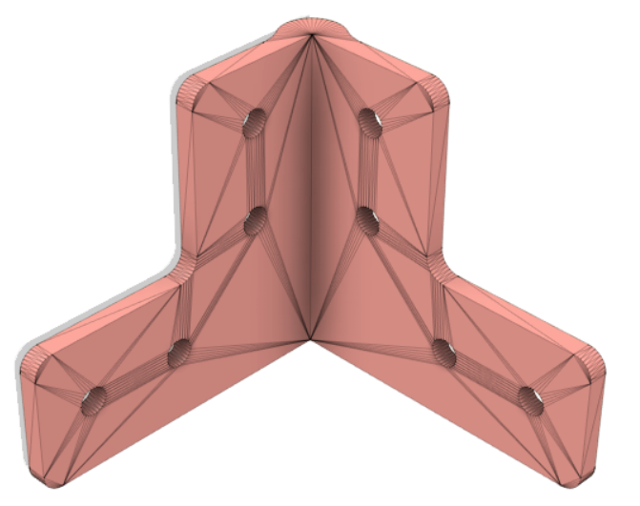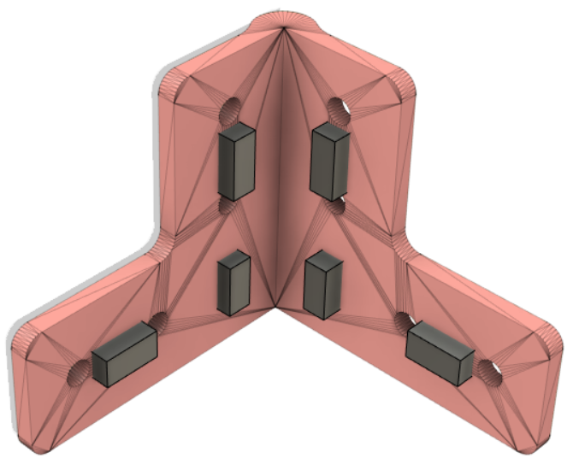

Figure 1. 3D printed bracket with only spine modification (left) and 3D printed bracked with poka yoke guiderail design.

3. Design for Cost

Cost was a limiting factor for the design team when coming up with ways to produce the shaker for Dr. Austin Downey. Inflationary reasons have made some parts of the build extremely expensive to buy and alternatives had to be sourced out. For example, non-name brand microcontrollers were purchased for the computation of the data and a VFD (Variable Frequency Driver) was sourced from Amazon instead of a big-name product. This saved a few dollars throughout but ultimately ended up reducing the gross amount spent more than expected. Another way the team designed for cost was by trying to use aluminum parts rather than steel parts. The ARTS Lab had an abundance of extruded aluminum for the team to use that reduced the frame production cost to $0. A similar approach was taken to the motor and the brackets. The motor was recycled, with permission, from one of the older projects that are stored in the sub-basement of 300 Main St. This three-phase motor would have been $400-700 (gathered from online stores while sourcing motors) off the shelf, instead the group spent no money on it. Since the brackets for the frame have been designed and 3D printed, the cost for each bracket went from $10-20 apiece, down to virtually $0 thanks to the ARTS Lab’s stockpile of PLA plastic. Lastly, an element of purchasing that saved a fair amount of money was sourcing parts through Grainger and placing a bulk order. Grainger offers free shipping and on larger orders such as the one placed, it saved a favorable amount of money compared to other online parts stores in shipping costs.

4. Design for Safety

Operating a shaker that involves handling a weight through high voltage rotation poses significant safety concerns for any individuals within close proximity during usage. An identified concern is the potential for the vibrational mass shaker to become overly efficient and cause disintegration, thus projecting debris and the weight. To diminish this potential safety hazard, it is crucial to ensure that the shaker is securely mounted onto the bridge, withstanding any forces generated during operation without the risk of tipping over. The design team opted to stabilize the shaker with sandbags to guarantee operational safety. A further concern to consider is the possibility of encountering electrical issues. If the electrical components, namely the motor and VFD, are not correctly wired and grounded, the vibrational mass shaker could pose a potential electrical shock hazard. To preclude these electrical risks, the design team conducted thorough research on wiring diagrams and component datasheets to ensure that all components were appropriately grounded and correctly wired. In order to prevent any of these safety concerns from ever becoming a problem, regular maintenance and inspection of the shaker and its components should be performed to ensure proper operation and determine any potential safety hazards.

5. Design for Customer Requirements

The goal of this project is to design a bridge shaker for Professor Austin Downey and the ARTs lab that will be used to test vibration data by operating at different frequencies. It must be safe to operate and leave the bridge undamaged. The mass shaker will induce vibrations via an oscillating weight which will transfer that energy to the bridge. The Needs Metrics Matrix, shown in Figure 2, has remained stagnant throughout the design and assembly process, with the most important engineering characteristics still being adaptability, usability by others, and product details. The contact area and weight of the shaker have been refined to have more emphasis on total product weight at the expense of the contact area, which will still be sufficient to transmit the force as the product will still be fully on the bridge, with the force increasing at the frame components in the base due to less material that would dissipate it.

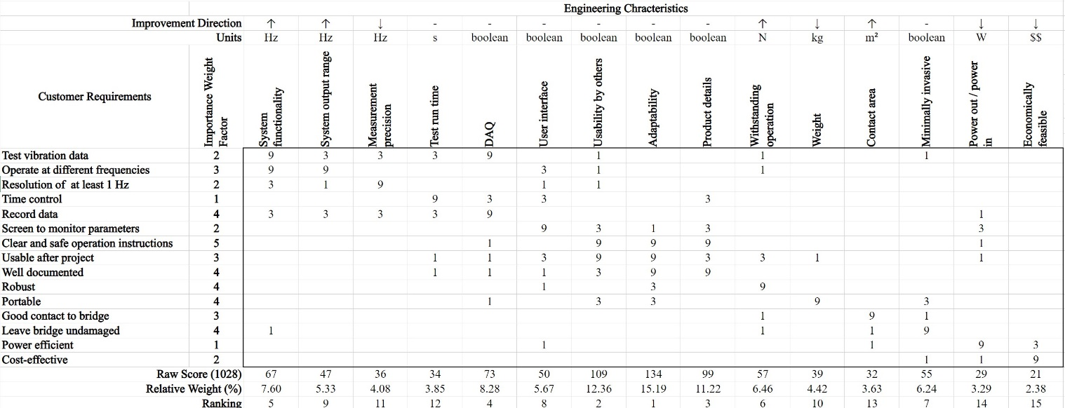Figure 2. Needs Metrics Matrix shows the top engineering characteristics of importance along with customer needs.

5a. Design for Ease of Use

Ease of use was chosen because the Usability by Others EC was rated number 2 in the Needs Metrics Matrix. To enhance user experience, an external Arduino is added to clearly show the frequency and duration of the test. The VFD reads all user input to control the motor speed, but the data it shows is for the motor rather than for the weight. The external Arduino uses sensors to obtain and show the desired parameters for ease of use. The main tradeoff of having the Arduino is power consumption, as it requires extra power just for itself. Additionally, the shaker is entirely open-source with an extensive GitHub to promote user understanding and adaptability. The tradeoff of having the project open-source is that it would be less profitable in a market as competitors could recreate the design, but that is not a concern for the sponsor.

5b. Design for Durability/Reliability

To ensure the durability and reliability of the vibrational mass shaker, the design team prioritized the selection of high-quality materials and components. The frame of the shaker, constructed from high-strength 8020 series extruded aluminum, was chosen to withstand the significant forces exerted during operation and provide resistance to corrosion and wear. The metallic components, including gears, links, and weight, were similarly selected for their durability and longevity, with either steel or aluminum materials used. The 3-phase AC motor chosen for the shaker was a high-quality component that is expected to function optimally for the entire operational lifespan of the shaker. Coupled with a reliable and functional VFD, these components provide a robust and dependable vibrational mass shaker, which is engineered for long-term use.

5c. Design for Serviceability

The shaker will be a relatively violent machine that will attempt to vibrate itself into pieces. For this reason, the team attempted to minimize the parts used and design a shaker that was robust enough to remain strong even under the immense stress of the vibrations. With this comes the fear of part degradation or even failure. The team has sourced commercial products for the gears, shafts, frame, linkages, bearings, etc. this way anyone using the shaker after it has been commissioned can easily source a part to repair the shaker. Additionally, everything purchased, changed, or installed will be documented in a repository on GitHub that will allow for a new user to understand the device and be able to make simple repairs with ease. The only foreseeable serviceability concerns are with the motor and the VFD. These two items cannot be worked on explicitly like the other parts of the shaker. The VFD will have to be sourced out and purchased again if it were to break. The motor was recycled from an old project so it is likely that another motor would need to be sourced if the current one breaks.

6. Conclusions [and/or] Recommendations

Major refinements to this project mainly occurred in the layout and method of connecting parts to the frame, as well as refining the design of the brackets to increase robustness. Only minor changes were made to the sourcing of parts for the drive train, mainly the shaft and the sleeve which will be secured to the frame. The dimensions for the sprockets have remained constant, as well as the method of meshing them together via chains. The chain method will allow for flexibility of motor/sprocket replacement, especially if the dimensions of the motor or sprocket change. Further inspection of product safety may deem that the addition of surrounding walls for the shaker may be necessary in case of an unexpected failure in one of the moving parts. Tradeoffs have occurred primarily in the mass shaker’s base. While it needs sufficient contact to the bridge with a solid frame to place the components, too much weight on the bottom will ultimately affect the ergonomics of the product. An entirely metal base would also increase the price of the project, while providing no benefits to the wasted space. The method of stabilizing the shaker has also been changed from ratchet straps to sandbags on protruding extruded aluminum connected to the frame. This will give the shaker more vertical stability than the original horizontal, which is completely logical considering the acting force is strictly vertical. This method will also ensure the rachet straps wouldn’t end up pulling the shaker apart by slowly warping the frame, and users cannot accidentally over tighten them and break the shaker.