**Economic Analysis**

1. Introduction

Evaluating the economic gain or loss of a certain product is a vital aspect of engineering analysis. Ensuring that the product will have a net positive gain and not be a ‘money pit’ is done by evaluating the current assembly costs and operating costs coupled with the yearly expected expenses tied to maintenance and operation. The shaker being for Dr. Austin Downey and company has no industry value as this is a ‘one-of-a-kind' product that is designed specifically for the students who are testing the structural integrity of bridges and walking paths. The monetary value for this product can be estimated through the possibility of grants being offered to the students for research in this field. Given this fact, the break-even analysis, variable cost of labor, “year zero” cost, and the cost reduction analysis will be estimated using reasonable values. This analysis will also cover the expenses incurred and compare them to the expected future value of the parts most often replaced.

2. Costs, Savings, and Revenues

The bridge shaker being designed by Downey1 is intended to be an academic tool rather than a commercial product; however, the value of this shaker lies in the grant money that stands to be awarded by using the shaker for long-term vibration testing on large structures, something the ARTS Lab does not currently have equipment for. The costs are primarily from materials, as the labor required to build the shaker can be delegated to lab researchers. The cost for a single prototype is broken into fixed (materials, manufacturing/assembly) and variable costs below, and are modeled assuming the product would be commercially sold. This means that technician labor is estimated rather than researcher labor, and all parts are sourced from professional suppliers. Table 1 shows the fixed costs for a single bridge shaker based on the current prototype.

Table 1. Fixed costs per unit of current prototype.

|  |  |  |  |
| --- | --- | --- | --- |
| **Materials** | | | |
| Description | Cost (USD) | Quantity | Source |
| 3 Phase AC Motor | 705.18 | 1 | Grainger |
| Industrial Chain | 29.55 | 1 | Grainger |
| Shaft pinion, 4" | 40.00 | 2 | Grainger |
| Motor gear, 8” | 64.58 | 1 | Grainger |
| Keyed Shaft: 1 in Dia, Aluminum | 52.63 | 1 | Grainger |
| Aluminum 80/20 40 series, 1 ft | 15.44 | 18 | Grainger |
| Elegoo Uno R3 | 17.99 | 1 | Bill of materials |
| LCD | 5.99 | 1 | Bill of materials |
| 3pin IR Infrared Module | 1.89 | 2 | Bill of materials |
| OSH Park custom PCB for sensor input to Arduino UNO (shield form factor) | 23.55 | 1 | Bill of materials |
| Shaft bearings | 26.79 | 2 | Bill of materials |
| Extension cord | 25.98 | 1 | Bill of materials |
| Weight, aluminum 4 kg | 9.89 | 1 | Grainger |
| 80/20 40 series fasteners | 1.54 | 100 | McMaster Carr |
| VFD, 230 Volts, 1 to 3 Phase | 118.84 | 1 | Bill of materials |
| PLA 3-way bracket | 2.52 | 6 | Cura 3D printer slicing estimate (101 g PLA per unit) |
| PLA triangle bracket | 1.42 | 20 | Cura 3D printer slicing estimate (57g PLA per unit) |
| Total: | 1666.98 | | |
| **Manufacture/Assembly** | | | |
| Description | Cost | Quantity | Source |
| Machining labor (2D cutting) | 20.00 | 2 hours | Wade 2022 |
| Assembly labor | 18.81 | 5 hours | Indeed 2023 |
| Total: | 134.05 | | |
| **Total fixed cost:** | **1801.03** | | |

The total fixed cost per one bridge shaker is $1,801.03. It is important to note that for the shaker built by Downey1, many parts were able to be sourced for free, including the AC motor and Arduino. In the case of commercial production, this is a reasonable fixed cost considering the size and scale compared to other modal shakers. Table 2 displays the variable costs per year of the shaker.

Table 2. Variable costs per unit per year of current prototype.

|  |  |  |  |
| --- | --- | --- | --- |
| Description | Cost | Quantity | Source |
| Maintenance | 18.81 | 20 hours | Indeed 2023 |
| Operational electricity | 14.54/hr | 0.15 hours per test, assume 50 tests | Dominion Energy 2021 (0.021086 per kWh, at 690W) |
| **Total variable cost:** | **485.25** | | |

The total variable cost per year is approximated at $485.25. This estimate assumes 50 ten-minute tests per year and 20 hours of maintenance over the year by the same technicians responsible for the assembly of the shaker in the fixed costs. The predicted lifespan of the bridge shaker is 3 years, assuming proper pre-test maintenance (tightening fasteners, lubrication). Table 3 shows the up-front cost of the shaker.

Table 3. Up front (“Year Zero”) costs.

|  |  |  |
| --- | --- | --- |
| Description | Cost | Quantity |
| Research and development | 50.00/hr | 90 hours |
| Creality 3D printer | 236.00 | 1 |
| **Total Year Zero cost:** | **4736.00** | |

The up-front project costs total to $4,736.00 and are primarily the cost of design consulting with the team. The cost of the printer is included as an equipment cost, but the cost of the machine that manages 2D cutting of the aluminum is not included because the task is outsourced to machinists.

Table 4. Reduced cost of the materials for a version of the shaker.

|  |  |  |  |
| --- | --- | --- | --- |
| **Reduced Cost Version of Materials** | | | |
| Description | Cost (USD) | Quantity | Source |
| 3 Phase AC Motor | 705.18 | 1 | Grainger (Dayton) |
| Industrial Chain | 15.32 | 1 | McMaster Carr |
| Shaft pinion, 4" | 40.00 | 2 | Grainger |
| Motor gear, 8” | 64.58 | 1 | Grainger |
| Keyed Shaft: 1 in Dia, Aluminum | 45.15 | 1 | McMaster Carr |
| Aluminum 80/20 40 series, 1 ft | 15.44 | 18 | Grainger |
| Elegoo Uno R3 | 8.96 | 1 | eBay |
| LCD | 5.99 | 1 | Bill of materials |
| 3pin IR Infrared Module | 1.89 | 2 | Bill of materials |
| OSH Park custom PCB for sensor input to Arduino UNO (shield form factor) | 23.55 | 1 | Bill of materials |
| Shaft bearings | 26.79 | 2 | Bill of materials |
| Extension cord | 25.98 | 1 | Bill of materials |
| Weight, aluminum 4 kg | 9.62 | 1 | McMaster Carr |
| 80/20 40 series fasteners | 1.54 | 100 | McMaster Carr |
| VFD, 230 Volts, 1 to 3 Phase | 118.84 | 1 | Bill of materials |
| PLA 3-way bracket | 2.52 | 6 | Cura 3D printer slicing estimate (101 g PLA per unit) |
| PLA triangle bracket | 1.42 | 20 | Cura 3D printer slicing estimate (57g PLA per unit) |
| **Total:** | **1635.97** | | |

Table 4 includes material cost reductions in terms of money on parts. It is important to note that the reduction is not substantial as the team was trying to optimize costs for the current prototype already. However, there were some significant optimizations when sourcing some materials, such as the keyed shaft, from McMaster Carr rather than Grainger. There are cheaper options for building a frame such as welding materials together, but the team found that unnecessary as the shaker would need to have the option to be taken apart. As sourcing cheaper materials will not change the cost of labor for assembly, the cost of assembly will stay the same at $134.05. This would bring the reduced total fixed cost to $1770.02, having around a 2% reduction in cost. An option for increasing longevity and reducing the need for maintenance would be to source aluminum brackets to replace the PLA. This would increase the cost of the triangle brackets from $1.42/bracket to $21.99/bracket and the 3-way bracket from $2.52/bracket to $10.99/bracket when sourcing from Amazon.

3. Analysis

**Break-Even Analysis:**

The bridge shaker is planned to be a viable tool in engineering work for 10 years. This period was chosen because at that point the research performed with the shaker will most likely be completed and the project will have turned a project in the break-even analysis, which was performed to determine when the revenue would surpass the cost along with initial startup. The following values were considered in Table 5.

Table 5. Break even analysis conditions.

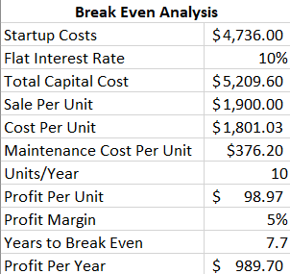

These values are assuming the shaker is relatively low demand, only producing 10 a year and requiring yearly maintenance for upkeep. The shaker’s price is set at $1,900, which makes about a 5% profit per sale. With these variables, Figure 1 shown below shows the method by which the break-even point was determined.

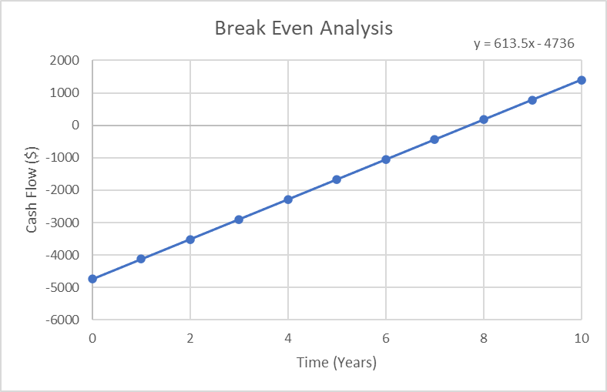

Figure 1. Break-Even Analysis

As shown above in Figure 1, the equation of the trendline can be used to estimate the year this project breaks even at 7.7 years. This is unfavorable as the use for this project is for short term research applications. The cash flow diagram of this project is shown below in Figure 2, with the initial cost of startup at year 0, and every year, having costs to produce 10 shakers a year. The profits each year come from the sales of 10 shakers each year.

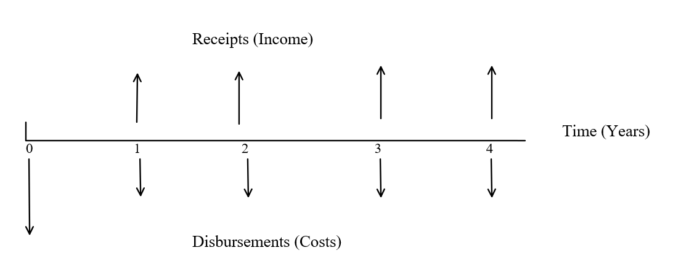

Figure 2. Cash flow diagram

**Net Present Value:**

The Net Present Value represents the difference between the present value of cash inflows and outflows over a specified period. It is used to analyze the profitability of the project over its life cycle/useful lifetime [4]. The equation used to determine the present value for each year is shown below as Equation 1.

$NPV= \sum_{t=1}^{T}{\frac{C_{t}}{{(1+r)}^{t}}-C_{o}}$ Eq.1

In this equation, *NPV* is the net present value, *t* is the period, starting at 0 and stretching over its life cycle until year 10, $C_{t}$ is the net cash inflow of the period, *r* is the discount rate, and $C_{o}$ is total initial investment cost. In order to find the discount rate, the *NPV* equation must be set to 0, and the other values are known besides *r* as shown below in Table 6.

Table 6. Values for the NPV Equation

|  |  |
| --- | --- |
| **Variable** | **Value** |
| t | 10 |
| $$C_{t}$$ | 98.97 × 10 |
| $$C_{o}$$ | 4,736 |
| NPV | 0 |

With these variables all know and *r* unknown, the discount rate can be calculated to be 14.5%. Finally, the NPV can be calculated as shown in Table 7 below.

Table 7. NPV Calculation

|  |  |  |
| --- | --- | --- |
| **Net Present Value** |  |  |
|  | **Project Time (Years)** | 10 |
|  | **Discount Rate** | 14.5% |
|  |  |  |
| Year | Present Value |  |
| 0 | -$4,736.00 |  |
| 1 | $5,600.37 |  |
| 2 | $5,490.91 |  |
| 3 | $5,395.31 |  |
| 4 | $5,311.81 |  |
| 5 | $5,238.89 |  |
| 6 | $5,294.66 |  |
| 7 | $5,119.59 |  |
| 8 | $5,071.01 |  |
| 9 | $5,028.59 |  |
| 10 | $4,991.53 |  |
| **Total Net Present Worth** | $47,806.67 |  |

As shown above, the net present worth of the project can be estimated to be $47,806.67. This is a favorable outcome and could hold opportunity to be profitable. However, this project is not meant for something to be in mass production. While the sourcing of the parts was relatively easy, the fact of the matter is there is no way of knowing the demand for the product, which has means only to serve the ARTS lab in conducting experiments dealing with constant impulse-induced vibrations. While there could be universities that would like to fund this and may want to purchase a shaker for these reasons, there is no guarantee that the market would be there. Additionally, the shaker is designed to last for at least 10 years with relatively minimal maintenance besides replacements for parts which are under the greatest stress. Therefore, it is advised to keep this as a small scope project for the purposes of the University and research grants that come in for which this shaker can be used to aid in its development.

4. Conclusions/Recommendations

In conclusion, the bridge shaker is expected to be useful for three years until research is completed. A break-even analysis was conducted to determine when revenue would exceed costs by assuming low demand, a production rate of 10 units per year, and yearly maintenance. The shaker is priced at $1900, resulting in a 5% profit per sale. The break-even point is estimated to be 7.7 years based on the trendline equation.

List of References

1. Wade, A. O. (2022, September 20). How much does CNC cost per hour? www.remodelormove.com. <https://www.remodelormove.com/how-much-does-cnc-cost-per-hour/#:~:text=Generally%2C%20simpler%20CNC%20machining%20jobs%2C%20such%20as%20drilling%2C>
2. ‌Indeed. (2023, March 15). Assembly technician salary in United States [Review of Assembly technician salary in United States]. Indeed. <https://www.indeed.com/career/assembly-technician/salaries>
3. ‌Dominion Energy. (2021, December 9). Schedule 1-Basic Residential Rate [Review of Schedule 1-Basic Residential Rate]. Dominion Energy. <https://www.dominionenergy.com/-/media/pdfs/virginia/residential-rates/schedule-1.pdf?la=en&rev=77a761f57c8241038dfa13e990c3caf0&hash=BF54C2E8EC883D3A6C6323326A3E3F25>
4. Fernando, J. (2022, November 16). *Net present value (NPV): What it means and steps to calculate it*. Investopedia. Retrieved March 20, 2023, from https://www.investopedia.com/terms/n/npv.asp