**Preliminary Design Review Report**

1. **Brief Background**

The team was tasked with creating a long-term usable product by the Adaptive Real-Time Systems (ARTS) Laboratory. Dr. Austin R.J. Downey is the head of the laboratory and the studies that it conducts. The ARTS Lab is developing a sensor package to measure vibrations in bridges; therefore, a shaker is needed to excite the bridge to determine mode shapes. The current shakers in the ARTS Lab are too small to excite large structures hence the need for a more powerful shaker. Impulse testing has been performed on bridges, but continuous testing is desired. Continuous testing allows for testing different frequencies and permits excitement to more modes. Our purpose as the design team is to create a shaker for continuous bridge vibration testing so that the ARTS Lab can use this shaker for more accurate data acquisition in the sensor packages. Throughout the semester, the team had to objectively identify customer needs, project specifications, and product functionality, design viable shakers for continuous testing of vibration data, and next semester the team must build and test a final design for the shaker to deliver to the ARTS Lab.

1. **Customer Needs and Requirements**

After meeting with Dr. Austin Downey, the project sponsor, a comprehensive list of needs was made to include what the final design should have. The list created for this project is shown below.

Table 1: List of preliminary needs.

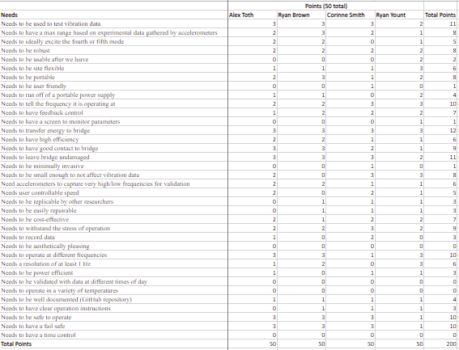

After voting on all 36 original needs, the top seven moved on to the second round of voting to determine the critical to quality (CTQ) needs. These top needs are shown in table 2 below.

Table 2: List of priority needs.

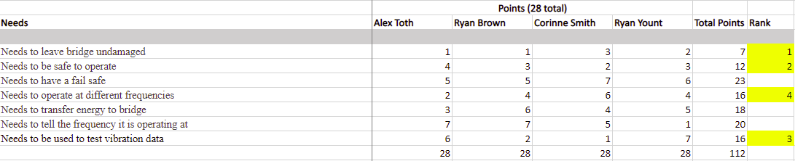

This voting process allowed the group to view the project from the perspective of abundant needs as well as a simpler, more concise list of needs. From the voting process outlined in the two tables above, a product mission statement was created from the top four needs and shown below.

“Dr. Austin Downey needs a bridge shaker that needs to test vibration data, operate at different frequencies, be safe to operate, and leave the bridge undamaged.”

1. **Key Engineering Characteristics/Specs**

Below is a quality matrix showcasing all the engineering characteristics of the project. The engineering characteristics (EC’s) are shown as the columns and the rows are customer requirements. Each EC was given numeric values of 1, 3, or 9 to indicate how strongly it contributes to the customer requirement. A 1 indicates low correlation while 9 indicates high correlation and leaving the cell blank indicates no correlation.

Table 3: Quality matrix showcasing engineering characteristics.

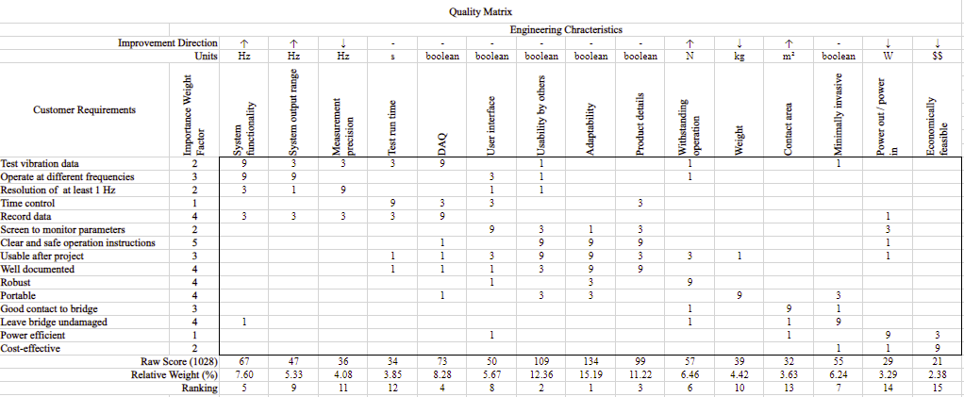

List of Critical EC’s:

* Adaptability
* Usability by others
* Product details

From the quality matrix, the critical EC’s are determined to be adaptability, usability by others, and product details. Adaptability would be an important characteristic of the project as the bridge shaker would need to be able to excite more than one bridge. Usability by others was important because researchers should be able to use the shaker without much difficulty. The last critical EC, product details, was important because good documentation helps ease of use, adaptability, and other engineering characteristics become more doable.

1. **Selected Concept**

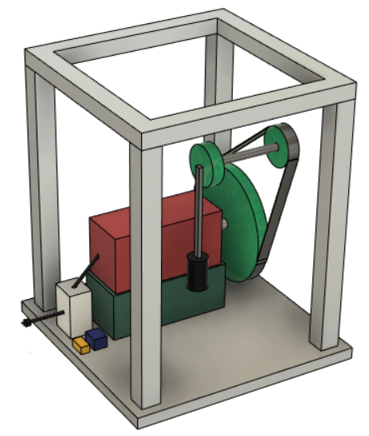

*Figure 1: Side view of design will all components visible.*

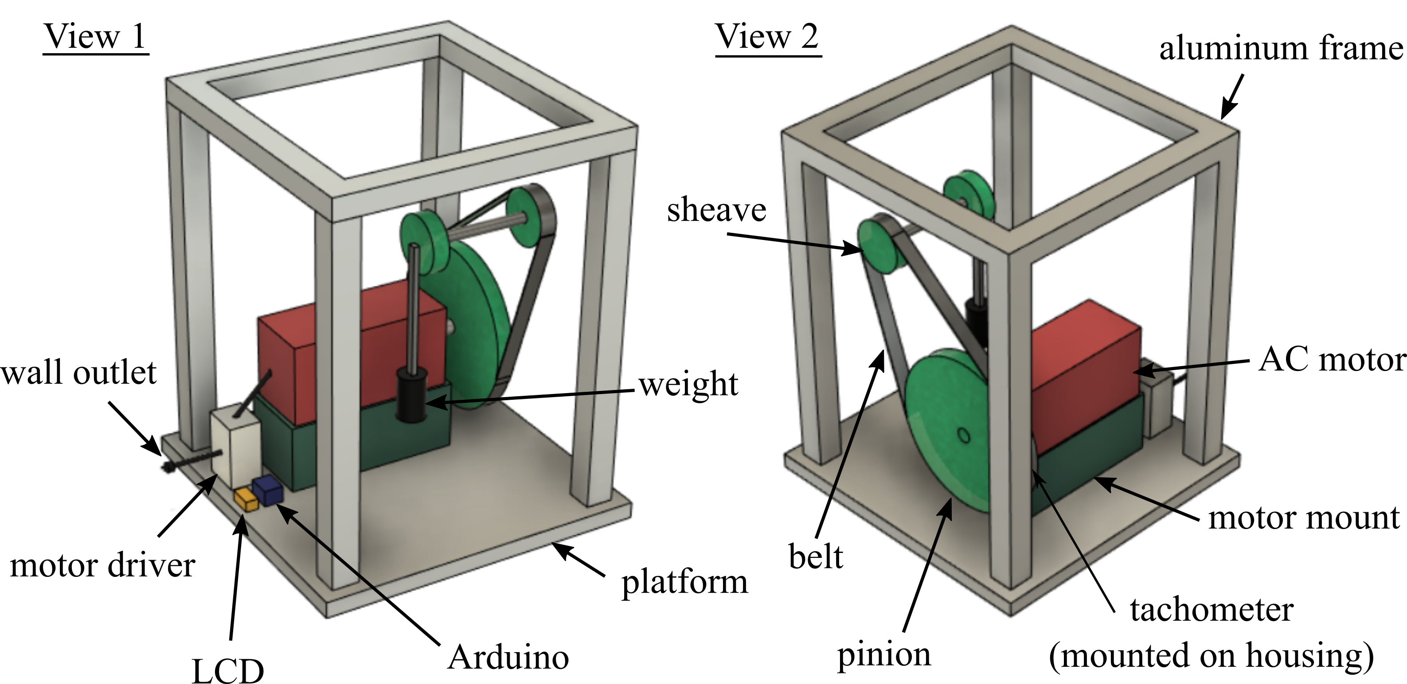

*Figure 2: Two side views with labeled parts.*

This updated design has some notable updates including the following in Figures 1 and 2:

* Inverted the gear ratio to favor speed over torque, therefore needing to raise the motor on a platform.
* The MOSFET has been replaced with a motor driver, which will directly control the speed of the motor with the voltage control on the analog dial.
* The frequency will be determined based on the tachometer which will be attached to the sheave to observe the rotation rate. This information will be shown on the LCD screen with the aid of an Arduino.
* The motor driver will plug directly into a wall outlet, which will facilitate the need for an extension cord.

Strengths:

* Compact design.
* Easy analog control of motor**.**
* Very high output force according to simulations run on Simulink, as well as easier to simulate as opposed to the other designs.
* Relatively simple and intuitive design, low maintenance with the use of a belt.
* Very economical and cost-effective compared to other designs considered.

Weaknesses:

* No feedback control to get a specific frequency and will have to tune it manually.
* The maximum output force could shake components loose or worse, destroy the product. Precautions and perhaps limiting the maximum voltage output of the motor driver could be necessary for safety and longevity purposes.
* The friction between the weight and its sleeve will need planar joints and possible lubricants to keep down wear and tear, as well as minimize heat.
* Moving parts pose a safety hazard that can be mitigated with barriers.

1. **Architecture**

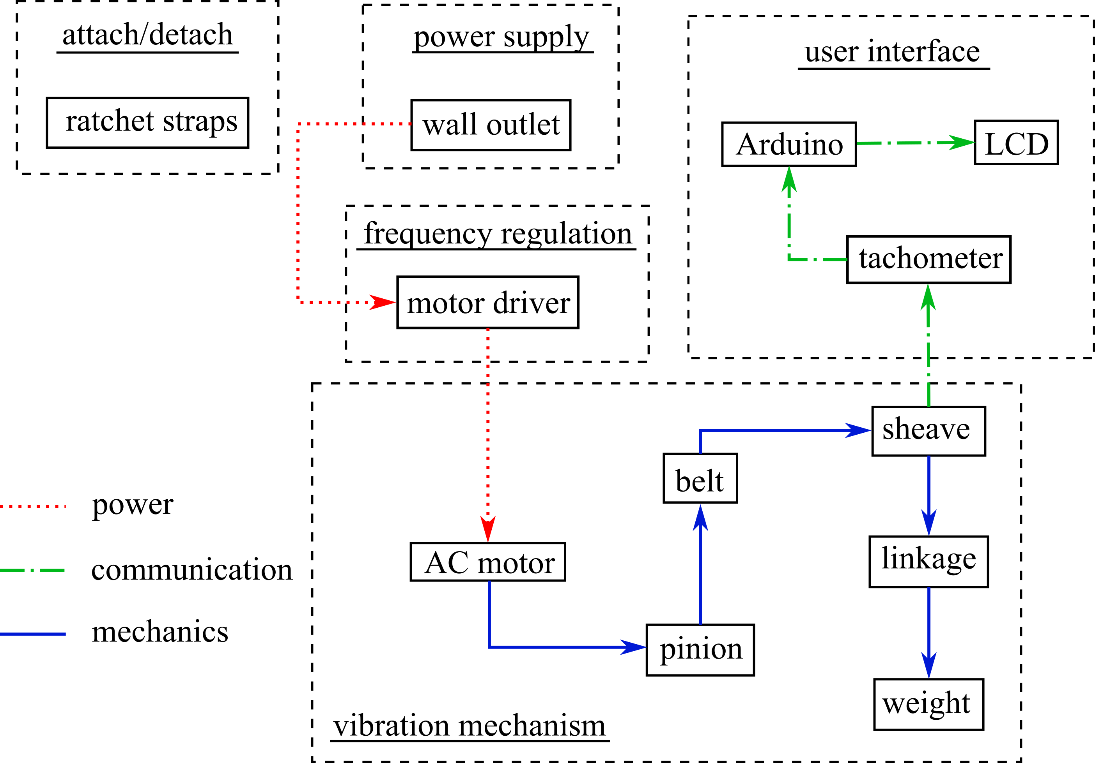

*Figure 3: Product layout with functional clusters.*

The functional components have been divided into five clusters as seen in Figure 3.

1. The first cluster is the attach/detach cluster which only contains the ratchet straps, which are used to secure the shaker to the bridge.
2. The second cluster is the power supply, which consists of the wall outlet to supply electrical energy to the system.
3. The third cluster is frequency regulation, which houses the motor driver which takes an analog input from the user for power regulation, which in turn will regulate the frequency/speed of the motor.
4. The frequency regulation cluster directly impacts the vibration mechanism, as the motor driver will change the speed of the motor, thus changing the linear velocity of the weight via the gear train.
5. The vibration mechanism cluster will directly affect the user interface cluster by having a tachometer attached to the sheave. This will be displayed on the user interface via an Arduino and LCD to show the current frequency of the sheave with the weight.

Some consequential interactions are as follows:

1. The vibrations from the shaker will be transferred to the electronics and the shaker frame. To minimize this effect, each element will be secured to the frame to minimize any extra shaking of components.
2. Heat will be generated from the motor as well, which may decrease the longevity of the shaker. The effect of heat generation could be lowered by allowing adequate airflow.
3. The shaker presents a possible safety hazard to any user as it has many moving parts and will have a moving weight. To fix this problem, steps can be taken to make the shaker more user-friendly such as adding handles for a better grip or covering dangerous moving parts.

The approximate dimensions of the shaker are 2 ft by 2 ft for the portion touching the ground and around 2.5 ft tall, as seen in Figures 1 and 2. This should supply adequate room for all the moving parts. The largest gear will be a foot in diameter, and the other two which will be attached via a belt to the large gear and linkage to the weight will both be four inches in diameter. The linkage will be 6 inches long, and the 5 kg weight itself, assuming being made of 3003 Aluminum, will be 4 inches in diameter and 7.874 inches in height.

1. **Identification of critical decisions TBD**

Key critical decisions that are yet to be determined are as follows:

* Frequency range: the realistic frequency range of the shaker must be customized for the bridges that it will be tested on. Current values are estimates based on past work and input from stakeholders, but the team will perform testing on the bridges using accelerometers to determine the frequency requirements of the shaker. This testing will be conducted in late December/early January.
* Motor: this is the motor that will turn the gear train to oscillate the weight at the desired frequency. This is still a TBD because the ARTS Lab already has a motor that may be used for the shaker, but testing must be done to determine if the maximum rpm is sufficient to reach the highest required frequency. This will be determined once the first prototype of the shaker is built in late January.
* Types of bearings: these bearings will be implemented to control the movement of the weight and constrain its pathway. This is still a TBD because the team lacks technical knowledge on the bearings required to support the highest frequency of the weight. This TBD will be resolved once the maximum frequency of the weight is determined in early January.

1. **Preliminary Budget**

Preliminary budgets were created in triplicate to show the variety of materials available to complete the shaker. Items were sourced from different websites and distributors to determine the best parts to take and implement into the groups design. Table 1 houses all this information and shows the prices for each component identified. At the end of each bill of materials, there are two values listed. The first is the subtotal which is just the raw price of the components added together. The total amount considers an extra 25% in value to cover shipping, contingencies, taxes, etc.

Table 4: Bill of Materials, completed in triplicate.



Each corresponding bill of materials has similarly high value items. This is the motor, the v-belt sheaves, and the frame for the shaker to sit in. these items will need to be reviewed in depth to weigh the pros and cons for purchasing. These items also must be purchased first because they likely have the largest lead time and will be the major source of change if something were to go wrong. Lastly, the only ‘to be determined’ item is the bearings. The bearings will need to be designed to fit the shafts purchased and the supports created. There is also further discussion to be had about the types of bearings needed for this design. Bearings should be sourced by the end of December.

1. **Future work**

The tentative timeline for the bridge shaker project is shown in Table 5. The team will spend most of its time validating and refining the first prototype in order to deliver an excellent end product.

Table 5. Proposed timeline for bridge shaker project.

|  |  |  |  |  |  |
| --- | --- | --- | --- | --- | --- |
|  | Jan | Feb | Mar | Apr | May |
| Accelerometer testing | X |  |  |  |  |
| Engineering analysis | X | X |  |  |  |
| First prototype construction | X | X |  |  |  |
| Validation and refinement |  | X | X | X |  |
| Final product construction |  |  |  | X |  |
| Product and documentation delivered |  |  |  |  | X |